How to Read Blind: https://accessinformationnews.com/read
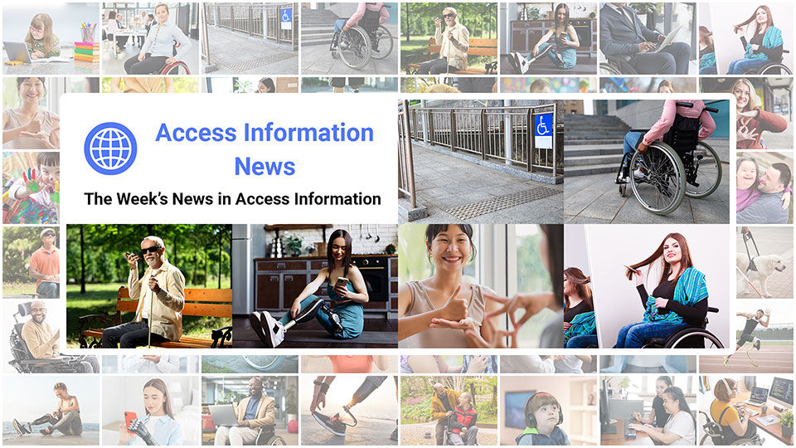
 |  |  |  |  |  |  |  |  |  |  |  | 
Access Information News for Monday, October 6, 2025 - Volume 1035
♿️ The Week's News in Access Information
Access Information News. The world's #1 online resource for current news and trends in access information.
A Mind Vault Solutions, Ltd. Publication
Subscribers: 41,315 🔢️ opt-in subscribers were sent this issue via email.

Sponsors 🏅️
 | 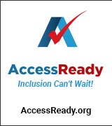 | 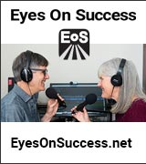 | 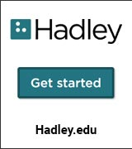 |  | 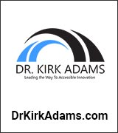
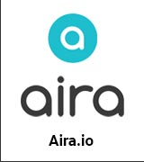 |  | 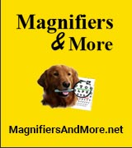 | 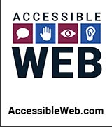 | 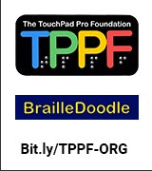 | 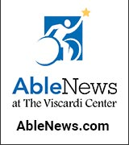
 |  |  |  |  | 

Access Awareness: Updates That Matter ♿️
I Went On A Trip With 20 Other Disabled People! | Molly Burke | YouTube.com | September 30, 2025
Join a remarkable journey as 21 individuals with disabilities embark on an extraordinary trip together. Experience the beauty of accessible travel, featuring breathtaking destinations and heartwarming moments that celebrate inclusion and adventure.

This Week's Featured Advertisement 🎯️
Would Your Product, Service or Message Benefit From Reaching Over 41,000 Access-Specific Readers Each Week? Join Access Information News as a Sponsor Today.

Join Access Information News as a Sponsor today and begin reaching over 41,000 access information readers each week, all while supporting the ongoing distribution of Access Information News for those very same readers. Only $200 / month.
Key Newsletter Statistics:
- Subscribers: 41,000 + per week and growing.
- Open Rate: 47% (Average. Last 12 months.)
- Click Rate: 34% (Average. Last 12 months.)
- Bounce Rate: 1.2% (Average. Last 12 months.)
- Ad CTRs: 2-12% (Average. Last 12 months.)
Benefits All Sponsors Receive:
- One (1) Sponsor Profile on the Access Information News website.
- One (1) Sponsor Profile in each weekly newsletter.
- One (1) Sponsor Wall Brand Advertisement on the Access Information News home page.
- One (1) Sponsor Wall Brand Advertisement in each weekly newsletter.
- One (1) Classified Advertisement in each weekly newsletter.
- 50% Discount on all Sponsored News Article Advertisements.
- Free link tracking.
- Permanent SEO benefits.
- Gratitude from over 41,000 access information subscribers for keeping Access Information News free to read.
With additional benefits for Sponsors that pay quarterly or annually. Learn more today.

News 📰️
👉 Submit a News Article for free here, with timing and placement determined by our editors.
👉 Submit a Sponsored News Article here, with timing and placement determined by you.

1.) Top 5 Most Clicked News Articles From Last Week 📊️
A.) They Faked Being Disabled To Win The Paralympics… | Molly Burke | YouTube.com | September 24, 2025
An incredible story unfolds as individuals attempt to exploit the Paralympics, presenting as disabled to gain a competitive edge. Insights into the ramifications of deceit in competitive sports highlight the importance of integrity and fairness.
B.) Strict Rules Can Foster Calm Classrooms. But Some Students Pay The Price | NPR.org | September 25, 2025
At Paramount Englewood in Indianapolis, strict disciplinary practices have led to repeated suspensions for students like Levent, who has ADHD, raising concerns about how rigid rules can disproportionately affect students with disabilities.
C.) U.S. Adults Report Rising Rates Of Cognitive Disability | News.yale.edu | September 24, 2025
A Yale study finds self-reported cognitive disability is increasing among U.S. adults, especially those aged 18 to 39, based on CDC survey data on memory and decision-making challenges.
D.) Disability Activist Stacey Park Milbern Becomes The First Woman In A Wheelchair On U.S. Currency | Weareresonate.com | September 24, 2025
The U.S. Mint has released a new quarter featuring Stacey Park Milbern, honoring her legacy as a disability rights advocate and marking the first time a woman in a wheelchair has appeared on American currency.
E.) Introducing The PWD Media Distribution Co-op: A One-of-a-Kind Business Resource For Consistently Reaching The Largest Audience of Persons With Disabilities In The World Today | Aaron Di Blasi | AT-Newswire.com | September 22, 2025
Greetings everyone. I am very excited to announce to you today the official launch of the PWD Media Distribution Cooperative. Why and how is it a "cooperative"? Well, that is precisely what I hope to explain in the following paragraphs. Let's open with a bit of background as to how this cooperative got started, and then I'll explain what it is, what it does, how it works, and finally, how you can reach out for consideration if you're interested.
October 6, 2025 📅️
2.) Sponsorship Packages Available | AccessInformationNews.com | October 6, 2025
Would your product, service or message benefit from reaching over 41,000 access information readers each week? For just $200 / month? If you're thinking yes, we invite you to try a Sponsorship Package with Access Information News. The benefits are amazing and the traffic delivered to your properties each week is measurable. No obligation. Cancel anytime.
3.) One Time Advertisements Available | AccessInformationNews.com | October 6, 2025
One time advertisements are available to anyone, with or without a Sponsorship. Would your product, service or message benefit from reaching over 41,000 access information subscribers? If you're thinking yes, please check out our one time advertising options. They are cost-effective, targeted and measurable. Scheduling is optional. Learn more today.
4.) Premium Subscribers | AccessInformationNews.com | October 6, 2025
Next Issue: Premium Subscribers will receive their 10th issue of the Top 60 Most Clicked News Articles for July, August and September of 2025 on Monday, October 6, 2025. Back Issues: There are currently 10 back issues available. Premium Subscribers are entitled to all back issues, anytime they sign up. All available back issues will be sent to you via email within 24 hours of purchasing your subscription. Please Join Us: If you would like to receive a perfectly formatted and searchable Word Document with each of the Top 60 Most Clicked News Articles of the last 3 months listed neatly within it, please consider joining us today for just $1 a month.
5.) Sponsored News Articles | AccessInformationNews.com | October 6, 2025
Use Sponsored News Articles to reach the access community when you need to. Whether you are a current Sponsor or not. Drive traffic to your access product and service announcements, events, updates or fundraisers using this incredibly cost-effective and easy-to-use advertisement tool. Learn more today.
6.) Do You Have A Link In This Issue? Learn How To Track It For Free | AccessInformationNews.com | October 6, 2025
This article will outline, step-by-step, how you can get free website traffic reporting on any link to your domain (AKA domain name, website or web address) that has been published by Access Information News since January 22, 2024, when we launched this feature.
7.) Access Information News Welcomes Ed Henkler of the The Blind Guide | AccessInformationNews.com | October 6, 2025
Please join me in giving a warm access welcome to Ed Henkler of the The Blind Guide, who has so very graciously agreed to support the ongoing distribution of Access Inforamtion News via sponsorship. If you enjoy reading Access Information News for free each week, it is sponsors like The Blind Guide that make it possible. The Blind Guide is a mission-driven platform helping people who are blind or low-vision, and the families and employers who support them, move from surviving to thriving through practical resources, free weekly articles, low-cost eBooks, mentorship, and skills-first job matching. They also spotlight enabling technologies, and partner with leading pipelines to connect great talent with inclusive employers. Please join me in thanking Ed and The Blind Guide for their ongoing support of our community. Learn more today at: https://theblindguide.com or reach out to Ed directly on LinkedIn.
October 4, 2025 📅️
8.) Podcast: "None Of Us Know Our Future" | Insights & Sound Bites | October 4, 2025
When Carol Lee was diagnosed with age-related macular degeneration, she was angry and frustrated. Over time, resentment began to fade a bit and the shock wore off. Gradually, her perspective started to shift.
October 3, 2025 📅️
9.) Family Perspectives on Technology Across Generations | Vicki Walton | AT-Newswire.com | October 3, 2025
Here, Vicki Walton turns a family gathering into a multigenerational reflection on how technology both empowers and excludes. A web accessibility specialist and IT QA tester, Walton evaluates digital tools with assistive tech like screen readers and voice navigation yet admits even "computer people" can feel overwhelmed by the pace of change. This personal vantage point frames perspectives from their pre-internet mother, Gen Z daughter, and boomer-age sister and wife, contrasting technology's efficiency with the frictions and anxieties it creates in everyday life.
10.) World-Renowned Advocate Donna J. Jodhan Speaks out On Inaccessible And Unusable Online Courses And Exams | Donna J. Jodhan, LLC, ASCP, MBA | Barrier Free Canada | October 3, 2025
Online courses and exams continue to pose significant challenges for many people — particularly individuals with disabilities, older adults, and those who did not grow up with technology.
11.) This Event Forces You To Walk In Someone Else's Shoes For A Good Cause | News5Cleveland.com | October 3, 2025
The Annual Walk for White Cane Safety Awareness Day will take place in Willoughby, Ohio, on October 11 from 10 a.m. to 1 p.m. The event aims to raise awareness about visual impairments and support those affected in the community as participants walk blindfolded using white canes, accompanied by sighted partners.
12.) New Zealand: The Blind Cost Of Living: New Figures Reveal Inequities Facing 183,000 New Zealanders | Auckland.scoop.co.nz | October 3, 2025
Data from Blind Low Vision NZ highlights the disproportionate impact of cost-of-living pressures on blind, deafblind, and low vision New Zealanders, revealing emotional and financial inequities. Reports indicate systemic barriers in employment and access to services, exacerbating challenges for a vulnerable community.
13.) Blind Veterans Group Donates Braille American Flag To Library | HeraldGuide.com | October 3, 2025
A tactile braille American flag will be presented at the St. Charles Parish library, enhancing accessibility for visually impaired visitors. This initiative by the Blinded Veterans Association aims to promote inclusion and patriotism through interactive displays in libraries across the state.
October 2, 2025 📅️
14.) Space Camp Empowers Visually Impaired Students With Adapted Astronaut Training | FOX54 News Huntsville | YouTube.com | October 2, 2025
The U.S. Space & Rocket Center is pioneering an innovative camp experience for visually impaired students, facilitating adapted astronaut training and simulated space missions. Through this initiative, participants engage in hands-on activities designed to inspire and empower the next generation of space enthusiasts.
15.) Tennessee Won't Track How Many Students With Disabilities Benefit From New Voucher Program | ChalkBeat.org | October 2, 2025
Tennessee's new education voucher program is drawing criticism for failing to track students with disabilities, prompting concerns over transparency and equitable access among advocates and lawmakers.
16.) Keeping The Visually Impaired Safe In The Kitchen | FloridaWeekly.com | October 2, 2025
Lighthouse of Collier received a $14,000 grant to support cooking classes for seniors with vision loss. The program aims to teach safe kitchen techniques and enhance independence through adaptive cooking methods and tools.
October 1, 2025 📅️
17.) Finding Your Calm: Practical Tips for Managing Stress | Ed Henkler | TheBlindGuide.com | October 1, 2025
Managing stress with vision loss is a critical skill but I want to acknowledge that it is a different focus than my typical thriving with blindness. I like to keep things positive. Managing stress is critical but tends to have a bit of a negative aspect.
18.) Visual Impairment In Children May Affect Their Mental Health | AAO.org | October 1, 2025
A study using data from the 2022 National Health Interview Survey highlights the link between visual impairment in children and increased rates of mental health issues such as depression and anxiety. Results show that visually impaired children face greater difficulties in learning and recall, further emphasizing the need for comprehensive support for their wellbeing.
19.) Colorado RTD Riders With Disabilities Will Have To Pay More For Door-To-Door Access | CBSNews.com | October 1, 2025
Colorado's RTD board voted to raise the cost of its Access on Demand service for riders with disabilities, increasing fares and reducing subsidies while expanding the service area.
20.) Big Country Advocates React To Federal Autism Study | KTXS.com | October 1, 2025
Local advocates in the Big Country are responding to the federal government's launch of the Autism Data Science Initiative, which aims to fund research and educate stakeholders on autism risks and treatments.
21.) UK: Accessible Train Tours 'Increase Confidence' | BBC.com | October 1, 2025
A guided tour of a train carriage organized for blind and partially sighted individuals by the Merseyside Sight Loss Council helped boost their confidence in navigating rail travel independently.
September 30, 2025 📅️
22.) I Went On A Trip With 20 Other Disabled People! | Molly Burke | YouTube.com | September 30, 2025
Join a remarkable journey as 21 individuals with disabilities embark on an extraordinary trip together. Experience the beauty of accessible travel, featuring breathtaking destinations and heartwarming moments that celebrate inclusion and adventure.
23.) Be My Eyes Partners With Zain Iraq To Expand Accessibility For Blind And Low Vision Customers | BeMyEyes.com | September 30, 2025
Be My Eyes announces a partnership with Zain Iraq, making it the first telecom in the Middle East to integrate Be My Eyes for enhancing customer service for blind and low-vision customers. This integration aims to provide accessibility, increasing independence and confidence for users through innovative technology.
24.) UK: Sefton Council Showcased For Pioneering Work To Improve Voting Accessibility For Disabled Residents | StandUpForSouthport.com | September 30, 2025
Sefton Council has been recognized for its innovative efforts to make voting more accessible for disabled residents, including the creation of a mock polling station in collaboration with People First Merseyside.
25.) Canada: As An Autistic, Disabled Entrepreneur In B.C., I've Had To Create The Space That Workplaces Denied Me | BCBusiness.ca | September 30, 2025
Margaux Wosk shares how systemic barriers in traditional workplaces led her to entrepreneurship, allowing her to build an inclusive environment that accommodates her needs as an autistic, disabled person.
September 29, 2025 📅️
26.) Legal Update: September 2025 | ConvergeAccessibility.com | September 29, 2025
The article outlines recent developments in ADA web accessibility cases, including significant court rulings that emphasize the importance of demonstrating a genuine intent to return to a physical location for standing in lawsuits. Key cases such as Herrera v. Retrofitness and Hwang v. Couple Spa 65, Inc. are discussed, highlighting various outcomes based on plaintiffs' alleged injuries and accessibility barriers encountered.
27.) DOJ's Lawsuit Against Uber Illustrates The Limits Of Tech Innovation For Accessibility | TechPolicy.press | September 29, 2025
A DOJ lawsuit against Uber highlights ongoing accessibility issues, citing blind and wheelchair-using passengers who were routinely denied rides despite the platform's promise of inclusive transit.
28.) Blind Plaintiff Sues DraftKings Over Website Accessibility Barriers | AboutLawsuits.com | September 29, 2025
A blind plaintiff has filed a class action lawsuit against DraftKings, claiming the site's design blocks access to fantasy sports and gambling features for users reliant on screen-reading software.
29.) US Will Not Enforce Biden Wheelchair Passenger Protection Rule | Reuters.com | September 29, 2025
The U.S. Transportation Department announced it will not enforce key provisions of a Biden-era rule aimed at strengthening protections for airline passengers who use wheelchairs, following legal challenges from major airlines.
30.) DC's Disability Transportation Time Tax | GGWash.org | September 29, 2025
A long-term DC resident and power wheelchair user highlights how transportation accessibility challenges in the city consume significant time and shape every aspect of life decisions.
31.) Carden Wyckoff Becomes Youngest Atlanta City Council Member, Brings Disability Advocacy To City Hall | CBSNews.com | September 29, 2025
At 32, Carden Wyckoff becomes the youngest and only wheelchair-using member of Atlanta's City Council, using her platform to prioritize accessibility and bring personal experience to the forefront of policymaking.
32.) Nashville Metro Council Approves Resolution For ADA Accessibility Audit | NewsChannel5.com | September 29, 2025
Nashville's Metro Council has approved an ADA accessibility audit to examine how accessible the city is for people with disabilities, responding to community advocacy and public concerns.
Last Week 📅️
33.) Why Many Young Adults Turn On TV Or Movie Subtitles, According To A New Poll | APNews.com | September 28, 2025
A new poll finds that many young adults use subtitles while watching TV or movies to accommodate multitasking and noisy environments, improving their ability to follow dialogue without missing content.
34.) Canada: Sask. Bryan Adams Fan Almost Denied VIP Experience Due To Accessibility Restrictions | CTVNews.ca | September 28, 2025
Jodi MacEachern, a wheelchair user and longtime Bryan Adams fan, nearly missed out on a VIP concert experience due to accessibility limitations at the Brandt Centre, highlighting challenges in event inclusivity.
35.) Ireland: Dublin Zoo Leads The Way With ISL Accessibility For Deaf And Hard Of Hearing Visitors | Droghedalife.com | September 28, 2025
Dublin Zoo has become Ireland's first to offer Irish Sign Language-interpreted content via QR codes, enhancing accessibility for deaf and hard of hearing visitors in partnership with national charity Chime.
36.) Delivery Robot Collides With Mobility Scooter, Sparking Accessibility Outrage | WebProNews.com | September 27, 2025
A Serve Robotics delivery robot collided with a mobility scooter operated by cerebral palsy patient Mark Chaney in West Hollywood, sparking public outcry and concerns over accessibility and autonomous tech.
37.) Australia: Calls For Change After Qantas Refuses To Fly British Woman With Mobility Scooter Due To Its Battery | TheGuardian.com | September 27, 2025
Qantas denied boarding to Dr. Jurai Darongkamas due to her mobility scooter's lithium battery, sparking a six-month dispute and raising questions about accessibility standards in air travel.
38.) Canada: Camp Kindle Wraps Up $9-Million Expansion And Accessibility Project | CalgaryHerald.com | September 27, 2025
Camp Kindle has completed a $9-million expansion aimed at improving facilities and accessibility for children affected by cancer, featuring new play areas and enhanced infrastructure for mobility support.
39.) UK: Don't Trust Trump': How UK Health Experts Are Fighting Back Against A War On Medicine | TheGuardian.com | September 27, 2025
UK Health Secretary Wes Streeting responded with concern after former U.S. President Donald Trump claimed Tylenol could cause autism, prompting UK health experts to counter the misinformation amid rising distrust in medical guidance.
40.) Rebecca Gayheart Describes 'Journey' Of Supporting Eric Dane Through ALS Diagnosis | TheNationalDesk.com | September 26, 2025
Actress Rebecca Gayheart shared her emotional experience supporting husband Eric Dane through his ALS diagnosis, highlighting their efforts to maintain grace, dignity, and love through the challenges.
41.) AMC Theatres Accused Of Disability Discrimination | DisabilityScoop.com | September 26, 2025
The EEOC has filed a lawsuit against AMC Theatres, alleging it violated the ADA by denying simple accommodations to Marc Gillis, an employee with cerebral palsy who had worked there for 22 years.
42.) Assault On Accessibility Initiatives Hits Early Career Scientists Hard | CapitalAndMain.com | September 26, 2025
Major funding cuts to NIH and NSF have created a mental health crisis among early career researchers, particularly affecting those with disabilities like Uma Chatterjee, a doctoral student experiencing OCD flare-ups.
43.) AI Is Overlooking Accessibility. Here's How To Change That | BuiltIn.com | September 26, 2025
While AI promises transformative potential for people with disabilities, a lack of inclusive design risks reinforcing existing barriers and excluding marginalized users from its benefits.
44.) Target Unveils Game-Changing Self-Checkout Technology Designed For Blind Customers Nationwide | Target.com | September 26, 2025
Target has launched a nationwide rollout of accessible self-checkout systems tailored for blind and low vision shoppers, led by accessibility manager Steve Decker who personally understands the challenges.
45.) New Mexico Courts Boost Accessibility Through Collaboration And Data | Pew.org | September 26, 2025
New Mexico courts are improving accessibility through data-driven reforms, as a Pew poll shows people with disabilities are significantly more likely to interact with the court system than those without.
46.) Canada: Canadian Seniors React To Canada Post's Door-To-Door Delivery Changes | CTVNews.ca | September 26, 2025
Canada Post has received approval to eliminate door-to-door mail delivery for four million households, prompting concerns among seniors like 78-year-old John Peters who rely heavily on home delivery for essential communications.
47.) The Need for Accessibility Excellence | AccessibleAndroid.com | September 25, 2025
This article highlights the challenges faced by individuals with disabilities regarding the accessibility of technology, specifically criticizing Google's AI Edge Gallery app for lacking accessibility features. It advocates for a higher standard of accessibility, emphasizing the importance of prioritizing inclusive design and listening to the disabled community.
48.) The 5th Motivation For Accessibility: Brand And Marketing — The Binary Choice | Nira11y.com | September 21, 2023
The article explores the critical impact of accessibility on brand perception, emphasizing that companies are seen either as champions of inclusion or as blockers for people with disabilities. It highlights examples from Apple and Domino's to illustrate how accessibility can enhance or damage brand loyalty and marketability, framing accessibility as a vital part of modern brand strategy.
49.) The Unruh Act: Understand The Lawsuits And How State And Federal Regulations Could Combine To Create Blockbuster Settlements | Deque.com | September 17, 2025
This article explores the implications of California's Unruh Act on digital accessibility lawsuits, highlighting the potential for significant financial penalties for violations. As accessibility issues in digital storefronts become more prevalent, businesses are urged to prioritize compliance to avoid costly litigation and maintain inclusivity.
50.) Forced-Color-Adjust: None Is An Unavoidable Foot Gun | SarahMHigley.com | September 17, 2025
This article highlights the challenges of using the CSS property 'forced-color-adjust: none' within accessibility contexts, particularly in complex codebases where styles can be unintentionally overridden. It discusses the trade-offs of using this property for controlling high contrast styles while also recognizing the risks of compromising accessibility when other developers modify the CSS.
51.) Reviewing The Logic And Value Of The W3C's Accessibility Maturity Model | Afixt.com | September 11, 2025
The article examines the necessity of a distinct Accessibility Maturity Model by the W3C, arguing for its importance in effectively addressing accessibility needs distinct from traditional frameworks. It highlights the need for domain-specific expertise, stakeholder engagement, and cultural change within organizations, while also discussing the potential pitfalls of introducing yet another framework in an already saturated compliance environment.
52.) Testing Methods: Visual Presentation | DennisDeacon.com | September 9, 2025
This article explains the WCAG 1.4.8 Visual Presentation criteria, highlighting how users can customize text presentation for better accessibility. It discusses the strengths and limitations of automated, AI, and manual testing methods in identifying visual presentation issues that impact readability for users with disabilities.
53.) Why Moving Away From SPAs Improves Usability, Accessibility, And SEO | Innoweb.com.au | September 8, 2025
This article explores the advantages of moving from Single Page Applications (SPAs) to server-rendered websites, emphasizing improved usability, accessibility, and SEO. It discusses how server-rendered structures provide faster load times, enhance user experience, and yield better SEO outcomes compared to SPAs, which often struggle with performance and accessibility issues.

Featured Events 📅️
👉 Submit your event for consideration within this section here.

October 6, 2025 through October 8, 2025 | M-Enabling Summit | Promoting Accessible Technologies and Environments
Ready for a Transformative Journey into Digital Accessibility? Embark on a transformational journey by participating in the 2025 M-Enabling Summit, where we will delve into "Digital Accessibility Innovation — A Deep Dive into Next-Generation User Experiences" from the perspective of the latest tech trends for organizational inclusion. Gain insights and network discussions with business executives, disability advocates, developers, and policy experts across various sectors, including private, public, nonprofit, and education. A key feature of the Summit is the Accessibility Professionals Forum, which will focus on accessibility within organizations at the intersection of physical and digital environments. Unable to make it to Washington, D.C.? No worries! You can still be part of the Summit by joining us online. Access a curated selection of streamed sessions, interact with leading industry experts through our app, or catch up with post-event recordings.
October 7, 2024 | Join Our October Webinar | Blazie Technologies
4:00 PM PT, 5:00 PM MT, 6:00 PM CT, 7:00 PM ET, 11:00 PM GMT
Join Blazie Technologies for this webinar highlighting upcoming features in the next BT Speak update, including a detailed demonstration and updates on BT Braille, followed by an interactive Q&A session.
October 8, 2025 | Navigating Powerpoint With JAWS (Assistive Technology Webinar) | Marisa Church And Michael Vitagliano | Access Ingenuity
10 AM PT, 11 AM MT, 12 PM CT, 1 PM ET, 5 PM GMT
Techniques for navigating PowerPoint with JAWS, including editing text within slides and constructing presentations. Designed for both new and experienced JAWS users.
October 11, 2025 | What's New In JAWS, Zoomtext And Fusion | Technology User Group At The Maryland State Library For The Blind And Print Disabled
10:00 AM PT, 11:00 AM MT, 12:00 PM CT, 1:00 PM ET, 5:00 PM GMT
TUG welcomes Elizabeth Whitaker from Freedom Scientific to detail the latest changes in JAWS, ZoomText, and Fusion.
October 14, 2025 and October 15, 2025| Virtual Web Accessibility Training | WebAIM
9:00 AM PT, 10:00 AM MT, 11:00 AM CT, 12:00 PM ET, 4:00 PM GMT
In this two-day, expert-led online program from WebAIM, participants will learn essential and advanced web accessibility practices to ensure compliance with international guidelines and legal requirements. Designed for developers, designers, and accessibility professionals, the training covers WCAG principles, assistive technology use, inclusive design for various disabilities, evaluation techniques, and offers a complimentary document accessibility course.
October 15, 2025 | Basics Of Creating Accessible Powerpoint Presentations - Remediation And Testing (Digital Accessibility Webinar) | Rachel Reeves | Access Ingenuity
10 AM PT, 11 AM MT, 12 PM CT, 1 PM ET, 5 PM GMT
Learn the basics of structuring PowerPoint for accessibility, adding alternate text (especially for complex images like flowcharts), and best practices for screen reader compatibility.
October 20, 2025 | This Is Your Brain On Birds Programming: A Conversation About Pain With Dr. Rachel Zoffness | Birdability
In this conversation, Birdability's Jayme Boucher and Dr. Rachel Zoffness explore how chronic pain intersects with birding, and how scientific insight can help people live more connected, flourishing lives.
October 21, 2025 | Pathways To Disability Empowerment: Navigating On-Line Credentials To Boost Your Skills | The Lighthouse For The Blind, Inc.
4:00 PM PT, 5:00 PM MT, 6:00 PM CT, 7:00 PM ET, 11:00 PM GMT
In this monthly career webinar from The Lighthouse for the Blind, Inc., job seekers who are blind, low vision, DeafBlind, or blind with other disabilities will explore how platforms like EdX and Udemy can help close skill gaps and earn certifications across industries. Topics include writing, communication, interpersonal development, artificial intelligence, marketing, and project management.
October 21, 2025 | Accessibility In Conservation Panel | Birdability
Birdability Captains working in conservation will share stories, challenges, and successes in making outdoor spaces more accessible and inclusive for disabled visitors and colleagues.
October 21, 2025 | Car Birding In Rhode Island And Beyond | Birdability
This webinar reviews car birding techniques, useful equipment and software, and examples from Rhode Island and other states to help participants take their car-birding to the next level.
October 22, 2025 | Monarch Meets JAWS: Unlocking The Future Of Multiline Braille | Vispero And Humanware
9:00 AM PT, 10:00 AM MT, 11:00 AM CT, 12:00 PM ET, 4:00 PM GMT
In this exclusive webinar, Vispero and HumanWare showcase how Monarch and JAWS together unlock new possibilities for multiline and split braille, enhancing education, productivity, and independence. The session highlights intuitive navigation with multiline cursor routing and the seamless integration between JAWS and Monarch for braille users at every level.
October 22, 2025 | JAWS For Windows: Quick Ways To Get Help & Beginner Resources (Assistive Technology Webinar) | Mark Schafer | Access Ingenuity
10 AM PT, 11 AM MT, 12 PM CT, 1 PM ET, 5 PM GMT
Explore JAWS help tools such as Keyboard Help, Screen Sensitive Help, and other resources for beginners. Interactive session with Q&A.
October 22, 2025 | Birding And Belonging: A Panel About Accessible Birding While Using A Wheelchair | Birdability
Birdability's founder and geographically diverse Captains will discuss how to make birding accessible from a wheelchair, share barriers they've faced, and highlight creative solutions for inclusive participation.
October 23, 2025 | Social Field Safety Workshop By Field Inclusive | Birdability
This workshop raises awareness of social risks in outdoor fieldwork faced by marginalized individuals and offers strategies for creating safer, more inclusive field environments.
October 23, 2025 | Bird-a-Thons And Belonging: Stories From The Blind Birder Community | Birdability
Organizers and participants in the Blind Birder Bird-a-Thon will share stories of inclusion, community, and the impact of birding while blind, and discuss plans for future events.
October 24, 2025 | Accessible Nature Journaling Workshop | Birdability
Birdability Captains Emily Nichols and Cassandra Dean lead a one-hour journaling session, offering prompts and accessible tools so participants of all abilities can connect with nature through journaling.
October 25, 2025 | You Belong Here: Joy, Belonging & Community Through Birding With Dexter Patterson | Birdability
Dexter Patterson (the Wisco Birder) leads a keynote celebrating the connections, joy, and shared belonging that birding can foster among diverse participants.
October 26, 2025 | Birdability Week Celebration + Photo/Video Contest Winners Announced | Birdability
Join the Birdability community to celebrate the week, share participant submissions, and announce winners of the Birdability Week Photo & Video Contest.
October 29, 2025 | Part 2: Web Accessibility Basics - Manual Screen Reader (Digital Accessibility Webinar) | Michael Parker And Marisa Church | Access Ingenuity
10 AM PT, 11 AM MT, 12 PM CT, 1 PM ET, 5 PM GMT
Focused on desktop screen reader testing using JAWS and NVDA with Chrome on Windows 11. Covers navigation, form labeling, error handling, and accessibility barriers. Mapped to WCAG 2.2 Level AA.
November 5, 2025 | Jaws, Zoomtext & Fusion 2026: Latest Features (Assistive Technology Webinar) | Ian Ramos And Marisa Church | Access Ingenuity
10 AM PT, 11 AM MT, 12 PM CT, 1 PM ET, 5 PM GMT
Explore updates and new features in the 2026 versions of JAWS, ZoomText, and Fusion.
November 12, 2025 | Part 3: Web Accessibility Basics - Manual Mobile Testing (Digital Accessibility Webinar) | Michael Parker And Marisa Church | Access Ingenuity
10 AM PT, 11 AM MT, 12 PM CT, 1 PM ET, 5 PM GMT
Covers mobile testing challenges, including use of VoiceOver (iOS) and TalkBack (Android). Learn gestures, navigation, testing touch targets, and reflow issues.
November 13, 2025 and November 14, 2025 | Blind Travel Summit | Blind Travel Foundation
Led by Paralympian and accessibility trailblazer Mike May, the Blind Travel Summit at the Texas School for the Blind in Austin features interactive, solutions-focused sessions designed to foster real connection among blind travelers, tech users, and advocates. Each session combines concise presentations with facilitated discussions to co-create better travel solutions.
November 14, 2025 | Deadline to Invest in Doppler Labs' At-Home Hearing | Dr. Kirk Adams
Doppler Labs offers audiologist-grade hearing aids and a patented at-home fitting platform designed to deliver fast, accessible hearing care at scale. The Netcapital raise aims to fund expansion, production, and a nonprofit arm targeting underserved regions, with clinical trials completed and pricing locked in for sustainable impact and global reach.
November 15, 2025 | International Neurology Conference 2025 | PubScholars Group
12:00 AM PT, 1:00 AM MT, 2:00 AM CT, 3:00 AM ET, 8:00 AM GMT
The International Neurology Conference 2025 is a flagship hybrid event hosted by PubScholars Group on November 15-16, 2025, at the Hard Rock Hotel at Universal Orlando (5800 Universal Blvd, Orlando, FL) and streamed online. The conference explores "Mind-Brain Connection: Understanding Neuroscience through Mental Health," aiming to integrate cutting-edge science with clinical relevance. Who Should Attend: Neurologists, neurosurgeons, neuroscientists, psychologists, rehabilitation professionals, engineers, industry leaders, students, and allied health practitioners. Important Dates & times: Abstract Submission Deadline: September 15, 2025. Registration Deadline: September 30, 2025. Event Timing: November 15, 2025 (8 AM start) - November 16, 2025 (6 PM close). Format: Hybrid Event (In-person & Virtual.) Contact Person: Richard A. Email: info@pubscholars.org 📧️. Phone: +91 7042134266 📱️. Venue: Hard Rock Hotel at Universal Orlando, 5800 Universal Blvd, Orlando, FL 32819, USA.
November 19, 2025 | Portable OCR Solutions - Easily Access Text Again (Assistive Technology Webinar - ACVREP CE Approved) | Ian Ramos (Access Ingenuity) And Joseph Mcdaniel (Vispero)
10 AM PT, 11 AM MT, 12 PM CT, 1 PM ET, 5 PM GMT
Presentation on OCR technology for the visually impaired. Open to all participants; TVIs can earn ACVREP continuing education credit.
December 9, 2025 and December 19, 2025 | 6th Annual Sight Tech Global | SightTechGlobal.com
Sight Tech Global returns for its sixth year as a free, virtual conference spotlighting how AI and emerging technologies are reshaping assistive tech and accessibility worldwide. Featuring expert panels, demos, and discussions with leaders from Google, Meta, and Microsoft, the conference explores innovations that empower independence and drive digital equity.
May 21, 2026 | Tech Blitz 2026: Assistive Technology Showcase Brings Together Blind, Deafblind, And Low Vision Community For Innovation, Discovery, And Connection. | Helen Keller Services
3:00 PM PT, 4:00 PM MT, 5:00 PM CT, 6:00 PM ET, 11:00 PM GMT
In this in-person showcase hosted by Helen Keller Services, assistive technology vendors, innovators, and users come together for a day of interactive demonstrations, in-depth discussions, and community connection focused on advancing access and independence for the blind, DeafBlind, and low vision communities.

Directories 📝️
1) Access Information Email Newsletter Directory | Submit

Sponsor Classified Ads 🎯️

⬆︎ 3.) Sponsor: Eyes on Success

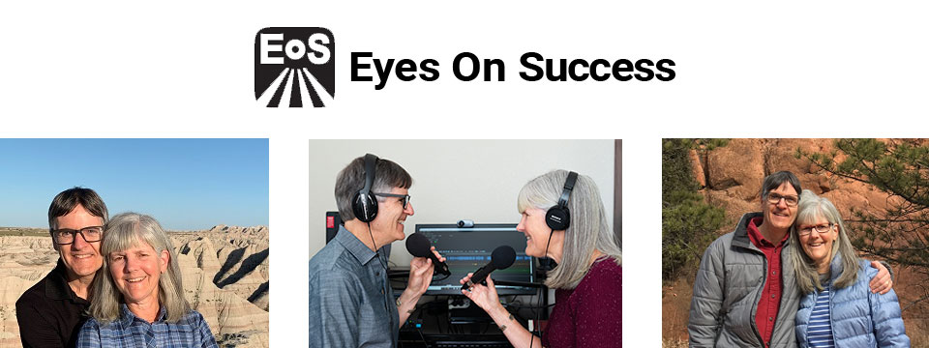
Sponsor Since: August 21, 2023 📅️
Website: https://www.eyesonsuccess.net/ 🌐️
About: This half-hour weekly podcast and radio program discusses products, services and daily living tips for people with vision loss. It is available through radio reading services across North America, via several internet streaming services, and to everyone else as a podcast. To date, the show has been downloaded in all 50 states in the US and over 100 other countries on all the inhabited continents. Eyes On Success is hosted and produced by Peter Torpey and Nancy Goodman Torpey.
Each episode is basically a success story. Some are human stories of visually impaired people's accomplishments in academics, employment, sports or pastimes. Others are descriptions of adaptive aids that enable visually impaired people to achieve things. These include screen readers, magnifiers, navigation aids, and others. In all cases, the focus is on success.
Eyes On Success has been airing weekly since January 2011. Prior to January 2013 the name of the show was ViewPoints. Other than the name, nothing has changed.
Listening To Eyes On Success
You can listen to Eyes On Success on your smart home device by saying “play the Eyes On Success podcast”, subscribe to the podcast wherever you get your podcasts, or listen on Apple Podcasts, iTunes, YouTube or your local radio reading service. Listeners can also follow the show on Facebook and X (Formerly Twitter).
Connecting with Eyes On Success
Email: To contact us with questions, comments or suggestions for future shows send an e-mail to hosts@EyesOnSuccess.net 📧️.
Weekly Announcements: If you would like to receive weekly announcements of upcoming episodes, you can join our low traffic "announcements only" list by sending an e-mail to: EyesOnSuccess+subscribe@GoogleGroups.com 📧️.
Email Forum: If you would like to connect with other listeners and share your thoughts about what you've heard on the show, you can join our listener email forum by sending an email to: EOS_Discuss+Subscribe@GoogleGroups.com 📧️

⬆︎ 2.) Sponsor: Access Ready, Inc.

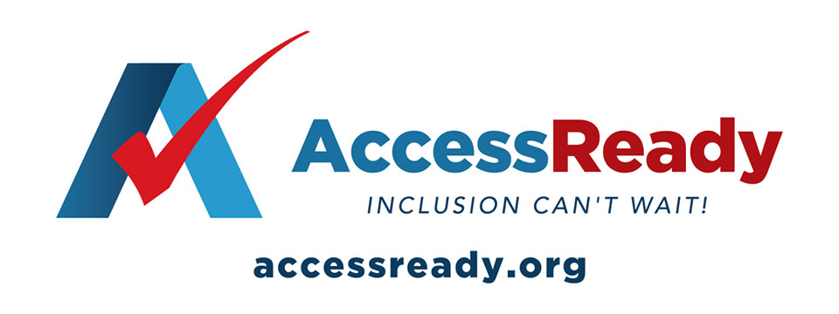
👉️ Classified Advertisement: Help Access Ready, Inc. Rebuild After Hurricanes Helene and Milton | Access Ready, Inc.
Help Access Ready, Inc. support people with disabilities after Hurricanes Helene and Milton.
Based in Saint Petersburg, Florida, Access Ready is committed to providing adaptive equipment, restoring independence and dignity to those affected. Many lost vital devices that help them communicate, work, and live independently.
Donations will go toward repairing or replacing this equipment, ensuring people can regain normalcy after the disaster. Every contribution directly aids recovery efforts.
Since 2018, Access Ready has promoted accessible technology, led by CEO Douglas George Towne.
Your support can make a real difference. Donate Now — be a lifeline for those in need.
info@accessready.org 📧️
+1 (727) 531-1000 📱️
Sponsor Since: December 1st 2022 📅️
Website: https://accessready.org/ 🌐️
Email: info@accessready.org 📧️
Phone: (727) 531-1000 📱️
About: Access Ready Inc. is a certified, 501(c)(3) nonprofit organization. The mission of Access Ready Inc., a nonprofit cross-disability rights advocacy organization, is to promote a policy of accessibility benefiting all people regardless of ability across information and communications technology utilized for two way communications.
The purpose of Access Ready Inc. is to educate the public and private sectors of the importance of accessible information and communications technology to the future of all people regardless of ability.
To support this education by developing initiatives that promote policies that ensure the creation and maintenance of accessible technologies utilized for two way communications at all levels which allow for easy use by people with the widest range of abilities possible.
To develop employment and business opportunities for people with disabilities that support its educational activities in the field of information and communications technology and related areas.
To provide consulting and educational services to buyers, developers, and users of information and communications technology that promotes its highest and best use in society.
To promote the concept of a technologically accessible society which fosters:
Freedom of expression, speech, and worship.
Freedom from fear, ignorance, and want.
Freedom from dishonesty, exclusion, and immorality.
Freedom of aspiration, invention, and inclusion.

⬆︎ 1.) Sponsor: Pneuma Solutions

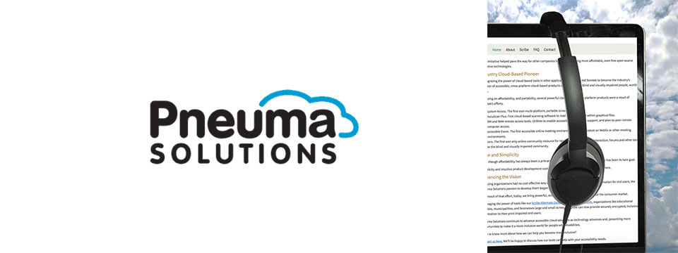
👉️ Classified Advertisement: From Now Through the 18th: Experience Unmatched Independence in the Field of Remote Desktop Access with a Remote Incident Manager Free for All! | Pneuma Solutions
As the United States finishes celebrating Independence Day, regular attendees of the summer blindness conventions will prepare to begin activities centered around independence for people who are blind or visually impaired. IN light of this, we at Pneuma Solutions are lighting our own fireworks over a very unique and never-before-seen level of independence in the field of remote desktop access!
To a technician or trainer who is blind, nothing says independence quite like performing a remote session with a sighted end user's computer, regardless of platform, and being able to fully use it, despite the lack of an installed screen reader. Our Remote Incident Manager is the world's first application that allows this to happen. As such, To celebrate this exciting level of independence, we are proud to offer unlimited access to Remote Incident Manager for the next 14 days, completely free of charge!
Sponsor Since: November 7th 2022 📅️
Website: https://pneumasolutions.com/ 🌐️
Email Newsletter: Click here to receive periodic news via email concerning Pneuma Solutions products for business, consumers and education.
Sales: (866) 202-0520 📱️
Support: (650) 249-1000 📱️
About: Backed by two decades of creating award-winning accessible cloud technologies for people with visual impairments, Pneuma Solutions is the global leader in accessible cloud-based solutions. Pneuma Solutions was founded by long-time accessibility developers Mike Calvo and Matt Campbell. For more information on their individual profiles, click on their respective bio pages. We're proud to be the first company to develop cloud-based accessibility at the network level. Our tools provide organizations, like yours, a way to deliver secure, accessible information right from your network or from our secure servers. You can provide your print disabled consumers, students, employees, and citizens with a multitude of accessible options. Additionally, we offer a suite of cloud-based applications to blind and print disabled consumers directly from our website. Our consumer products are designed to make the day-to-day lives of blind and print disabled individuals more accessible and simpler to manage. Access to information is not a privilege, it's a right. It's also your right to obtain affordable, accessible cloud solutions to serve your end user. When organizations like yours implement our tools, together we help make it a more inclusive world for people with disabilities. Want to know more about how we can help you become more inclusive?
Contact us here. We'll be happy to discuss how our tools can help with your accessibility needs.

⬆︎ 13.) Sponsor: The Blind Guide, LLC

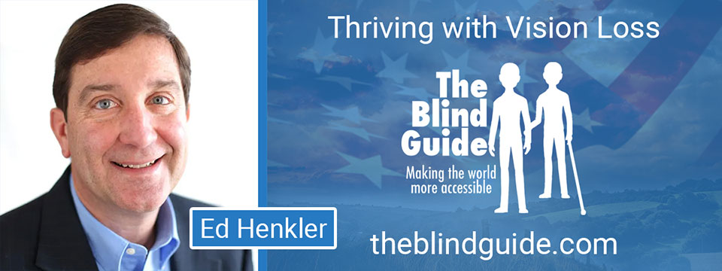
Sponsor Since: October 6, 2025 📅️
Website: https://theblindguide.com 🌐️
About: The Blind Guide is passionate about helping people thrive with vision loss. My website includes many resources for people losing their vision and their caregivers. Register for my weekly blog post or read one or more of my eBook series, which cover the initial vision loss journey through education, entertainment, and home modifications.
Assistive technology is a key enabler of thriving with blindness. I've worked with emerging technologies to make everyday life more accessible and enjoyable, enabling independent travel, better access to sporting events, your inner musician, and so much more.
My ecosystem also includes resources for jobseekers and employers. The list of jobs someone who is blind cannot do is much shorter than the list of jobs they can do. Ask me about employment programs from cybersecurity to talent sourcing.
For employers, I can connect you with a hidden market of exceptional, resilient talent: people who are blind plus veterans and military spouses.

⬆︎ 12.) Sponsor: Able News at The Viscardi Center

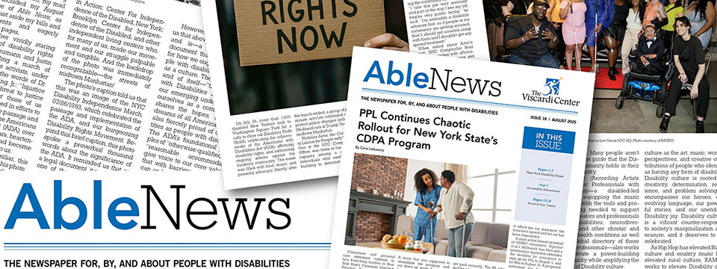
👉️ Classified Advertisement: Able News Brings You Disability News Like No Other Source | Able News at The Viscardi Center
Able News at The Viscardi Center is a monthly periodical for, by, and about people with disabilities. It amplifies the perspective of a diverse disability community and reports on news, technology, sports, health and wellness, culture, travel, advocacy and opportunities to learn and connect. Visit Ablenews.com to sign up to receive Able News in your inbox monthly. Advertising opportunities in the digital edition and on the website are also available.
Sponsor Since: July 4, 2025 📅️
Website: https://ablenews.com 🌐️
Email: ablenews@viscardicenter.org 📧️
About: Able News at The Viscardi Center is a monthly periodical for, by, and about people with disabilities. It amplifies the perspective of a diverse disability community and reports on news, technology, sports, health and wellness, culture, travel, advocacy and opportunities to learn and connect. It is a valuable resource and brings readers disability news like no other source.
Read Able News

⬆︎ 11.) Sponsor: The Touch Pad Pro Foundation / BrailleDoodle

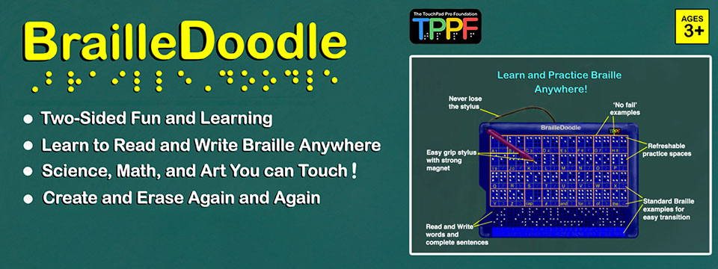
👉️ Classified Advertisement: BrailleDoodle Available at A. T. Guys Now! Just $149.00 USD | The Touch Pad Pro Foundation / BrailleDoodle
The BrailleDoodle is a groundbreaking, affordable, two-sided tablet designed to empower individuals of all ages and skill levels with Braille literacy and tactile exploration. One side is dedicated to Braille learning, featuring practice spaces for letters, numbers, and words, making it perfect for beginners or those looking to improve their skills. The other side offers a tactile refreshable surface, ideal for creating art, exploring STEM concepts like math and graphing, and expressing creativity in limitless ways.
With its easy-to-use magnetic stylus, users can write and create tactile designs, feel their progress as they go, and erase effortlessly, making learning and creativity interactive and engaging. Whether you're a teacher, parent, or individual learner, the BrailleDoodle is a versatile tool that combines education, creativity, and fun. Priced at just $149.00 USD, it is an affordable solution to enhance accessibility and opportunity for blind and low-vision individuals. Order now and take the first step in transforming education and creativity! Visit A.T. Guys today to learn more.
Sponsor Since: January 1, 2025 📅️
Website: https://touchpadprofoundation.org 🌐️
About: The TouchPad Pro Foundation (TPPF) is a 501(c)(3) nonprofit organization committed to creating opportunities for blind and low-vision individuals through Braille literacy, STEM, and art education.
Founded by educators and innovators passionate about accessibility, TPPF strives to address the critical gaps in resources and tools for the visually impaired community. With a mission to promote equality and unleash human potential, the foundation provides innovative solutions that make education inclusive, engaging, and affordable.
Their initiatives include offering free devices to under-served communities and providing training to maximize the impact of their groundbreaking tools.
At the heart of their mission is the BrailleDoodle, a dual-sided, tactile learning tablet designed to make education and creativity accessible to all.
One side focuses on Braille literacy, offering interactive learning spaces for letters, numbers, and words, while the other provides a refreshable surface for tactile drawing, STEM exploration, and artistic expression.
Affordable and versatile, the BrailleDoodle empowers individuals of all ages and skill levels to develop essential literacy and creative skills.
By fostering independence and encouraging innovation, TPPF and the BrailleDoodle are transforming the lives of blind and low-vision learners worldwide.
For more information, visit the TouchPad Pro Foundation website.

⬆︎ 10.) Sponsor: AccessibleWeb

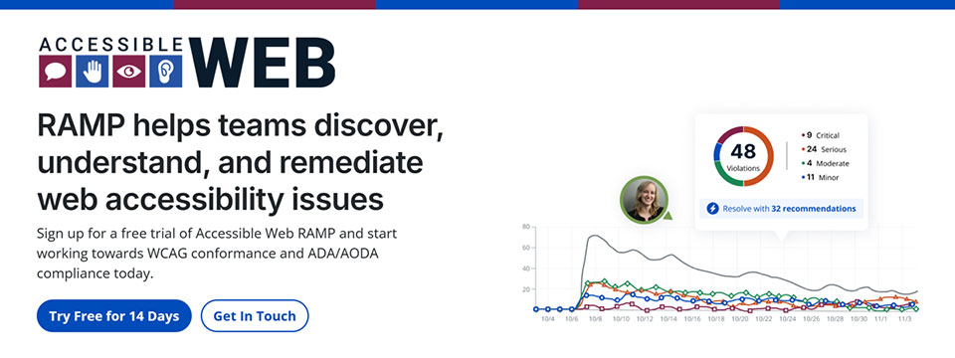
👉️ Classified Advertisement: Have You Run Into An Accessibility Barrier On A Website Recently? | AccessibleWeb
Accessible Web is on a mission to help eliminate online barriers and make the digital space more inclusive for everyone, regardless of ability. Our accessibility testing software, RAMP, allows organizations of any size to discover, understand, and remediate barriers. We offer tools to integrate with existing sites and workflows so businesses with a digital presence can start making their sites more accessible quickly.
Plans start at $49 a month. Plus, we have a 14-day free trial with no credit card needed. We believe any organization can start making progress with Accessible Web RAMP.
Sponsor Since: December 16, 2024 📅️
Website: https://accessibleweb.com 🌐️
About: At Accessible Web, our mission is to make the internet accessible to everyone, regardless of ability.
We offer a comprehensive suite of accessibility testing software tools and educational resources to help organizations achieve and maintain web accessibility in line with the Web Content Accessibility Guidelines (WCAG) and comply with legal standards such as the Americans with Disabilities Act (ADA) and the Accessibility for Ontarians with Disabilities Act (AODA).
➜︎ Services:
⚫️ WCAG Audits: Our certified specialists conduct thorough analyses of websites and applications, identifying accessibility issues and providing detailed recommendations for remediation.
⚫️ VPAT Preparation: We prepare Voluntary Product Accessibility Templates (VPATs), offering industry-standard reports that demonstrate a product's accessibility compliance, which can be crucial for sales and contractual obligations.
⚫️ Accessibility Testing: Our team of individuals with disabilities tests websites and web applications using assistive technologies, providing actionable feedback to enhance user experience and accessibility.
⚫️ Remediation Support: Our certified specialists offer coaching and support to assist organizations in implementing accessibility improvements effectively, ensuring that digital assets meet accessibility standards.
⚫️ Accessibility Certification: Through a comprehensive process of auditing, remediation, and verification, we provide WCAG certifications that validate a company's conformance and commitment to accessibility best practices.
➜︎ Tools:
⚫️ Accessible Web RAMP: Our digital accessibility platform that enables teams to discover, monitor, and remediate web accessibility violations. RAMP offers continuous monitoring, prioritized workflows, and progress reporting to facilitate ongoing compliance efforts.
⚫️ Accessible Web Helper Extension: An accessibility browser extension that allows users to scan web pages, highlight accessibility violations, and check color contrast ratios directly from their browser, streamlining the auditing process.
➜︎ Education:
⚫️ Accessible Web Academy: We offer self-guided online courses tailored to various organizational roles, promoting a culture of inclusivity and equipping teams with the knowledge to implement accessible design from the outset.
⚫️ Knowledge Base and Blog: Our resources include articles on assistive technologies, remediation tutorials, and answers to common web accessibility questions, supporting continuous learning and awareness. We host webinars most Thursdays on various accessibility topics.
We emphasize a proactive approach to web accessibility, advocating for integrating accessible design principles early in the development process to enhance user experience, attract new customers, and mitigate legal risks associated with non-compliance.
For more information or to explore our services and resources, visit our website.
Facebook | LinkedIn | Reddit | YouTube

⬆︎ 9.) Sponsor: Magnifiers & More

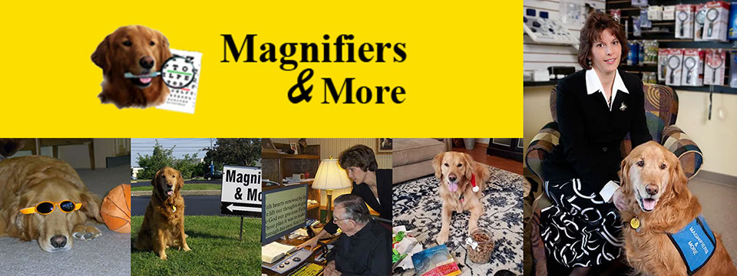
Sponsor Since: October 25, 2024 📅️
Website: https://www.magnifiersandmore.net 🌐️
Email: info@magnifiersandmore.net 📧️
Phone: (440) 946-3363 📱️
Fax: (440) 946-8899 📠️
Visit: 7775 Mentor Avenue, Mentor, Ohio 44060, USA
About: Magnifiers & More, established in 2002 by Deborah Kogler, is Northeast Ohio's only retail store dedicated to providing products and consultations for individuals with low vision, blindness, and vision disabilities. With over forty years of experience in eye care, Deborah founded the company to create a one-stop shop for vision aids, including specialized tools for managing conditions like macular degeneration, glaucoma, diabetic retinopathy, and cataracts.
The store offers a wide range of over seventy-five magnifiers, talking items, large print products, special lights, electronic aids, Braille items, glare control solutions and More.
A key figure in the company's story is Murphy, Deborah's Golden Retriever and original CEO, "Canine Executive Officer," who was the store's mascot and greeter for 15 years. Today, Jeffrey, another Golden Retriever trained as a service dog, serves as the CFO, "Canine Fun Officer," delighting customers and supporting Deborah.
Deborah's journey into vision rehabilitation was inspired by her grandmother's experience with macular degeneration, sparking her passion to make vision aids accessible. She continues to advocate for and educate those living with vision disabilities, both locally and internationally.
Magnifiers & More is committed to helping people improve their quality of life through practical solutions and compassionate support.

⬆︎ 8.) Sponsor: Innosearch.ai

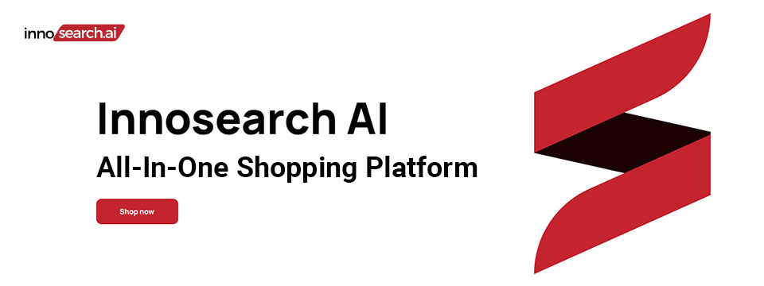
👉️ Classified Advertisement: Shop by Phone — No Screens, Just Your Voice!
Call 1-855-SHOP-GPT (1-855-746-7478)
Shopping online can be hard if you're blind, visually impaired, or not tech-savvy. That's why Innosearch AI created Shop by Phone — a 100% free, voice-only service.
Just call and say what you need:
👉 “Find me a phone charger.”
👉 “Add it to my cart.”
👉 “Check out.”
No apps, no websites — just easy, hands-free shopping from over 500,000 stores.
- ✔ Free to use
- ✔ Works anywhere, anytime
- ✔ Perfect for seniors, blind, and low-vision users
Available in:
- 🇬🇧 UK: +44 7727 247467 📱️
- 🇨🇦 Canada: +1 782 222 7467 📱️
- 🇦🇺 Australia: +61 489 267 467 📱️
- 🇺🇸 USA: 1-855-SHOP-GPT 📱️ (1-855-746-7478 📱️)
Call now and shop with ease!
Sponsor Since: October 15, 2024 📅️
Website: https://www.innosearch.ai 🌐️
Email: info@innosearch.ai 📧️
About: Innosearch is an all-in-one shopping platform augmented with a cutting-edge AI-powered shopping assistant. This innovative feature mimics the experience of shopping in real life by allowing you to interact with the assistant using natural language. It aggregates millions of products from top US online retailers, bringing them directly to you. With this advanced generative AI, Innosearch offers personalized product recommendations, highlights the best deals, and provides comprehensive information including reviews, total prices, shipping options, and more. Innosearch delivers a seamless end-to-end shopping experience, eliminating the need to search and browse in multiple tabs across retailers.
YouTube Review By Sam Seavey: https://youtube.com/watch?v=-rjL-HAwaZY.
Key Features: Key Features of the Innosearch All-in-One AI Shopping Platform include:
➜ Research Products: Easily compare products across retailers, or weigh pros and cons of similar products to make informed decisions.
➜ Uncover the Best Deals: Never miss a door buster, coupon, or clearance sale again. Get notified about the best prices and offers.
➜ AI Summarized Trusted Reviews: See what others are saying and make confident purchases.
➜ All in One: Innosearch brings millions of products from top online retailers directly to you, allowing you to shop the best deals with easy checkout and personalized AI assistance.
➜ Shop with Confidence: Rest assured, Innosearch has you covered with free shipping and returns on every purchase.
➜ Know Before You Buy: Innosearch equips you with expert buying guides, empowering you to make well-informed decisions.
How To Shop: Simply create a free account and start shopping today!

⬆︎ 7.) Sponsor: Aira

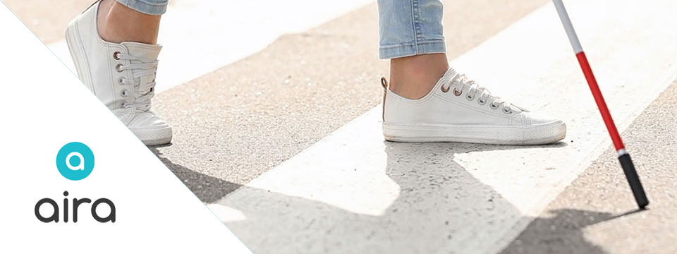
Sponsor Since: September 9, 2024 📅️
Website: https://aira.io/ 🌐️
Download the App: Apple App Store | Google Play Store
Plans and Pricing: https://aira.io/pricing/
Phone: NA: +1.800.835.1934 📱️ | AU: +1.800.765.096 📱️ | UK: +0.800.046.5668 📱️ | NZ: +1.800.425.451 📱️
Text Message: NA: +1.858.242.4457 📱️ | AU: +61.488.839.767 📱️ | UK: +44.149.320.2474 📱️
Email: support@aira.io 📧️
Social: Twitter | Facebook | LinkedIn | YouTube | Instagram
About: Aira's mission is to remove barriers and make the world more accessible with visual interpreting.
We provide a live, human-to-human professional assistance service, an accommodation or productivity tool, that enhances independence by delivering on-demand, skilled and reliable visual interpreting for just about any task. Using the powerful combination of a camera and the Aira app on someone's device of 'choice', a professionally-trained agent will assist by visually interpreting what is in the camera's view or on screen, from describing to reading, from explaining to navigating - just about anything, safely and securely. Aira supports a growing range of devices including smart and tactile button phones, desktop computers and soon, wearables.
Whether you are involved in the work of business, the work of school or the work of life, Aira enhances everyday efficiency, engagement, and independence. Used by employees and customers of hundreds of organizations including airports, banks, the largest software companies, financial firms, retailers and universities, we invite you to join the community, access the Aira app today and try it for free.
https://aira.io/download-and-try-it/
Step One: Subscribe and Download. Pick the plan that lets you explore on your terms and on your time, sign up in a few minutes, and download the Aira app to your smartphone. Plans shown are for the United States, Canada, Australia, New Zealand and the United Kingdom. Add or cancel at any time.
Step Two: Connect with an Aira Agent. On the first call, connect with one of our certified, specially-trained Agents and learn how everything works.
Step Three: Real-time Assistance. At the touch of a button, Aira delivers instant access to visual information, when and where you want it.

⬆︎ 6.) Sponsor: Dr. Kirk Adams

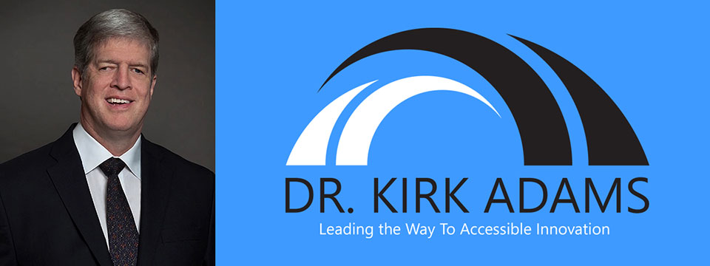
Sponsor Since: July 22, 2024 📅️
Website: https://drkirkadams.com 🌐️
About: Dr. Kirk Adams is a visionary leader, transformative speaker, and lifelong advocate for disability inclusion. With over three decades of experience in advancing accessibility and creating opportunities for individuals who are blind or low-vision, Dr. Adams has become a powerful force for change in the areas of leadership, accessibility, and inclusion. His journey — from navigating vision loss as a young child to becoming a recognized thought leader in disability empowerment — uniquely equips him to help organizations understand, integrate, and champion inclusive practices that benefit all.
Dr. Adams is a highly sought-after speaker, known for his engaging and thought-provoking keynotes on disability inclusion, accessible leadership, and the power of resilience. He has spoken at numerous national and international conferences, including corporate seminars, public policy forums, and industry events, where his personal story and professional insights have inspired leaders to rethink their approach to diversity, equity, and inclusion. His passion lies in empowering organizations to create environments where every individual — regardless of ability — can thrive.
As a speaker, Dr. Adams brings authenticity, warmth, and a depth of experience that resonates with audiences from all backgrounds. He understands that true leadership is about more than just policy; it's about creating cultural shifts that value each person's unique contributions. Whether he is addressing a Fortune 500 company, a non-profit, or a community group, Dr. Adams' message is clear: inclusion benefits everyone, and together we can build a world where opportunity is accessible to all.
Dr. Adams currently resides in Seattle, Washington, where he continues his advocacy work, builds strategic partnerships, and enjoys life with his family. He is proud to be a part of the movement towards a more inclusive future — one conversation at a time.

⬆︎ 5.) Sponsor: Barrier Free Canada

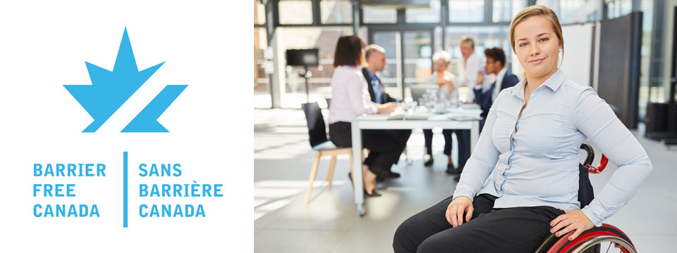
👉️ Classified Advertisement: Barrier Free Canada — Canada sans Barrières Announces Strategic Investment to Empower the Workforce of Tomorrow | Barrier Free Canada
Barrier Free Canada — Canada sans Barrières is proud to announce a bold new strategic investment aimed at advancing accessibility and inclusion in Canada's workforce. This initiative supports innovative training, education, and employment opportunities for persons with disabilities, helping to eliminate systemic barriers and foster a more equitable labor market. By partnering with key stakeholders across sectors, the investment will drive meaningful change, preparing a diverse and inclusive workforce to meet the challenges of tomorrow. This milestone reflects Barrier Free Canada's ongoing commitment to building a barrier-free nation where everyone can thrive and contribute fully to society.
Sponsor Since: November 10, 2023 📅️
Website: https://barrierfreecanada.org/ 🌐️
About: Barrier-Free Canada/Canada Sans Barrieres (BFC/CSB) advocates for the Canadian Parliament to enact a strong and effective Canadians with Disabilities Act (CDA) to achieve a barrier-free Canada for all persons with disabilities.
To this end, BFC/CSB is seeking endorsements from national disability organizations to build a non-partisan community coalition. BFC/CSB would also like to identify point persons from these organizations to act as key contacts.
The steering committee of BFC/CSB has drafted a set of principles concerning a CDA that are drawn from the principles that underpin the provincial disability legislation in Ontario and Manitoba. A CDA is not meant to replace provincial disability legislation. It will complement such legislation and benefit Canadians living in provinces with and without provincial disability legislation. At this point in time, CNIB, March of Dimes Canada, Canadian Hearing Society and MS Society of Canada have endorsed the BFC/CSB principles and confirmed their support for the movement to enact a CDA. There is no individual or organizational charge for membership in BFC/CSB.
Please contact Donna Jodhan, Founder of Barrier-Free Canada, at info@barrierfreecanada.org 📧️ with any questions or to express your organization's support and identify a key contact.
Social: Facebook | X (Formerly Twitter) | Mastodon (Search For: @news@mastodon.barrierfreecanada.org).

⬆︎ 4.) Sponsor: Hadley

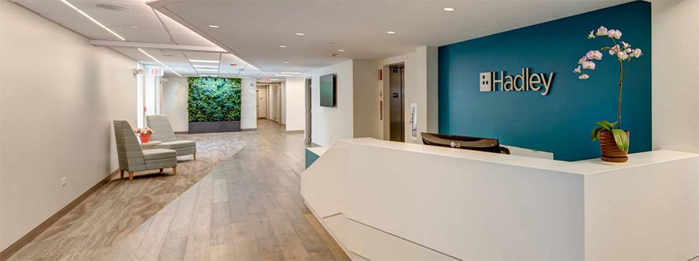
👉️ Classified Advertisement: New NVDA Workshops at Hadley | Hadley
Learn the basics of NVDA. From getting started with the program to customizing the speech to learning helpful shortcuts, Hadley's workshops have you covered.
Sponsor Since: September 18th 2023 📅️
Website: https://hadleyhelps.org/ 🌐️
Email: info@hadleyhelps.org 📧️
Phone: (800) 323-4238 📱️
Get Started: https://hadleyhelps.org/learn 🎓
What would you like to learn today?
Donate: https://hadleyhelps.org/donate/support-hadley ❤
A 501(c)(3) non-profit organization, Hadley relies on contributions from individuals, foundations, and corporations to fund its programs.
About: The mission of Hadley is to create personalized learning opportunities that empower adults with vision loss or blindness to thrive — at home, at work, and in their communities.
Founded in 1920 by William Hadley, an educator who lost his eyesight later in life, Hadley offers practical help, connection and support free of charge to anyone with a visual impairment, their families and professionals supporting them. With Hadley, you can discover new ways to do things that have become more difficult due to vision loss and connect with a network of peers who "get it." And you don't need to come to Hadley. Hadley's help comes to you; online, on the phone or through the mail.
Since relaunching in July 2020, more than 70,000 people have signed up with Hadley, registering more than 200,000 workshop interactions. And our workshops have 98% satisfaction ratings. We reach all 50 states and more than 100 countries. And more people learn braille from Hadley than from any other organization worldwide.
Hadley is a proud partner of the National Eye Institute and the National Eye Health Education Program.
Hadley's help conveniently meets learners where they are. Free of wait lists. Free of office visits. Free of charge.
Social: Facebook | X (Formerly Twitter) | YouTube

⬆︎ 14.) Sponsor: Your Name Here

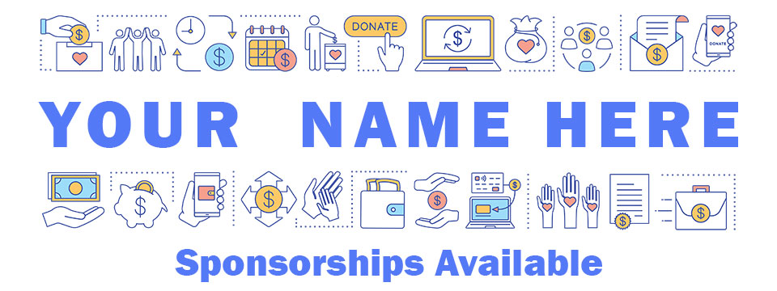
Sponsor Since: Today 📅️
Website: https://accessinformationnews.com/dearsponsor 🌐️
Phone: (855) 578-6660 📱️
Email: news@accessinformationnews.com 📧️
About: Founded in 2022, Access Information News is the world's leading not-for-profit access information news publication that reaches over 41,000 blind, low vision, deaf, hard of hearing, deafblind, neurodivergent and/or disabled professionals, educators and enthusiasts, all over the world, each week. Subscribe here. Review the most recent issues here.

Access Information News Supporters 🤝️
We couldn't do it without you! Thank you for your support!
Why: Access Information News Supporters donate an amount of their choosing either one time or annually in order to assist with the ongoing distribution of the Access Information News publication.
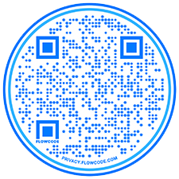
Benefits: All Access Information News Supporters receive a listing within the "Our Supporters" section of each weekly newsletter, as well as a listing within the "Our Supporters" section of the Access Information News website.
In addition, all Access Information News Supporters automatically become Premium Subscribers as well, and therefore enjoy all of the benefits that a Premium Subscription has to offer.
One Time Donation: If you would like to become a Access Information News Supporter by making a one time donation in an amount of your choosing to assist with the ongoing distribution of the Access Information News publication, you may utilize this donate link, or scan the QR code to the right.
Annual Donation: If you would like to become a Access Information News Supporter by making a small annual donation to assist with the ongoing distribution of the Access Information News publication, we also offer the following options, all with our sincerest thanks, and most heartfelt gratitude for your ongoing support.
Support: In tandem with Our Sponsors, these are the people that make the ongoing distribution of Access Information News possible.

Platinum Supporters:

Become an Access Information News Platinum Supporter today.
1.) James Hulme
Platinum Supporter Since: December 5, 2022
2.) Donna Jodhan
Platinum Supporter Since: March 24, 2023
3.) Your name here.
Platinum Supporter since ...

Gold Supporters:

Become an Access Information News Gold Supporter today.
1.) Your name here.
Gold Supporter since ...

Silver Supporters:

Become an Access Information News Silver Supporter today.
1.) Your name here.
Silver Supporter since ...

Bronze Supporters:

Become an Access Information News Bronze Supporter today.
1.) Your name here.
Bronze Supporter since ...

One Time Supporters:

One Time Supporters donate an amount of their choosing — one time to assist with the ongoing distribution of the Access Information News Publication.
Become an Access Information News One Time Supporter today.
1.) Sharyn Sobel
One Time Supporter on November 28, 2023
2.) Amanda Lee
One Time Supporter on July 31, 2023
3.) Gaylen Kapperman
One Time Supporter on June 4, 2024
4.) Your name here.
One Time Supporter on ...

Access Information News Team 🗞️

Distribution: Sponsors, Supporters and Mind Vault Solutions, Ltd.

Distribution Since: 2022
As of November 7, 2022 the distribution of Access Information News is made possible by our Sponsors, our Supporters, our Advertisers and Mind Vault Solutions, Ltd., a leading international provider of professionally outsourced marketing administration and consultation services.
Any time the Access Information News Publication carries less than its Sponsor limit, Mind Vault Solutions, Ltd. donates the remaining dollars necessary to keep the publication running.
Please help us to support the ongoing distribution of this publication. Learn more about the benefits of Sponsorship today.

Publisher: Aaron Di Blasi

Publisher Since: November 7, 2022
Location: Cleveland, Ohio
Time Zone: Eastern Standard Time (EST/EDT) (GMT-5/GMT-4)
In addition to serving as Publisher for Access Information News Aaron also serves as Publisher for the Top Tech Tidbits and AI-Weekly newsletters, PR-Director for the AT-Newswire Press Release News Distribution Service, and President and Senior Project Management Professional for Mind Vault Solutions, Ltd.
As Publisher Aaron oversees the weekly distribution of Access Information News on behalf of Mind Vault Solutions, Ltd.
Aaron Di Blasi, PMP
Email: publisher@accessinformationnews.com 📧️
Toll-Free: +1 (855) 578-6660 📱️
Aaron Di Blasi, PMP
Email: publisher@toptechtidbits.com 📧️
Toll Free: +1 (855) 578-6660 📱️
PR Director (2024-Present)
AT-Newswire 🌐
Access Technology's Digital Newswire
Publisher (2024-Present)
AI-Weekly 🌐
The Week's News in Artificial Intelligence
Publisher (2022-Present)
Access Information News 🌐
The Week's News in Access Information
Publisher (2020-Present)
Top Tech Tidbits 🌐
The Week's News in Access Technology
Sr. Project Management Professional (2006 - Present)
Mind Vault Solutions, Ltd. 🌐
Innovative ideas. Solutions that perform.
Certified:
Digital Marketing Associate
Meta Certified (2022 - Present)
Social Marketing Professional
Hootsuite Certified (2020 - Present)
Email Marketing Professional
Constant Contact Certified (2019 - Present)
Specializing in:
Digital Strategy and Content Marketing
Social Media Advertising
Online Fundraising
ADA, WCAG and Section 508 Compliance

Editor: John Hanlin

Editor Since: November 7, 2022
Location: Boulder, Colorado
Time Zone: Mountain Standard Time (MST/MDT) (GMT-7/GMT-6)
In addition to serving as an Editor to Access Information News John also serves as an Editor to the Top Tech Tidbits and AI-Weekly newsletters and is also an attorney-at-law specializing in long-term disability claims for blind and low-vision persons.
John is also a long-time contractor and member of the Board of Trustees at Mind Vault Solutions, Ltd.
John Hanlin, Esq.
Editor (2024-Present)
AI-Weekly 🌐
The Week's News in Artificial Intelligence
Editor (2022-Present)
Access Information News 🌐
The Week's News in Access Information
Editor (2020-Present)
Top Tech Tidbits 🌐
The Week's News in Access Technology
Board of Trustees (2006 - Present)
Mind Vault Solutions, Ltd. 🌐
Innovative ideas. Solutions that perform.

Editor: Jenna Lang

Editor Since: November 7, 2022
Location: Des Moines, Iowa
Time Zone: Central Standard Time (CST/CDT) (GMT-6/GMT-5)
In addition to serving as an Editor to Access Information News Jenna also serves as an Editor to the Top Tech Tidbits and AI-Weekly newsletters and runs her own advocacy foundation.
Jenna also serves as a certified Project Management Professional (PMP) for Mind Vault Solutions, Ltd.
Jenna's son was born blind and she is always seeking new and innovative ways to empower him through technology.
Jenna Lang, PMP
Editor (2024-Present)
AI-Weekly 🌐
The Week's News in Artificial Intelligence
Editor (2022-Present)
Access Information News 🌐
The Week's News in Access Information
Project Management Professional (2022 - Present)
Mind Vault Solutions, Ltd. 🌐
Innovative ideas. Solutions that perform.
Editor (2020-Present)
Top Tech Tidbits 🌐
The Week's News in Access Technology

Editor: David Woodbridge

Editor Since: February 6, 2023
Location: Central Coast, New South Wales, Australia
Time Zone: Australia Eastern Standard Time (AEST/AEDT) (GMT+10)
In addition to serving as an Editor to Access Information News David also serves as an Editor to the Top Tech Tidbits publication and is also the National Commercial Assistive Technology Advisor for Vision Australia where he has worked since 1990. Over this time he has assisted people who are blind or vision impaired in their home, education, and work settings to take advantage of the benefits of using assistive and main stream technology.
In the last seventeen years, he has also been involved with evaluating technology for use by people who are blind or vision impaired covering both low and high tech equipment (including Microsoft, Samsung, Google, Amazon, and Apple). David is also one of the key spokespersons for Vision Australia relating to technology.
He has been an Apple Ambassador for Apple Australia since 2009 with a group of other Ambassadors / Apple Distinguished Educators (ADE)'s covering the range of Apple's Accessibility solutions throughout Australia.
David produces a range of podcasts (since 2011) covering Apple and other technologies which are distributed on his own podcast (http://davidwoodbr.podbean.com). In addition, he also has a regular Talking Tech program (since 2013) which can be heard every Tuesday at 4:30 Eastern Summer Time on Vision Australia Radio Melbourne (available online) or via https://omny.fm/shows/talking-tech-vision-australia-radio
David also runs a weekly Tech Monday where people can chat about assistive and main stream technology, share information, and any tips and tricks.
David lost his sight when he was 8 years old and had to learn Braille. Since then, he completed high school, went to Sydney University receiving a Social Work degree, spent 4 years drug and alcohol counselling, and then moved into his current job.
As a person who is blind, David believes that as a user of the technology that he recommends to others, that he is well situated to look at the strengths and shortcomings of the assistive technology that he comes across in both his professional and personal life, in particular, mainstream technology that is accessible.
In addition to his weekly contributions to Access Information News and Top Tech Tidbits, David's regularly occurring activities are his weekly tech radio show, bi-monthly exploring tech webinars for Vision Australia, his iSee podcast when something of note grabs his attention, and the weekly Tech Monday chat sessions.
David Woodbridge
X (Formerly Twitter): @dwoodbridge
Mastodon: woody@dragonscave.space
iSee Podcast: https://davidwoodbr.podbean.com
Vision Australia Radio Talking Tech: https://omny.fm/shows/talking-tech-vision-australia-radio
Editor (2023-Present)
Top Tech Tidbits 🌐
The Week's News in Access Technology
Editor (2023-Present)
Access Information News 🌐
The Week's News in Access Information
National Commercial Assistive Technology Advisor
(1990 - Present)
Vision Australia 🌐
Live the life you choose. We're here to support all Australians who are blind or have low vision.

Editor: Vicki Walton

Editor Since: January 9, 2024
Location: Benton City, WA
Time Zone: Pacific Standard Time (PST/PDT) (GMT-6/GMT-7)
IIn addition to serving as an Editor to Access Information News Vicki also serves as an Editor to the Top Tech Tidbits publication and works as a Web Accessibility Specialist / IT Quality Assurance Tester at Washington State Board for Community and Technical Colleges.
Vicki Walton
Editor (2024-Present)
Top Tech Tidbits 🌐
The Week's News in Access Technology
Editor (2024-Present)
Access Information News 🌐
The Week's News in Access Information
Web Accessibility Specialist / IT Quality Assurance Tester
Washington State Board for Community and Technical Colleges 🌐
Better Jobs, Brighter Futures, a Stronger Washington

Subscription Information 📰️
ABOUT ♿️
Founded in 2022, Access Information News is the world's leading not-for-profit access information news publication that reaches over 41,000 blind, low vision, deaf, hard of hearing, deafblind, neurodivergent and/or disabled professionals, educators and enthusiasts, all over the world, each week. Subscribe here. Review the most recent issues here. Access Information refers to informational topics that directly affect the lives of people with disabilities. Access Information includes any and all information related to bettering the lives of people who are blind, low vision, deaf, hard of hearing, deafblind, neurodivergent and/or disabled. Access Information News is a Mind Vault Solutions, Ltd. Publication. Publisher: Aaron Di Blasi. Editors: John Hanlin, Jenna Lang, David Woodbridge and Vicki Walton. Access Information News is a sponsor, reader and advertiser supported publication.
RELEASE SCHEDULE 📅️
Access Information News is released every Monday morning at 6:00 AM ET.
SUBSCRIBE 📧️
Do you, a friend, or colleague wish to receive the Access Information Newsletter? If so, please use or pass along our CAPTCHA-free sign-up link. You can also subscribe to receive the Access Information Newsletter on the Access Information News Website. Either of these methods will provide you with an accessibly friendly and secure medium through which you can subscribe to our mailing list. Just enter your email address, click send, and begin receiving the Access Information Newsletter. It's that easy.
WEBSITE 🌐️
Visit the Access Information News website online at: https://accessinformationnews.com.
PREMIUM SUBSCRIBER 💸️
Only Access Information News Premium Subscribers receive our special quarterly issue listing the Top 60 Most Clicked News Articles of the Last 3 Months. Just $12 USD per year. This special quarterly issue is provided to Premium Subscribers as a native Microsoft Word document with full headings, links and abstracts to all 60 articles. There are no restrictions placed on these documents. Complete list of all back issues available. Premium Subscribers are entitled to all back issues, anytime they sign up. Join us today and begin receiving this incredibly informative issue every 3 months.
SPONSOR 🏅️
If you would like to become 1 of only 24 Access Information News Sponsors whose ongoing support makes the distribution of Access Information News possible, we offer you the following advertising benefits, with our sincerest thanks, and most heartfelt gratitude for your ongoing support.
ADVERTISE 🎯️
Access Information News offers a variety of one-time advertising options to both Sponsors and non-Sponsors alike. Here we offer a sample newsletter that provides a breakdown of exactly what those one-time advertising options are, where they appear, and what they cost per publication.
DONATE ❤️
If you would like to become an Access Information News Supporter by making a small donation to assist with the ongoing distribution of the Access Information News publication, we offer the following options, with our sincerest thanks, and most heartfelt gratitude for your support.
FACEBOOK 💬️
Are you on Facebook? Follow Access Information News on Facebook to begin receiving current news and trends in Access Information as part of your Facebook News Feed.
X (FORMERLY TWITTER) 💬️
Are you on X? Follow Access Information News on X to begin receiving current news and trends in Access Information as part of your X News Feed.
MASTODON 💬️
Are you on Mastodon? Follow Access Information News on Mastodon to begin receiving current news and trends in Access Information as part of your Mastodon News Feed or by searching for @news@mastodon.accessinformationnews.com on your server today.
LINKEDIN 💬️
Are you on LinkedIn? Follow Access Information News on LinkedIn to begin receiving current news and trends in Access Information as part of your LinkedIn News Feed.
YOUTUBE ▶️
Are you on YouTube? Follow Access Information News on YouTube to begin receiving current news and trends in Access Information as part of your YouTube Video Feed.
RSS 📡️
Do you prefer RSS? Follow Access Information News via RSS today to begin receiving current news and trends in Access Information using your choice of news aggregator.
QUESTIONS ❓️
Article abstracts are intentionally concise. As a result we know that some readers may not always understand all of the items listed because little explanation is given. If a particular article brings up a question in your mind, feel free to ask, and we will try to answer as time and knowledge permit.
ARCHIVE 🗄️
Read the most recently released issues of Access Information News online here. Visit the Access Information News Archive here, where you can read back issues.
CONTENT CONTRIBUTORS ✍️
Any information for future issues of Access Information News may be submitted online via our News Item Submission Form or directed to our Editors via email.
THANK YOU 🙏️
Thank you for reading. On behalf of all of us here at Access Information News we look forward to keeping you informed.
Information provided by:
Access Information News
https://accessinformationnews.com/ 🌐️
A Mind Vault Solutions, Ltd. Publication
1284 SOM Center Road, PMB 194,
Mayfield Heights, Ohio 44124
+1 (855) 578-6660 📱️

