How to Read Blind: https://accessinformationnews.com/read
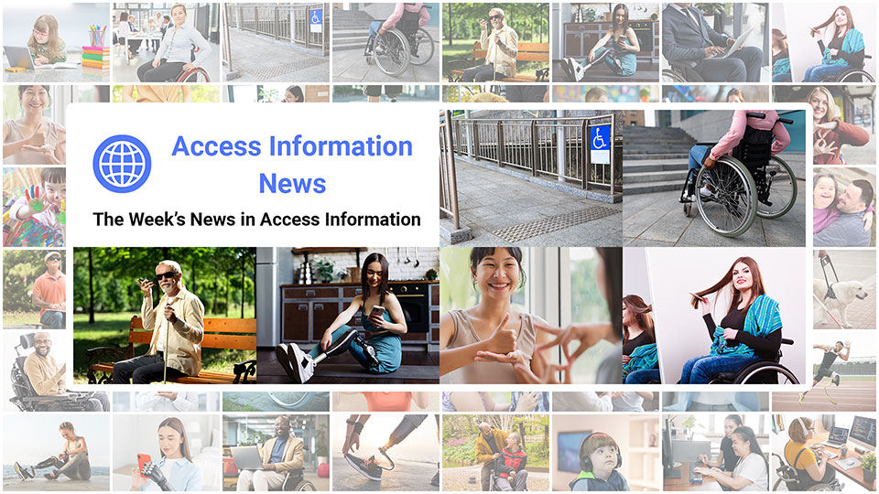
 |  |  |  |  |  |  |  |  |  |  |  | 
Access Information News for Monday, September 22, 2025 - Volume 1033
♿️ The Week's News in Access Information
Access Information News. The world's #1 online resource for current news and trends in access information.
A Mind Vault Solutions, Ltd. Publication
Subscribers: 41,051 🔢️ opt-in subscribers were sent this issue via email.

Sponsors 🏅️
 | 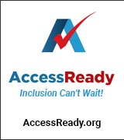 | 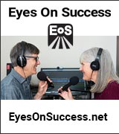 | 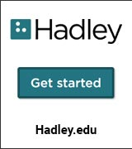 |  | 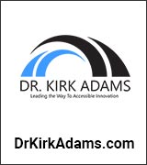
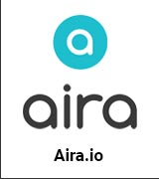 |  |  | 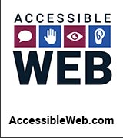 | 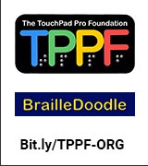 | 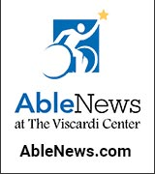
 |  |  |  |  | 

Access Awareness: Updates That Matter ♿️
Remarkable World Commentary Episode #42: Interview with Robert Lattanzio, Executive Director of ARCH Disability Law Centre, Toronto | Donna J. Jodhan, LLB, ACSP, MBA | September 17, 2025
In this engaging episode of Remarkable World Commentary, Donna J. Jodhan sits down with Robert (Rob) Lattanzio, Executive Director of ARCH Disability Law Centre, for a candid conversation about how durable partnerships between community advocates and lawyers are built on trust, shared values, and a relentless commitment to disability rights. Rob traces ARCH's roots as a Legal Aid, funded, test-case poverty law clinic founded in 1979/1980, now in its 45th year, explaining its unique mandate: systemic litigation, law reform and rights education grounded in lived experience, alongside direct legal services and free, confidential advice for Ontarians with disabilities. He and Donna unpack ARCH's holistic approach to choosing test cases, the importance of long-standing community relationships, and how a provincial mandate can yield national impact.

This Week's Featured Advertisement 🎯️
Webinar: Pathways to Disability Empowerment: Navigating On-line Credentials to Boost Your Skills | October 21, 2025 | The Lighthouse for the Blind, Inc.

The Lighthouse for the Blind, Inc. invites you to a Monthly career Webinar.
This webinar is for job seekers who are blind, Low Vision, DeafBlind and blind with other disabilities.
Date: Tuesday, October 21, 2025
Time: 4:00 PM PT
Location: Online
ASL Interpreters will be available.
Position yourself for a promotion, pursue work in a new field, and demonstrate to employers your commitment to growth. Today's internet provides opportunities for individuals to erase skill gaps, gain new skills and certification in many industries.
Join us as we explore two prominent on-line training sites: EdX and Udemy.
Whether interested in improving your writing skills, interpersonal development, communication skills, Artificial Intelligence, marketing, project management, and much more, there's a course and a certification for that on EdX and Udemy.
✏️ Register and join us.
After registering, you will receive a confirmation email containing information about joining the webinar. Please reach out to WorkforceDevelopment@lhblind.org 📧️ if you have any questions or need assistance registering for this event.

News 📰️
👉 Submit a News Article for free here, with timing and placement determined by our editors.
👉 Submit a Sponsored News Article here, with timing and placement determined by you.

1.) Top 5 Most Clicked News Articles From Last Week 📊️
A.) Six Tips For Interacting With A Visually Impaired Person | Healthcare.utah.edu | September 10, 2025
Interacting with individuals who have visual impairments can feel daunting, but understanding some basic etiquette can ease these interactions. Key tips include introducing yourself, asking for assistance before offering help, and using normal conversational topics, ensuring a respectful and engaging dialogue.
B.) People With Disabilities Are Bracing For The Impacts Of Trump's 'Big Beautiful Bill' | PrismReports.org | September 11, 2025
Trump's One Big Beautiful Bill Act includes deep Medicaid cuts, raising alarms among disability advocates who warn the legislation could endanger access to essential services for vulnerable Americans.
C.) US Government Sues Uber, Alleging Discrimination Against Disabled Passengers | TheGuardian.com | September 11, 2025
The Department of Justice has filed a lawsuit against Uber, accusing the company of violating federal laws by denying rides and charging fees to passengers with disabilities.
D.) How to Tell a Driver You are Blind | Austin Seraphin | September 14, 2025
Ridesharing companies like Lyft and Uber have a problem. Many times, a blind passenger needs to tell their driver that they cannot see, but the driver does not understand due to the language barrier. At best it will work out. At worst it can present a physical safety issue. The blind have no other way to communicate.
E.) E-Transfers, If You Can See Them: The Accessibility Gap at Canada's Top Bank — and Across the Big Five | Donna J. Jodhan, LLB, ACSP, MBA | September 11, 2025
For more than a year I have tried to complete a simple e-Transfer on the personal banking page of Canada's top bank. Promises were made; nothing changed. I have now filed a complaint with the Canadian Human Rights Commission. This is not a glitch or a one-off annoyance, it is a warning that accessible banking in Canada still lives too much on paper and not enough in code and customer journeys. Research by IPSOS from March of 2025 reinforces what many of us experience: automated scans catch only part of the problem; banks must test with real users of assistive technology and fix the exact journeys we rely on every day.
September 22, 2025 📅️
2.) Sponsorship Packages Available | AccessInformationNews.com | September 22, 2025
Would your product, service or message benefit from reaching over 40,000 access information readers each week? For just $200 / month? If you're thinking yes, we invite you to try a Sponsorship Package with Access Information News. The benefits are amazing and the traffic delivered to your properties each week is measurable. No obligation. Cancel anytime.
3.) One Time Advertisements Available | AccessInformationNews.com | September 22, 2025
One time advertisements are available to anyone, with or without a Sponsorship. Would your product, service or message benefit from reaching over 40,000 access information subscribers? If you're thinking yes, please check out our one time advertising options. They are cost-effective, targeted and measurable. Scheduling is optional. Learn more today.
4.) Premium Subscribers | AccessInformationNews.com | September 22, 2025
Next Issue: Premium Subscribers will receive their 10th issue of the Top 60 Most Clicked News Articles for April, May and June of 2025 on Monday, July 7, 2025. Back Issues: There are currently 9 back issues available. Premium Subscribers are entitled to all back issues, anytime they sign up. All available back issues will be sent to you via email within 24 hours of purchasing your subscription. Please Join Us: If you would like to receive a perfectly formatted and searchable Word Document with each of the Top 60 Most Clicked News Articles of the last 3 months listed neatly within it, please consider joining us today for just $1 a month.
5.) Sponsored News Articles | AccessInformationNews.com | September 22, 2025
Use Sponsored News Articles to reach the access community when you need to. Whether you are a current Sponsor or not. Drive traffic to your access product and service announcements, events, updates or fundraisers using this incredibly cost-effective and easy-to-use advertisement tool. Learn more today.
6.) Do You Have A Link In This Issue? Learn How To Track It For Free | AccessInformationNews.com | September 22, 2025
This article will outline, step-by-step, how you can get free website traffic reporting on any link to your domain (AKA domain name, website or web address) that has been published by Access Information News since January 22, 2024, when we launched this feature.
September 20, 2025 📅️
7.) Podcast: "I Didn't Have To Figure It Out On My Own" | Insights & Sound Bites | Hadley | September 20, 2025
When Cliff unexpectedly lost a fair amount of his sight, he felt overwhelmed. But with time, he found a way forward.
September 19, 2025 📅️
8.) World-Renowned Advocate Donna J. Jodhan Stresses The Importance Of Reaching Out And Engaging | BarrierFreeCanada.org | September 19, 2025
This editorial emphasizes the critical need for genuine human connections in a fragmented world. It outlines practical steps for fostering meaningful engagement and underscores the importance of empathy, commitment, and ongoing support in building resilient communities.
9.) One National Door, Local Results: How Kathy West-Evans' NET Turns Inclusion into a Hiring Advantage: September 25, 2025 LinkedIn Live Preview | Dr. Kirk Adams | September 19, 2025
Here Dr. Kirk Adams frames disability inclusion as a hiring advantage powered by one national door and local execution. He spotlights CSAVR's National Employment Team (NET), led by Kathleen West-Evans, as a single gateway into every state and territorial public VR agency, with TAP (the Talent Acquisition Portal) and on-the-ground VR specialists turning postings into interviews, OJT, accommodations, and retention. The article walks leaders through why inclusion breaks at the national-to-local seam, how the NET's “one company” model fixes it, and where the ROI shows up—shorter time-to-fill, stronger 90/180-day retention, and reduced compliance risk. Case patterns from Hyatt (1,000+ trainees), Microsoft (dozens of hires), CVS Health (hundreds of hires), and Kwik Trip (300+ hires across 600+ stores) demonstrate repeatable designs: employer-built curricula, alternative assessments, role redesign, and national agreements executed locally.
September 18, 2025 📅️
10.) Remarkable World Commentary Episode #43: Interview with Louise Gillis, Past President, Canadian Council of the Blind | Donna J. Jodhan, LLB, ACSP, MBA | September 18, 2025
In this heartfelt episode of Remarkable World Commentary, Donna J. Jodhan welcomes her mentor, friend, and advisor Louise Gillis for an intimate conversation about resilience, leadership, and the power of community. Louise traces her path from nursing in Cape Breton to national advocacy after sudden vision loss in the late 1990s, describing how volunteering with CNIB and the Canadian Council of the Blind ignited a full-time commitment to barrier-busting. She shares a mentoring philosophy rooted in listening first and matching advocates to the issues they care about, from transportation and health systems to hospital accessibility, and reminds listeners that White Cane Week is a year-round mindset of education and celebration.
11.) You Don't Need 20/20 to Lead: Ken Brandt's 'Positive Vision' for Work and Life | Dr. Kirk Adams | September 18, 2025
Here Dr. Kirk Adams spotlights Ken Brandt, a global IT and cybersecurity leader turned author, whose memoir 'Positive Vision' shows how reframing constraints can fuel performance. Drawing on Brandt's "advantages of poor eyesight" lens (like calmer public speaking and practical "menu tactics"), Adams translates story into system: embed inclusive meeting norms, simplify decision paths with clear defaults, and treat access as non-optional. He connects these behaviors to measurable returns through his own Apex Program work and NICE-aligned pathways, showing how accessible design, mentoring, and practicums move overlooked talent to billable roles faster and at lower cost.
12.) Tennessee Equal Employment Plan No Longer References Minorities, Women, Veterans And Disabled People | TimesFreePress.com | September 18, 2025
Tennessee has removed references to protected groups from its equal employment plan following a Trump administration order, raising concerns about accountability in state hiring practices.
13.) How Two CT Men With Disabilities Climbed Mount Kilimanjaro | NHRegister.com | September 18, 2025
Andy Gardner and Sam Fischgrund, both on the autism spectrum, successfully climbed Mount Kilimanjaro after months of training, overcoming physical and mental challenges to reach Africa's highest peak.
14.) UK: Keep An Open Mind: 3 Ways To Engage Neurodiverse Audiences Now | TheDrum.com | September 18, 2025
A UK-wide campaign led by Made By Dyslexia and Virgin aims to celebrate dyslexic entrepreneurs, highlighting their economic contributions and urging brands to recognize and support neurodiverse talent through inclusive practices.
15.) Canada: Accessibility And Employment: It's Not A One-Size-Fits-All | GoodMenProject.com | September 18, 2025
An autistic entrepreneur reflects on Canada's employment accessibility report, arguing for greater recognition of self-employment as a valid pathway for disabled individuals seeking work that accommodates their unique needs.
September 17, 2025 📅️
16.) Remarkable World Commentary Episode #42: Interview with Robert Lattanzio, Executive Director of ARCH Disability Law Centre, Toronto | Donna J. Jodhan, LLB, ACSP, MBA | September 17, 2025
In this engaging episode of Remarkable World Commentary, Donna J. Jodhan sits down with Robert (Rob) Lattanzio, Executive Director of ARCH Disability Law Centre, for a candid conversation about how durable partnerships between community advocates and lawyers are built on trust, shared values, and a relentless commitment to disability rights. Rob traces ARCH's roots as a Legal Aid, funded, test-case poverty law clinic founded in 1979/1980, now in its 45th year, explaining its unique mandate: systemic litigation, law reform and rights education grounded in lived experience, alongside direct legal services and free, confidential advice for Ontarians with disabilities. He and Donna unpack ARCH's holistic approach to choosing test cases, the importance of long-standing community relationships, and how a provincial mandate can yield national impact.
17.) The City Spent $300K Making Accessible Homes. Most Went To Buyers Without Disabilities | JSOnline.com | September 17, 2025
Milwaukee spent $300,000 in federal funds to make homes accessible for people with disabilities, but most of the homes were ultimately sold to buyers without mobility challenges, sparking scrutiny.
18.) Healey-Driscoll Administration Announces Accessible Fall Recreation Opportunities | Mass.gov | September 17, 2025
Massachusetts' Universal Access Program is expanding adaptive fall recreation activities — including hiking, paddling, cycling, and golfing—across state parks to serve residents of all abilities.
19.) European Union: Affordable Housing In The EU: Towards Inclusion And Accessibility For All | EESC.europa.eu | September 17, 2025
The European Commission is drafting its first Affordable Housing Plan to improve access to inclusive, sustainable housing for vulnerable populations, with input from civil society and initiatives like the Renovation Wave and New European Bauhaus.
September 16, 2025 📅️
20.) Remarkable World Commentary Episode #41: Interview with Paul Jorgenson, Assistant Director, Stakeholder Mobilization, Elections Canada | Donna J. Jodhan, LLB, ACSP, MBA | September 16, 2025
In this episode of Remarkable World Commentary, Donna J. Jodhan welcomes Elections Canada changemaker Paul Jorgenson for a candid look at how accessibility is woven into Canada's federal elections. The two revisit their first collaboration at the 2019 coast-to-coast disability town halls and unpack why Elections Canada grounds its services in lived experience, from Canadians with disabilities to Indigenous communities, youth, newcomers, and electors experiencing homelessness. Jorgenson explains his remit as Assistant Director for Stakeholder Mobilization, a role that is busiest between elections as his team builds partnerships, runs consultations, audits programs, and keeps the agency ready to deliver whenever a vote is called.
21.) Paper Checks Going Away Soon For Social Security, Most Federal Payments | WashingtonPost.com | September 16, 2025
Consumer advocates say the phase-out could create headaches for seniors and other beneficiaries who don't move to direct deposit or other options by September 30, 2025.
22.) Donald Trump's Assault On Disability Rights | NewYorker.com | September 16, 2025
Sara Fernandez, a federal civil rights officer with dwarfism, experienced degrading treatment at airport security, illustrating the broader rollback of disability rights under the Trump administration.
23.) CDC Temporarily Revokes Remote Work Approvals For Employees With Disabilities | StatNews.com | September 16, 2025
The CDC has suspended remote work accommodations for employees with disabilities, following a Trump administration directive to curtail federal telework, prompting concern over workplace accessibility.
24.) Australia: Opera Reviewer Takes Aim At Accessibility Policy | Limelight-Arts.com.au | September 16, 2025
A controversial opera review criticizes Opera Queensland's inclusion of Auslan-interpreted performances, sparking debate over the role of accessibility in the arts and attitudes toward inclusivity in cultural institutions.
25.) Canada: B.C. Court Overturns Human Rights Decision That Ordered Uber To Pay Wheelchair User $35K | CTVNews.ca | September 16, 2025
The B.C. Supreme Court has overturned a tribunal ruling that ordered Uber to compensate a wheelchair user $35,000 for discrimination, prompting renewed debate on accessible ride services and legal protections for disabled passengers.
September 15, 2025 📅️
26.) Make Research Accessible. It Benefits All Chemists | CEN.acs.org | September 15, 2025
The C&EN Trailblazers issue honors 12 chemists with disabilities who are innovating in science while redefining accessibility in the lab, from data sonification to adaptive work schedules.
27.) Parents Fear Losing Disability Protections As Trump Slashes Civil Rights Office | KFFHealthNews.org | September 15, 2025
The Trump administration's cuts to the Office for Civil Rights have hindered its ability to investigate a record number of complaints, many involving disability discrimination in education.
28.) Virginia Statewide Candidates Address Three Key Issues For Voters With Disabilities | WTVR.com | September 15, 2025
Six Virginia candidates discussed major disability-related issues during a virtual forum held during National Disability Voting Rights Week, representing 15% of the state's electorate.
29.) The Quest To Make WA's Legal System More Accessible For People With Disabilities | WashingtonStateStandard.com | September 15, 2025
Justice G. Helen Whitener, once a wheelchair-using immigrant teen, reflects on her journey to the Washington Supreme Court and the importance of improving accessibility in the legal system.
30.) CHS Student Is Helping Pave The Way For Accessible Assistive Technology | CoronadoNewsca.com | September 15, 2025
Grace Dabbieri, a blind student at Coronado High School, is working with USD interns on developing accessible tech and using her robotics experience to inspire visually impaired students.
31.) Robots Are Measuring ADA Compliance In Irvine, Calif. | GovTech.com | September 15, 2025
The city of Irvine is deploying robots to assess sidewalk accessibility as part of broader efforts to meet ADA standards, reflecting a post-pandemic push to support inclusive urban mobility using technology and AI.
32.) Rare “Tooth-In-Eye” Surgery Restores Man's Vision After Two Decades | CNN.com | September 15, 2025
Brent Chapman regained his vision through a rare procedure called osteo-odonto-keratoprosthesis, which uses a tooth to hold a prosthetic lens, following decades of blindness caused by a severe drug reaction.
33.) UK: Experts Warn Preventable Deaths Will Persist Without Improved NHS Accessibility For Autistic People | BioEngineer.org | September 15, 2025
A recent study finds systemic failings in NHS accessibility are denying autistic individuals critical mental health support during crises, contributing to preventable deaths and persistently poor health outcomes.
34.) Australia: Abigail Boyd: Ableism Behind Failure To Meet Housing Accessibility Standards | GreenLeft.org.au | September 15, 2025
Abigail Boyd criticizes systemic ableism in New South Wales for failing to meet housing accessibility standards, leaving millions of Australians with disabilities at increased risk of homelessness amid a shortage of suitable housing and rising wait times.
Last Week 📅️
35.) Inside A 'Hell On Earth' In Oklahoma | NYTimes.com | September 14, 2025
A whistleblower's account has revealed disturbing conditions and abuse at the Robert M. Greer Center, a facility for people with developmental disabilities in Enid, Oklahoma.
36.) Teen Celebrates 5 Years Of Reading To Kids With Disabilities Since Opening First Book During Pandemic | GoodNewsNetwork.org | September 14, 2025
Seventeen-year-old Asher Rosenfeld continues his Audibles with Asher program, offering weekly Zoom reading sessions for children with special needs that he began during the 2020 pandemic lockdown.
37.) 'PowerPoint Broke Me': The Challenges For Blind Professionals | JapanTimes.co.jp | September 13, 2025
Emeline Lakrout left her job due to widespread software inaccessibility for blind users, highlighting broader challenges faced by professionals with visual impairments in navigating common workplace tools.
38.) UK: 'A Tube Strike Makes The Whole City Inaccessible' | BBC.com | September 13, 2025
Wheelchair user and access consultant Katie McConnell describes how recent Tube strikes in London have severely impacted her mobility, with reduced public patience and driver negligence exacerbating accessibility challenges.
39.) UK: 'Every Beach Should Have Accessible Wheelchairs' | BBC.com | September 13, 2025
Jo Whitehouse, a former triathlete and Channel swimmer, advocates for accessible wheelchairs on all beaches after a joyful experience in Lincolnshire helped her reconnect with the sea and her sense of freedom.
40.) Australia: Disability Advocates Slam Suggestion Queensland Opt-Out Of Accessibility Standards To Increase Construction Productivity | 9News.com.au | September 13, 2025
Disability advocates have condemned a proposal for Queensland to opt out of national accessibility standards, highlighting the human cost through stories like that of Peter Steenstrup, who has been separated from his family due to inadequate housing access.
41.) Vatican City: Pope Leo XIV Approves New Measures To Include People With Disabilities In Vatican Workforce | CatholicNewsAgency.com | September 13, 2025
Pope Leo XIV has enacted new regulations promoting disability inclusion within the Vatican workforce, requiring accommodations and revising health criteria to ensure equal employment opportunities.
42.) 'It's Near And Dear To My Heart' | Volunteer Gives Inside Look At Austin's Accessible Parking Program | KVUE.com | September 12, 2025
Austin has expanded its Accessible Parking Enforcement Program, training over 160 volunteers to issue citations for illegal parking in ADA spots, with support from the police department.
43.) UK: It's Not Too Late: The House Of Lords Can Still Protect Disabled People From This Dangerous Assisted Dying Bill | TheGuardian.com | September 12, 2025
As the House of Lords begins debate on the assisted dying bill, advocates urge peers to listen to disabled groups and experts to address critical flaws in the legislation and safeguard vulnerable populations.
44.) Disability Inclusion Requires More Than A Lanyard | ButtonDown.com | September 10, 2025
The Sunflower Lanyard program, aimed at assisting those with invisible disabilities, inadvertently shifts the burden of accessibility onto individuals needing help. This approach can perpetuate a two-tier system of access and often substitutes for comprehensive staff training and system redesign. True inclusivity must be embedded into environments and practices rather than relying on visible indicators for assistance.
45.) Making Content Accessible For People With Limited English Proficiency | EqualEntry.com | September 10, 2025
Irina Morozova emphasizes the significance of creating inclusive designs and clear content for users with limited English proficiency, detailing practical strategies to enhance accessibility. She underscores the need for plain language, meaningful headings, and thoughtful multimedia design to empower these users and minimize cognitive overload.
46.) Education Dept. Halts Funds To Programs For Deafblind Students Over DEI Concerns | ProPublica.org | September 10, 2025
The U.S. Department of Education has cut funding for deafblind student programs in eight states due to concerns over diversity, equity, and inclusion, impacting services for some of the nation's most vulnerable students.
47.) How To Minimize Legal Risks In Accessibility Compliance | Tarnoff.info | September 1, 2025
Understanding and addressing the common legal risks associated with accessibility lawsuits is essential for businesses. This guide outlines critical claims to focus on, including the necessity for alternative text for images, proper labeling of form fields, and ensuring clear communication of status messages during interactions.

Featured Events 📅️
👉 Submit your event for consideration within this section here.

September 22, 2025 | Disability Strong Virtual Conference: Civic Engagement, Policymaking, And Advocacy Panel | Disability Strong Virtual Conference
4:00 PM PT, 5:00 PM MT, 6:00 PM CT, 7:00 PM ET, 11:00 PM GMT
Panelists Nico Meyering, Nancy Williams-Nettles, and Jesse Schwartzman discuss practical ways to engage in community advocacy, both politically and non-politically. They share strategies for using personal experiences to drive change and highlight the power of active participation in shaping more inclusive communities.
September 22, 2025 | Twenty-Sixth Audio Description Institute | American Council Of The Blind
1:00 PM PT, 2:00 PM MT, 3:00 PM CT, 4:00 PM ET, 8:00 PM GMT
Led by Dr. Joel Snyder, this five-day virtual training from the American Council of the Blind offers an in-depth introduction to the theory, techniques, and applications of audio description. Attendees will gain practical skills through lectures, discussions, and collaborative sessions, and receive a certificate of completion along with a training manual.
September 23, 2025 | Disability Strong Virtual Conference: Using Inclusive Language / How To Be An Ally | Disability Strong Virtual Conference
5:00 PM PT, 6:00 PM MT, 7:00 PM CT, 8:00 PM ET, 12:00 AM GMT
Nicole Demos guides participants through strategies for fostering belonging, equity, and empathy by using inclusive language and practicing genuine allyship. Attendees will explore how words and actions can work together to make accessibility and inclusivity an everyday reality.
September 23, 2024 | Webinar — Project Tacticos: Promoting Literacy And Inclusion For Visually Impaired Children Through Innovative Illustrated Tactile Books | Enviter
1:30 AM PT, 2:30 AM MT, 3:30 AM CT, 4:30 AM ET, 8:30 AM GMT
This free webinar from Enviter introduces Project TACTICOS, an Erasmus+ initiative that promotes literacy and inclusion for visually impaired children through innovative tactile books. Attendees will explore practical guidelines, hands-on examples, and support tips for educators, parents, and professionals involved in accessible learning.
September 24, 2025 | Disability Strong Virtual Conference: How Violence And Disability Converge | Disability Strong Virtual Conference
5:00 PM PT, 6:00 PM MT, 7:00 PM CT, 8:00 PM ET, 12:00 AM GMT
Margaux Sorenson examines how violence disproportionately impacts people with disabilities, the systemic barriers to reporting, and the historical roots of ableism. The session highlights advocacy efforts centering disabled survivors and explores ways to promote safety, equity, and justice for all.
September 25, 2025 | Supercharge Your Bottom Line Through Disability Inclusion: Interview with Kathy West-Evans, Executive Director, CSAVR National Employment Team (NET) | Dr. Kirk Adams | LinkedIn Live Event
11:00 AM PT, 12:00 PM MT, 1:00 PM CT, 2:00 PM ET, 6:00 PM GMT
Here Dr. Kirk Adams frames disability inclusion as a hiring advantage powered by one national door and local execution. He spotlights CSAVR's National Employment Team (NET), led by Kathleen West-Evans, as a single gateway into every state and territorial public VR agency, with TAP (the Talent Acquisition Portal) and on-the-ground VR specialists turning postings into interviews, OJT, accommodations, and retention. The article walks leaders through why inclusion breaks at the national-to-local seam, how the NET's “one company” model fixes it, and where the ROI shows up—shorter time-to-fill, stronger 90/180-day retention, and reduced compliance risk. Case patterns from Hyatt (1,000+ trainees), Microsoft (dozens of hires), CVS Health (hundreds of hires), and Kwik Trip (300+ hires across 600+ stores) demonstrate repeatable designs: employer-built curricula, alternative assessments, role redesign, and national agreements executed locally.
September 27, 2025 | NJCB Virtual Convention: The Grassroots Revival | New Jersey Council Of The Blind
9:00 AM PT, 10:00 AM MT, 11:00 AM CT, 12:00 PM ET, 4:00 PM GMT
The New Jersey Council of the Blind presents its 2025 Virtual Convention, The Grassroots Revival, bringing together expert speakers, live Q&A sessions, assistive technology demonstrations, and community engagement. Running for the first time in over 15 years, this online gathering highlights advocacy, access, and connection with presentations on adaptive living, accessible technology, healthcare, and independent living resources.
September 27, 2024 | What To Expect With The New Iphone Operating System Update iOS 26 | Maryland State Library For The Blind And Print Disabled Technology User Group
10:00 AM PT, 11:00 AM MT, 12:00 PM CT, 1:00 PM ET, 5:00 PM GMT
The Technology User Group (TUG) reveals the latest changes coming to the iPhone's operating system, iOS 26, and explores whether these updates will enhance accessibility or fall short of expectations.
October 1, 2025 | Agile And Accessible User Experiences With At User Flow Testing | TPGi
9:00 AM PT, 10:00 AM MT, 11:00 AM CT, 12:00 PM ET, 4:00 PM GMT
In this webinar from TPGi, David Sloan, Chief Accessibility Officer at Vispero, and Isabel Holdsworth, Senior Accessibility Engineer and JAWS user, demonstrate how AT user flow testing complements technical accessibility evaluations. They share strategies for integrating usability insights into fast-paced development cycles, uncovering business-critical issues, and validating accessibility remediation through real-world assistive technology user experiences.
October 1, 2025 | Part 1: Web Accessibility Basics - Manual Testing: Color Contrast, Keyboard Access, And Reflow (Digital Accessibility Webinar) | Michael Parker | Access Ingenuity
10 AM PT, 11 AM MT, 12 PM CT, 1 PM ET, 5 PM GMT
This session covers the basics of manual testing techniques that form the foundation of a web accessibility evaluation. Learn to verify color contrast ratios, conduct keyboard accessibility analysis, and assess reflow and responsive design. Tools like WAVE and axe will be demonstrated.
October 8, 2025 | Navigating Powerpoint With JAWS (Assistive Technology Webinar) | Marisa Church And Michael Vitagliano | Access Ingenuity
10 AM PT, 11 AM MT, 12 PM CT, 1 PM ET, 5 PM GMT
Techniques for navigating PowerPoint with JAWS, including editing text within slides and constructing presentations. Designed for both new and experienced JAWS users.
October 14, 2025 and October 15, 2025| Virtual Web Accessibility Training | WebAIM
9:00 AM PT, 10:00 AM MT, 11:00 AM CT, 12:00 PM ET, 4:00 PM GMT
In this two-day, expert-led online program from WebAIM, participants will learn essential and advanced web accessibility practices to ensure compliance with international guidelines and legal requirements. Designed for developers, designers, and accessibility professionals, the training covers WCAG principles, assistive technology use, inclusive design for various disabilities, evaluation techniques, and offers a complimentary document accessibility course.
October 15, 2025 | Basics Of Creating Accessible Powerpoint Presentations - Remediation And Testing (Digital Accessibility Webinar) | Rachel Reeves | Access Ingenuity
10 AM PT, 11 AM MT, 12 PM CT, 1 PM ET, 5 PM GMT
Learn the basics of structuring PowerPoint for accessibility, adding alternate text (especially for complex images like flowcharts), and best practices for screen reader compatibility.
October 21, 2025 | Pathways To Disability Empowerment: Navigating On-Line Credentials To Boost Your Skills | The Lighthouse For The Blind, Inc.
4:00 PM PT, 5:00 PM MT, 6:00 PM CT, 7:00 PM ET, 11:00 PM GMT
In this monthly career webinar from The Lighthouse for the Blind, Inc., job seekers who are blind, low vision, DeafBlind, or blind with other disabilities will explore how platforms like EdX and Udemy can help close skill gaps and earn certifications across industries. Topics include writing, communication, interpersonal development, artificial intelligence, marketing, and project management.
October 22, 2025 | Monarch Meets JAWS: Unlocking The Future Of Multiline Braille | Vispero And Humanware
9:00 AM PT, 10:00 AM MT, 11:00 AM CT, 12:00 PM ET, 4:00 PM GMT
In this exclusive webinar, Vispero and HumanWare showcase how Monarch and JAWS together unlock new possibilities for multiline and split braille, enhancing education, productivity, and independence. The session highlights intuitive navigation with multiline cursor routing and the seamless integration between JAWS and Monarch for braille users at every level.
October 22, 2025 | JAWS For Windows: Quick Ways To Get Help & Beginner Resources (Assistive Technology Webinar) | Mark Schafer | Access Ingenuity
10 AM PT, 11 AM MT, 12 PM CT, 1 PM ET, 5 PM GMT
Explore JAWS help tools such as Keyboard Help, Screen Sensitive Help, and other resources for beginners. Interactive session with Q&A.
October 29, 2025 | Part 2: Web Accessibility Basics - Manual Screen Reader (Digital Accessibility Webinar) | Michael Parker And Marisa Church | Access Ingenuity
10 AM PT, 11 AM MT, 12 PM CT, 1 PM ET, 5 PM GMT
Focused on desktop screen reader testing using JAWS and NVDA with Chrome on Windows 11. Covers navigation, form labeling, error handling, and accessibility barriers. Mapped to WCAG 2.2 Level AA.
November 5, 2025 | Jaws, Zoomtext & Fusion 2026: Latest Features (Assistive Technology Webinar) | Ian Ramos And Marisa Church | Access Ingenuity
10 AM PT, 11 AM MT, 12 PM CT, 1 PM ET, 5 PM GMT
Explore updates and new features in the 2026 versions of JAWS, ZoomText, and Fusion.
November 12, 2025 | Part 3: Web Accessibility Basics - Manual Mobile Testing (Digital Accessibility Webinar) | Michael Parker And Marisa Church | Access Ingenuity
10 AM PT, 11 AM MT, 12 PM CT, 1 PM ET, 5 PM GMT
Covers mobile testing challenges, including use of VoiceOver (iOS) and TalkBack (Android). Learn gestures, navigation, testing touch targets, and reflow issues.
November 13, 2025 and November 14, 2025 | Blind Travel Summit | Blind Travel Foundation
Led by Paralympian and accessibility trailblazer Mike May, the Blind Travel Summit at the Texas School for the Blind in Austin features interactive, solutions-focused sessions designed to foster real connection among blind travelers, tech users, and advocates. Each session combines concise presentations with facilitated discussions to co-create better travel solutions.
November 14, 2025 | Deadline to Invest in Doppler Labs' At-Home Hearing | Dr. Kirk Adams
Doppler Labs offers audiologist-grade hearing aids and a patented at-home fitting platform designed to deliver fast, accessible hearing care at scale. The Netcapital raise aims to fund expansion, production, and a nonprofit arm targeting underserved regions, with clinical trials completed and pricing locked in for sustainable impact and global reach.
November 15, 2025 | International Neurology Conference 2025 | PubScholars Group
12:00 AM PT, 1:00 AM MT, 2:00 AM CT, 3:00 AM ET, 8:00 AM GMT
The International Neurology Conference 2025 is a flagship hybrid event hosted by PubScholars Group on November 15-16, 2025, at the Hard Rock Hotel at Universal Orlando (5800 Universal Blvd, Orlando, FL) and streamed online. The conference explores "Mind-Brain Connection: Understanding Neuroscience through Mental Health," aiming to integrate cutting-edge science with clinical relevance. Who Should Attend: Neurologists, neurosurgeons, neuroscientists, psychologists, rehabilitation professionals, engineers, industry leaders, students, and allied health practitioners. Important Dates & times: Abstract Submission Deadline: September 15, 2025. Registration Deadline: September 30, 2025. Event Timing: November 15, 2025 (8 AM start) - November 16, 2025 (6 PM close). Format: Hybrid Event (In-person & Virtual.) Contact Person: Richard A. Email: info@pubscholars.org 📧️. Phone: +91 7042134266 📱️. Venue: Hard Rock Hotel at Universal Orlando, 5800 Universal Blvd, Orlando, FL 32819, USA.
November 19, 2025 | Portable OCR Solutions - Easily Access Text Again (Assistive Technology Webinar - ACVREP CE Approved) | Ian Ramos (Access Ingenuity) And Joseph Mcdaniel (Vispero)
10 AM PT, 11 AM MT, 12 PM CT, 1 PM ET, 5 PM GMT
Presentation on OCR technology for the visually impaired. Open to all participants; TVIs can earn ACVREP continuing education credit.
December 9, 2025 and December 19, 2025 | 6th Annual Sight Tech Global | SightTechGlobal.com
Sight Tech Global returns for its sixth year as a free, virtual conference spotlighting how AI and emerging technologies are reshaping assistive tech and accessibility worldwide. Featuring expert panels, demos, and discussions with leaders from Google, Meta, and Microsoft, the conference explores innovations that empower independence and drive digital equity.
May 21, 2026 | Tech Blitz 2026: Assistive Technology Showcase Brings Together Blind, Deafblind, And Low Vision Community For Innovation, Discovery, And Connection. | Helen Keller Services
3:00 PM PT, 4:00 PM MT, 5:00 PM CT, 6:00 PM ET, 11:00 PM GMT
In this in-person showcase hosted by Helen Keller Services, assistive technology vendors, innovators, and users come together for a day of interactive demonstrations, in-depth discussions, and community connection focused on advancing access and independence for the blind, DeafBlind, and low vision communities.

Directories 📝️
1) Access Information Email Newsletter Directory | Submit

Sponsor Classified Ads 🎯️

⬆︎ 1.) Sponsor: Pneuma Solutions

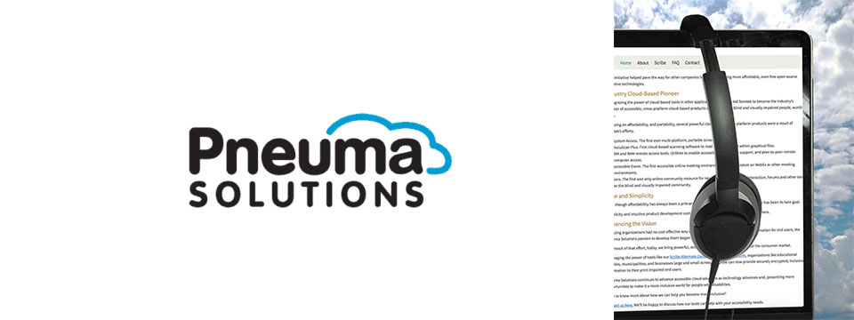
👉️ Classified Advertisement: From Now Through the 18th: Experience Unmatched Independence in the Field of Remote Desktop Access with a Remote Incident Manager Free for All! | Pneuma Solutions
As the United States finishes celebrating Independence Day, regular attendees of the summer blindness conventions will prepare to begin activities centered around independence for people who are blind or visually impaired. IN light of this, we at Pneuma Solutions are lighting our own fireworks over a very unique and never-before-seen level of independence in the field of remote desktop access!
To a technician or trainer who is blind, nothing says independence quite like performing a remote session with a sighted end user's computer, regardless of platform, and being able to fully use it, despite the lack of an installed screen reader. Our Remote Incident Manager is the world's first application that allows this to happen. As such, To celebrate this exciting level of independence, we are proud to offer unlimited access to Remote Incident Manager for the next 14 days, completely free of charge!
Sponsor Since: November 7th 2022 📅️
Website: https://pneumasolutions.com/ 🌐️
Email Newsletter: Click here to receive periodic news via email concerning Pneuma Solutions products for business, consumers and education.
Sales: (866) 202-0520 📱️
Support: (650) 249-1000 📱️
About: Backed by two decades of creating award-winning accessible cloud technologies for people with visual impairments, Pneuma Solutions is the global leader in accessible cloud-based solutions. Pneuma Solutions was founded by long-time accessibility developers Mike Calvo and Matt Campbell. For more information on their individual profiles, click on their respective bio pages. We're proud to be the first company to develop cloud-based accessibility at the network level. Our tools provide organizations, like yours, a way to deliver secure, accessible information right from your network or from our secure servers. You can provide your print disabled consumers, students, employees, and citizens with a multitude of accessible options. Additionally, we offer a suite of cloud-based applications to blind and print disabled consumers directly from our website. Our consumer products are designed to make the day-to-day lives of blind and print disabled individuals more accessible and simpler to manage. Access to information is not a privilege, it's a right. It's also your right to obtain affordable, accessible cloud solutions to serve your end user. When organizations like yours implement our tools, together we help make it a more inclusive world for people with disabilities. Want to know more about how we can help you become more inclusive?
Contact us here. We'll be happy to discuss how our tools can help with your accessibility needs.

⬆︎ 12.) Sponsor: Able News at The Viscardi Center

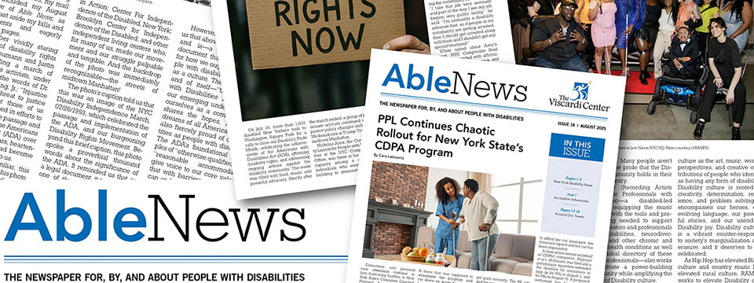
👉️ Classified Advertisement: Able News Brings You Disability News Like No Other Source | Able News at The Viscardi Center
Able News at The Viscardi Center is a monthly periodical for, by, and about people with disabilities. It amplifies the perspective of a diverse disability community and reports on news, technology, sports, health and wellness, culture, travel, advocacy and opportunities to learn and connect. Visit Ablenews.com to sign up to receive Able News in your inbox monthly. Advertising opportunities in the digital edition and on the website are also available.
Sponsor Since: July 4, 2025 📅️
Website: https://ablenews.com 🌐️
Email: ablenews@viscardicenter.org 📧️
About: Able News at The Viscardi Center is a monthly periodical for, by, and about people with disabilities. It amplifies the perspective of a diverse disability community and reports on news, technology, sports, health and wellness, culture, travel, advocacy and opportunities to learn and connect. It is a valuable resource and brings readers disability news like no other source.
Read Able News

⬆︎ 11.) Sponsor: The Touch Pad Pro Foundation / BrailleDoodle

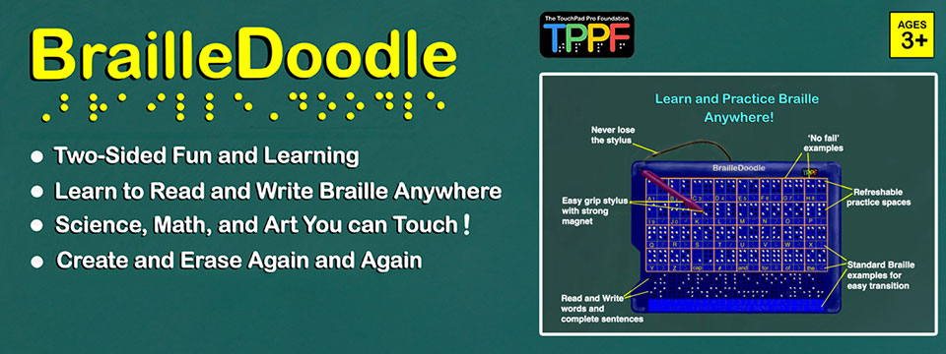
👉️ Classified Advertisement: BrailleDoodle Available at A. T. Guys Now! Just $149.00 USD | The Touch Pad Pro Foundation / BrailleDoodle
The BrailleDoodle is a groundbreaking, affordable, two-sided tablet designed to empower individuals of all ages and skill levels with Braille literacy and tactile exploration. One side is dedicated to Braille learning, featuring practice spaces for letters, numbers, and words, making it perfect for beginners or those looking to improve their skills. The other side offers a tactile refreshable surface, ideal for creating art, exploring STEM concepts like math and graphing, and expressing creativity in limitless ways.
With its easy-to-use magnetic stylus, users can write and create tactile designs, feel their progress as they go, and erase effortlessly, making learning and creativity interactive and engaging. Whether you're a teacher, parent, or individual learner, the BrailleDoodle is a versatile tool that combines education, creativity, and fun. Priced at just $149.00 USD, it is an affordable solution to enhance accessibility and opportunity for blind and low-vision individuals. Order now and take the first step in transforming education and creativity! Visit A.T. Guys today to learn more.
Sponsor Since: January 1, 2025 📅️
Website: https://touchpadprofoundation.org 🌐️
About: The TouchPad Pro Foundation (TPPF) is a 501(c)(3) nonprofit organization committed to creating opportunities for blind and low-vision individuals through Braille literacy, STEM, and art education.
Founded by educators and innovators passionate about accessibility, TPPF strives to address the critical gaps in resources and tools for the visually impaired community. With a mission to promote equality and unleash human potential, the foundation provides innovative solutions that make education inclusive, engaging, and affordable.
Their initiatives include offering free devices to under-served communities and providing training to maximize the impact of their groundbreaking tools.
At the heart of their mission is the BrailleDoodle, a dual-sided, tactile learning tablet designed to make education and creativity accessible to all.
One side focuses on Braille literacy, offering interactive learning spaces for letters, numbers, and words, while the other provides a refreshable surface for tactile drawing, STEM exploration, and artistic expression.
Affordable and versatile, the BrailleDoodle empowers individuals of all ages and skill levels to develop essential literacy and creative skills.
By fostering independence and encouraging innovation, TPPF and the BrailleDoodle are transforming the lives of blind and low-vision learners worldwide.
For more information, visit the TouchPad Pro Foundation website.

⬆︎ 10.) Sponsor: AccessibleWeb

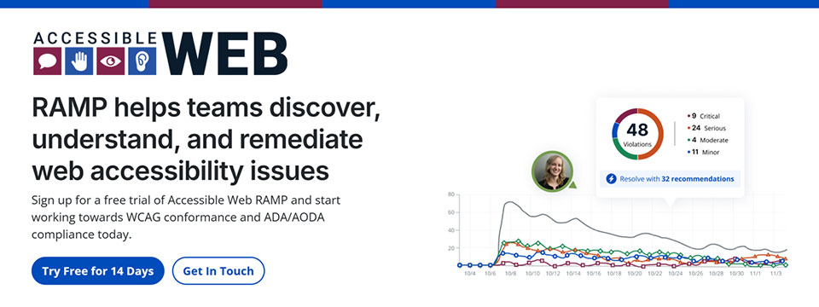
👉️ Classified Advertisement: Have You Run Into An Accessibility Barrier On A Website Recently? | AccessibleWeb
Accessible Web is on a mission to help eliminate online barriers and make the digital space more inclusive for everyone, regardless of ability. Our accessibility testing software, RAMP, allows organizations of any size to discover, understand, and remediate barriers. We offer tools to integrate with existing sites and workflows so businesses with a digital presence can start making their sites more accessible quickly.
Plans start at $49 a month. Plus, we have a 14-day free trial with no credit card needed. We believe any organization can start making progress with Accessible Web RAMP.
Sponsor Since: December 16, 2024 📅️
Website: https://accessibleweb.com 🌐️
About: At Accessible Web, our mission is to make the internet accessible to everyone, regardless of ability.
We offer a comprehensive suite of accessibility testing software tools and educational resources to help organizations achieve and maintain web accessibility in line with the Web Content Accessibility Guidelines (WCAG) and comply with legal standards such as the Americans with Disabilities Act (ADA) and the Accessibility for Ontarians with Disabilities Act (AODA).
➜︎ Services:
⚫️ WCAG Audits: Our certified specialists conduct thorough analyses of websites and applications, identifying accessibility issues and providing detailed recommendations for remediation.
⚫️ VPAT Preparation: We prepare Voluntary Product Accessibility Templates (VPATs), offering industry-standard reports that demonstrate a product's accessibility compliance, which can be crucial for sales and contractual obligations.
⚫️ Accessibility Testing: Our team of individuals with disabilities tests websites and web applications using assistive technologies, providing actionable feedback to enhance user experience and accessibility.
⚫️ Remediation Support: Our certified specialists offer coaching and support to assist organizations in implementing accessibility improvements effectively, ensuring that digital assets meet accessibility standards.
⚫️ Accessibility Certification: Through a comprehensive process of auditing, remediation, and verification, we provide WCAG certifications that validate a company's conformance and commitment to accessibility best practices.
➜︎ Tools:
⚫️ Accessible Web RAMP: Our digital accessibility platform that enables teams to discover, monitor, and remediate web accessibility violations. RAMP offers continuous monitoring, prioritized workflows, and progress reporting to facilitate ongoing compliance efforts.
⚫️ Accessible Web Helper Extension: An accessibility browser extension that allows users to scan web pages, highlight accessibility violations, and check color contrast ratios directly from their browser, streamlining the auditing process.
➜︎ Education:
⚫️ Accessible Web Academy: We offer self-guided online courses tailored to various organizational roles, promoting a culture of inclusivity and equipping teams with the knowledge to implement accessible design from the outset.
⚫️ Knowledge Base and Blog: Our resources include articles on assistive technologies, remediation tutorials, and answers to common web accessibility questions, supporting continuous learning and awareness. We host webinars most Thursdays on various accessibility topics.
We emphasize a proactive approach to web accessibility, advocating for integrating accessible design principles early in the development process to enhance user experience, attract new customers, and mitigate legal risks associated with non-compliance.
For more information or to explore our services and resources, visit our website.
Facebook | LinkedIn | Reddit | YouTube

⬆︎ 9.) Sponsor: Magnifiers & More

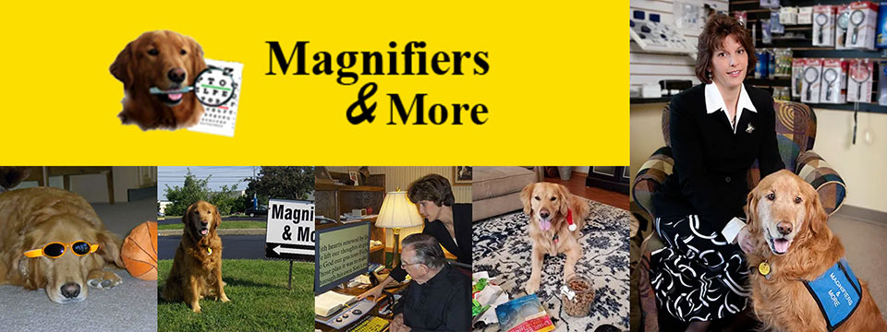
Sponsor Since: October 25, 2024 📅️
Website: https://www.magnifiersandmore.net 🌐️
Email: info@magnifiersandmore.net 📧️
Phone: (440) 946-3363 📱️
Fax: (440) 946-8899 📠️
Visit: 7775 Mentor Avenue, Mentor, Ohio 44060, USA
About: Magnifiers & More, established in 2002 by Deborah Kogler, is Northeast Ohio's only retail store dedicated to providing products and consultations for individuals with low vision, blindness, and vision disabilities. With over forty years of experience in eye care, Deborah founded the company to create a one-stop shop for vision aids, including specialized tools for managing conditions like macular degeneration, glaucoma, diabetic retinopathy, and cataracts.
The store offers a wide range of over seventy-five magnifiers, talking items, large print products, special lights, electronic aids, Braille items, glare control solutions and More.
A key figure in the company's story is Murphy, Deborah's Golden Retriever and original CEO, "Canine Executive Officer," who was the store's mascot and greeter for 15 years. Today, Jeffrey, another Golden Retriever trained as a service dog, serves as the CFO, "Canine Fun Officer," delighting customers and supporting Deborah.
Deborah's journey into vision rehabilitation was inspired by her grandmother's experience with macular degeneration, sparking her passion to make vision aids accessible. She continues to advocate for and educate those living with vision disabilities, both locally and internationally.
Magnifiers & More is committed to helping people improve their quality of life through practical solutions and compassionate support.

⬆︎ 8.) Sponsor: Innosearch.ai

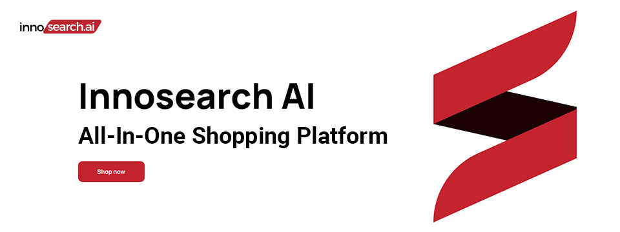
👉️ Classified Advertisement: Shop by Phone — No Screens, Just Your Voice!
Call 1-855-SHOP-GPT (1-855-746-7478)
Shopping online can be hard if you're blind, visually impaired, or not tech-savvy. That's why Innosearch AI created Shop by Phone — a 100% free, voice-only service.
Just call and say what you need:
👉 “Find me a phone charger.”
👉 “Add it to my cart.”
👉 “Check out.”
No apps, no websites — just easy, hands-free shopping from over 500,000 stores.
- ✔ Free to use
- ✔ Works anywhere, anytime
- ✔ Perfect for seniors, blind, and low-vision users
Available in:
- 🇬🇧 UK: +44 7727 247467 📱️
- 🇨🇦 Canada: +1 782 222 7467 📱️
- 🇦🇺 Australia: +61 489 267 467 📱️
- 🇺🇸 USA: 1-855-SHOP-GPT 📱️ (1-855-746-7478 📱️)
Call now and shop with ease!
Sponsor Since: October 15, 2024 📅️
Website: https://www.innosearch.ai 🌐️
Email: info@innosearch.ai 📧️
About: Innosearch is an all-in-one shopping platform augmented with a cutting-edge AI-powered shopping assistant. This innovative feature mimics the experience of shopping in real life by allowing you to interact with the assistant using natural language. It aggregates millions of products from top US online retailers, bringing them directly to you. With this advanced generative AI, Innosearch offers personalized product recommendations, highlights the best deals, and provides comprehensive information including reviews, total prices, shipping options, and more. Innosearch delivers a seamless end-to-end shopping experience, eliminating the need to search and browse in multiple tabs across retailers.
YouTube Review By Sam Seavey: https://youtube.com/watch?v=-rjL-HAwaZY.
Key Features: Key Features of the Innosearch All-in-One AI Shopping Platform include:
➜ Research Products: Easily compare products across retailers, or weigh pros and cons of similar products to make informed decisions.
➜ Uncover the Best Deals: Never miss a door buster, coupon, or clearance sale again. Get notified about the best prices and offers.
➜ AI Summarized Trusted Reviews: See what others are saying and make confident purchases.
➜ All in One: Innosearch brings millions of products from top online retailers directly to you, allowing you to shop the best deals with easy checkout and personalized AI assistance.
➜ Shop with Confidence: Rest assured, Innosearch has you covered with free shipping and returns on every purchase.
➜ Know Before You Buy: Innosearch equips you with expert buying guides, empowering you to make well-informed decisions.
How To Shop: Simply create a free account and start shopping today!

⬆︎ 7.) Sponsor: Aira

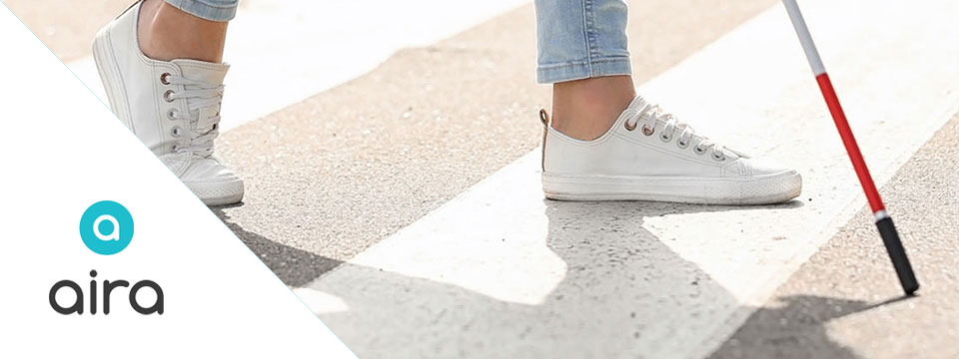
Sponsor Since: September 9, 2024 📅️
Website: https://aira.io/ 🌐️
Download the App: Apple App Store | Google Play Store
Plans and Pricing: https://aira.io/pricing/
Phone: NA: +1.800.835.1934 📱️ | AU: +1.800.765.096 📱️ | UK: +0.800.046.5668 📱️ | NZ: +1.800.425.451 📱️
Text Message: NA: +1.858.242.4457 📱️ | AU: +61.488.839.767 📱️ | UK: +44.149.320.2474 📱️
Email: support@aira.io 📧️
Social: Twitter | Facebook | LinkedIn | YouTube | Instagram
About: Aira's mission is to remove barriers and make the world more accessible with visual interpreting.
We provide a live, human-to-human professional assistance service, an accommodation or productivity tool, that enhances independence by delivering on-demand, skilled and reliable visual interpreting for just about any task. Using the powerful combination of a camera and the Aira app on someone's device of 'choice', a professionally-trained agent will assist by visually interpreting what is in the camera's view or on screen, from describing to reading, from explaining to navigating - just about anything, safely and securely. Aira supports a growing range of devices including smart and tactile button phones, desktop computers and soon, wearables.
Whether you are involved in the work of business, the work of school or the work of life, Aira enhances everyday efficiency, engagement, and independence. Used by employees and customers of hundreds of organizations including airports, banks, the largest software companies, financial firms, retailers and universities, we invite you to join the community, access the Aira app today and try it for free.
https://aira.io/download-and-try-it/
Step One: Subscribe and Download. Pick the plan that lets you explore on your terms and on your time, sign up in a few minutes, and download the Aira app to your smartphone. Plans shown are for the United States, Canada, Australia, New Zealand and the United Kingdom. Add or cancel at any time.
Step Two: Connect with an Aira Agent. On the first call, connect with one of our certified, specially-trained Agents and learn how everything works.
Step Three: Real-time Assistance. At the touch of a button, Aira delivers instant access to visual information, when and where you want it.

⬆︎ 6.) Sponsor: Dr. Kirk Adams

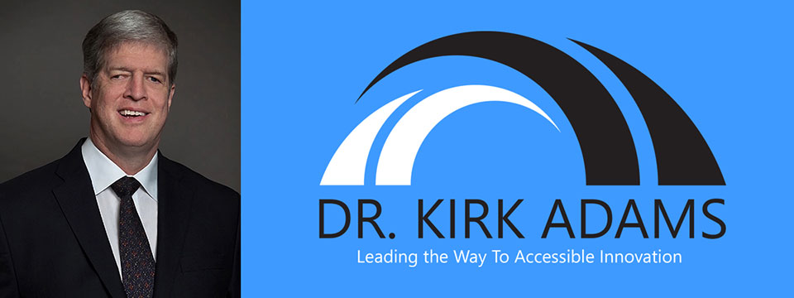
Sponsor Since: July 22, 2024 📅️
Website: https://drkirkadams.com 🌐️
About: Dr. Kirk Adams is a visionary leader, transformative speaker, and lifelong advocate for disability inclusion. With over three decades of experience in advancing accessibility and creating opportunities for individuals who are blind or low-vision, Dr. Adams has become a powerful force for change in the areas of leadership, accessibility, and inclusion. His journey — from navigating vision loss as a young child to becoming a recognized thought leader in disability empowerment — uniquely equips him to help organizations understand, integrate, and champion inclusive practices that benefit all.
Dr. Adams is a highly sought-after speaker, known for his engaging and thought-provoking keynotes on disability inclusion, accessible leadership, and the power of resilience. He has spoken at numerous national and international conferences, including corporate seminars, public policy forums, and industry events, where his personal story and professional insights have inspired leaders to rethink their approach to diversity, equity, and inclusion. His passion lies in empowering organizations to create environments where every individual — regardless of ability — can thrive.
As a speaker, Dr. Adams brings authenticity, warmth, and a depth of experience that resonates with audiences from all backgrounds. He understands that true leadership is about more than just policy; it's about creating cultural shifts that value each person's unique contributions. Whether he is addressing a Fortune 500 company, a non-profit, or a community group, Dr. Adams' message is clear: inclusion benefits everyone, and together we can build a world where opportunity is accessible to all.
Dr. Adams currently resides in Seattle, Washington, where he continues his advocacy work, builds strategic partnerships, and enjoys life with his family. He is proud to be a part of the movement towards a more inclusive future — one conversation at a time.

⬆︎ 5.) Sponsor: Barrier Free Canada

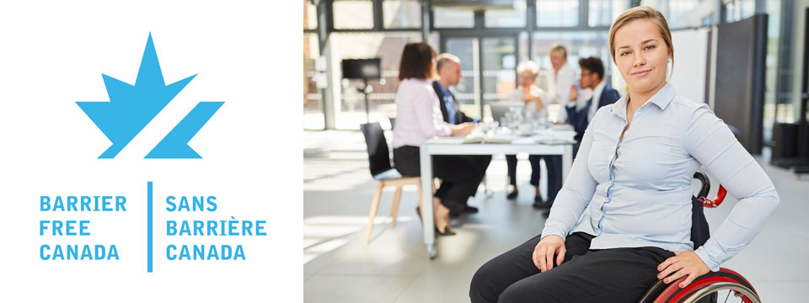
👉️ Classified Advertisement: Barrier Free Canada — Canada sans Barrières Announces Strategic Investment to Empower the Workforce of Tomorrow | Barrier Free Canada
Barrier Free Canada — Canada sans Barrières is proud to announce a bold new strategic investment aimed at advancing accessibility and inclusion in Canada's workforce. This initiative supports innovative training, education, and employment opportunities for persons with disabilities, helping to eliminate systemic barriers and foster a more equitable labor market. By partnering with key stakeholders across sectors, the investment will drive meaningful change, preparing a diverse and inclusive workforce to meet the challenges of tomorrow. This milestone reflects Barrier Free Canada's ongoing commitment to building a barrier-free nation where everyone can thrive and contribute fully to society.
Sponsor Since: November 10, 2023 📅️
Website: https://barrierfreecanada.org/ 🌐️
About: Barrier-Free Canada/Canada Sans Barrieres (BFC/CSB) advocates for the Canadian Parliament to enact a strong and effective Canadians with Disabilities Act (CDA) to achieve a barrier-free Canada for all persons with disabilities.
To this end, BFC/CSB is seeking endorsements from national disability organizations to build a non-partisan community coalition. BFC/CSB would also like to identify point persons from these organizations to act as key contacts.
The steering committee of BFC/CSB has drafted a set of principles concerning a CDA that are drawn from the principles that underpin the provincial disability legislation in Ontario and Manitoba. A CDA is not meant to replace provincial disability legislation. It will complement such legislation and benefit Canadians living in provinces with and without provincial disability legislation. At this point in time, CNIB, March of Dimes Canada, Canadian Hearing Society and MS Society of Canada have endorsed the BFC/CSB principles and confirmed their support for the movement to enact a CDA. There is no individual or organizational charge for membership in BFC/CSB.
Please contact Donna Jodhan, Founder of Barrier-Free Canada, at info@barrierfreecanada.org 📧️ with any questions or to express your organization's support and identify a key contact.
Social: Facebook | X (Formerly Twitter) | Mastodon (Search For: @news@mastodon.barrierfreecanada.org).

⬆︎ 4.) Sponsor: Hadley

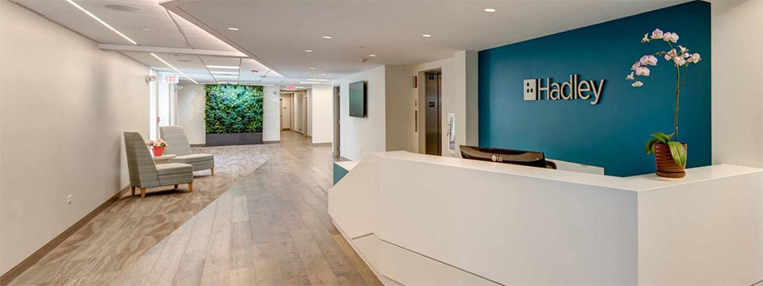
👉️ Classified Advertisement: New NVDA Workshops at Hadley | Hadley
Learn the basics of NVDA. From getting started with the program to customizing the speech to learning helpful shortcuts, Hadley's workshops have you covered.
Sponsor Since: September 18th 2023 📅️
Website: https://hadleyhelps.org/ 🌐️
Email: info@hadleyhelps.org 📧️
Phone: (800) 323-4238 📱️
Get Started: https://hadleyhelps.org/learn 🎓
What would you like to learn today?
Donate: https://hadleyhelps.org/donate/support-hadley ❤
A 501(c)(3) non-profit organization, Hadley relies on contributions from individuals, foundations, and corporations to fund its programs.
About: The mission of Hadley is to create personalized learning opportunities that empower adults with vision loss or blindness to thrive — at home, at work, and in their communities.
Founded in 1920 by William Hadley, an educator who lost his eyesight later in life, Hadley offers practical help, connection and support free of charge to anyone with a visual impairment, their families and professionals supporting them. With Hadley, you can discover new ways to do things that have become more difficult due to vision loss and connect with a network of peers who "get it." And you don't need to come to Hadley. Hadley's help comes to you; online, on the phone or through the mail.
Since relaunching in July 2020, more than 70,000 people have signed up with Hadley, registering more than 200,000 workshop interactions. And our workshops have 98% satisfaction ratings. We reach all 50 states and more than 100 countries. And more people learn braille from Hadley than from any other organization worldwide.
Hadley is a proud partner of the National Eye Institute and the National Eye Health Education Program.
Hadley's help conveniently meets learners where they are. Free of wait lists. Free of office visits. Free of charge.
Social: Facebook | X (Formerly Twitter) | YouTube

⬆︎ 3.) Sponsor: Eyes on Success

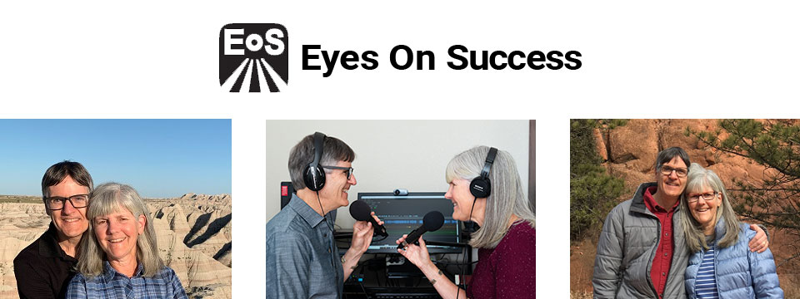
Sponsor Since: August 21, 2023 📅️
Website: https://www.eyesonsuccess.net/ 🌐️
About: This half-hour weekly podcast and radio program discusses products, services and daily living tips for people with vision loss. It is available through radio reading services across North America, via several internet streaming services, and to everyone else as a podcast. To date, the show has been downloaded in all 50 states in the US and over 100 other countries on all the inhabited continents. Eyes On Success is hosted and produced by Peter Torpey and Nancy Goodman Torpey.
Each episode is basically a success story. Some are human stories of visually impaired people's accomplishments in academics, employment, sports or pastimes. Others are descriptions of adaptive aids that enable visually impaired people to achieve things. These include screen readers, magnifiers, navigation aids, and others. In all cases, the focus is on success.
Eyes On Success has been airing weekly since January 2011. Prior to January 2013 the name of the show was ViewPoints. Other than the name, nothing has changed.
Listening To Eyes On Success
You can listen to Eyes On Success on your smart home device by saying “play the Eyes On Success podcast”, subscribe to the podcast wherever you get your podcasts, or listen on Apple Podcasts, iTunes, YouTube or your local radio reading service. Listeners can also follow the show on Facebook and X (Formerly Twitter).
Connecting with Eyes On Success
Email: To contact us with questions, comments or suggestions for future shows send an e-mail to hosts@EyesOnSuccess.net 📧️.
Weekly Announcements: If you would like to receive weekly announcements of upcoming episodes, you can join our low traffic "announcements only" list by sending an e-mail to: EyesOnSuccess+subscribe@GoogleGroups.com 📧️.
Email Forum: If you would like to connect with other listeners and share your thoughts about what you've heard on the show, you can join our listener email forum by sending an email to: EOS_Discuss+Subscribe@GoogleGroups.com 📧️

⬆︎ 2.) Sponsor: Access Ready, Inc.

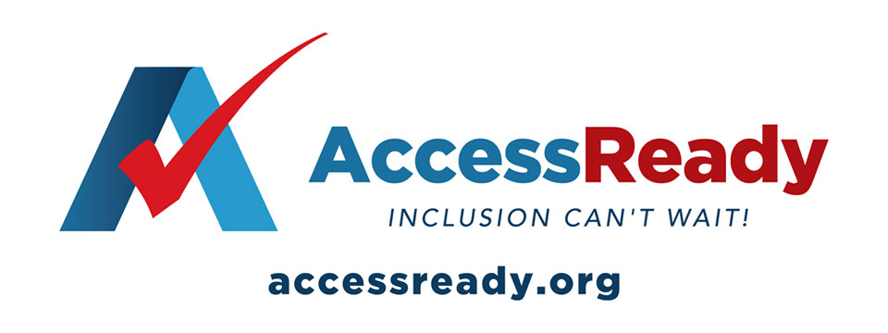
👉️ Classified Advertisement: Help Access Ready, Inc. Rebuild After Hurricanes Helene and Milton | Access Ready, Inc.
Help Access Ready, Inc. support people with disabilities after Hurricanes Helene and Milton.
Based in Saint Petersburg, Florida, Access Ready is committed to providing adaptive equipment, restoring independence and dignity to those affected. Many lost vital devices that help them communicate, work, and live independently.
Donations will go toward repairing or replacing this equipment, ensuring people can regain normalcy after the disaster. Every contribution directly aids recovery efforts.
Since 2018, Access Ready has promoted accessible technology, led by CEO Douglas George Towne.
Your support can make a real difference. Donate Now — be a lifeline for those in need.
info@accessready.org 📧️
+1 (727) 531-1000 📱️
Sponsor Since: December 1st 2022 📅️
Website: https://accessready.org/ 🌐️
Email: info@accessready.org 📧️
Phone: (727) 531-1000 📱️
About: Access Ready Inc. is a certified, 501(c)(3) nonprofit organization. The mission of Access Ready Inc., a nonprofit cross-disability rights advocacy organization, is to promote a policy of accessibility benefiting all people regardless of ability across information and communications technology utilized for two way communications.
The purpose of Access Ready Inc. is to educate the public and private sectors of the importance of accessible information and communications technology to the future of all people regardless of ability.
To support this education by developing initiatives that promote policies that ensure the creation and maintenance of accessible technologies utilized for two way communications at all levels which allow for easy use by people with the widest range of abilities possible.
To develop employment and business opportunities for people with disabilities that support its educational activities in the field of information and communications technology and related areas.
To provide consulting and educational services to buyers, developers, and users of information and communications technology that promotes its highest and best use in society.
To promote the concept of a technologically accessible society which fosters:
Freedom of expression, speech, and worship.
Freedom from fear, ignorance, and want.
Freedom from dishonesty, exclusion, and immorality.
Freedom of aspiration, invention, and inclusion.

⬆︎ 13.) Sponsor: Your Name Here

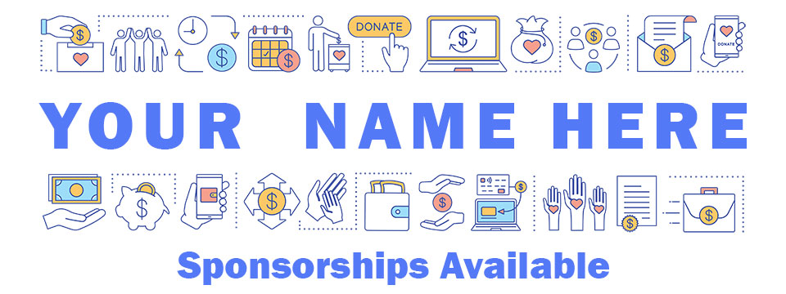
Sponsor Since: Today 📅️
Website: https://accessinformationnews.com/dearsponsor 🌐️
Phone: (855) 578-6660 📱️
Email: news@accessinformationnews.com 📧️
About: Founded in 2022, Access Information News is the world's leading not-for-profit access information news publication that reaches over 40,000 blind, low vision, deaf, hard of hearing, deafblind, neurodivergent and/or disabled professionals, educators and enthusiasts, all over the world, each week. Subscribe here. Review the most recent issues here.

Access Information News Supporters 🤝️
We couldn't do it without you! Thank you for your support!
Why: Access Information News Supporters donate an amount of their choosing either one time or annually in order to assist with the ongoing distribution of the Access Information News publication.
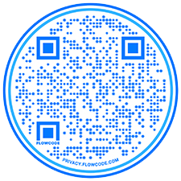
Benefits: All Access Information News Supporters receive a listing within the "Our Supporters" section of each weekly newsletter, as well as a listing within the "Our Supporters" section of the Access Information News website.
In addition, all Access Information News Supporters automatically become Premium Subscribers as well, and therefore enjoy all of the benefits that a Premium Subscription has to offer.
One Time Donation: If you would like to become a Access Information News Supporter by making a one time donation in an amount of your choosing to assist with the ongoing distribution of the Access Information News publication, you may utilize this donate link, or scan the QR code to the right.
Annual Donation: If you would like to become a Access Information News Supporter by making a small annual donation to assist with the ongoing distribution of the Access Information News publication, we also offer the following options, all with our sincerest thanks, and most heartfelt gratitude for your ongoing support.
Support: In tandem with Our Sponsors, these are the people that make the ongoing distribution of Access Information News possible.

Platinum Supporters:

Become an Access Information News Platinum Supporter today.
1.) James Hulme
Platinum Supporter Since: December 5, 2022
2.) Donna Jodhan
Platinum Supporter Since: March 24, 2023
3.) Your name here.
Platinum Supporter since ...

Gold Supporters:

Become an Access Information News Gold Supporter today.
1.) Your name here.
Gold Supporter since ...

Silver Supporters:

Become an Access Information News Silver Supporter today.
1.) Your name here.
Silver Supporter since ...

Bronze Supporters:

Become an Access Information News Bronze Supporter today.
1.) Your name here.
Bronze Supporter since ...

One Time Supporters:

One Time Supporters donate an amount of their choosing — one time to assist with the ongoing distribution of the Access Information News Publication.
Become an Access Information News One Time Supporter today.
1.) Sharyn Sobel
One Time Supporter on November 28, 2023
2.) Amanda Lee
One Time Supporter on July 31, 2023
3.) Gaylen Kapperman
One Time Supporter on June 4, 2024
4.) Your name here.
One Time Supporter on ...

Access Information News Team 🗞️

Distribution: Sponsors, Supporters and Mind Vault Solutions, Ltd.

Distribution Since: 2022
As of November 7, 2022 the distribution of Access Information News is made possible by our Sponsors, our Supporters, our Advertisers and Mind Vault Solutions, Ltd., a leading international provider of professionally outsourced marketing administration and consultation services.
Any time the Access Information News Publication carries less than its Sponsor limit, Mind Vault Solutions, Ltd. donates the remaining dollars necessary to keep the publication running.
Please help us to support the ongoing distribution of this publication. Learn more about the benefits of Sponsorship today.

Publisher: Aaron Di Blasi

Publisher Since: November 7, 2022
Location: Cleveland, Ohio
Time Zone: Eastern Standard Time (EST/EDT) (GMT-5/GMT-4)
In addition to serving as Publisher for Access Information News Aaron also serves as Publisher for the Top Tech Tidbits and AI-Weekly newsletters, PR-Director for the AT-Newswire Press Release News Distribution Service, and President and Senior Project Management Professional for Mind Vault Solutions, Ltd.
As Publisher Aaron oversees the weekly distribution of Access Information News on behalf of Mind Vault Solutions, Ltd.
Aaron Di Blasi, PMP
Email: publisher@accessinformationnews.com 📧️
Toll-Free: +1 (855) 578-6660 📱️
Aaron Di Blasi, PMP
Email: publisher@toptechtidbits.com 📧️
Toll Free: +1 (855) 578-6660 📱️
PR Director (2024-Present)
AT-Newswire 🌐
Access Technology's Digital Newswire
Publisher (2024-Present)
AI-Weekly 🌐
The Week's News in Artificial Intelligence
Publisher (2022-Present)
Access Information News 🌐
The Week's News in Access Information
Publisher (2020-Present)
Top Tech Tidbits 🌐
The Week's News in Access Technology
Sr. Project Management Professional (2006 - Present)
Mind Vault Solutions, Ltd. 🌐
Innovative ideas. Solutions that perform.
Certified:
Digital Marketing Associate
Meta Certified (2022 - Present)
Social Marketing Professional
Hootsuite Certified (2020 - Present)
Email Marketing Professional
Constant Contact Certified (2019 - Present)
Specializing in:
Digital Strategy and Content Marketing
Social Media Advertising
Online Fundraising
ADA, WCAG and Section 508 Compliance

Editor: John Hanlin

Editor Since: November 7, 2022
Location: Boulder, Colorado
Time Zone: Mountain Standard Time (MST/MDT) (GMT-7/GMT-6)
In addition to serving as an Editor to Access Information News John also serves as an Editor to the Top Tech Tidbits and AI-Weekly newsletters and is also an attorney-at-law specializing in long-term disability claims for blind and low-vision persons.
John is also a long-time contractor and member of the Board of Trustees at Mind Vault Solutions, Ltd.
John Hanlin, Esq.
Editor (2024-Present)
AI-Weekly 🌐
The Week's News in Artificial Intelligence
Editor (2022-Present)
Access Information News 🌐
The Week's News in Access Information
Editor (2020-Present)
Top Tech Tidbits 🌐
The Week's News in Access Technology
Board of Trustees (2006 - Present)
Mind Vault Solutions, Ltd. 🌐
Innovative ideas. Solutions that perform.

Editor: Jenna Lang

Editor Since: November 7, 2022
Location: Des Moines, Iowa
Time Zone: Central Standard Time (CST/CDT) (GMT-6/GMT-5)
In addition to serving as an Editor to Access Information News Jenna also serves as an Editor to the Top Tech Tidbits and AI-Weekly newsletters and runs her own advocacy foundation.
Jenna also serves as a certified Project Management Professional (PMP) for Mind Vault Solutions, Ltd.
Jenna's son was born blind and she is always seeking new and innovative ways to empower him through technology.
Jenna Lang, PMP
Editor (2024-Present)
AI-Weekly 🌐
The Week's News in Artificial Intelligence
Editor (2022-Present)
Access Information News 🌐
The Week's News in Access Information
Project Management Professional (2022 - Present)
Mind Vault Solutions, Ltd. 🌐
Innovative ideas. Solutions that perform.
Editor (2020-Present)
Top Tech Tidbits 🌐
The Week's News in Access Technology

Editor: David Woodbridge

Editor Since: February 6, 2023
Location: Central Coast, New South Wales, Australia
Time Zone: Australia Eastern Standard Time (AEST/AEDT) (GMT+10)
In addition to serving as an Editor to Access Information News David also serves as an Editor to the Top Tech Tidbits publication and is also the National Commercial Assistive Technology Advisor for Vision Australia where he has worked since 1990. Over this time he has assisted people who are blind or vision impaired in their home, education, and work settings to take advantage of the benefits of using assistive and main stream technology.
In the last seventeen years, he has also been involved with evaluating technology for use by people who are blind or vision impaired covering both low and high tech equipment (including Microsoft, Samsung, Google, Amazon, and Apple). David is also one of the key spokespersons for Vision Australia relating to technology.
He has been an Apple Ambassador for Apple Australia since 2009 with a group of other Ambassadors / Apple Distinguished Educators (ADE)'s covering the range of Apple's Accessibility solutions throughout Australia.
David produces a range of podcasts (since 2011) covering Apple and other technologies which are distributed on his own podcast (http://davidwoodbr.podbean.com). In addition, he also has a regular Talking Tech program (since 2013) which can be heard every Tuesday at 4:30 Eastern Summer Time on Vision Australia Radio Melbourne (available online) or via https://omny.fm/shows/talking-tech-vision-australia-radio
David also runs a weekly Tech Monday where people can chat about assistive and main stream technology, share information, and any tips and tricks.
David lost his sight when he was 8 years old and had to learn Braille. Since then, he completed high school, went to Sydney University receiving a Social Work degree, spent 4 years drug and alcohol counselling, and then moved into his current job.
As a person who is blind, David believes that as a user of the technology that he recommends to others, that he is well situated to look at the strengths and shortcomings of the assistive technology that he comes across in both his professional and personal life, in particular, mainstream technology that is accessible.
In addition to his weekly contributions to Access Information News and Top Tech Tidbits, David's regularly occurring activities are his weekly tech radio show, bi-monthly exploring tech webinars for Vision Australia, his iSee podcast when something of note grabs his attention, and the weekly Tech Monday chat sessions.
David Woodbridge
X (Formerly Twitter): @dwoodbridge
Mastodon: woody@dragonscave.space
iSee Podcast: https://davidwoodbr.podbean.com
Vision Australia Radio Talking Tech: https://omny.fm/shows/talking-tech-vision-australia-radio
Editor (2023-Present)
Top Tech Tidbits 🌐
The Week's News in Access Technology
Editor (2023-Present)
Access Information News 🌐
The Week's News in Access Information
National Commercial Assistive Technology Advisor
(1990 - Present)
Vision Australia 🌐
Live the life you choose. We're here to support all Australians who are blind or have low vision.

Editor: Vicki Walton

Editor Since: January 9, 2024
Location: Benton City, WA
Time Zone: Pacific Standard Time (PST/PDT) (GMT-6/GMT-7)
IIn addition to serving as an Editor to Access Information News Vicki also serves as an Editor to the Top Tech Tidbits publication and works as a Web Accessibility Specialist / IT Quality Assurance Tester at Washington State Board for Community and Technical Colleges.
Vicki Walton
Editor (2024-Present)
Top Tech Tidbits 🌐
The Week's News in Access Technology
Editor (2024-Present)
Access Information News 🌐
The Week's News in Access Information
Web Accessibility Specialist / IT Quality Assurance Tester
Washington State Board for Community and Technical Colleges 🌐
Better Jobs, Brighter Futures, a Stronger Washington

Subscription Information 📰️
ABOUT ♿️
Founded in 2022, Access Information News is the world's leading not-for-profit access information news publication that reaches over 40,000 blind, low vision, deaf, hard of hearing, deafblind, neurodivergent and/or disabled professionals, educators and enthusiasts, all over the world, each week. Subscribe here. Review the most recent issues here. Access Information refers to informational topics that directly affect the lives of people with disabilities. Access Information includes any and all information related to bettering the lives of people who are blind, low vision, deaf, hard of hearing, deafblind, neurodivergent and/or disabled. Access Information News is a Mind Vault Solutions, Ltd. Publication. Publisher: Aaron Di Blasi. Editors: John Hanlin, Jenna Lang, David Woodbridge and Vicki Walton. Access Information News is a sponsor, reader and advertiser supported publication.
RELEASE SCHEDULE 📅️
Access Information News is released every Monday morning at 6:00 AM ET.
SUBSCRIBE 📧️
Do you, a friend, or colleague wish to receive the Access Information Newsletter? If so, please use or pass along our CAPTCHA-free sign-up link. You can also subscribe to receive the Access Information Newsletter on the Access Information News Website. Either of these methods will provide you with an accessibly friendly and secure medium through which you can subscribe to our mailing list. Just enter your email address, click send, and begin receiving the Access Information Newsletter. It's that easy.
WEBSITE 🌐️
Visit the Access Information News website online at: https://accessinformationnews.com.
PREMIUM SUBSCRIBER 💸️
Only Access Information News Premium Subscribers receive our special quarterly issue listing the Top 60 Most Clicked News Articles of the Last 3 Months. Just $12 USD per year. This special quarterly issue is provided to Premium Subscribers as a native Microsoft Word document with full headings, links and abstracts to all 60 articles. There are no restrictions placed on these documents. Complete list of all back issues available. Premium Subscribers are entitled to all back issues, anytime they sign up. Join us today and begin receiving this incredibly informative issue every 3 months.
SPONSOR 🏅️
If you would like to become 1 of only 24 Access Information News Sponsors whose ongoing support makes the distribution of Access Information News possible, we offer you the following advertising benefits, with our sincerest thanks, and most heartfelt gratitude for your ongoing support.
ADVERTISE 🎯️
Access Information News offers a variety of one-time advertising options to both Sponsors and non-Sponsors alike. Here we offer a sample newsletter that provides a breakdown of exactly what those one-time advertising options are, where they appear, and what they cost per publication.
DONATE ❤️
If you would like to become an Access Information News Supporter by making a small donation to assist with the ongoing distribution of the Access Information News publication, we offer the following options, with our sincerest thanks, and most heartfelt gratitude for your support.
FACEBOOK 💬️
Are you on Facebook? Follow Access Information News on Facebook to begin receiving current news and trends in Access Information as part of your Facebook News Feed.
X (FORMERLY TWITTER) 💬️
Are you on X? Follow Access Information News on X to begin receiving current news and trends in Access Information as part of your X News Feed.
MASTODON 💬️
Are you on Mastodon? Follow Access Information News on Mastodon to begin receiving current news and trends in Access Information as part of your Mastodon News Feed or by searching for @news@mastodon.accessinformationnews.com on your server today.
LINKEDIN 💬️
Are you on LinkedIn? Follow Access Information News on LinkedIn to begin receiving current news and trends in Access Information as part of your LinkedIn News Feed.
YOUTUBE ▶️
Are you on YouTube? Follow Access Information News on YouTube to begin receiving current news and trends in Access Information as part of your YouTube Video Feed.
RSS 📡️
Do you prefer RSS? Follow Access Information News via RSS today to begin receiving current news and trends in Access Information using your choice of news aggregator.
QUESTIONS ❓️
Article abstracts are intentionally concise. As a result we know that some readers may not always understand all of the items listed because little explanation is given. If a particular article brings up a question in your mind, feel free to ask, and we will try to answer as time and knowledge permit.
ARCHIVE 🗄️
Read the most recently released issues of Access Information News online here. Visit the Access Information News Archive here, where you can read back issues.
CONTENT CONTRIBUTORS ✍️
Any information for future issues of Access Information News may be submitted online via our News Item Submission Form or directed to our Editors via email.
THANK YOU 🙏️
Thank you for reading. On behalf of all of us here at Access Information News we look forward to keeping you informed.
Information provided by:
Access Information News
https://accessinformationnews.com/ 🌐️
A Mind Vault Solutions, Ltd. Publication
1284 SOM Center Road, PMB 194,
Mayfield Heights, Ohio 44124
+1 (855) 578-6660 📱️

