How to Read Blind: https://accessinformationnews.com/read
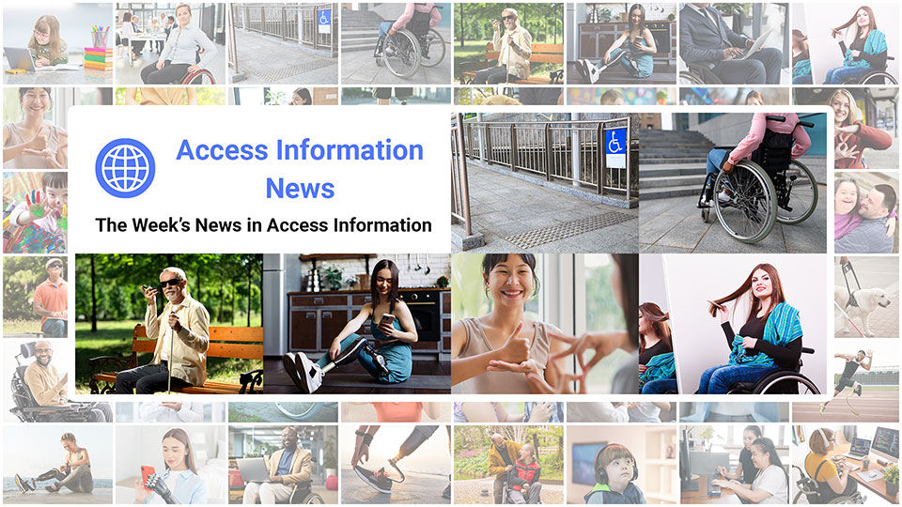
 |  |  |  |  |  |  |  |  |  |  |  | 
Access Information News for Monday, September 1, 2025 - Volume 1030
♿️ The Week's News in Access Information
Access Information News. The world's #1 online resource for current news and trends in access information.
A Mind Vault Solutions, Ltd. Publication
Subscribers: 40,823 🔢️ opt-in subscribers were sent this issue via email.

Sponsors 🏅️
 | 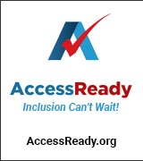 | 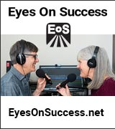 | 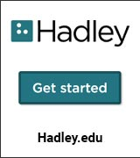 |  | 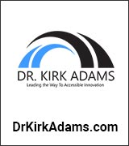
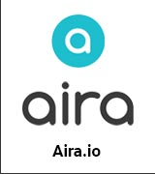 |  |  | 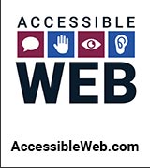 | 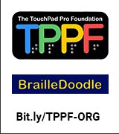 | 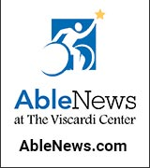
 |  |  |  |  | 

Access Awareness: Updates That Matter ♿️
Parents Are Encouraging Their Kids to Fake BLIND in This Disgusting TikTok Trend… | Molly Burke | August 27, 2025
Here Molly Burke addresses a disturbing TikTok trend in which parents encourage their children to pretend to be blind in order to win prizes or views. After a brief sponsor segment, Molly, who is blind herself, shares her outrage and deep concern about the ableism this perpetuates. She explains how the trend relies on harmful stereotypes about blindness, teaches children to mock disabilities, fosters pity-driven narratives, and trivializes the real experiences of blind people. Drawing on her own life and advocacy, Molly emphasizes that disability is not a costume or a punchline, but a lived reality deserving respect, representation, and empathy.

This Week's Featured Advertisement 🎯️
Would Your Product, Service or Message Benefit From Reaching Over 40,000 Access-Specific Readers Each Week? Join Access Information News as a Sponsor Today.

Join Access Information News as a Sponsor today and begin reaching over 40,000 access information readers each week, all while supporting the ongoing distribution of Access Information News for those very same readers. Only $200 / month.
Key Newsletter Statistics:
- Subscribers: 40,000 + per week and growing.
- Open Rate: 47% (Average. Last 12 months.)
- Click Rate: 34% (Average. Last 12 months.)
- Bounce Rate: 1.2% (Average. Last 12 months.)
- Ad CTRs: 2-12% (Average. Last 12 months.)
Benefits All Sponsors Receive:
- One (1) Sponsor Profile on the Access Information News website.
- One (1) Sponsor Profile in each weekly newsletter.
- One (1) Sponsor Wall Brand Advertisement on the Access Information News home page.
- One (1) Sponsor Wall Brand Advertisement in each weekly newsletter.
- One (1) Classified Advertisement in each weekly newsletter.
- 50% Discount on all Sponsored News Article Advertisements.
- Free link tracking.
- Permanent SEO benefits.
- Gratitude from over 40,000 access information subscribers for keeping Access Information News free to read.
With additional benefits for Sponsors that pay quarterly or annually. Learn more today.

News 📰️
👉 Submit a News Article for free here, with timing and placement determined by our editors.
👉 Submit a Sponsored News Article here, with timing and placement determined by you.

1.) Top 5 Most Clicked News Articles From Last Week 📊️
A.) Higher Rates Of Loneliness Persist Among Working-Age Adults With Disabilities, Study Finds | Sph.brown.edu | August 21, 2025
A Brown University study found that nearly one third of working-age adults with disabilities report persistent loneliness, with about two thirds experiencing severe isolation regardless of disability type.
B.) Podcast: "Not Butterflies And Rainbows. This Is Hard Stuff." | Hadley | Insights & Sound Bites | August 24, 2025
Nikki has lost her vision due to a rare autoimmune disease. While she appreciates positive bits of advice and encouragement, she also stays grounded in the struggles she's facing and knows others do, too. She's feeling the loss.
C.) The Adaptation Advantage: Rich And Brittany Palmer's First-Money-In Play For Disability Innovation | DrKirkAdams.com | August 20, 2025
The biggest “emerging market” isn't on a map; it's the global disability community, and the hundreds of millions more who benefit when design removes friction. In my work with founders and employers, the first barrier isn't ingenuity or technical feasibility; it's the early capital that turns validated need into product and revenue. Adaptation Ventures, led by Rich and Brittany Palmer, was built to close that gap for disability-forward startups. My thesis is simple: when first checks meet first-rate operators, disability innovation stops being “niche” and starts compounding into mainstream performance.
D.) It's Legal To Pay Disabled People Less Than Minimum Wage? (Let's Talk "Mission Washing") | Molly Burke | Molly Burke | YouTube.com | August 19, 2025
Molly Burke addresses the controversial topic of wage disparities for disabled individuals, exploring the implications of "mission washing" in employment practices. Join the conversation around advocacy, rights, and the need for fair treatment in the workforce.
E.) Students With Disabilities Can More Quickly Be Removed From Class Under A New Tennessee Rule | ChalkBeat.org | August 19, 2025
Tennessee's Board of Education approved a rule allowing schools to remove students with disabilities from classrooms more quickly, even before a formal behavioral assessment is completed. The change alters protections previously required under federal special education law.
September 1, 2025 📅️
2.) Sponsorship Packages Available | AccessInformationNews.com | September 1, 2025
Would your product, service or message benefit from reaching over 40,000 access information readers each week? For just $200 / month? If you're thinking yes, we invite you to try a Sponsorship Package with Access Information News. The benefits are amazing and the traffic delivered to your properties each week is measurable. No obligation. Cancel anytime.
3.) One Time Advertisements Available | AccessInformationNews.com | September 1, 2025
One time advertisements are available to anyone, with or without a Sponsorship. Would your product, service or message benefit from reaching over 40,000 access information subscribers? If you're thinking yes, please check out our one time advertising options. They are cost-effective, targeted and measurable. Scheduling is optional. Learn more today.
4.) Premium Subscribers | AccessInformationNews.com | September 1, 2025
Next Issue: Premium Subscribers will receive their 10th issue of the Top 60 Most Clicked News Articles for April, May and June of 2025 on Monday, July 7, 2025. Back Issues: There are currently 9 back issues available. Premium Subscribers are entitled to all back issues, anytime they sign up. All available back issues will be sent to you via email within 24 hours of purchasing your subscription. Please Join Us: If you would like to receive a perfectly formatted and searchable Word Document with each of the Top 60 Most Clicked News Articles of the last 3 months listed neatly within it, please consider joining us today for just $1 a month.
5.) Sponsored News Articles | AccessInformationNews.com | September 1, 2025
Use Sponsored News Articles to reach the access community when you need to. Whether you are a current Sponsor or not. Drive traffic to your access product and service announcements, events, updates or fundraisers using this incredibly cost-effective and easy-to-use advertisement tool. Learn more today.
6.) Do You Have A Link In This Issue? Learn How To Track It For Free | AccessInformationNews.com | September 1, 2025
This article will outline, step-by-step, how you can get free website traffic reporting on any link to your domain (AKA domain name, website or web address) that has been published by Access Information News since January 22, 2024, when we launched this feature.
7.) The Innovative Impact Newsletter By Dr. Kirk Adams for Monday, September 1, 2025 — Issue 106 | September 1, 2025
The world's leading business strategy and workplace inclusion newsletter.
8.) Breaking Barriers, Building Bridges: Innovative Impact, LLC Partners with Accessible Data | Dr. Kirk Adams | September 1, 2025
At Innovative Impact LLC, we believe in bold ideas, real equity, and designing systems where everyone, and I mean everyone, can show up fully and authentically. That's why I'm absolutely buzzing to announce our active partnership with Accessible Data, a company doing more than just talking the talk, they're coding the code and walking the walk.
August 31, 2025 📅️
9.) Podcast: A Chat with a Retina Specialist | Hadley Presents: A Conversation with the Experts | August 31, 2025
Dr. Mathew MacCumber from Illinois Retina Associates joins us to discuss common problems that can affect the retina (macular degeneration, diabetic retinopathy and retinitis pigmentosa, to name a few). What should you ask your doctor to make sure you get the most from your eye doctor visits? What is he excited about for the future of treatments in his field? Ricky asks those questions and more.
August 29, 2025 📅️
10.) How These Startups Are Transforming Lives With Assistive Technology | YourStory.com | August 29, 2025
Here Indian startups are developing life-changing assistive technologies — from bionic prosthetics to AI-powered smart wearables — designed to empower individuals with disabilities and foster greater independence and inclusion.
11.) How Is Online Banking In Canada Keeping Up These Days? | Donna Jodhan | BarrierFreeCanada.org | August 29, 2025
Canadian banks have made improvements in their online services, but accessibility and usability still lag for many users, especially those using assistive technologies, highlighting that equity must be more than an afterthought in digital banking.
12.) Pregnancy Test for Blind Women Puts Results Within Reach | TheBump.com | August 29, 2025
Here a graduate student at the University of Limerick introduces AMY, a reusable saliva-based pregnancy test prototype offering results through touch, sight, and sound, while parallel tactile and vibration-based designs from RNIB and MIT aim to guide accessible reproductive experiences.
August 28, 2025 📅️
13.) Podcasts By Dr. Kirk Adams: Supercharge Your Bottom Line Through Disability Inclusion Webinar: August 28, 2025: Interview with Paolo Gaudiano, Founder & Chief Scientist, Aleria (PBC) | August 28, 2025
In this engaging episode, Dr. Kirk Adams sits down with Paolo Gaudiano, Founder & Chief Scientist at Aleria to unpack how measuring day-to-day workplace experiences, rather than headcounts or vague culture scores, translates inclusion into business outcomes. Gaudiano traces his path from computational neuroscience and complexity modeling to a 2015 “lightbulb moment” that led him to build simulations and tools showing how inclusion lifts productivity and retention, and how focusing on diversity alone can spark backlash. He outlines the premise of his 2024 book Measuring Inclusion: Higher Profits and Happier People, Without Guesswork or Backlash, and makes the practical case for aligning inclusion with financial performance rather than sentiment.
14.) Recording: SYBL-TDI Webinar: August 28, 2025: From Rocket Science to Inclusion Science: Paolo Gaudiano's Data-Driven Path to Disability ROI | Dr. Kirk Adams | August 28, 2025
In this engaging episode, Dr. Kirk Adams sits down with Paolo Gaudiano, Founder & Chief Scientist at Aleria to unpack how measuring day-to-day workplace experiences, rather than headcounts or vague culture scores, translates inclusion into business outcomes. Gaudiano traces his path from computational neuroscience and complexity modeling to a 2015 “lightbulb moment” that led him to build simulations and tools showing how inclusion lifts productivity and retention, and how focusing on diversity alone can spark backlash. He outlines the premise of his 2024 book Measuring Inclusion: Higher Profits and Happier People, Without Guesswork or Backlash, and makes the practical case for aligning inclusion with financial performance rather than sentiment.
15.) Medicare Will Require Prior Approval For Certain Procedures | NYTimes.com | August 28, 2025
The federal government will require prior approval for certain procedures under Medicare Advantage plans, a move addressing growing concerns over delays and denials in private insurance coverage for essential treatments.
16.) Lesson Plan: Opening More Doors — Inventing Ways To Make Schools More Accessible | PBS.org | August 28, 2025
Despite ADA protections, many school facilities remain inaccessible for students using wheelchairs; innovations in assistive technology are helping bridge this gap and promote inclusive education.
17.) Justice Department Secures Agreement With North Carolina Department Of Adult Corrections To Improve Communication Access For Incarcerated People Who Are Deaf Or Hard Of Hearing | Justice.gov | August 28, 2025
A new agreement with North Carolina's prison system ensures that incarcerated individuals with hearing disabilities will receive adequate communication support, including interpreters and assistive devices, in line with ADA requirements.
18.) Detroit Housing Crisis Deepens For Disabled Residents | Axios.com | August 28, 2025
An August study highlights a severe shortage of accessible housing options in Detroit, where about 20% of residents live with disabilities, pushing city officials to consider new inclusive housing policies.
19.) US FDA Narrows Under-65 COVID Vaccine Eligibility; Maintains Full Access For Older Americans | Reuters.com | August 28, 2025
The FDA has restricted COVID-19 vaccine eligibility for people under 65 to those with health risks while keeping full access for older adults, marking a shift from earlier universal eligibility.
20.) Student Housing At People's Park To Be Named After Judith Heumann, Disability Rights Leader | Berkeley.edu | August 28, 2025
UC Berkeley will name a new student housing facility after Judith Heumann, honoring the late disability rights activist whose work helped drive national legislation supporting accessibility and inclusion.
21.) Forward Momentum In Pennsylvania's Disability Services Waitlist | TheCenterSquare.com | August 28, 2025
Pennsylvania has reduced its adult emergency disability services waitlist by 28% over the past year, alongside boosting pay for direct service professionals and expanding statewide support services.
22.) Canada: Vehicle Or Mobility Device? Growing Safety Concern For Local Accessibility Advocate | CityNews.ca | August 28, 2025
Devin Sisak, founder of Barrier-free Cambridge, raises public safety concerns over enclosed mobility devices on sidewalks, warning they blur lines between vehicles and assistive devices while exploiting accessibility regulations.
23.) UK Employment Appeal Tribunal Rules On Protection Against Disability Discrimination For Workers With ADHD And Autism | NatLawReview.com | August 28, 2025
In a ruling on the Stedman v Haven Leisure case, the UK Employment Appeal Tribunal clarified protections under the Equality Act 2010 for job seekers with ADHD and autism in the context of employment discrimination.
24.) Canada: Alberta Minister Calls For Automatic Enrolment In Canada's New Disability Benefit | MSN.com | August 28, 2025
Alberta's Social Services Minister Jason Nixon urges Ottawa to implement automatic enrollment for the Canada Disability Benefit, arguing it would simplify access by deferring to provincial eligibility systems.
25.) UK: Unlocking The Workplace For Disabled People — The Case For Flex Plus Jobs As A Pathway To Work | LSE.ac.uk | August 28, 2025
Despite backlash against recent benefits cuts, proposals like Flex Plus jobs from the Get Britain Working White Paper aim to increase workforce inclusion by promoting flexible employment opportunities for disabled individuals.
26.) UK: How Does Disability Discrimination Differ From Other Protected Characteristics Under The Equality Act? | PeopleManagement.co.uk | August 28, 2025
Disability-related early conciliation notifications surged 41%, prompting renewed attention to the unique aspects of disability protections under the Equality Act, including long-term impairments affecting daily activities.
August 27, 2025 📅️
27.) Parents Are Encouraging Their Kids To Fake Blind In This Disgusting TikTok Trend… | Molly Burke | YouTube.com | August 27, 2025
The alarming trend of children pretending to be blind for social media attention raises ethical concerns about the impact on the visually impaired community. Insights from advocates highlight the importance of promoting empathy and understanding towards disabilities rather than trivializing them for online fame.
28.) 5 Benefits Under The Umbrella Or Veterans Readiness And Employment | Veterans InfoTap | YouTube.com | August 27, 2025
Explore the significant advantages available under Veterans Readiness and Employment, shedding light on how veterans can leverage these benefits for improved quality of life and support. Gain insights on guaranteeing rating increases and the assistance offered for navigating VA claims successfully.
29.) National Coalition On Accessible Voting Has Launched Its Web Site | NCAVote.org | August 27, 2025
The National Coalition on Accessible Voting has launched a new website to support its mission of achieving full voting accessibility for people with disabilities through collaboration among leading advocacy organizations.
30.) Maryland's Digital Revamp Aims For An Online Presence That's Cohesive, Secure, Accessible | StateScoop.com | August 27, 2025
Maryland is overhauling its digital platforms to ensure a cohesive, secure, and accessible experience for residents, addressing outdated content and improving overall usability under the leadership of Chief Digital Experience Officer Marcy Jacobs.
August 26, 2025 📅️
31.) My Favorite Trash TV Is Ruined By Its Ableism | ElectricLiterature.com | August 26, 2025
A writer reflects on how ableist tropes in reality TV conflict with personal experiences of disability, revealing the need for more inclusive and respectful media representation.
32.) Gavin Newsom Is Trying To Have It Both Ways On Disability Rights | TheHill.com | August 26, 2025
California Governor Gavin Newsom faces criticism for inconsistencies in his stance on disability rights, as disability employment in state government reportedly declined by 40 percent between 2017 and 2023.
33.) UK: Stations Improved After Disabled Man Left Stranded | BBC.com | August 26, 2025
After being stranded due to a canceled accessible taxi and lack of staff assistance, Doug Paulley's legal efforts led to accessibility upgrades at six Northern railway stations.
August 25, 2025 📅️
34.) How Federal Officials Talk About Health Is Shifting In Troubling Ways — And That Change Makes Me Worried For My Autistic Child | TheConversation.com | August 25, 2025
A health rhetoric researcher raises alarms over the Make America Healthy Again movement, criticizing its language for potentially marginalizing individuals with disabilities and chronic conditions.
35.) Deaf Man Completes Short Film To Bring More Awareness To Access To Media Without Hearing | SpectrumLocalNews.com | August 25, 2025
Zain Ahmed, a deaf filmmaker, completed a short film titled 'INVERSE' to highlight the need for greater media accessibility for the deaf and hard-of-hearing community.
36.) Teen Entrepreneurs In Michigan Make A Difference Through Baking And Accessibility | MidMichiganNow.com | August 25, 2025
Two teenage girls in Michigan are using their entrepreneurial ventures in baking and advocacy to positively impact their communities and promote accessibility.
37.) North Texas Nonprofit Transforms Lives By Bringing Technology To The Blind | Cbsnews.com | August 25, 2025
Here the nonprofit Computers for the Blind refurbishes donated computers with accessibility tools like JAWS and ZoomText—delivering not just technology, but independence and confidence to people who are blind or visually impaired across the U.S.
38.) North Texas Nonprofit Transforms Lives By Bringing Technology To The Blind | CBSNews.com | August 25, 2025
Computers for the Blind refurbishes and distributes accessible computers to blind and visually impaired individuals, offering life-changing digital access and independence.
39.) Australia: People With Disability Still Dealing With Inaccessible Air Travel As Aviation Reforms Drag On | ABC.net.au | August 25, 2025
Disability advocate Jono Bredin was unable to attend an accessibility summit due to inadequate airline and accommodation accessibility, underscoring ongoing delays in aviation reforms for people with disabilities.
Last Week 📅️
40.) People With Disabilities Are 'Eating The Cost' Of Tariffs | Mashable.com | August 23, 2025
Global tariffs are increasing the cost of electronic and accessibility devices, putting added financial pressure on people with disabilities and creating uncertainty across multiple consumer markets.
41.) My Autoimmune Medication Left Me With Osteoporosis At 32 — How I Found A Better Way | MindBodyGreen.com | August 23, 2025
A former law student recounts how autoimmune medication led to early-onset osteoporosis, sparking a personal health journey toward alternative solutions for managing chronic illness.
42.) Canada: OKIB Members Have The Chance To Meet Canadian Icon Rick Hansen | CastaNet.net | August 23, 2025
Rick Hansen, renowned for his Man in Motion World Tour and advocacy for inclusion, met with Okanagan Indian Band members to promote accessible community design and inspire discussions on building inclusive spaces.
43.) Canada: Ontario's Disability Policies Can Do More For Children With Disabilities And Their Families | GoodMenProject.com | August 23, 2025
Despite a $175 million boost to Ontario's Autism Program, significant gaps remain in the province's disability policies, preventing children and others with disabilities from fully participating in society as promised under the AODA.
44.) Special Education Complaints Jump In Michigan | DailyPress.net | August 22, 2025
A Michigan mother of six has filed over two dozen complaints and four legal grievances against Howell Public Schools, alleging the district failed to provide adequate services and accurate information for her children with disabilities.
45.) Attacks On Vote-By-Mail, Voting Machines Threaten Disabled Voters | AAPD | August 22, 2025
President Trump's plans to restrict vote-by-mail and certain voting machines have drawn condemnation from disability advocates, who warn such actions could suppress the rights of millions of disabled voters.
46.) UK: Accessibility Improvements Secured At Six Northern Railway Stations Following Legal Challenge | LeighDay.co.uk | August 22, 2025
Following a legal challenge by disability rights campaigner Doug Paulley, six Northern railway stations will undergo accessibility improvements to address issues with staff-operated barrow crossings that left some disabled passengers stranded.
47.) Canada: New Art Piece At Royal BC Museum Advocates For More Accessibility In Public Spaces | ChekNews.ca | August 22, 2025
A collaborative mosaic titled 'Garden City Arts' displayed at the Royal BC Museum symbolizes a collective call for greater inclusiveness and accessibility in public spaces, featuring contributions from the Garth Homer Society and local artists.
48.) Accessible Recruitment | Tetralogical.com | August 19, 2025
This article emphasizes the importance of accessible recruitment practices that enable all candidates, regardless of background or disability, to demonstrate their skills effectively. It outlines best practices for job adverts, the application process, interviews, and onboarding to create an inclusive hiring environment that respects diversity.
49.) A Billion People, Ten Minutes, One Platform: The Case for Doppler Labs' At-Home Hearing: Netcapital Raise Ends November 14, 2025 | Dr. Kirk Adams | August 26, 2025
This article is for leaders in healthcare, accessibility, HR/benefits, philanthropy, impact investing, and public policy who care about measurable inclusion and scalable health access. I approach this work from a systems-and-operations vantage point: clear problem definition, practical solutions, and accountability for outcomes. Expect both mission and mechanics, not marketing, and a direct conversation about what it takes to expand access responsibly while building durable adoption.
50.) Ask Congress To Fund Library Services | American Council of the Blind | August 25, 2025
The American Council of the Blind is urging public support to ensure continued funding for the Institute for Museum and Library Services, which supports state library programs that provide essential access to written materials through the National Library Service.
51.) I Heard Gunshots, And Then This Happened… | Molly Burke | YouTube.com | August 22, 2025
Molly Burke shares a gripping account of an unexpected experience involving gunshots, emphasizing her resilience and perspective as she navigates life's challenges. Her journey serves as an inspiring reminder of finding strength and hope amid chaos.
52.) A11M - Part I On A11y And LLMs | Nira11y.com | August 13, 2023
This article examines the challenges and implications of accessibility in the context of large language models (LLMs) and chat interfaces, which transform user interactions with websites. It highlights that, despite the tools for accessibility being available, 95% of the web remains inaccessible, affecting users with disabilities, and discusses potential shifts in focus for accessibility legislation.
53.) The Best Line Length | Glyph.im | August 7, 2025
Determining the optimal line length in coding is an ongoing debate, often centered around the historical 80-character limit. The author explores human reading physiology and modern display capabilities, ultimately suggesting a maximum line length of 88 characters, as per the Black code style guide.
54.) Testing Methods: Contrast (Minimum) | DennisDeacon.com | August 5, 2025
This article outlines the WCAG 1.4.3 Contrast (Minimum) success criteria, highlighting the necessity of maintaining a contrast ratio of at least 4.5:1 for text. It emphasizes the importance of combining automated, AI-powered, and manual testing methods to ensure digital accessibility, particularly for individuals with low vision or color blindness.
55.) A11y 101: 2.4.1 Bypass Blocks | Tarnoff.info | August 4, 2025
The article explores the importance of skip links in web design, particularly for enhancing accessibility for users with physical limitations and screen reader users. It emphasizes that repeated navigation components create barriers and advocates for implementing effective bypass mechanisms to improve user experience.
56.) Focus Not Obscured | A11y-Blog.dev | August 1, 2025
WCAG 2.2 introduces criteria to ensure that focused elements remain visible for keyboard users, addressing issues of obscured navigation. The article outlines problematic patterns and offers practical solutions to prevent focus from being blocked by overlapping elements, ensuring better accessibility for all users.

Featured Events 📅️
👉 Submit your event for consideration within this section here.

September 2, 2025 | Join Us For Our September Webinar | Blazie Technologies
4:00 PM PT, 5:00 PM MT, 6:00 PM CT, 7:00 PM ET, 11:00 PM GMT
In this interactive webinar, Blazie Technologies provides an update on the upcoming September BT Speak release and answers audience questions about the BT Speak device and the BT Braille platform.
September 4, 2024 | AI Tips, Tools, And Techniques: Where To Begin | Freedom Scientific
9:00 AM PT, 10:00 AM MT, 11:00 AM CT, 12:00 PM ET, 4:00 PM GMT
In this free, live webinar from Freedom Scientific, presenters Elizabeth Whitaker and Rachel Buchanan introduce key artificial intelligence concepts and demonstrate how to use AI tools with JAWS, ZoomText, or Fusion. Topics include prompt creation, document drafting, and data analysis, with real-world examples designed to help users confidently apply AI in professional settings.
September 16-17, 2025 | The Deaf And Hard Of Hearing Accessible Technology's State Of Science Conference | Gallaudet University's Technology Access Program
6:00 AM PT, 7:00 AM MT, 8:00 AM CT, 9:00 AM ET, 1:00 PM GMT
In this two-day hybrid gathering, Gallaudet University's Technology Access Program showcases cutting-edge research on caption quality, hearing-technology accessibility and sign-language innovation, featuring keynotes, breakout discussions and student presentations aimed at advancing equitable communication tools for the Deaf and Hard of Hearing community.
September 20, 2025 | Disability Strong Virtual Conference: Building Change | Disability Strong Virtual Conference
1:00 PM PT, 2:00 PM MT, 3:00 PM CT, 4:00 PM ET, 8:00 PM GMT
Disability advocate and civic leader Nico Meyering shares his lived experience with orphan disease and navigating inaccessible systems toward impactful leadership. Drawing from his work in reshaping civic institutions, Nico offers practical insights on building power, forging coalitions, and creating inclusive spaces where Disabled people lead, thrive, and belong.
September 21, 2025 | Disability Strong Virtual Conference: From Trauma To Healing & Intersectionality Of Race And Disability | Disability Strong Virtual Conference
9:00 AM PT, 10:00 AM MT, 11:00 AM CT, 12:00 PM ET, 4:00 PM GMT & 1:00 PM PT, 2:00 PM MT, 3:00 PM CT, 4:00 PM ET, 8:00 PM GMT
Nicole Demos shares her personal journey of trauma and healing in Finland, highlighting the importance of self-care, advocacy, and safe spaces. Later, Nancy Williams-Nettles examines how racism and ableism intersect, creating unique challenges for people of color with disabilities, and explores ways to foster inclusive, justice-driven approaches.
September 22, 2025 | Disability Strong Virtual Conference: Civic Engagement, Policymaking, And Advocacy Panel | Disability Strong Virtual Conference
4:00 PM PT, 5:00 PM MT, 6:00 PM CT, 7:00 PM ET, 11:00 PM GMT
Panelists Nico Meyering, Nancy Williams-Nettles, and Jesse Schwartzman discuss practical ways to engage in community advocacy, both politically and non-politically. They share strategies for using personal experiences to drive change and highlight the power of active participation in shaping more inclusive communities.
September 22, 2025 | Twenty-Sixth Audio Description Institute | American Council Of The Blind
1:00 PM PT, 2:00 PM MT, 3:00 PM CT, 4:00 PM ET, 8:00 PM GMT
Led by Dr. Joel Snyder, this five-day virtual training from the American Council of the Blind offers an in-depth introduction to the theory, techniques, and applications of audio description. Attendees will gain practical skills through lectures, discussions, and collaborative sessions, and receive a certificate of completion along with a training manual.
September 23, 2025 | Disability Strong Virtual Conference: Using Inclusive Language / How To Be An Ally | Disability Strong Virtual Conference
5:00 PM PT, 6:00 PM MT, 7:00 PM CT, 8:00 PM ET, 12:00 AM GMT
Nicole Demos guides participants through strategies for fostering belonging, equity, and empathy by using inclusive language and practicing genuine allyship. Attendees will explore how words and actions can work together to make accessibility and inclusivity an everyday reality.
September 24, 2025 | Disability Strong Virtual Conference: How Violence And Disability Converge | Disability Strong Virtual Conference
5:00 PM PT, 6:00 PM MT, 7:00 PM CT, 8:00 PM ET, 12:00 AM GMT
Margaux Sorenson examines how violence disproportionately impacts people with disabilities, the systemic barriers to reporting, and the historical roots of ableism. The session highlights advocacy efforts centering disabled survivors and explores ways to promote safety, equity, and justice for all.
September 27, 2025 | NJCB Virtual Convention: The Grassroots Revival | New Jersey Council Of The Blind
9:00 AM PT, 10:00 AM MT, 11:00 AM CT, 12:00 PM ET, 4:00 PM GMT
The New Jersey Council of the Blind presents its 2025 Virtual Convention, The Grassroots Revival, bringing together expert speakers, live Q&A sessions, assistive technology demonstrations, and community engagement. Running for the first time in over 15 years, this online gathering highlights advocacy, access, and connection with presentations on adaptive living, accessible technology, healthcare, and independent living resources.
September 27, 2024 | What To Expect With The New Iphone Operating System Update iOS 26 | Maryland State Library For The Blind And Print Disabled Technology User Group
10:00 AM PT, 11:00 AM MT, 12:00 PM CT, 1:00 PM ET, 5:00 PM GMT
The Technology User Group (TUG) reveals the latest changes coming to the iPhone's operating system, iOS 26, and explores whether these updates will enhance accessibility or fall short of expectations.
October 14, 2025 and October 15, 2025| Virtual Web Accessibility Training | WebAIM
9:00 AM PT, 10:00 AM MT, 11:00 AM CT, 12:00 PM ET, 4:00 PM GMT
In this two-day, expert-led online program from WebAIM, participants will learn essential and advanced web accessibility practices to ensure compliance with international guidelines and legal requirements. Designed for developers, designers, and accessibility professionals, the training covers WCAG principles, assistive technology use, inclusive design for various disabilities, evaluation techniques, and offers a complimentary document accessibility course.
November 14, 2025 | Deadline to Invest in Doppler Labs' At-Home Hearing | Dr. Kirk Adams
Doppler Labs offers audiologist-grade hearing aids and a patented at-home fitting platform designed to deliver fast, accessible hearing care at scale. The Netcapital raise aims to fund expansion, production, and a nonprofit arm targeting underserved regions, with clinical trials completed and pricing locked in for sustainable impact and global reach.
November 15, 2025 | International Neurology Conference 2025 | PubScholars Group
12:00 AM PT, 1:00 AM MT, 2:00 AM CT, 3:00 AM ET, 8:00 AM GMT
The International Neurology Conference 2025 is a flagship hybrid event hosted by PubScholars Group on November 15-16, 2025, at the Hard Rock Hotel at Universal Orlando (5800 Universal Blvd, Orlando, FL) and streamed online. The conference explores "Mind-Brain Connection: Understanding Neuroscience through Mental Health," aiming to integrate cutting-edge science with clinical relevance. Who Should Attend: Neurologists, neurosurgeons, neuroscientists, psychologists, rehabilitation professionals, engineers, industry leaders, students, and allied health practitioners. Important Dates & times: Abstract Submission Deadline: September 15, 2025. Registration Deadline: September 30, 2025. Event Timing: November 15, 2025 (8 AM start) - November 16, 2025 (6 PM close). Format: Hybrid Event (In-person & Virtual. Contact Person: Richard A. Email: info@pubscholars.org 📧️. Phone: +91 7042134266 📱️. Venue: Hard Rock Hotel at Universal Orlando, 5800 Universal Blvd, Orlando, FL 32819, USA.
May 21, 2026 | Tech Blitz 2026: Assistive Technology Showcase Brings Together Blind, Deafblind, And Low Vision Community For Innovation, Discovery, And Connection. | Helen Keller Services
3:00 PM PT, 4:00 PM MT, 5:00 PM CT, 6:00 PM ET, 11:00 PM GMT
In this in-person showcase hosted by Helen Keller Services, assistive technology vendors, innovators, and users come together for a day of interactive demonstrations, in-depth discussions, and community connection focused on advancing access and independence for the blind, DeafBlind, and low vision communities.

Directories 📝️
1) Access Information Email Newsletter Directory | Submit

Sponsor Classified Ads 🎯️

⬆︎ 10.) Sponsor: AccessibleWeb

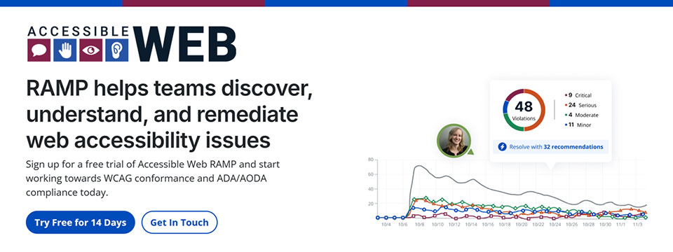
👉️ Classified Advertisement: Have You Run Into An Accessibility Barrier On A Website Recently? | AccessibleWeb
Accessible Web is on a mission to help eliminate online barriers and make the digital space more inclusive for everyone, regardless of ability. Our accessibility testing software, RAMP, allows organizations of any size to discover, understand, and remediate barriers. We offer tools to integrate with existing sites and workflows so businesses with a digital presence can start making their sites more accessible quickly.
Plans start at $49 a month. Plus, we have a 14-day free trial with no credit card needed. We believe any organization can start making progress with Accessible Web RAMP.
Sponsor Since: December 16, 2024 📅️
Website: https://accessibleweb.com 🌐️
About: At Accessible Web, our mission is to make the internet accessible to everyone, regardless of ability.
We offer a comprehensive suite of accessibility testing software tools and educational resources to help organizations achieve and maintain web accessibility in line with the Web Content Accessibility Guidelines (WCAG) and comply with legal standards such as the Americans with Disabilities Act (ADA) and the Accessibility for Ontarians with Disabilities Act (AODA).
➜︎ Services:
⚫️ WCAG Audits: Our certified specialists conduct thorough analyses of websites and applications, identifying accessibility issues and providing detailed recommendations for remediation.
⚫️ VPAT Preparation: We prepare Voluntary Product Accessibility Templates (VPATs), offering industry-standard reports that demonstrate a product's accessibility compliance, which can be crucial for sales and contractual obligations.
⚫️ Accessibility Testing: Our team of individuals with disabilities tests websites and web applications using assistive technologies, providing actionable feedback to enhance user experience and accessibility.
⚫️ Remediation Support: Our certified specialists offer coaching and support to assist organizations in implementing accessibility improvements effectively, ensuring that digital assets meet accessibility standards.
⚫️ Accessibility Certification: Through a comprehensive process of auditing, remediation, and verification, we provide WCAG certifications that validate a company's conformance and commitment to accessibility best practices.
➜︎ Tools:
⚫️ Accessible Web RAMP: Our digital accessibility platform that enables teams to discover, monitor, and remediate web accessibility violations. RAMP offers continuous monitoring, prioritized workflows, and progress reporting to facilitate ongoing compliance efforts.
⚫️ Accessible Web Helper Extension: An accessibility browser extension that allows users to scan web pages, highlight accessibility violations, and check color contrast ratios directly from their browser, streamlining the auditing process.
➜︎ Education:
⚫️ Accessible Web Academy: We offer self-guided online courses tailored to various organizational roles, promoting a culture of inclusivity and equipping teams with the knowledge to implement accessible design from the outset.
⚫️ Knowledge Base and Blog: Our resources include articles on assistive technologies, remediation tutorials, and answers to common web accessibility questions, supporting continuous learning and awareness. We host webinars most Thursdays on various accessibility topics.
We emphasize a proactive approach to web accessibility, advocating for integrating accessible design principles early in the development process to enhance user experience, attract new customers, and mitigate legal risks associated with non-compliance.
For more information or to explore our services and resources, visit our website.
Facebook | LinkedIn | Reddit | YouTube

⬆︎ 9.) Sponsor: Magnifiers & More

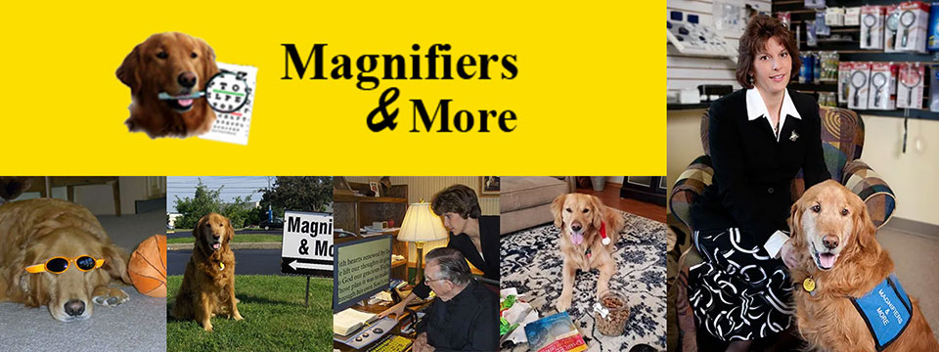
Sponsor Since: October 25, 2024 📅️
Website: https://www.magnifiersandmore.net 🌐️
Email: info@magnifiersandmore.net 📧️
Phone: (440) 946-3363 📱️
Fax: (440) 946-8899 📠️
Visit: 7775 Mentor Avenue, Mentor, Ohio 44060, USA
About: Magnifiers & More, established in 2002 by Deborah Kogler, is Northeast Ohio's only retail store dedicated to providing products and consultations for individuals with low vision, blindness, and vision disabilities. With over forty years of experience in eye care, Deborah founded the company to create a one-stop shop for vision aids, including specialized tools for managing conditions like macular degeneration, glaucoma, diabetic retinopathy, and cataracts.
The store offers a wide range of over seventy-five magnifiers, talking items, large print products, special lights, electronic aids, Braille items, glare control solutions and More.
A key figure in the company's story is Murphy, Deborah's Golden Retriever and original CEO, "Canine Executive Officer," who was the store's mascot and greeter for 15 years. Today, Jeffrey, another Golden Retriever trained as a service dog, serves as the CFO, "Canine Fun Officer," delighting customers and supporting Deborah.
Deborah's journey into vision rehabilitation was inspired by her grandmother's experience with macular degeneration, sparking her passion to make vision aids accessible. She continues to advocate for and educate those living with vision disabilities, both locally and internationally.
Magnifiers & More is committed to helping people improve their quality of life through practical solutions and compassionate support.

⬆︎ 8.) Sponsor: Innosearch.ai

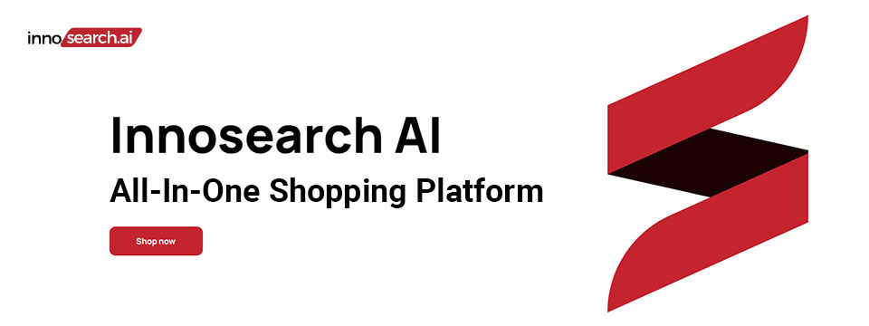
👉️ Classified Advertisement: Shop by Phone — No Screens, Just Your Voice!
Call 1-855-SHOP-GPT (1-855-746-7478)
Shopping online can be hard if you're blind, visually impaired, or not tech-savvy. That's why Innosearch AI created Shop by Phone — a 100% free, voice-only service.
Just call and say what you need:
👉 “Find me a phone charger.”
👉 “Add it to my cart.”
👉 “Check out.”
No apps, no websites — just easy, hands-free shopping from over 500,000 stores.
- ✔ Free to use
- ✔ Works anywhere, anytime
- ✔ Perfect for seniors, blind, and low-vision users
Available in:
- 🇬🇧 UK: +44 7727 247467 📱️
- 🇨🇦 Canada: +1 782 222 7467 📱️
- 🇦🇺 Australia: +61 489 267 467 📱️
- 🇺🇸 USA: 1-855-SHOP-GPT 📱️ (1-855-746-7478 📱️)
Call now and shop with ease!
Sponsor Since: October 15, 2024 📅️
Website: https://www.innosearch.ai 🌐️
Email: info@innosearch.ai 📧️
About: Innosearch is an all-in-one shopping platform augmented with a cutting-edge AI-powered shopping assistant. This innovative feature mimics the experience of shopping in real life by allowing you to interact with the assistant using natural language. It aggregates millions of products from top US online retailers, bringing them directly to you. With this advanced generative AI, Innosearch offers personalized product recommendations, highlights the best deals, and provides comprehensive information including reviews, total prices, shipping options, and more. Innosearch delivers a seamless end-to-end shopping experience, eliminating the need to search and browse in multiple tabs across retailers.
YouTube Review By Sam Seavey: https://youtube.com/watch?v=-rjL-HAwaZY.
Key Features: Key Features of the Innosearch All-in-One AI Shopping Platform include:
➜ Research Products: Easily compare products across retailers, or weigh pros and cons of similar products to make informed decisions.
➜ Uncover the Best Deals: Never miss a door buster, coupon, or clearance sale again. Get notified about the best prices and offers.
➜ AI Summarized Trusted Reviews: See what others are saying and make confident purchases.
➜ All in One: Innosearch brings millions of products from top online retailers directly to you, allowing you to shop the best deals with easy checkout and personalized AI assistance.
➜ Shop with Confidence: Rest assured, Innosearch has you covered with free shipping and returns on every purchase.
➜ Know Before You Buy: Innosearch equips you with expert buying guides, empowering you to make well-informed decisions.
How To Shop: Simply create a free account and start shopping today!

⬆︎ 7.) Sponsor: Aira

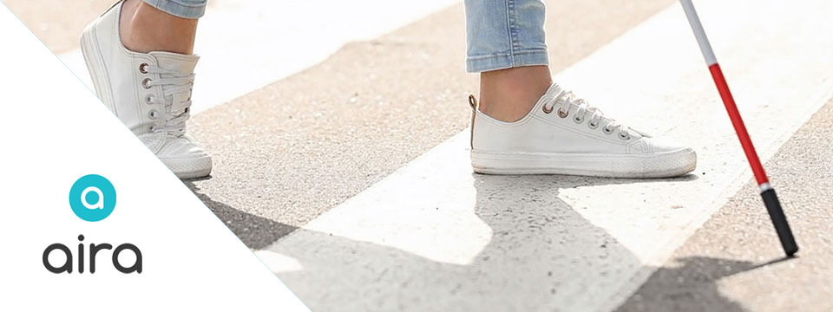
Sponsor Since: September 9, 2024 📅️
Website: https://aira.io/ 🌐️
Download the App: Apple App Store | Google Play Store
Plans and Pricing: https://aira.io/pricing/
Phone: NA: +1.800.835.1934 📱️ | AU: +1.800.765.096 📱️ | UK: +0.800.046.5668 📱️ | NZ: +1.800.425.451 📱️
Text Message: NA: +1.858.242.4457 📱️ | AU: +61.488.839.767 📱️ | UK: +44.149.320.2474 📱️
Email: support@aira.io 📧️
Social: Twitter | Facebook | LinkedIn | YouTube | Instagram
About: Aira's mission is to remove barriers and make the world more accessible with visual interpreting.
We provide a live, human-to-human professional assistance service, an accommodation or productivity tool, that enhances independence by delivering on-demand, skilled and reliable visual interpreting for just about any task. Using the powerful combination of a camera and the Aira app on someone's device of 'choice', a professionally-trained agent will assist by visually interpreting what is in the camera's view or on screen, from describing to reading, from explaining to navigating - just about anything, safely and securely. Aira supports a growing range of devices including smart and tactile button phones, desktop computers and soon, wearables.
Whether you are involved in the work of business, the work of school or the work of life, Aira enhances everyday efficiency, engagement, and independence. Used by employees and customers of hundreds of organizations including airports, banks, the largest software companies, financial firms, retailers and universities, we invite you to join the community, access the Aira app today and try it for free.
https://aira.io/download-and-try-it/
Step One: Subscribe and Download. Pick the plan that lets you explore on your terms and on your time, sign up in a few minutes, and download the Aira app to your smartphone. Plans shown are for the United States, Canada, Australia, New Zealand and the United Kingdom. Add or cancel at any time.
Step Two: Connect with an Aira Agent. On the first call, connect with one of our certified, specially-trained Agents and learn how everything works.
Step Three: Real-time Assistance. At the touch of a button, Aira delivers instant access to visual information, when and where you want it.

⬆︎ 6.) Sponsor: Dr. Kirk Adams

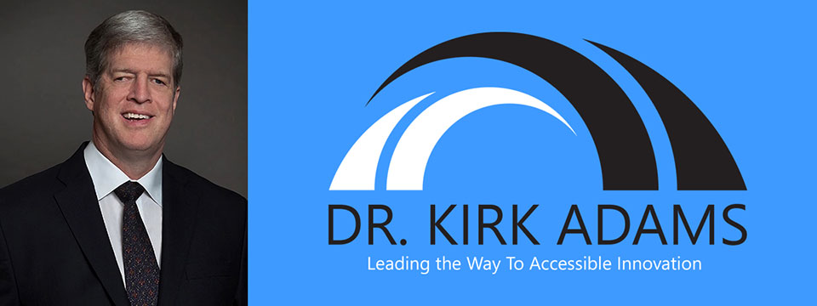
Sponsor Since: July 22, 2024 📅️
Website: https://drkirkadams.com 🌐️
About: Dr. Kirk Adams is a visionary leader, transformative speaker, and lifelong advocate for disability inclusion. With over three decades of experience in advancing accessibility and creating opportunities for individuals who are blind or low-vision, Dr. Adams has become a powerful force for change in the areas of leadership, accessibility, and inclusion. His journey — from navigating vision loss as a young child to becoming a recognized thought leader in disability empowerment — uniquely equips him to help organizations understand, integrate, and champion inclusive practices that benefit all.
Dr. Adams is a highly sought-after speaker, known for his engaging and thought-provoking keynotes on disability inclusion, accessible leadership, and the power of resilience. He has spoken at numerous national and international conferences, including corporate seminars, public policy forums, and industry events, where his personal story and professional insights have inspired leaders to rethink their approach to diversity, equity, and inclusion. His passion lies in empowering organizations to create environments where every individual — regardless of ability — can thrive.
As a speaker, Dr. Adams brings authenticity, warmth, and a depth of experience that resonates with audiences from all backgrounds. He understands that true leadership is about more than just policy; it's about creating cultural shifts that value each person's unique contributions. Whether he is addressing a Fortune 500 company, a non-profit, or a community group, Dr. Adams' message is clear: inclusion benefits everyone, and together we can build a world where opportunity is accessible to all.
Dr. Adams currently resides in Seattle, Washington, where he continues his advocacy work, builds strategic partnerships, and enjoys life with his family. He is proud to be a part of the movement towards a more inclusive future — one conversation at a time.

⬆︎ 5.) Sponsor: Barrier Free Canada

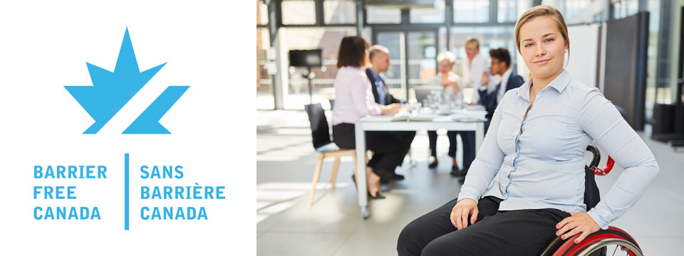
👉️ Classified Advertisement: Barrier Free Canada — Canada sans Barrières Announces Strategic Investment to Empower the Workforce of Tomorrow | Barrier Free Canada
Barrier Free Canada — Canada sans Barrières is proud to announce a bold new strategic investment aimed at advancing accessibility and inclusion in Canada's workforce. This initiative supports innovative training, education, and employment opportunities for persons with disabilities, helping to eliminate systemic barriers and foster a more equitable labor market. By partnering with key stakeholders across sectors, the investment will drive meaningful change, preparing a diverse and inclusive workforce to meet the challenges of tomorrow. This milestone reflects Barrier Free Canada's ongoing commitment to building a barrier-free nation where everyone can thrive and contribute fully to society.
Sponsor Since: November 10, 2023 📅️
Website: https://barrierfreecanada.org/ 🌐️
About: Barrier-Free Canada/Canada Sans Barrieres (BFC/CSB) advocates for the Canadian Parliament to enact a strong and effective Canadians with Disabilities Act (CDA) to achieve a barrier-free Canada for all persons with disabilities.
To this end, BFC/CSB is seeking endorsements from national disability organizations to build a non-partisan community coalition. BFC/CSB would also like to identify point persons from these organizations to act as key contacts.
The steering committee of BFC/CSB has drafted a set of principles concerning a CDA that are drawn from the principles that underpin the provincial disability legislation in Ontario and Manitoba. A CDA is not meant to replace provincial disability legislation. It will complement such legislation and benefit Canadians living in provinces with and without provincial disability legislation. At this point in time, CNIB, March of Dimes Canada, Canadian Hearing Society and MS Society of Canada have endorsed the BFC/CSB principles and confirmed their support for the movement to enact a CDA. There is no individual or organizational charge for membership in BFC/CSB.
Please contact Donna Jodhan, Founder of Barrier-Free Canada, at info@barrierfreecanada.org 📧️ with any questions or to express your organization's support and identify a key contact.
Social: Facebook | X (Formerly Twitter) | Mastodon (Search For: @news@mastodon.barrierfreecanada.org).

⬆︎ 4.) Sponsor: Hadley

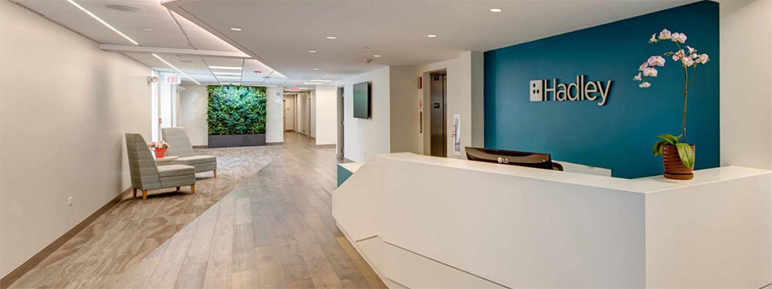
👉️ Classified Advertisement: New NVDA Workshops at Hadley | Hadley
Learn the basics of NVDA. From getting started with the program to customizing the speech to learning helpful shortcuts, Hadley's workshops have you covered.
Sponsor Since: September 18th 2023 📅️
Website: https://hadleyhelps.org/ 🌐️
Email: info@hadleyhelps.org 📧️
Phone: (800) 323-4238 📱️
Get Started: https://hadleyhelps.org/learn 🎓
What would you like to learn today?
Donate: https://hadleyhelps.org/donate/support-hadley ❤
A 501(c)(3) non-profit organization, Hadley relies on contributions from individuals, foundations, and corporations to fund its programs.
About: The mission of Hadley is to create personalized learning opportunities that empower adults with vision loss or blindness to thrive — at home, at work, and in their communities.
Founded in 1920 by William Hadley, an educator who lost his eyesight later in life, Hadley offers practical help, connection and support free of charge to anyone with a visual impairment, their families and professionals supporting them. With Hadley, you can discover new ways to do things that have become more difficult due to vision loss and connect with a network of peers who "get it." And you don't need to come to Hadley. Hadley's help comes to you; online, on the phone or through the mail.
Since relaunching in July 2020, more than 70,000 people have signed up with Hadley, registering more than 200,000 workshop interactions. And our workshops have 98% satisfaction ratings. We reach all 50 states and more than 100 countries. And more people learn braille from Hadley than from any other organization worldwide.
Hadley is a proud partner of the National Eye Institute and the National Eye Health Education Program.
Hadley's help conveniently meets learners where they are. Free of wait lists. Free of office visits. Free of charge.
Social: Facebook | X (Formerly Twitter) | YouTube

⬆︎ 3.) Sponsor: Eyes on Success

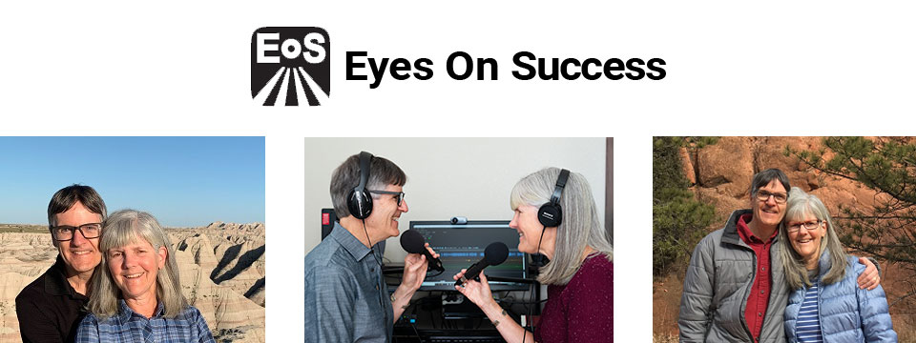
Sponsor Since: August 21, 2023 📅️
Website: https://www.eyesonsuccess.net/ 🌐️
About: This half-hour weekly podcast and radio program discusses products, services and daily living tips for people with vision loss. It is available through radio reading services across North America, via several internet streaming services, and to everyone else as a podcast. To date, the show has been downloaded in all 50 states in the US and over 100 other countries on all the inhabited continents. Eyes On Success is hosted and produced by Peter Torpey and Nancy Goodman Torpey.
Each episode is basically a success story. Some are human stories of visually impaired people's accomplishments in academics, employment, sports or pastimes. Others are descriptions of adaptive aids that enable visually impaired people to achieve things. These include screen readers, magnifiers, navigation aids, and others. In all cases, the focus is on success.
Eyes On Success has been airing weekly since January 2011. Prior to January 2013 the name of the show was ViewPoints. Other than the name, nothing has changed.
Listening To Eyes On Success
You can listen to Eyes On Success on your smart home device by saying “play the Eyes On Success podcast”, subscribe to the podcast wherever you get your podcasts, or listen on Apple Podcasts, iTunes, YouTube or your local radio reading service. Listeners can also follow the show on Facebook and X (Formerly Twitter).
Connecting with Eyes On Success
Email: To contact us with questions, comments or suggestions for future shows send an e-mail to hosts@EyesOnSuccess.net 📧️.
Weekly Announcements: If you would like to receive weekly announcements of upcoming episodes, you can join our low traffic "announcements only" list by sending an e-mail to: EyesOnSuccess+subscribe@GoogleGroups.com 📧️.
Email Forum: If you would like to connect with other listeners and share your thoughts about what you've heard on the show, you can join our listener email forum by sending an email to: EOS_Discuss+Subscribe@GoogleGroups.com 📧️

⬆︎ 2.) Sponsor: Access Ready, Inc.

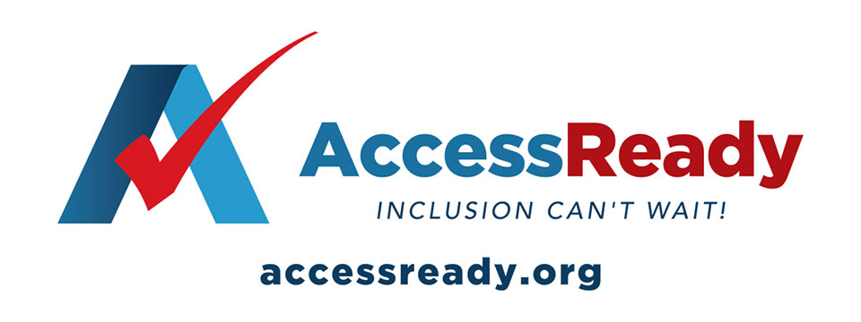
👉️ Classified Advertisement: Help Access Ready, Inc. Rebuild After Hurricanes Helene and Milton | Access Ready, Inc.
Help Access Ready, Inc. support people with disabilities after Hurricanes Helene and Milton.
Based in Saint Petersburg, Florida, Access Ready is committed to providing adaptive equipment, restoring independence and dignity to those affected. Many lost vital devices that help them communicate, work, and live independently.
Donations will go toward repairing or replacing this equipment, ensuring people can regain normalcy after the disaster. Every contribution directly aids recovery efforts.
Since 2018, Access Ready has promoted accessible technology, led by CEO Douglas George Towne.
Your support can make a real difference. Donate Now — be a lifeline for those in need.
info@accessready.org 📧️
+1 (727) 531-1000 📱️
Sponsor Since: December 1st 2022 📅️
Website: https://accessready.org/ 🌐️
Email: info@accessready.org 📧️
Phone: (727) 531-1000 📱️
About: Access Ready Inc. is a certified, 501(c)(3) nonprofit organization. The mission of Access Ready Inc., a nonprofit cross-disability rights advocacy organization, is to promote a policy of accessibility benefiting all people regardless of ability across information and communications technology utilized for two way communications.
The purpose of Access Ready Inc. is to educate the public and private sectors of the importance of accessible information and communications technology to the future of all people regardless of ability.
To support this education by developing initiatives that promote policies that ensure the creation and maintenance of accessible technologies utilized for two way communications at all levels which allow for easy use by people with the widest range of abilities possible.
To develop employment and business opportunities for people with disabilities that support its educational activities in the field of information and communications technology and related areas.
To provide consulting and educational services to buyers, developers, and users of information and communications technology that promotes its highest and best use in society.
To promote the concept of a technologically accessible society which fosters:
Freedom of expression, speech, and worship.
Freedom from fear, ignorance, and want.
Freedom from dishonesty, exclusion, and immorality.
Freedom of aspiration, invention, and inclusion.

⬆︎ 1.) Sponsor: Pneuma Solutions

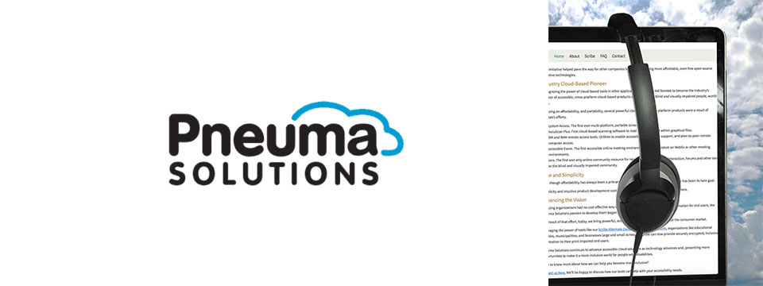
👉️ Classified Advertisement: From Now Through the 18th: Experience Unmatched Independence in the Field of Remote Desktop Access with a Remote Incident Manager Free for All! | Pneuma Solutions
As the United States finishes celebrating Independence Day, regular attendees of the summer blindness conventions will prepare to begin activities centered around independence for people who are blind or visually impaired. IN light of this, we at Pneuma Solutions are lighting our own fireworks over a very unique and never-before-seen level of independence in the field of remote desktop access!
To a technician or trainer who is blind, nothing says independence quite like performing a remote session with a sighted end user's computer, regardless of platform, and being able to fully use it, despite the lack of an installed screen reader. Our Remote Incident Manager is the world's first application that allows this to happen. As such, To celebrate this exciting level of independence, we are proud to offer unlimited access to Remote Incident Manager for the next 14 days, completely free of charge!
Sponsor Since: November 7th 2022 📅️
Website: https://pneumasolutions.com/ 🌐️
Email Newsletter: Click here to receive periodic news via email concerning Pneuma Solutions products for business, consumers and education.
Sales: (866) 202-0520 📱️
Support: (650) 249-1000 📱️
About: Backed by two decades of creating award-winning accessible cloud technologies for people with visual impairments, Pneuma Solutions is the global leader in accessible cloud-based solutions. Pneuma Solutions was founded by long-time accessibility developers Mike Calvo and Matt Campbell. For more information on their individual profiles, click on their respective bio pages. We're proud to be the first company to develop cloud-based accessibility at the network level. Our tools provide organizations, like yours, a way to deliver secure, accessible information right from your network or from our secure servers. You can provide your print disabled consumers, students, employees, and citizens with a multitude of accessible options. Additionally, we offer a suite of cloud-based applications to blind and print disabled consumers directly from our website. Our consumer products are designed to make the day-to-day lives of blind and print disabled individuals more accessible and simpler to manage. Access to information is not a privilege, it's a right. It's also your right to obtain affordable, accessible cloud solutions to serve your end user. When organizations like yours implement our tools, together we help make it a more inclusive world for people with disabilities. Want to know more about how we can help you become more inclusive?
Contact us here. We'll be happy to discuss how our tools can help with your accessibility needs.

⬆︎ 12.) Sponsor: Able News at The Viscardi Center

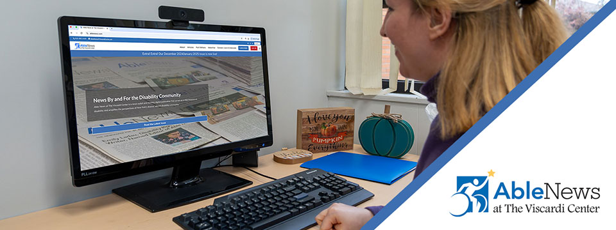
👉️ Classified Advertisement: Your Disability News Platform — Subscribe Now! Discounted Rate! | Able News at The Viscardi Center
Digital subscription just $15 a year with promo code ACCESS.
We share news for, by, and about people with disabilities. As a subscriber, you'll have 24/7 full access and be the first to read about news, community resources, culture, technology, advocacy, health/wellness, and stories from the disability community. You'll also receive our bi-weekly newsletter. Subscribe today!
Sponsor Since: July 4, 2025 📅️
Website: https://ablenews.com 🌐️
Email: ablenews@viscardicenter.org 📧️
Phone: +1 (516) 465-1416 📱️
About: Able News at The Viscardi Center is a news outlet and monthly digital publication that serves as a vital resource on disability and amplifies the perspectives of the diverse, vibrant disability community. The Viscardi Center is a Long Island-based network of non-profit organizations that educate, employ, and empower children, adults, and veterans with disabilities. Central to our mission is featuring original content by writers with disabilities on a range of important topics, from policy and legislative updates, to arts and culture, to community events.

⬆︎ 11.) Sponsor: The Touch Pad Pro Foundation / BrailleDoodle

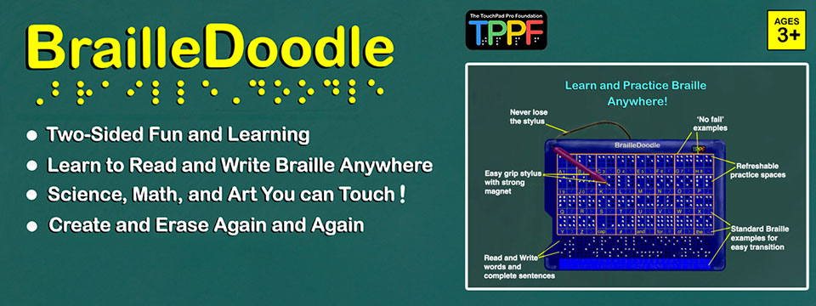
👉️ Classified Advertisement: BrailleDoodle Available at A. T. Guys Now! Just $149.00 USD | The Touch Pad Pro Foundation / BrailleDoodle
The BrailleDoodle is a groundbreaking, affordable, two-sided tablet designed to empower individuals of all ages and skill levels with Braille literacy and tactile exploration. One side is dedicated to Braille learning, featuring practice spaces for letters, numbers, and words, making it perfect for beginners or those looking to improve their skills. The other side offers a tactile refreshable surface, ideal for creating art, exploring STEM concepts like math and graphing, and expressing creativity in limitless ways.
With its easy-to-use magnetic stylus, users can write and create tactile designs, feel their progress as they go, and erase effortlessly, making learning and creativity interactive and engaging. Whether you're a teacher, parent, or individual learner, the BrailleDoodle is a versatile tool that combines education, creativity, and fun. Priced at just $149.00 USD, it is an affordable solution to enhance accessibility and opportunity for blind and low-vision individuals. Order now and take the first step in transforming education and creativity! Visit A.T. Guys today to learn more.
Sponsor Since: January 1, 2025 📅️
Website: https://touchpadprofoundation.org 🌐️
About: The TouchPad Pro Foundation (TPPF) is a 501(c)(3) nonprofit organization committed to creating opportunities for blind and low-vision individuals through Braille literacy, STEM, and art education.
Founded by educators and innovators passionate about accessibility, TPPF strives to address the critical gaps in resources and tools for the visually impaired community. With a mission to promote equality and unleash human potential, the foundation provides innovative solutions that make education inclusive, engaging, and affordable.
Their initiatives include offering free devices to under-served communities and providing training to maximize the impact of their groundbreaking tools.
At the heart of their mission is the BrailleDoodle, a dual-sided, tactile learning tablet designed to make education and creativity accessible to all.
One side focuses on Braille literacy, offering interactive learning spaces for letters, numbers, and words, while the other provides a refreshable surface for tactile drawing, STEM exploration, and artistic expression.
Affordable and versatile, the BrailleDoodle empowers individuals of all ages and skill levels to develop essential literacy and creative skills.
By fostering independence and encouraging innovation, TPPF and the BrailleDoodle are transforming the lives of blind and low-vision learners worldwide.
For more information, visit the TouchPad Pro Foundation website.

⬆︎ 13.) Sponsor: Your Name Here

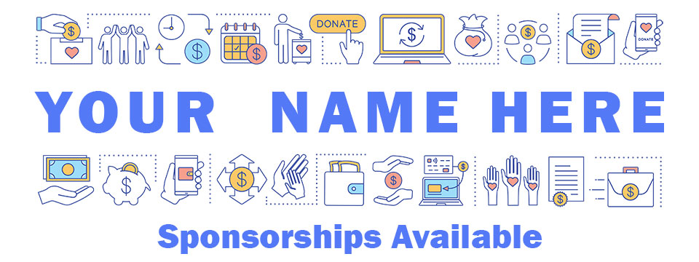
Sponsor Since: Today 📅️
Website: https://accessinformationnews.com/dearsponsor 🌐️
Phone: (855) 578-6660 📱️
Email: news@accessinformationnews.com 📧️
About: Founded in 2022, Access Information News is the world's leading not-for-profit access information news publication that reaches over 40,000 blind, low vision, deaf, hard of hearing, deafblind, neurodivergent and/or disabled professionals, educators and enthusiasts, all over the world, each week. Subscribe here. Review the most recent issues here.

Access Information News Supporters 🤝️
We couldn't do it without you! Thank you for your support!
Why: Access Information News Supporters donate an amount of their choosing either one time or annually in order to assist with the ongoing distribution of the Access Information News publication.
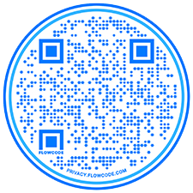
Benefits: All Access Information News Supporters receive a listing within the "Our Supporters" section of each weekly newsletter, as well as a listing within the "Our Supporters" section of the Access Information News website.
In addition, all Access Information News Supporters automatically become Premium Subscribers as well, and therefore enjoy all of the benefits that a Premium Subscription has to offer.
One Time Donation: If you would like to become a Access Information News Supporter by making a one time donation in an amount of your choosing to assist with the ongoing distribution of the Access Information News publication, you may utilize this donate link, or scan the QR code to the right.
Annual Donation: If you would like to become a Access Information News Supporter by making a small annual donation to assist with the ongoing distribution of the Access Information News publication, we also offer the following options, all with our sincerest thanks, and most heartfelt gratitude for your ongoing support.
Support: In tandem with Our Sponsors, these are the people that make the ongoing distribution of Access Information News possible.

Platinum Supporters:

Become an Access Information News Platinum Supporter today.
1.) James Hulme
Platinum Supporter Since: December 5, 2022
2.) Donna Jodhan
Platinum Supporter Since: March 24, 2023
3.) Your name here.
Platinum Supporter since ...

Gold Supporters:

Become an Access Information News Gold Supporter today.
1.) Your name here.
Gold Supporter since ...

Silver Supporters:

Become an Access Information News Silver Supporter today.
1.) Your name here.
Silver Supporter since ...

Bronze Supporters:

Become an Access Information News Bronze Supporter today.
1.) Your name here.
Bronze Supporter since ...

One Time Supporters:

One Time Supporters donate an amount of their choosing — one time to assist with the ongoing distribution of the Access Information News Publication.
Become an Access Information News One Time Supporter today.
1.) Sharyn Sobel
One Time Supporter on November 28, 2023
2.) Amanda Lee
One Time Supporter on July 31, 2023
3.) Gaylen Kapperman
One Time Supporter on June 4, 2024
4.) Your name here.
One Time Supporter on ...

Access Information News Team 🗞️

Distribution: Sponsors, Supporters and Mind Vault Solutions, Ltd.

Distribution Since: 2022
As of November 7, 2022 the distribution of Access Information News is made possible by our Sponsors, our Supporters, our Advertisers and Mind Vault Solutions, Ltd., a leading international provider of professionally outsourced marketing administration and consultation services.
Any time the Access Information News Publication carries less than its Sponsor limit, Mind Vault Solutions, Ltd. donates the remaining dollars necessary to keep the publication running.
Please help us to support the ongoing distribution of this publication. Learn more about the benefits of Sponsorship today.

Publisher: Aaron Di Blasi

Publisher Since: November 7, 2022
Location: Cleveland, Ohio
Time Zone: Eastern Standard Time (EST/EDT) (GMT-5/GMT-4)
In addition to serving as Publisher for Access Information News Aaron also serves as Publisher for the Top Tech Tidbits and AI-Weekly newsletters, PR-Director for the AT-Newswire Press Release News Distribution Service, and President and Senior Project Management Professional for Mind Vault Solutions, Ltd.
As Publisher Aaron oversees the weekly distribution of Access Information News on behalf of Mind Vault Solutions, Ltd.
Aaron Di Blasi, PMP
Email: publisher@accessinformationnews.com 📧️
Toll-Free: +1 (855) 578-6660 📱️
Aaron Di Blasi, PMP
Email: publisher@toptechtidbits.com 📧️
Toll Free: +1 (855) 578-6660 📱️
PR Director (2024-Present)
AT-Newswire 🌐
Access Technology's Digital Newswire
Publisher (2024-Present)
AI-Weekly 🌐
The Week's News in Artificial Intelligence
Publisher (2022-Present)
Access Information News 🌐
The Week's News in Access Information
Publisher (2020-Present)
Top Tech Tidbits 🌐
The Week's News in Access Technology
Sr. Project Management Professional (2006 - Present)
Mind Vault Solutions, Ltd. 🌐
Innovative ideas. Solutions that perform.
Certified:
Digital Marketing Associate
Meta Certified (2022 - Present)
Social Marketing Professional
Hootsuite Certified (2020 - Present)
Email Marketing Professional
Constant Contact Certified (2019 - Present)
Specializing in:
Digital Strategy and Content Marketing
Social Media Advertising
Online Fundraising
ADA, WCAG and Section 508 Compliance

Editor: John Hanlin

Editor Since: November 7, 2022
Location: Boulder, Colorado
Time Zone: Mountain Standard Time (MST/MDT) (GMT-7/GMT-6)
In addition to serving as an Editor to Access Information News John also serves as an Editor to the Top Tech Tidbits and AI-Weekly newsletters and is also an attorney-at-law specializing in long-term disability claims for blind and low-vision persons.
John is also a long-time contractor and member of the Board of Trustees at Mind Vault Solutions, Ltd.
John Hanlin, Esq.
Editor (2024-Present)
AI-Weekly 🌐
The Week's News in Artificial Intelligence
Editor (2022-Present)
Access Information News 🌐
The Week's News in Access Information
Editor (2020-Present)
Top Tech Tidbits 🌐
The Week's News in Access Technology
Board of Trustees (2006 - Present)
Mind Vault Solutions, Ltd. 🌐
Innovative ideas. Solutions that perform.

Editor: Jenna Lang

Editor Since: November 7, 2022
Location: Des Moines, Iowa
Time Zone: Central Standard Time (CST/CDT) (GMT-6/GMT-5)
In addition to serving as an Editor to Access Information News Jenna also serves as an Editor to the Top Tech Tidbits and AI-Weekly newsletters and runs her own advocacy foundation.
Jenna also serves as a certified Project Management Professional (PMP) for Mind Vault Solutions, Ltd.
Jenna's son was born blind and she is always seeking new and innovative ways to empower him through technology.
Jenna Lang, PMP
Editor (2024-Present)
AI-Weekly 🌐
The Week's News in Artificial Intelligence
Editor (2022-Present)
Access Information News 🌐
The Week's News in Access Information
Project Management Professional (2022 - Present)
Mind Vault Solutions, Ltd. 🌐
Innovative ideas. Solutions that perform.
Editor (2020-Present)
Top Tech Tidbits 🌐
The Week's News in Access Technology

Editor: David Woodbridge

Editor Since: February 6, 2023
Location: Central Coast, New South Wales, Australia
Time Zone: Australia Eastern Standard Time (AEST/AEDT) (GMT+10)
In addition to serving as an Editor to Access Information News David also serves as an Editor to the Top Tech Tidbits publication and is also the National Commercial Assistive Technology Advisor for Vision Australia where he has worked since 1990. Over this time he has assisted people who are blind or vision impaired in their home, education, and work settings to take advantage of the benefits of using assistive and main stream technology.
In the last seventeen years, he has also been involved with evaluating technology for use by people who are blind or vision impaired covering both low and high tech equipment (including Microsoft, Samsung, Google, Amazon, and Apple). David is also one of the key spokespersons for Vision Australia relating to technology.
He has been an Apple Ambassador for Apple Australia since 2009 with a group of other Ambassadors / Apple Distinguished Educators (ADE)'s covering the range of Apple's Accessibility solutions throughout Australia.
David produces a range of podcasts (since 2011) covering Apple and other technologies which are distributed on his own podcast (http://davidwoodbr.podbean.com). In addition, he also has a regular Talking Tech program (since 2013) which can be heard every Tuesday at 4:30 Eastern Summer Time on Vision Australia Radio Melbourne (available online) or via https://omny.fm/shows/talking-tech-vision-australia-radio
David also runs a weekly Tech Monday where people can chat about assistive and main stream technology, share information, and any tips and tricks.
David lost his sight when he was 8 years old and had to learn Braille. Since then, he completed high school, went to Sydney University receiving a Social Work degree, spent 4 years drug and alcohol counselling, and then moved into his current job.
As a person who is blind, David believes that as a user of the technology that he recommends to others, that he is well situated to look at the strengths and shortcomings of the assistive technology that he comes across in both his professional and personal life, in particular, mainstream technology that is accessible.
In addition to his weekly contributions to Access Information News and Top Tech Tidbits, David's regularly occurring activities are his weekly tech radio show, bi-monthly exploring tech webinars for Vision Australia, his iSee podcast when something of note grabs his attention, and the weekly Tech Monday chat sessions.
David Woodbridge
X (Formerly Twitter): @dwoodbridge
Mastodon: woody@dragonscave.space
iSee Podcast: https://davidwoodbr.podbean.com
Vision Australia Radio Talking Tech: https://omny.fm/shows/talking-tech-vision-australia-radio
Editor (2023-Present)
Top Tech Tidbits 🌐
The Week's News in Access Technology
Editor (2023-Present)
Access Information News 🌐
The Week's News in Access Information
National Commercial Assistive Technology Advisor
(1990 - Present)
Vision Australia 🌐
Live the life you choose. We're here to support all Australians who are blind or have low vision.

Editor: Vicki Walton

Editor Since: January 9, 2024
Location: Benton City, WA
Time Zone: Pacific Standard Time (PST/PDT) (GMT-6/GMT-7)
IIn addition to serving as an Editor to Access Information News Vicki also serves as an Editor to the Top Tech Tidbits publication and works as a Web Accessibility Specialist / IT Quality Assurance Tester at Washington State Board for Community and Technical Colleges.
Vicki Walton
Editor (2024-Present)
Top Tech Tidbits 🌐
The Week's News in Access Technology
Editor (2024-Present)
Access Information News 🌐
The Week's News in Access Information
Web Accessibility Specialist / IT Quality Assurance Tester
Washington State Board for Community and Technical Colleges 🌐
Better Jobs, Brighter Futures, a Stronger Washington

Subscription Information 📰️
ABOUT ♿️
Founded in 2022, Access Information News is the world's leading not-for-profit access information news publication that reaches over 40,000 blind, low vision, deaf, hard of hearing, deafblind, neurodivergent and/or disabled professionals, educators and enthusiasts, all over the world, each week. Subscribe here. Review the most recent issues here. Access Information refers to informational topics that directly affect the lives of people with disabilities. Access Information includes any and all information related to bettering the lives of people who are blind, low vision, deaf, hard of hearing, deafblind, neurodivergent and/or disabled. Access Information News is a Mind Vault Solutions, Ltd. Publication. Publisher: Aaron Di Blasi. Editors: John Hanlin, Jenna Lang, David Woodbridge and Vicki Walton. Access Information News is a sponsor, reader and advertiser supported publication.
RELEASE SCHEDULE 📅️
Access Information News is released every Monday morning at 6:00 AM ET.
SUBSCRIBE 📧️
Do you, a friend, or colleague wish to receive the Access Information Newsletter? If so, please use or pass along our CAPTCHA-free sign-up link. You can also subscribe to receive the Access Information Newsletter on the Access Information News Website. Either of these methods will provide you with an accessibly friendly and secure medium through which you can subscribe to our mailing list. Just enter your email address, click send, and begin receiving the Access Information Newsletter. It's that easy.
WEBSITE 🌐️
Visit the Access Information News website online at: https://accessinformationnews.com.
PREMIUM SUBSCRIBER 💸️
Only Access Information News Premium Subscribers receive our special quarterly issue listing the Top 60 Most Clicked News Articles of the Last 3 Months. Just $12 USD per year. This special quarterly issue is provided to Premium Subscribers as a native Microsoft Word document with full headings, links and abstracts to all 60 articles. There are no restrictions placed on these documents. Complete list of all back issues available. Premium Subscribers are entitled to all back issues, anytime they sign up. Join us today and begin receiving this incredibly informative issue every 3 months.
SPONSOR 🏅️
If you would like to become 1 of only 24 Access Information News Sponsors whose ongoing support makes the distribution of Access Information News possible, we offer you the following advertising benefits, with our sincerest thanks, and most heartfelt gratitude for your ongoing support.
ADVERTISE 🎯️
Access Information News offers a variety of one-time advertising options to both Sponsors and non-Sponsors alike. Here we offer a sample newsletter that provides a breakdown of exactly what those one-time advertising options are, where they appear, and what they cost per publication.
DONATE ❤️
If you would like to become an Access Information News Supporter by making a small donation to assist with the ongoing distribution of the Access Information News publication, we offer the following options, with our sincerest thanks, and most heartfelt gratitude for your support.
FACEBOOK 💬️
Are you on Facebook? Follow Access Information News on Facebook to begin receiving current news and trends in Access Information as part of your Facebook News Feed.
X (FORMERLY TWITTER) 💬️
Are you on X? Follow Access Information News on X to begin receiving current news and trends in Access Information as part of your X News Feed.
MASTODON 💬️
Are you on Mastodon? Follow Access Information News on Mastodon to begin receiving current news and trends in Access Information as part of your Mastodon News Feed or by searching for @news@mastodon.accessinformationnews.com on your server today.
LINKEDIN 💬️
Are you on LinkedIn? Follow Access Information News on LinkedIn to begin receiving current news and trends in Access Information as part of your LinkedIn News Feed.
YOUTUBE ▶️
Are you on YouTube? Follow Access Information News on YouTube to begin receiving current news and trends in Access Information as part of your YouTube Video Feed.
RSS 📡️
Do you prefer RSS? Follow Access Information News via RSS today to begin receiving current news and trends in Access Information using your choice of news aggregator.
QUESTIONS ❓️
Article abstracts are intentionally concise. As a result we know that some readers may not always understand all of the items listed because little explanation is given. If a particular article brings up a question in your mind, feel free to ask, and we will try to answer as time and knowledge permit.
ARCHIVE 🗄️
Read the most recently released issues of Access Information News online here. Visit the Access Information News Archive here, where you can read back issues.
CONTENT CONTRIBUTORS ✍️
Any information for future issues of Access Information News may be submitted online via our News Item Submission Form or directed to our Editors via email.
THANK YOU 🙏️
Thank you for reading. On behalf of all of us here at Access Information News we look forward to keeping you informed.
Information provided by:
Access Information News
https://accessinformationnews.com/ 🌐️
A Mind Vault Solutions, Ltd. Publication
1284 SOM Center Road, PMB 194,
Mayfield Heights, Ohio 44124
+1 (855) 578-6660 📱️

