How to Read Blind: https://accessinformationnews.com/read
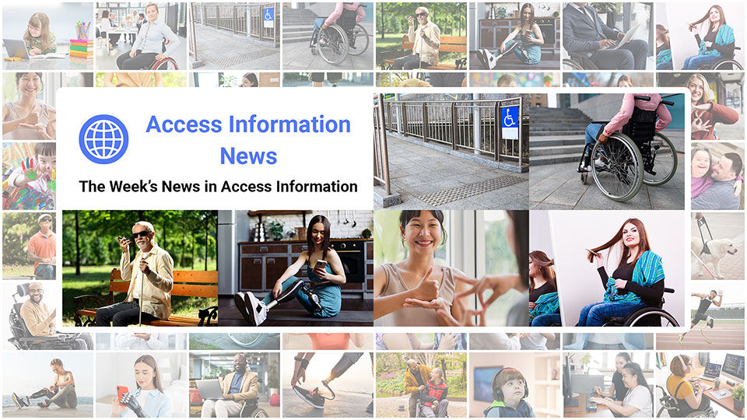
 |  |  |  |  |  |  |  |  |  |  |  | 
Access Information News for Monday, August 25, 2025 - Volume 1029
♿️ The Week's News in Access Information
Access Information News. The world's #1 online resource for current news and trends in access information.
A Mind Vault Solutions, Ltd. Publication
Subscribers: 40,648 🔢️ opt-in subscribers were sent this issue via email.

Sponsors 🏅️
 | 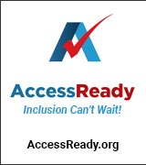 | 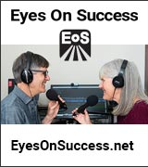 | 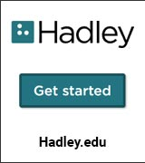 |  | 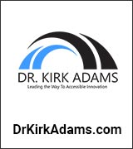
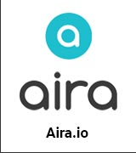 |  |  | 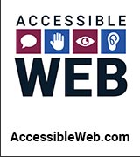 | 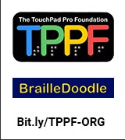 | 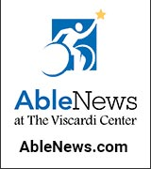
 |  |  |  |  | 

Access Awareness: Updates That Matter ♿️
VA Reducing Rating for Disability Compensation Benefits Why And What You Should Do Protect Yourself | Veterans InfoTap | August 19, 2025
VA rating reduction means the Department of Veterans Affairs proposes to lower a veteran's disability rating, potentially reducing their monthly compensation. If a reduction is proposed, the VA must notify the veteran with a proposal letter, providing 60 days to submit evidence and potentially request a hearing.

This Week's Featured Advertisement 🎯️
Would Your Product, Service or Message Benefit From Reaching Over 40,000 Access-Specific Readers Each Week? Join Access Information News as a Sponsor Today.

Join Access Information News as a Sponsor today and begin reaching over 40,000 access information readers each week, all while supporting the ongoing distribution of Access Information News for those very same readers. Only $200 / month.
Key Newsletter Statistics:
- Subscribers: 40,000 + per week and growing.
- Open Rate: 47% (Average. Last 12 months.)
- Click Rate: 34% (Average. Last 12 months.)
- Bounce Rate: 1.2% (Average. Last 12 months.)
- Ad CTRs: 2-12% (Average. Last 12 months.)
Benefits All Sponsors Receive:
- One (1) Sponsor Profile on the Access Information News website.
- One (1) Sponsor Profile in each weekly newsletter.
- One (1) Sponsor Wall Brand Advertisement on the Access Information News home page.
- One (1) Sponsor Wall Brand Advertisement in each weekly newsletter.
- One (1) Classified Advertisement in each weekly newsletter.
- 50% Discount on all Sponsored News Article Advertisements.
- Free link tracking.
- Permanent SEO benefits.
- Gratitude from over 40,000 access information subscribers for keeping Access Information News free to read.
With additional benefits for Sponsors that pay quarterly or annually. Learn more today.

News 📰️
👉 Submit a News Article for free here, with timing and placement determined by our editors.
👉 Submit a Sponsored News Article here, with timing and placement determined by you.

1.) Top 5 Most Clicked News Articles From Last Week 📊️
A.) Reacting To People Faking Their Disability? | Molly Burke | YouTube.com | August 15, 2025
Here, Molly Burke reflects on the ableism behind widespread accusations that disabled people are faking their conditions, emphasizing that while fraud exists, it is extremely rare compared to how often the media and public speculate about it. She critiques sensationalized news reports that encourage suspicion of disabled individuals, arguing that such coverage harms the broader community by reinforcing stereotypes and misunderstanding the spectrum of disability. Using examples ranging from veterans' benefits fraud to a Twitch streamer accused of faking paralysis, and even a blind man caught driving, she highlights how ableist assumptions, like believing blind people can't read, or wheelchair users can't stand, fuel harmful narratives. Burke insists that most disabled creators are genuine, not seeking "clout," and that society should lead with empathy and the benefit of the doubt rather than suspicion.
B.) Social Security Administration Adds 13 More Medical Conditions To Expedited Benefits List | PhillyBurbs.com | August 14, 2025
The Social Security Administration has expanded its Compassionate Allowances list, enabling applicants with 13 additional serious medical conditions to access expedited disability benefits processing.
C.) How Much Should You Spend On Accessibility? | KarlGroves.com | August 14, 2025
Determining an appropriate budget for digital accessibility is a strategic necessity for businesses, reflecting its emergence as a key compliance obligation alongside regulations like the ADA and GDPR. Organizations should consider allocating 5%—10% of their compliance budget to accessibility to mitigate risks and enhance inclusivity.
D.) We Are Not One Thing: Intersectionality Through a Disability Inclusion Lens | Dr. Kirk Adams | August 18, 2025
Inclusion fails when it's built for one story at a time. Real people live at intersections. Race, gender, disability, class, identity, all at once. And yet, most systems are built to see just one. Disability is everywhere. It cuts across every community, every culture, every conversation about equity. But too often, it's left out or treated as a single-issue checkbox. August is Intersectionality Awareness Month. This is the time to shift that frame.
E.) Leisure Activities When Blind | Ed Henkler | TheBlindGuide.com | August 13, 2025
Thriving with disabilities is so much more than performing ADL's (activities for daily living) like cooking and cleaning. Or even finding employment. Thriving with disabilities means you can do whatever you want. Previous posts have focused on thriving with sports, as an athlete and as a spectator. But how about video games?
August 25, 2025 📅️
2.) Sponsorship Packages Available | AccessInformationNews.com | August 25, 2025
Would your product, service or message benefit from reaching over 40,000 access information readers each week? For just $200 / month? If you're thinking yes, we invite you to try a Sponsorship Package with Access Information News. The benefits are amazing and the traffic delivered to your properties each week is measurable. No obligation. Cancel anytime.
3.) One Time Advertisements Available | AccessInformationNews.com | August 25, 2025
One time advertisements are available to anyone, with or without a Sponsorship. Would your product, service or message benefit from reaching over 40,000 access information subscribers? If you're thinking yes, please check out our one time advertising options. They are cost-effective, targeted and measurable. Scheduling is optional. Learn more today.
4.) Premium Subscribers | AccessInformationNews.com | August 25, 2025
Next Issue: Premium Subscribers will receive their 10th issue of the Top 60 Most Clicked News Articles for April, May and June of 2025 on Monday, July 7, 2025. Back Issues: There are currently 9 back issues available. Premium Subscribers are entitled to all back issues, anytime they sign up. All available back issues will be sent to you via email within 24 hours of purchasing your subscription. Please Join Us: If you would like to receive a perfectly formatted and searchable Word Document with each of the Top 60 Most Clicked News Articles of the last 3 months listed neatly within it, please consider joining us today for just $1 a month.
5.) Sponsored News Articles | AccessInformationNews.com | August 25, 2025
Use Sponsored News Articles to reach the access community when you need to. Whether you are a current Sponsor or not. Drive traffic to your access product and service announcements, events, updates or fundraisers using this incredibly cost-effective and easy-to-use advertisement tool. Learn more today.
6.) Do You Have A Link In This Issue? Learn How To Track It For Free | AccessInformationNews.com | August 25, 2025
This article will outline, step-by-step, how you can get free website traffic reporting on any link to your domain (AKA domain name, website or web address) that has been published by Access Information News since January 22, 2024, when we launched this feature.
August 24, 2025 📅️
7.) Podcast: "Not Butterflies And Rainbows. This Is Hard Stuff." | Hadley | Insights & Sound Bites | August 24, 2025
Nikki has lost her vision due to a rare autoimmune disease. While she appreciates positive bits of advice and encouragement, she also stays grounded in the struggles she's facing and knows others do, too. She's feeling the loss.
August 22, 2025 📅️
8.) How Some Canadian Government Departments Are Using Work Arounds | World-Renowned Blind Advocate Donna J. Jodhan | BarrierFreeCanada.org | August 22, 2025
Here Donna Jodhan critiques the practices of some Canadian government departments that use workarounds to meet consultation requirements of the Accessible Canada Act without truly valuing the input of persons with disabilities. She highlights issues of exploitation, urging departments to provide compensation for expertise rather than asking for free labor.
August 21, 2025 📅️
9.) Higher Rates Of Loneliness Persist Among Working-Age Adults With Disabilities, Study Finds | Sph.brown.edu | August 21, 2025
A Brown University study found that nearly one third of working-age adults with disabilities report persistent loneliness, with about two thirds experiencing severe isolation regardless of disability type.
10.) Wisconsin To Compensate Workers With Disabilities For Wrongfully Denied Unemployment Claims | WisconsinWatch.org | August 21, 2025
A federal judge ordered Wisconsin to compensate disabled workers denied unemployment benefits under a discriminatory 2013 law, potentially affecting thousands of claims as the state reprocesses a decade of denials.
11.) What It Means To Have A Woman In A Wheelchair Featured On U.S. Currency | 19thNews.org | August 21, 2025
Stacey Park Milbern, a disability justice co-founder, has become the first woman in a wheelchair depicted on U.S. currency with her image on a new quarter, celebrated at the Smithsonian by nearly 100 advocates, family, and friends.
12.) Australia: Interim Report Suggests Queensland Opt Out Of Building Accessibility Requirements | ABC.net.au | August 21, 2025
An interim report recommends Queensland opt out of new accessibility codes, raising concern among advocates like Jamie-Lee Dwyer, who describes her experience in a group home as restrictive and dehumanizing due to a lack of accessible housing options.
13.) Canada: First-Of-Its-Kind Role To Advance Accessibility In Canadian Screen Industry | PentictonHerald.ca | August 21, 2025
A new initiative from the Disability Screen Office and the National Screen Institute will introduce accessibility professionals on film and TV sets to eliminate barriers, with the goal of integrating the role industry-wide in collaboration with key stakeholders.
14.) Canada: Winnipeg Accessibility Advocate Creates Website In Support Of Manitobans With Disabilities | CTVNews.ca | August 21, 2025
George Loewen, an incomplete quadriplegic after a mountain bike accident, has launched a website to support Manitobans with disabilities, sharing his journey of resilience and encouraging others to explore what is still possible post-injury.
August 20, 2025 📅️
15.) The Adaptation Advantage: Rich And Brittany Palmer's First-Money-In Play For Disability Innovation | DrKirkAdams.com | August 20, 2025
The biggest “emerging market” isn't on a map; it's the global disability community, and the hundreds of millions more who benefit when design removes friction. In my work with founders and employers, the first barrier isn't ingenuity or technical feasibility; it's the early capital that turns validated need into product and revenue. Adaptation Ventures, led by Rich and Brittany Palmer, was built to close that gap for disability-forward startups. My thesis is simple: when first checks meet first-rate operators, disability innovation stops being “niche” and starts compounding into mainstream performance.
16.) August Newsletter | National Deaf Center | August 20, 2025
From new resources to campus visits and everything in between, check out what's happening at the National Deaf Center and all the ways you can access support and information.
17.) Apple's New Ad Puts Parkinson's Patients Behind The Camera | AdWeek.com | August 20, 2025
Apple's latest campaign, 'No Frame Missed,' showcases the iPhone 16 Pro's accessibility tools, enabling people with Parkinson's disease to record steady video despite tremors. The documentary-style film highlights how Action Mode and Voice Control restore creative independence.
18.) Kwik Trip To Pay Former Employee $35k To Settle Disability Discrimination Complaint | WPR.org | August 20, 2025
Kwik Trip agreed to pay $35,000 to resolve a federal disability discrimination case after mismanaging an employee's request for workplace accommodations. The EEOC found the chain reduced her hours drastically, forcing her to resign.
19.) Florida Will Phase Out Certificates Of Completion For Students With Disabilities | CFPublic.org | August 20, 2025
The Florida Board of Education voted to end certificates of completion for students with disabilities, eliminating an option for those unable to meet diploma requirements. Starting this year, students who cannot earn a diploma will graduate without formal recognition.
20.) UK: 77 Percent Of Disabled People Say Venue Websites Provide Confusing Or Inaccurate Details | ATToday.co.uk | August 20, 2025
Research by Euan's Guide shows that the majority of disabled people face significant frustration due to poor accessibility information on venue websites, often leading to cancelled or disappointing trips.
21.) UK: MND Left Her Without A Voice. Eight Seconds Of Scratchy Audio Gave It Back To Her | BBC.com | August 20, 2025
AI technology has restored Sarah Ezekiel's voice—lost for 25 years to motor neurone disease—by reconstructing it from just eight seconds of old audio, allowing her children to finally hear her real voice.
August 19, 2025 📅️
22.) It's Legal To Pay Disabled People Less Than Minimum Wage? (Let's Talk "Mission Washing") | Molly Burke | Molly Burke | YouTube.com | August 19, 2025
Molly Burke addresses the controversial topic of wage disparities for disabled individuals, exploring the implications of "mission washing" in employment practices. Join the conversation around advocacy, rights, and the need for fair treatment in the workforce.
23.) From The American Council Of The Blind: Share Your Stories About Inaccessible Websites | ACB.org | August 19, 2025
The American Council of the Blind is urging individuals to share their personal experiences with inaccessible websites and apps, which will be presented to Congress as part of ongoing advocacy for the Websites and Software Applications Accessibility Act. Stories highlighting local, district-based websites as well as nationwide platforms are especially encouraged to strengthen legislative discussions.
24.) 'Anyone Can Become Impaired': Adaptive Program At Lake Loramie Makes Recreation Accessible | WYSO.org | August 19, 2025
A volunteer-led initiative at Lake Loramie State Park is making outdoor recreation accessible through activities such as modified pontoon boat rides. The Family Adaptive program supports people with mobility and cognitive disabilities, helping ensure inclusive experiences in nature.
25.) Students With Disabilities Can More Quickly Be Removed From Class Under A New Tennessee Rule | ChalkBeat.org | August 19, 2025
Tennessee's Board of Education approved a rule allowing schools to remove students with disabilities from classrooms more quickly, even before a formal behavioral assessment is completed. The change alters protections previously required under federal special education law.
26.) Deadline Nears For State And Local Governments To Meet ADA Digital Accessibility Standards | ABC12.com | August 19, 2025
State and local governments face looming deadlines to comply with ADA digital accessibility standards, with larger municipalities required by April 2026 and smaller ones by April 2027. Michigan experts emphasize the need for captioning and accessible content to support people with disabilities.
27.) Settlement Mandates Montana Provide Education To Students With Disabilities Up To Age 22 | MontanaFreePress.org | August 19, 2025
A federal court settlement requires Montana to extend public education to students with disabilities until age 22, aligning the state with national practices. The agreement mandates re-enrollment opportunities for students who graduated without a diploma in 2025.
28.) Australia: Two Years After Royal Commission, New Report Finds No Progress For Students With Disability | EducationHQ.com | August 19, 2025
A new report reveals that systemic failures in Australia's education system persist for students with disabilities, including widespread exclusion, ineffective support plans, and a lack of trained educators, despite previous royal commission findings.
29.) Disability:in August Digital Accessibility Roundup | DisabilityIN.org | August 19, 2025
Disability:IN highlights recent updates and resources in digital accessibility, offering insights, best practices, and news to help organizations build more inclusive digital environments. The roundup provides tools and strategies to advance accessibility initiatives across industries.
August 18, 2025 📅️
30.) Podcasts By Dr. Kirk Adams: Interview with Rich and Brittany Palmer, Managing Partners, Adaptation Ventures | DrKirkAdams.com | August 18, 2025
In this engaging episode, Dr. Kirk Adams sits down with Rich and Brittany Palmer — Managing Partners of Adaptation Ventures — to trace the personal and entrepreneurial paths that led them to launch an angel, member-based fund focused on disability innovation. Brittany, a bilateral below-elbow amputee, shares how early prosthetics, supportive parents, and careers spanning environmental law and global consulting shaped her founder lens; when she built Beeyonder, a live virtual-tour startup for people with limited mobility, she ran into investors who mislabeled the opportunity as “niche,” a pattern she later saw across disability-tech. Rich recounts a winding route from RPI to Wall Street to startups, a life-threatening brain aneurysm at 28, and a reset at Babson that culminated in building and exiting an AI-for-philanthropy company — followed by leading one of the nation's largest angel groups and testifying to Congress about early-stage capital.
31.) Aging 1930s Boardwalk, Lack Of Elevators A US Open Nightmare For Disabled Tennis Fans | StreetsBlog.org | August 18, 2025
With no elevators at Mets-Willets Point subway and LIRR stations, disabled fans attending the U.S. Open face major accessibility barriers, navigating outdated infrastructure and limited ramp access that complicates travel to the tennis complex.
32.) After Life-Changing Diagnosis, Mendocino Woman Builds Community Through Accessible Walks | MendoVoice.com | August 18, 2025
Mendocino resident Leslie Krongold, living with a progressive neuromuscular condition, created Leslie's Accessible Walks to bring people together through scenic, inclusive group strolls designed for those with mobility challenges.
33.) Range Sued For Disability Discrimination, Retaliation By CEO's Ex-Assistant | HollywoodReporter.com | August 18, 2025
Former Range Media Partners executive assistant Michele Solis has filed a lawsuit alleging disability discrimination, retaliation, and wrongful termination after being pressured to accept a demotion or face firing when requesting medical leave.
34.) Trump's Promise To End Vote-By-Mail Is Yet Another Attack On Disabled Voters | MotherJones.com | August 18, 2025
President Trump announced plans to eliminate mail-in ballots through an executive order, a move critics warn would disproportionately harm disabled voters who rely on accessible voting options. The announcement followed a meeting with Vladimir Putin, who reportedly told Trump that mail-in voting rigged U.S. elections.
35.) Ed Department Preparing To Cut Millions In Special Education Funding, Advocates Warn | DisabilityScoop.com | August 18, 2025
Advocates warn the U.S. Department of Education may cancel hundreds of grants under the Individuals with Disabilities Education Act, potentially cutting hundreds of millions of dollars in funding for programs that support students with disabilities and their families.
36.) Improving ADA Compliance In The Built Environment With GIS, AI | GovTech.com | August 18, 2025
Cities are turning to GIS and AI technologies to improve accessibility and comply with a 2026 federal mandate. These tools help identify needs for infrastructure investments such as accessible sidewalks and curb ramps, offering benefits that extend to the wider public.
37.) Merit + Inclusion, Measurable Results: Why I'm Partnering with DIRC25 (Twice) on October 30, 2025 | DrKirkAdams.com | August 18, 2025
DEI is loud; outcomes are quiet. Too often, “merit” gets wielded as a shield while “inclusion” is waved off as a slogan. I'm partnering with DIRC25 twice, once as Innovative Impact and once as Dr. Kirk Adams, because this forum treats inclusion as a system you can build and merit as performance you can measure. The agenda focuses on practice over platitudes, aligning with how I work: supervisors as force multipliers, accessible tools as non-negotiables, and process changes that show up in hiring, productivity, and retention.
38.) UK: 'Video Calls Would Make 999 Service More Inclusive' | BBC.com | August 18, 2025
Daniel Burton, an autistic student from East Sussex, is advocating for video integration in 999 calls to improve accessibility for individuals who have difficulty communicating by phone, citing his own challenges during emergencies.
39.) UK: Waiting For The Bailiffs But Nowhere To Go: Sharp Rise In Disabled People Facing Homelessness | Sky.com | August 18, 2025
Disabled individuals like Chrystal Hendry, who has spinal muscular atrophy, are increasingly at risk of homelessness in the UK due to the scarcity of accessible housing and essential support services.
Last Week 📅️
40.) Beyond Parity: The Case For True Accessibility Affordances | Medium.com | August 17, 2025
The article advocates for the need to create powerful accessibility affordances beyond mere parity in digital experiences for blind users. It emphasizes the importance of unique capabilities that enhance usability, particularly highlighting shortcomings across different operating systems and devices in providing efficiency and respect for non-sighted users.
41.) Digital Transition: A Wake-Up Call For Inclusive Design | AbilityNet.org.uk | August 17, 2025
The BBC's report highlights the challenges faced by over 10 million UK adults who lack basic digital skills, particularly among older and disabled individuals. It underscores the importance of inclusive design to prevent further digital exclusion as services shift online, advocating that equal access to technology is a fundamental right.
42.) UK: How Sports Clubs Are Boosting Accessibility | BBC.com | August 17, 2025
Cornwall's sporting community is being recognized for inclusive initiatives across disability cricket, golf, and mental health-focused football, with nominees celebrated in the BBC Radio Cornwall Make a Difference Awards 2025.
43.) UK: Meet The Acrobat Making Aerial Skills Accessible | BBC.com | August 16, 2025
Adele Cliffe of Kinetic Heights CIC is making circus arts inclusive by offering free, accessible workshops led by instructors with disabilities and neurodivergence, aiming to support marginalized communities through performance skills.
44.) New Zealand: Funding For Disability Sport Is At Risk - And Willow's Story Shows Why It Matters | Stuff.co.nz | August 15, 2025
Eight-year-old Willow, who has cerebral palsy, gained confidence and acceptance after connecting with Paralympian Lisa Adams and delivering a moving speech at school, underscoring the importance of disability sport funding and inclusion.
45.) UK: Wheelchair User Hails M&S Changes After Access Row | BBC.com | August 15, 2025
Following a discrimination case, Marks & Spencer has revised store layouts to improve accessibility for wheelchair users, earning praise from campaigner Flick Williams for addressing barriers caused by fridge doors and wire racks.
46.) Missouri Doctoral Student Takes On Fashion Accessibility For Blind People | KOMU.com | August 14, 2025
Doctoral student Emma Nicoson, who has been passionate about fashion since childhood, is working to make the fashion industry more accessible for blind individuals, building on her lifelong love for design and inclusive practices.
47.) Australia: Disability Advocates Want More Alice Springs Transport Options After Dark | ABC.net.au | August 14, 2025
People with disabilities in Alice Springs face isolation due to a lack of accessible transport after 8pm, leaving many unable to participate in community life or attend late commitments like SES volunteer work.
48.) Ben's Beans Serves Up Community For Adults With Disabilities | Patch.com | August 12, 2025
Nearly a year after opening, Ben's Beans in Westborough has become a hub for community connection while providing vocational training and employment opportunities for adults with intellectual and developmental disabilities through the Post 22 program.
49.) True Disability Inclusion Requires Planning for the Unexpected | Buttondown.com | August 9, 2025
Effective disability inclusion requires careful planning and implementation beyond mere physical accessibility tools. Organizations must anticipate potential failures and ensure that systems function properly, even during unforeseen circumstances, to truly serve all individuals effectively.
50.) Rebuilding Graphs For Accessibility: Inside Khan Academy's Inclusive Design | Blog.KhanAcademy.org | August 8, 2025
Khan Academy has made significant improvements to the accessibility of its graphing exercises, ensuring that learners with disabilities can successfully interact with these tools. The update involves visual enhancements, keyboard navigability, and screen reader compatibility, allowing all students to engage equally in mathematical tasks.
51.) Types Of Accessibility Push Back | ChrisYoong.com | August 8, 2025
The piece outlines common types of pushback encountered in advocating for accessibility in organizations, emphasizing the negative impacts of such objections on inclusion efforts. It highlights the importance of engaging with established accessibility standards and integrating accessibility into processes from the start.
52.) Avoiding The Word “Help” | Yatil.net | August 8, 2025
Eric Eggert addresses the implications of using the word "help."
53.) Internet Archive Designated As A Federal Depository Library | Archive.org | July 24, 2025
The Internet Archive has been designated as a federal depository library, enhancing access to government publications. Senator Alex Padilla highlighted its digital-first approach and commitment to universal access to knowledge, supported by Internet Archive founder Brewster Kahle's emphasis on integrating government materials into the digital ecosystem.

Featured Events 📅️
👉 Submit your event for consideration within this section here.

August 25, 2025 | Join Selvas BLV At This Upcoming Webinar | Selvas BLV
5PM PT, 6PM MT, 7PM CT, 8PM ET, 1AM GMT
Selvas BLV's Earle Harrison and Hims' Jenny Axler showcase the newest features of the BrailleSense 6 Android tablet and Braille eMotion smart display during this free, one-hour evening webinar.
August 25, 2024 | Tek Talk Presentation | Selvas BLV
5:00 PM PT, 6:00 PM MT, 7:00 PM CT, 8:00 PM ET, 12:00 AM GMT
In this online session hosted by Selvas BLV, Earle Harrison and Jenny Axler will showcase the latest innovations in braille technology, highlighting new features of the BrailleSense 6 Android tablet and the Braille eMotion smart braille display.
August 26, 2025, 2024 | ADA Title II: What Public Entities Need To Know About Digital Accessibility | TPGI And 3Play Media
9:00 AM PT, 10:00 AM MT, 11:00 AM CT, 12:00 PM ET, 4:00 PM GMT
David Sloan, Chief Accessibility Officer at Vispero, and Erik Ducker, Senior Director of Product Marketing at 3Play Media, share insights on ADA Title II compliance for public entities. This session offers a plain-language guide to understanding requirements, building an actionable compliance roadmap, and adopting tools and strategies to make digital content fully accessible.
August 27, 2025 | Outlook With JAWS: Custom Rules And Signature Creation (Assistive Technology Webinar) | Access Ingenuity
10:00 AM PT, 11:00 AM MT, 12:00 PM CT, 1:00 PM ET, 5:00 PM GMT
Assistive Technology Specialists Mark Schaffer and Ian Ramos explain how to enhance email workflows using JAWS and Microsoft Outlook, covering custom rules, email management techniques, and creating professional signatures.
August 28, 2025 | Supercharge Your Bottom Line Through Disability Inclusion Webinar: From Rocket Science To Inclusion Science: Paolo Gaudiano's Data-Driven Path To Disability ROI | Dr. Kirk Adams
11AM PT, 12PM MT, 1PM CT, 2PM ET, 6PM GMT
In this live webinar, Dr. Kirk Adams and Paolo Gaudiano of Aleria demonstrate how data-driven tools like the Inclusion Impact Calculator can expose the hidden costs of exclusion and reveal measurable returns from disability inclusion, offering leaders clear, actionable steps to drive competitive advantage through evidence-based workplace equity.
August 28, 2024 | NFB Sponsor Virtual Seminar | Selvas BLV
2:00 PM PT, 3:00 PM MT, 4:00 PM CT, 5:00 PM ET, 9:00 PM GMT
Selvas BLV's Earle Harrison will present an in-depth look at the BrailleSense 6, BrailleSense 6 Mini, Braille eMotion, and SensePlayer, with live demonstrations and expert tips to maximize use of these advanced devices.
August 28, 2025 | Selvas BLV Product Overview | Selvas BLV
3:00 PM PT, 4:00 PM MT, 5:00 PM CT, 6:00 PM ET, 10:00 PM GMT
Earle Harrison and Antonio Guimaraes provide an overview of SELVAS BLV's productivity tools, including Braille tablets, Braille displays, and multimedia devices designed for seamless use and accessibility.
September 16-17, 2025 | The Deaf And Hard Of Hearing Accessible Technology's State Of Science Conference | Gallaudet University's Technology Access Program
6:00 AM PT, 7:00 AM MT, 8:00 AM CT, 9:00 AM ET, 1:00 PM GMT
In this two-day hybrid gathering, Gallaudet University's Technology Access Program showcases cutting-edge research on caption quality, hearing-technology accessibility and sign-language innovation, featuring keynotes, breakout discussions and student presentations aimed at advancing equitable communication tools for the Deaf and Hard of Hearing community.
September 20, 2025 | Disability Strong Virtual Conference: Building Change | Disability Strong Virtual Conference
1:00 PM PT, 2:00 PM MT, 3:00 PM CT, 4:00 PM ET, 8:00 PM GMT
Disability advocate and civic leader Nico Meyering shares his lived experience with orphan disease and navigating inaccessible systems toward impactful leadership. Drawing from his work in reshaping civic institutions, Nico offers practical insights on building power, forging coalitions, and creating inclusive spaces where Disabled people lead, thrive, and belong.
September 21, 2025 | Disability Strong Virtual Conference: From Trauma To Healing & Intersectionality Of Race And Disability | Disability Strong Virtual Conference
9:00 AM PT, 10:00 AM MT, 11:00 AM CT, 12:00 PM ET, 4:00 PM GMT & 1:00 PM PT, 2:00 PM MT, 3:00 PM CT, 4:00 PM ET, 8:00 PM GMT
Nicole Demos shares her personal journey of trauma and healing in Finland, highlighting the importance of self-care, advocacy, and safe spaces. Later, Nancy Williams-Nettles examines how racism and ableism intersect, creating unique challenges for people of color with disabilities, and explores ways to foster inclusive, justice-driven approaches.
September 22, 2025 | Disability Strong Virtual Conference: Civic Engagement, Policymaking, And Advocacy Panel | Disability Strong Virtual Conference
4:00 PM PT, 5:00 PM MT, 6:00 PM CT, 7:00 PM ET, 11:00 PM GMT
Panelists Nico Meyering, Nancy Williams-Nettles, and Jesse Schwartzman discuss practical ways to engage in community advocacy, both politically and non-politically. They share strategies for using personal experiences to drive change and highlight the power of active participation in shaping more inclusive communities.
September 22, 2025 | Twenty-Sixth Audio Description Institute | American Council Of The Blind
1:00 PM PT, 2:00 PM MT, 3:00 PM CT, 4:00 PM ET, 8:00 PM GMT
Led by Dr. Joel Snyder, this five-day virtual training from the American Council of the Blind offers an in-depth introduction to the theory, techniques, and applications of audio description. Attendees will gain practical skills through lectures, discussions, and collaborative sessions, and receive a certificate of completion along with a training manual.
September 23, 2025 | Disability Strong Virtual Conference: Using Inclusive Language / How To Be An Ally | Disability Strong Virtual Conference
5:00 PM PT, 6:00 PM MT, 7:00 PM CT, 8:00 PM ET, 12:00 AM GMT
Nicole Demos guides participants through strategies for fostering belonging, equity, and empathy by using inclusive language and practicing genuine allyship. Attendees will explore how words and actions can work together to make accessibility and inclusivity an everyday reality.
September 24, 2025 | Disability Strong Virtual Conference: How Violence And Disability Converge | Disability Strong Virtual Conference
5:00 PM PT, 6:00 PM MT, 7:00 PM CT, 8:00 PM ET, 12:00 AM GMT
Margaux Sorenson examines how violence disproportionately impacts people with disabilities, the systemic barriers to reporting, and the historical roots of ableism. The session highlights advocacy efforts centering disabled survivors and explores ways to promote safety, equity, and justice for all.
September 27, 2025 | NJCB Virtual Convention: The Grassroots Revival | New Jersey Council Of The Blind
9:00 AM PT, 10:00 AM MT, 11:00 AM CT, 12:00 PM ET, 4:00 PM GMT
The New Jersey Council of the Blind presents its 2025 Virtual Convention, The Grassroots Revival, bringing together expert speakers, live Q&A sessions, assistive technology demonstrations, and community engagement. Running for the first time in over 15 years, this online gathering highlights advocacy, access, and connection with presentations on adaptive living, accessible technology, healthcare, and independent living resources.
October 14, 2025 and October 15, 2025| Virtual Web Accessibility Training | WebAIM
9:00 AM PT, 10:00 AM MT, 11:00 AM CT, 12:00 PM ET, 4:00 PM GMT
In this two-day, expert-led online program from WebAIM, participants will learn essential and advanced web accessibility practices to ensure compliance with international guidelines and legal requirements. Designed for developers, designers, and accessibility professionals, the training covers WCAG principles, assistive technology use, inclusive design for various disabilities, evaluation techniques, and offers a complimentary document accessibility course.
November 15, 2025 | International Neurology Conference 2025 | PubScholars Group
12:00 AM PT, 1:00 AM MT, 2:00 AM CT, 3:00 AM ET, 8:00 AM GMT
The International Neurology Conference 2025 is a flagship hybrid event hosted by PubScholars Group on November 15-16, 2025, at the Hard Rock Hotel at Universal Orlando (5800 Universal Blvd, Orlando, FL) and streamed online. The conference explores "Mind-Brain Connection: Understanding Neuroscience through Mental Health," aiming to integrate cutting-edge science with clinical relevance. Who Should Attend: Neurologists, neurosurgeons, neuroscientists, psychologists, rehabilitation professionals, engineers, industry leaders, students, and allied health practitioners. Important Dates & times: Abstract Submission Deadline: September 15, 2025. Registration Deadline: September 30, 2025. Event Timing: November 15, 2025 (8 AM start) - November 16, 2025 (6 PM close). Format: Hybrid Event (In-person & Virtual. Contact Person: Richard A. Email: info@pubscholars.org 📧️. Phone: +91 7042134266 📱️. Venue: Hard Rock Hotel at Universal Orlando, 5800 Universal Blvd, Orlando, FL 32819, USA.
May 21, 2026 | Tech Blitz 2026: Assistive Technology Showcase Brings Together Blind, Deafblind, And Low Vision Community For Innovation, Discovery, And Connection. | Helen Keller Services
3:00 PM PT, 4:00 PM MT, 5:00 PM CT, 6:00 PM ET, 11:00 PM GMT
In this in-person showcase hosted by Helen Keller Services, assistive technology vendors, innovators, and users come together for a day of interactive demonstrations, in-depth discussions, and community connection focused on advancing access and independence for the blind, DeafBlind, and low vision communities.

Directories 📝️
1) Access Information Email Newsletter Directory | Submit

Sponsor Classified Ads 🎯️

⬆︎ 9.) Sponsor: Magnifiers & More

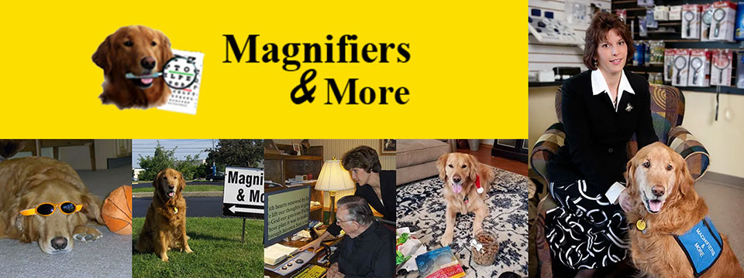
Sponsor Since: October 25, 2024 📅️
Website: https://www.magnifiersandmore.net 🌐️
Email: info@magnifiersandmore.net 📧️
Phone: (440) 946-3363 📱️
Fax: (440) 946-8899 📠️
Visit: 7775 Mentor Avenue, Mentor, Ohio 44060, USA
About: Magnifiers & More, established in 2002 by Deborah Kogler, is Northeast Ohio's only retail store dedicated to providing products and consultations for individuals with low vision, blindness, and vision disabilities. With over forty years of experience in eye care, Deborah founded the company to create a one-stop shop for vision aids, including specialized tools for managing conditions like macular degeneration, glaucoma, diabetic retinopathy, and cataracts.
The store offers a wide range of over seventy-five magnifiers, talking items, large print products, special lights, electronic aids, Braille items, glare control solutions and More.
A key figure in the company's story is Murphy, Deborah's Golden Retriever and original CEO, "Canine Executive Officer," who was the store's mascot and greeter for 15 years. Today, Jeffrey, another Golden Retriever trained as a service dog, serves as the CFO, "Canine Fun Officer," delighting customers and supporting Deborah.
Deborah's journey into vision rehabilitation was inspired by her grandmother's experience with macular degeneration, sparking her passion to make vision aids accessible. She continues to advocate for and educate those living with vision disabilities, both locally and internationally.
Magnifiers & More is committed to helping people improve their quality of life through practical solutions and compassionate support.

⬆︎ 8.) Sponsor: Innosearch.ai

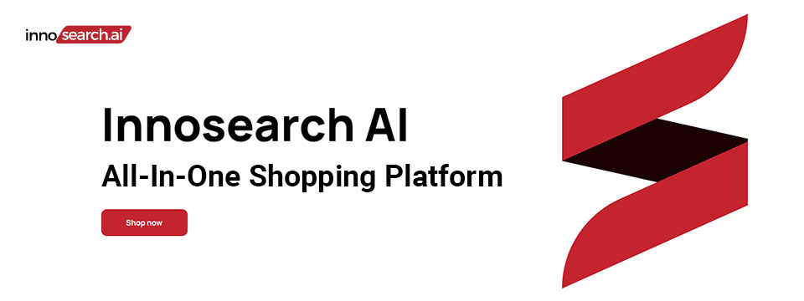
👉️ Classified Advertisement: Shop by Phone — No Screens, Just Your Voice!
Call 1-855-SHOP-GPT (1-855-746-7478)
Shopping online can be hard if you're blind, visually impaired, or not tech-savvy. That's why Innosearch AI created Shop by Phone — a 100% free, voice-only service.
Just call and say what you need:
👉 “Find me a phone charger.”
👉 “Add it to my cart.”
👉 “Check out.”
No apps, no websites — just easy, hands-free shopping from over 500,000 stores.
- ✔ Free to use
- ✔ Works anywhere, anytime
- ✔ Perfect for seniors, blind, and low-vision users
Available in:
- 🇬🇧 UK: +44 7727 247467 📱️
- 🇨🇦 Canada: +1 782 222 7467 📱️
- 🇦🇺 Australia: +61 489 267 467 📱️
- 🇺🇸 USA: 1-855-SHOP-GPT 📱️ (1-855-746-7478 📱️)
Call now and shop with ease!
Sponsor Since: October 15, 2024 📅️
Website: https://www.innosearch.ai 🌐️
Email: info@innosearch.ai 📧️
About: Innosearch is an all-in-one shopping platform augmented with a cutting-edge AI-powered shopping assistant. This innovative feature mimics the experience of shopping in real life by allowing you to interact with the assistant using natural language. It aggregates millions of products from top US online retailers, bringing them directly to you. With this advanced generative AI, Innosearch offers personalized product recommendations, highlights the best deals, and provides comprehensive information including reviews, total prices, shipping options, and more. Innosearch delivers a seamless end-to-end shopping experience, eliminating the need to search and browse in multiple tabs across retailers.
YouTube Review By Sam Seavey: https://youtube.com/watch?v=-rjL-HAwaZY.
Key Features: Key Features of the Innosearch All-in-One AI Shopping Platform include:
➜ Research Products: Easily compare products across retailers, or weigh pros and cons of similar products to make informed decisions.
➜ Uncover the Best Deals: Never miss a door buster, coupon, or clearance sale again. Get notified about the best prices and offers.
➜ AI Summarized Trusted Reviews: See what others are saying and make confident purchases.
➜ All in One: Innosearch brings millions of products from top online retailers directly to you, allowing you to shop the best deals with easy checkout and personalized AI assistance.
➜ Shop with Confidence: Rest assured, Innosearch has you covered with free shipping and returns on every purchase.
➜ Know Before You Buy: Innosearch equips you with expert buying guides, empowering you to make well-informed decisions.
How To Shop: Simply create a free account and start shopping today!

⬆︎ 7.) Sponsor: Aira

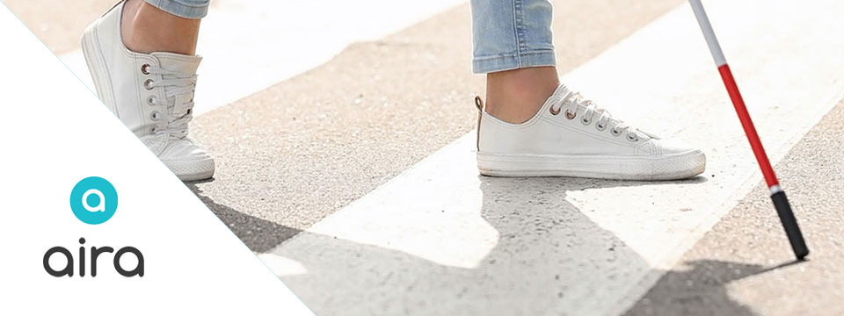
Sponsor Since: September 9, 2024 📅️
Website: https://aira.io/ 🌐️
Download the App: Apple App Store | Google Play Store
Plans and Pricing: https://aira.io/pricing/
Phone: NA: +1.800.835.1934 📱️ | AU: +1.800.765.096 📱️ | UK: +0.800.046.5668 📱️ | NZ: +1.800.425.451 📱️
Text Message: NA: +1.858.242.4457 📱️ | AU: +61.488.839.767 📱️ | UK: +44.149.320.2474 📱️
Email: support@aira.io 📧️
Social: Twitter | Facebook | LinkedIn | YouTube | Instagram
About: Aira's mission is to remove barriers and make the world more accessible with visual interpreting.
We provide a live, human-to-human professional assistance service, an accommodation or productivity tool, that enhances independence by delivering on-demand, skilled and reliable visual interpreting for just about any task. Using the powerful combination of a camera and the Aira app on someone's device of 'choice', a professionally-trained agent will assist by visually interpreting what is in the camera's view or on screen, from describing to reading, from explaining to navigating - just about anything, safely and securely. Aira supports a growing range of devices including smart and tactile button phones, desktop computers and soon, wearables.
Whether you are involved in the work of business, the work of school or the work of life, Aira enhances everyday efficiency, engagement, and independence. Used by employees and customers of hundreds of organizations including airports, banks, the largest software companies, financial firms, retailers and universities, we invite you to join the community, access the Aira app today and try it for free.
https://aira.io/download-and-try-it/
Step One: Subscribe and Download. Pick the plan that lets you explore on your terms and on your time, sign up in a few minutes, and download the Aira app to your smartphone. Plans shown are for the United States, Canada, Australia, New Zealand and the United Kingdom. Add or cancel at any time.
Step Two: Connect with an Aira Agent. On the first call, connect with one of our certified, specially-trained Agents and learn how everything works.
Step Three: Real-time Assistance. At the touch of a button, Aira delivers instant access to visual information, when and where you want it.

⬆︎ 6.) Sponsor: Dr. Kirk Adams

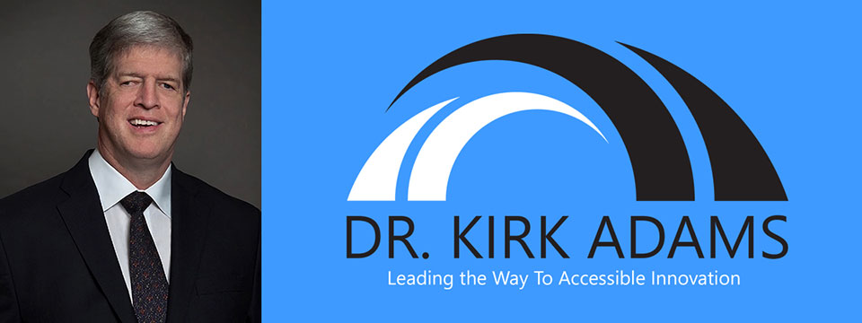
Sponsor Since: July 22, 2024 📅️
Website: https://drkirkadams.com 🌐️
About: Dr. Kirk Adams is a visionary leader, transformative speaker, and lifelong advocate for disability inclusion. With over three decades of experience in advancing accessibility and creating opportunities for individuals who are blind or low-vision, Dr. Adams has become a powerful force for change in the areas of leadership, accessibility, and inclusion. His journey — from navigating vision loss as a young child to becoming a recognized thought leader in disability empowerment — uniquely equips him to help organizations understand, integrate, and champion inclusive practices that benefit all.
Dr. Adams is a highly sought-after speaker, known for his engaging and thought-provoking keynotes on disability inclusion, accessible leadership, and the power of resilience. He has spoken at numerous national and international conferences, including corporate seminars, public policy forums, and industry events, where his personal story and professional insights have inspired leaders to rethink their approach to diversity, equity, and inclusion. His passion lies in empowering organizations to create environments where every individual — regardless of ability — can thrive.
As a speaker, Dr. Adams brings authenticity, warmth, and a depth of experience that resonates with audiences from all backgrounds. He understands that true leadership is about more than just policy; it's about creating cultural shifts that value each person's unique contributions. Whether he is addressing a Fortune 500 company, a non-profit, or a community group, Dr. Adams' message is clear: inclusion benefits everyone, and together we can build a world where opportunity is accessible to all.
Dr. Adams currently resides in Seattle, Washington, where he continues his advocacy work, builds strategic partnerships, and enjoys life with his family. He is proud to be a part of the movement towards a more inclusive future — one conversation at a time.

⬆︎ 5.) Sponsor: Barrier Free Canada

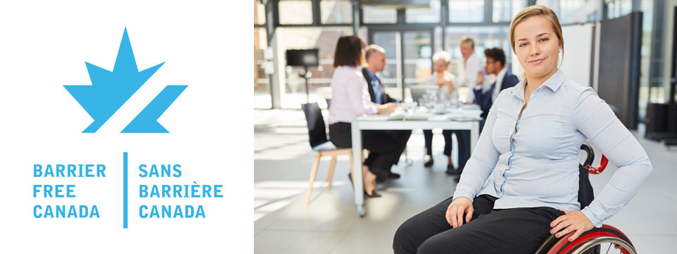
👉️ Classified Advertisement: Barrier Free Canada — Canada sans Barrières Announces Strategic Investment to Empower the Workforce of Tomorrow | Barrier Free Canada
Barrier Free Canada — Canada sans Barrières is proud to announce a bold new strategic investment aimed at advancing accessibility and inclusion in Canada's workforce. This initiative supports innovative training, education, and employment opportunities for persons with disabilities, helping to eliminate systemic barriers and foster a more equitable labor market. By partnering with key stakeholders across sectors, the investment will drive meaningful change, preparing a diverse and inclusive workforce to meet the challenges of tomorrow. This milestone reflects Barrier Free Canada's ongoing commitment to building a barrier-free nation where everyone can thrive and contribute fully to society.
Sponsor Since: November 10, 2023 📅️
Website: https://barrierfreecanada.org/ 🌐️
About: Barrier-Free Canada/Canada Sans Barrieres (BFC/CSB) advocates for the Canadian Parliament to enact a strong and effective Canadians with Disabilities Act (CDA) to achieve a barrier-free Canada for all persons with disabilities.
To this end, BFC/CSB is seeking endorsements from national disability organizations to build a non-partisan community coalition. BFC/CSB would also like to identify point persons from these organizations to act as key contacts.
The steering committee of BFC/CSB has drafted a set of principles concerning a CDA that are drawn from the principles that underpin the provincial disability legislation in Ontario and Manitoba. A CDA is not meant to replace provincial disability legislation. It will complement such legislation and benefit Canadians living in provinces with and without provincial disability legislation. At this point in time, CNIB, March of Dimes Canada, Canadian Hearing Society and MS Society of Canada have endorsed the BFC/CSB principles and confirmed their support for the movement to enact a CDA. There is no individual or organizational charge for membership in BFC/CSB.
Please contact Donna Jodhan, Founder of Barrier-Free Canada, at info@barrierfreecanada.org 📧️ with any questions or to express your organization's support and identify a key contact.
Social: Facebook | X (Formerly Twitter) | Mastodon (Search For: @news@mastodon.barrierfreecanada.org).

⬆︎ 4.) Sponsor: Hadley

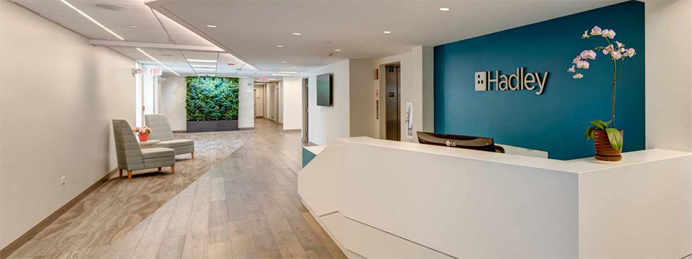
👉️ Classified Advertisement: New NVDA Workshops at Hadley | Hadley
Learn the basics of NVDA. From getting started with the program to customizing the speech to learning helpful shortcuts, Hadley's workshops have you covered.
Sponsor Since: September 18th 2023 📅️
Website: https://hadleyhelps.org/ 🌐️
Email: info@hadleyhelps.org 📧️
Phone: (800) 323-4238 📱️
Get Started: https://hadleyhelps.org/learn 🎓
What would you like to learn today?
Donate: https://hadleyhelps.org/donate/support-hadley ❤
A 501(c)(3) non-profit organization, Hadley relies on contributions from individuals, foundations, and corporations to fund its programs.
About: The mission of Hadley is to create personalized learning opportunities that empower adults with vision loss or blindness to thrive — at home, at work, and in their communities.
Founded in 1920 by William Hadley, an educator who lost his eyesight later in life, Hadley offers practical help, connection and support free of charge to anyone with a visual impairment, their families and professionals supporting them. With Hadley, you can discover new ways to do things that have become more difficult due to vision loss and connect with a network of peers who "get it." And you don't need to come to Hadley. Hadley's help comes to you; online, on the phone or through the mail.
Since relaunching in July 2020, more than 70,000 people have signed up with Hadley, registering more than 200,000 workshop interactions. And our workshops have 98% satisfaction ratings. We reach all 50 states and more than 100 countries. And more people learn braille from Hadley than from any other organization worldwide.
Hadley is a proud partner of the National Eye Institute and the National Eye Health Education Program.
Hadley's help conveniently meets learners where they are. Free of wait lists. Free of office visits. Free of charge.
Social: Facebook | X (Formerly Twitter) | YouTube

⬆︎ 3.) Sponsor: Eyes on Success

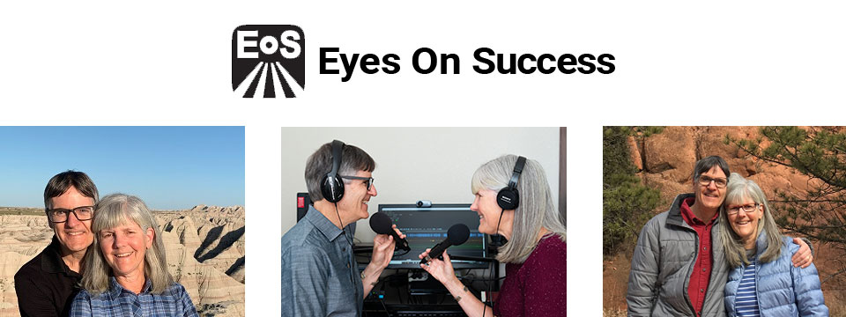
Sponsor Since: August 21, 2023 📅️
Website: https://www.eyesonsuccess.net/ 🌐️
About: This half-hour weekly podcast and radio program discusses products, services and daily living tips for people with vision loss. It is available through radio reading services across North America, via several internet streaming services, and to everyone else as a podcast. To date, the show has been downloaded in all 50 states in the US and over 100 other countries on all the inhabited continents. Eyes On Success is hosted and produced by Peter Torpey and Nancy Goodman Torpey.
Each episode is basically a success story. Some are human stories of visually impaired people's accomplishments in academics, employment, sports or pastimes. Others are descriptions of adaptive aids that enable visually impaired people to achieve things. These include screen readers, magnifiers, navigation aids, and others. In all cases, the focus is on success.
Eyes On Success has been airing weekly since January 2011. Prior to January 2013 the name of the show was ViewPoints. Other than the name, nothing has changed.
Listening To Eyes On Success
You can listen to Eyes On Success on your smart home device by saying “play the Eyes On Success podcast”, subscribe to the podcast wherever you get your podcasts, or listen on Apple Podcasts, iTunes, YouTube or your local radio reading service. Listeners can also follow the show on Facebook and X (Formerly Twitter).
Connecting with Eyes On Success
Email: To contact us with questions, comments or suggestions for future shows send an e-mail to hosts@EyesOnSuccess.net 📧️.
Weekly Announcements: If you would like to receive weekly announcements of upcoming episodes, you can join our low traffic "announcements only" list by sending an e-mail to: EyesOnSuccess+subscribe@GoogleGroups.com 📧️.
Email Forum: If you would like to connect with other listeners and share your thoughts about what you've heard on the show, you can join our listener email forum by sending an email to: EOS_Discuss+Subscribe@GoogleGroups.com 📧️

⬆︎ 2.) Sponsor: Access Ready, Inc.

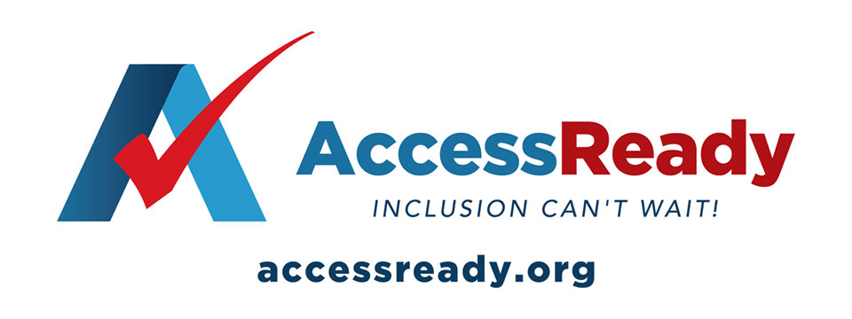
👉️ Classified Advertisement: Help Access Ready, Inc. Rebuild After Hurricanes Helene and Milton | Access Ready, Inc.
Help Access Ready, Inc. support people with disabilities after Hurricanes Helene and Milton.
Based in Saint Petersburg, Florida, Access Ready is committed to providing adaptive equipment, restoring independence and dignity to those affected. Many lost vital devices that help them communicate, work, and live independently.
Donations will go toward repairing or replacing this equipment, ensuring people can regain normalcy after the disaster. Every contribution directly aids recovery efforts.
Since 2018, Access Ready has promoted accessible technology, led by CEO Douglas George Towne.
Your support can make a real difference. Donate Now — be a lifeline for those in need.
info@accessready.org 📧️
+1 (727) 531-1000 📱️
Sponsor Since: December 1st 2022 📅️
Website: https://accessready.org/ 🌐️
Email: info@accessready.org 📧️
Phone: (727) 531-1000 📱️
About: Access Ready Inc. is a certified, 501(c)(3) nonprofit organization. The mission of Access Ready Inc., a nonprofit cross-disability rights advocacy organization, is to promote a policy of accessibility benefiting all people regardless of ability across information and communications technology utilized for two way communications.
The purpose of Access Ready Inc. is to educate the public and private sectors of the importance of accessible information and communications technology to the future of all people regardless of ability.
To support this education by developing initiatives that promote policies that ensure the creation and maintenance of accessible technologies utilized for two way communications at all levels which allow for easy use by people with the widest range of abilities possible.
To develop employment and business opportunities for people with disabilities that support its educational activities in the field of information and communications technology and related areas.
To provide consulting and educational services to buyers, developers, and users of information and communications technology that promotes its highest and best use in society.
To promote the concept of a technologically accessible society which fosters:
Freedom of expression, speech, and worship.
Freedom from fear, ignorance, and want.
Freedom from dishonesty, exclusion, and immorality.
Freedom of aspiration, invention, and inclusion.

⬆︎ 1.) Sponsor: Pneuma Solutions

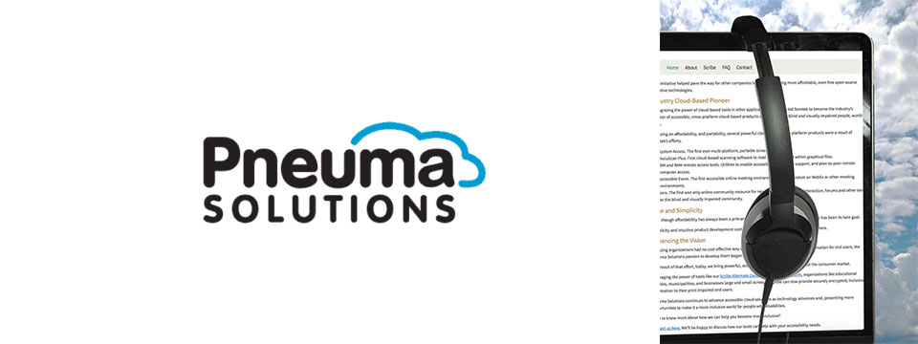
👉️ Classified Advertisement: From Now Through the 18th: Experience Unmatched Independence in the Field of Remote Desktop Access with a Remote Incident Manager Free for All! | Pneuma Solutions
As the United States finishes celebrating Independence Day, regular attendees of the summer blindness conventions will prepare to begin activities centered around independence for people who are blind or visually impaired. IN light of this, we at Pneuma Solutions are lighting our own fireworks over a very unique and never-before-seen level of independence in the field of remote desktop access!
To a technician or trainer who is blind, nothing says independence quite like performing a remote session with a sighted end user's computer, regardless of platform, and being able to fully use it, despite the lack of an installed screen reader. Our Remote Incident Manager is the world's first application that allows this to happen. As such, To celebrate this exciting level of independence, we are proud to offer unlimited access to Remote Incident Manager for the next 14 days, completely free of charge!
Sponsor Since: November 7th 2022 📅️
Website: https://pneumasolutions.com/ 🌐️
Email Newsletter: Click here to receive periodic news via email concerning Pneuma Solutions products for business, consumers and education.
Sales: (866) 202-0520 📱️
Support: (650) 249-1000 📱️
About: Backed by two decades of creating award-winning accessible cloud technologies for people with visual impairments, Pneuma Solutions is the global leader in accessible cloud-based solutions. Pneuma Solutions was founded by long-time accessibility developers Mike Calvo and Matt Campbell. For more information on their individual profiles, click on their respective bio pages. We're proud to be the first company to develop cloud-based accessibility at the network level. Our tools provide organizations, like yours, a way to deliver secure, accessible information right from your network or from our secure servers. You can provide your print disabled consumers, students, employees, and citizens with a multitude of accessible options. Additionally, we offer a suite of cloud-based applications to blind and print disabled consumers directly from our website. Our consumer products are designed to make the day-to-day lives of blind and print disabled individuals more accessible and simpler to manage. Access to information is not a privilege, it's a right. It's also your right to obtain affordable, accessible cloud solutions to serve your end user. When organizations like yours implement our tools, together we help make it a more inclusive world for people with disabilities. Want to know more about how we can help you become more inclusive?
Contact us here. We'll be happy to discuss how our tools can help with your accessibility needs.

⬆︎ 12.) Sponsor: Able News at The Viscardi Center

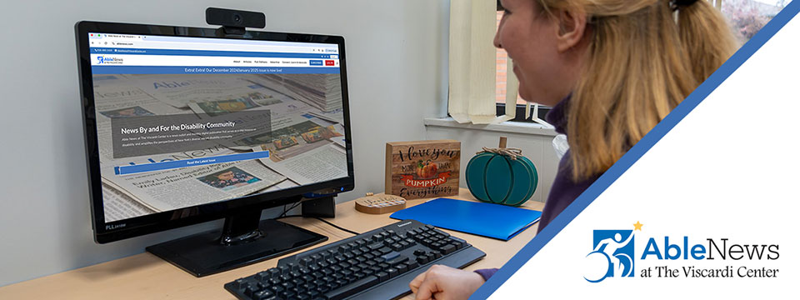
👉️ Classified Advertisement: Your Disability News Platform — Subscribe Now! Discounted Rate! | Able News at The Viscardi Center
Digital subscription just $15 a year with promo code ACCESS.
We share news for, by, and about people with disabilities. As a subscriber, you'll have 24/7 full access and be the first to read about news, community resources, culture, technology, advocacy, health/wellness, and stories from the disability community. You'll also receive our bi-weekly newsletter. Subscribe today!
Sponsor Since: July 4, 2025 📅️
Website: https://ablenews.com 🌐️
Email: ablenews@viscardicenter.org 📧️
Phone: +1 (516) 465-1416 📱️
About: Able News at The Viscardi Center is a news outlet and monthly digital publication that serves as a vital resource on disability and amplifies the perspectives of the diverse, vibrant disability community. The Viscardi Center is a Long Island-based network of non-profit organizations that educate, employ, and empower children, adults, and veterans with disabilities. Central to our mission is featuring original content by writers with disabilities on a range of important topics, from policy and legislative updates, to arts and culture, to community events.

⬆︎ 11.) Sponsor: The Touch Pad Pro Foundation / BrailleDoodle

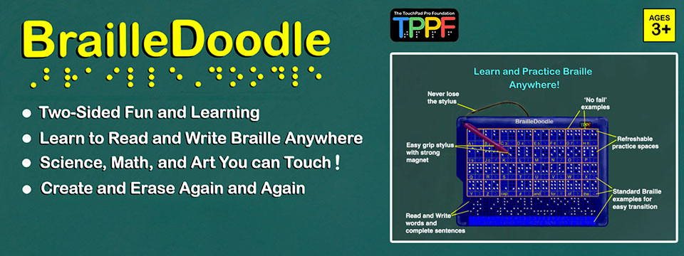
👉️ Classified Advertisement: BrailleDoodle Available at A. T. Guys Now! Just $149.00 USD | The Touch Pad Pro Foundation / BrailleDoodle
The BrailleDoodle is a groundbreaking, affordable, two-sided tablet designed to empower individuals of all ages and skill levels with Braille literacy and tactile exploration. One side is dedicated to Braille learning, featuring practice spaces for letters, numbers, and words, making it perfect for beginners or those looking to improve their skills. The other side offers a tactile refreshable surface, ideal for creating art, exploring STEM concepts like math and graphing, and expressing creativity in limitless ways.
With its easy-to-use magnetic stylus, users can write and create tactile designs, feel their progress as they go, and erase effortlessly, making learning and creativity interactive and engaging. Whether you're a teacher, parent, or individual learner, the BrailleDoodle is a versatile tool that combines education, creativity, and fun. Priced at just $149.00 USD, it is an affordable solution to enhance accessibility and opportunity for blind and low-vision individuals. Order now and take the first step in transforming education and creativity! Visit A.T. Guys today to learn more.
Sponsor Since: January 1, 2025 📅️
Website: https://touchpadprofoundation.org 🌐️
About: The TouchPad Pro Foundation (TPPF) is a 501(c)(3) nonprofit organization committed to creating opportunities for blind and low-vision individuals through Braille literacy, STEM, and art education.
Founded by educators and innovators passionate about accessibility, TPPF strives to address the critical gaps in resources and tools for the visually impaired community. With a mission to promote equality and unleash human potential, the foundation provides innovative solutions that make education inclusive, engaging, and affordable.
Their initiatives include offering free devices to under-served communities and providing training to maximize the impact of their groundbreaking tools.
At the heart of their mission is the BrailleDoodle, a dual-sided, tactile learning tablet designed to make education and creativity accessible to all.
One side focuses on Braille literacy, offering interactive learning spaces for letters, numbers, and words, while the other provides a refreshable surface for tactile drawing, STEM exploration, and artistic expression.
Affordable and versatile, the BrailleDoodle empowers individuals of all ages and skill levels to develop essential literacy and creative skills.
By fostering independence and encouraging innovation, TPPF and the BrailleDoodle are transforming the lives of blind and low-vision learners worldwide.
For more information, visit the TouchPad Pro Foundation website.

⬆︎ 10.) Sponsor: AccessibleWeb

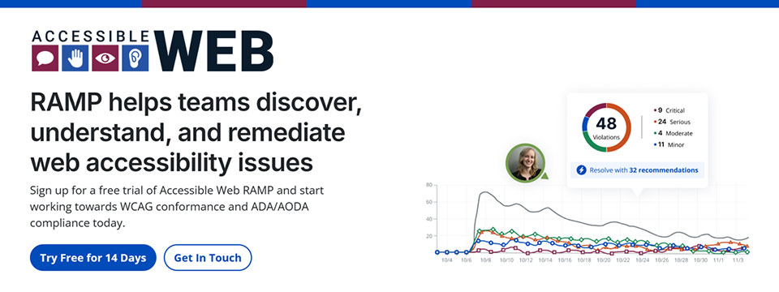
👉️ Classified Advertisement: Have You Run Into An Accessibility Barrier On A Website Recently? | AccessibleWeb
Accessible Web is on a mission to help eliminate online barriers and make the digital space more inclusive for everyone, regardless of ability. Our accessibility testing software, RAMP, allows organizations of any size to discover, understand, and remediate barriers. We offer tools to integrate with existing sites and workflows so businesses with a digital presence can start making their sites more accessible quickly.
Plans start at $49 a month. Plus, we have a 14-day free trial with no credit card needed. We believe any organization can start making progress with Accessible Web RAMP.
Sponsor Since: December 16, 2024 📅️
Website: https://accessibleweb.com 🌐️
About: At Accessible Web, our mission is to make the internet accessible to everyone, regardless of ability.
We offer a comprehensive suite of accessibility testing software tools and educational resources to help organizations achieve and maintain web accessibility in line with the Web Content Accessibility Guidelines (WCAG) and comply with legal standards such as the Americans with Disabilities Act (ADA) and the Accessibility for Ontarians with Disabilities Act (AODA).
➜︎ Services:
⚫️ WCAG Audits: Our certified specialists conduct thorough analyses of websites and applications, identifying accessibility issues and providing detailed recommendations for remediation.
⚫️ VPAT Preparation: We prepare Voluntary Product Accessibility Templates (VPATs), offering industry-standard reports that demonstrate a product's accessibility compliance, which can be crucial for sales and contractual obligations.
⚫️ Accessibility Testing: Our team of individuals with disabilities tests websites and web applications using assistive technologies, providing actionable feedback to enhance user experience and accessibility.
⚫️ Remediation Support: Our certified specialists offer coaching and support to assist organizations in implementing accessibility improvements effectively, ensuring that digital assets meet accessibility standards.
⚫️ Accessibility Certification: Through a comprehensive process of auditing, remediation, and verification, we provide WCAG certifications that validate a company's conformance and commitment to accessibility best practices.
➜︎ Tools:
⚫️ Accessible Web RAMP: Our digital accessibility platform that enables teams to discover, monitor, and remediate web accessibility violations. RAMP offers continuous monitoring, prioritized workflows, and progress reporting to facilitate ongoing compliance efforts.
⚫️ Accessible Web Helper Extension: An accessibility browser extension that allows users to scan web pages, highlight accessibility violations, and check color contrast ratios directly from their browser, streamlining the auditing process.
➜︎ Education:
⚫️ Accessible Web Academy: We offer self-guided online courses tailored to various organizational roles, promoting a culture of inclusivity and equipping teams with the knowledge to implement accessible design from the outset.
⚫️ Knowledge Base and Blog: Our resources include articles on assistive technologies, remediation tutorials, and answers to common web accessibility questions, supporting continuous learning and awareness. We host webinars most Thursdays on various accessibility topics.
We emphasize a proactive approach to web accessibility, advocating for integrating accessible design principles early in the development process to enhance user experience, attract new customers, and mitigate legal risks associated with non-compliance.
For more information or to explore our services and resources, visit our website.
Facebook | LinkedIn | Reddit | YouTube

⬆︎ 13.) Sponsor: Your Name Here

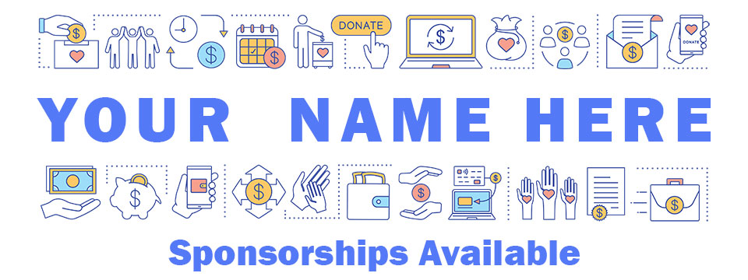
Sponsor Since: Today 📅️
Website: https://accessinformationnews.com/dearsponsor 🌐️
Phone: (855) 578-6660 📱️
Email: news@accessinformationnews.com 📧️
About: Founded in 2022, Access Information News is the world's leading not-for-profit access information news publication that reaches over 40,000 blind, low vision, deaf, hard of hearing, deafblind, neurodivergent and/or disabled professionals, educators and enthusiasts, all over the world, each week. Subscribe here. Review the most recent issues here.

Access Information News Supporters 🤝️
We couldn't do it without you! Thank you for your support!
Why: Access Information News Supporters donate an amount of their choosing either one time or annually in order to assist with the ongoing distribution of the Access Information News publication.
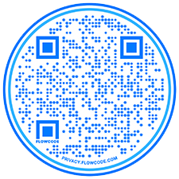
Benefits: All Access Information News Supporters receive a listing within the "Our Supporters" section of each weekly newsletter, as well as a listing within the "Our Supporters" section of the Access Information News website.
In addition, all Access Information News Supporters automatically become Premium Subscribers as well, and therefore enjoy all of the benefits that a Premium Subscription has to offer.
One Time Donation: If you would like to become a Access Information News Supporter by making a one time donation in an amount of your choosing to assist with the ongoing distribution of the Access Information News publication, you may utilize this donate link, or scan the QR code to the right.
Annual Donation: If you would like to become a Access Information News Supporter by making a small annual donation to assist with the ongoing distribution of the Access Information News publication, we also offer the following options, all with our sincerest thanks, and most heartfelt gratitude for your ongoing support.
Support: In tandem with Our Sponsors, these are the people that make the ongoing distribution of Access Information News possible.

Platinum Supporters:

Become an Access Information News Platinum Supporter today.
1.) James Hulme
Platinum Supporter Since: December 5, 2022
2.) Donna Jodhan
Platinum Supporter Since: March 24, 2023
3.) Your name here.
Platinum Supporter since ...

Gold Supporters:

Become an Access Information News Gold Supporter today.
1.) Your name here.
Gold Supporter since ...

Silver Supporters:

Become an Access Information News Silver Supporter today.
1.) Your name here.
Silver Supporter since ...

Bronze Supporters:

Become an Access Information News Bronze Supporter today.
1.) Your name here.
Bronze Supporter since ...

One Time Supporters:

One Time Supporters donate an amount of their choosing — one time to assist with the ongoing distribution of the Access Information News Publication.
Become an Access Information News One Time Supporter today.
1.) Sharyn Sobel
One Time Supporter on November 28, 2023
2.) Amanda Lee
One Time Supporter on July 31, 2023
3.) Gaylen Kapperman
One Time Supporter on June 4, 2024
4.) Your name here.
One Time Supporter on ...

Access Information News Team 🗞️

Distribution: Sponsors, Supporters and Mind Vault Solutions, Ltd.

Distribution Since: 2022
As of November 7, 2022 the distribution of Access Information News is made possible by our Sponsors, our Supporters, our Advertisers and Mind Vault Solutions, Ltd., a leading international provider of professionally outsourced marketing administration and consultation services.
Any time the Access Information News Publication carries less than its Sponsor limit, Mind Vault Solutions, Ltd. donates the remaining dollars necessary to keep the publication running.
Please help us to support the ongoing distribution of this publication. Learn more about the benefits of Sponsorship today.

Publisher: Aaron Di Blasi

Publisher Since: November 7, 2022
Location: Cleveland, Ohio
Time Zone: Eastern Standard Time (EST/EDT) (GMT-5/GMT-4)
In addition to serving as Publisher for Access Information News Aaron also serves as Publisher for the Top Tech Tidbits and AI-Weekly newsletters, PR-Director for the AT-Newswire Press Release News Distribution Service, and President and Senior Project Management Professional for Mind Vault Solutions, Ltd.
As Publisher Aaron oversees the weekly distribution of Access Information News on behalf of Mind Vault Solutions, Ltd.
Aaron Di Blasi, PMP
Email: publisher@accessinformationnews.com 📧️
Toll-Free: +1 (855) 578-6660 📱️
Aaron Di Blasi, PMP
Email: publisher@toptechtidbits.com 📧️
Toll Free: +1 (855) 578-6660 📱️
PR Director (2024-Present)
AT-Newswire 🌐
Access Technology's Digital Newswire
Publisher (2024-Present)
AI-Weekly 🌐
The Week's News in Artificial Intelligence
Publisher (2022-Present)
Access Information News 🌐
The Week's News in Access Information
Publisher (2020-Present)
Top Tech Tidbits 🌐
The Week's News in Access Technology
Sr. Project Management Professional (2006 - Present)
Mind Vault Solutions, Ltd. 🌐
Innovative ideas. Solutions that perform.
Certified:
Digital Marketing Associate
Meta Certified (2022 - Present)
Social Marketing Professional
Hootsuite Certified (2020 - Present)
Email Marketing Professional
Constant Contact Certified (2019 - Present)
Specializing in:
Digital Strategy and Content Marketing
Social Media Advertising
Online Fundraising
ADA, WCAG and Section 508 Compliance

Editor: John Hanlin

Editor Since: November 7, 2022
Location: Boulder, Colorado
Time Zone: Mountain Standard Time (MST/MDT) (GMT-7/GMT-6)
In addition to serving as an Editor to Access Information News John also serves as an Editor to the Top Tech Tidbits and AI-Weekly newsletters and is also an attorney-at-law specializing in long-term disability claims for blind and low-vision persons.
John is also a long-time contractor and member of the Board of Trustees at Mind Vault Solutions, Ltd.
John Hanlin, Esq.
Editor (2024-Present)
AI-Weekly 🌐
The Week's News in Artificial Intelligence
Editor (2022-Present)
Access Information News 🌐
The Week's News in Access Information
Editor (2020-Present)
Top Tech Tidbits 🌐
The Week's News in Access Technology
Board of Trustees (2006 - Present)
Mind Vault Solutions, Ltd. 🌐
Innovative ideas. Solutions that perform.

Editor: Jenna Lang

Editor Since: November 7, 2022
Location: Des Moines, Iowa
Time Zone: Central Standard Time (CST/CDT) (GMT-6/GMT-5)
In addition to serving as an Editor to Access Information News Jenna also serves as an Editor to the Top Tech Tidbits and AI-Weekly newsletters and runs her own advocacy foundation.
Jenna also serves as a certified Project Management Professional (PMP) for Mind Vault Solutions, Ltd.
Jenna's son was born blind and she is always seeking new and innovative ways to empower him through technology.
Jenna Lang, PMP
Editor (2024-Present)
AI-Weekly 🌐
The Week's News in Artificial Intelligence
Editor (2022-Present)
Access Information News 🌐
The Week's News in Access Information
Project Management Professional (2022 - Present)
Mind Vault Solutions, Ltd. 🌐
Innovative ideas. Solutions that perform.
Editor (2020-Present)
Top Tech Tidbits 🌐
The Week's News in Access Technology

Editor: David Woodbridge

Editor Since: February 6, 2023
Location: Central Coast, New South Wales, Australia
Time Zone: Australia Eastern Standard Time (AEST/AEDT) (GMT+10)
In addition to serving as an Editor to Access Information News David also serves as an Editor to the Top Tech Tidbits publication and is also the National Commercial Assistive Technology Advisor for Vision Australia where he has worked since 1990. Over this time he has assisted people who are blind or vision impaired in their home, education, and work settings to take advantage of the benefits of using assistive and main stream technology.
In the last seventeen years, he has also been involved with evaluating technology for use by people who are blind or vision impaired covering both low and high tech equipment (including Microsoft, Samsung, Google, Amazon, and Apple). David is also one of the key spokespersons for Vision Australia relating to technology.
He has been an Apple Ambassador for Apple Australia since 2009 with a group of other Ambassadors / Apple Distinguished Educators (ADE)'s covering the range of Apple's Accessibility solutions throughout Australia.
David produces a range of podcasts (since 2011) covering Apple and other technologies which are distributed on his own podcast (http://davidwoodbr.podbean.com). In addition, he also has a regular Talking Tech program (since 2013) which can be heard every Tuesday at 4:30 Eastern Summer Time on Vision Australia Radio Melbourne (available online) or via https://omny.fm/shows/talking-tech-vision-australia-radio
David also runs a weekly Tech Monday where people can chat about assistive and main stream technology, share information, and any tips and tricks.
David lost his sight when he was 8 years old and had to learn Braille. Since then, he completed high school, went to Sydney University receiving a Social Work degree, spent 4 years drug and alcohol counselling, and then moved into his current job.
As a person who is blind, David believes that as a user of the technology that he recommends to others, that he is well situated to look at the strengths and shortcomings of the assistive technology that he comes across in both his professional and personal life, in particular, mainstream technology that is accessible.
In addition to his weekly contributions to Access Information News and Top Tech Tidbits, David's regularly occurring activities are his weekly tech radio show, bi-monthly exploring tech webinars for Vision Australia, his iSee podcast when something of note grabs his attention, and the weekly Tech Monday chat sessions.
David Woodbridge
X (Formerly Twitter): @dwoodbridge
Mastodon: woody@dragonscave.space
iSee Podcast: https://davidwoodbr.podbean.com
Vision Australia Radio Talking Tech: https://omny.fm/shows/talking-tech-vision-australia-radio
Editor (2023-Present)
Top Tech Tidbits 🌐
The Week's News in Access Technology
Editor (2023-Present)
Access Information News 🌐
The Week's News in Access Information
National Commercial Assistive Technology Advisor
(1990 - Present)
Vision Australia 🌐
Live the life you choose. We're here to support all Australians who are blind or have low vision.

Editor: Vicki Walton

Editor Since: January 9, 2024
Location: Benton City, WA
Time Zone: Pacific Standard Time (PST/PDT) (GMT-6/GMT-7)
IIn addition to serving as an Editor to Access Information News Vicki also serves as an Editor to the Top Tech Tidbits publication and works as a Web Accessibility Specialist / IT Quality Assurance Tester at Washington State Board for Community and Technical Colleges.
Vicki Walton
Editor (2024-Present)
Top Tech Tidbits 🌐
The Week's News in Access Technology
Editor (2024-Present)
Access Information News 🌐
The Week's News in Access Information
Web Accessibility Specialist / IT Quality Assurance Tester
Washington State Board for Community and Technical Colleges 🌐
Better Jobs, Brighter Futures, a Stronger Washington

Subscription Information 📰️
ABOUT ♿️
Founded in 2022, Access Information News is the world's leading not-for-profit access information news publication that reaches over 40,000 blind, low vision, deaf, hard of hearing, deafblind, neurodivergent and/or disabled professionals, educators and enthusiasts, all over the world, each week. Subscribe here. Review the most recent issues here. Access Information refers to informational topics that directly affect the lives of people with disabilities. Access Information includes any and all information related to bettering the lives of people who are blind, low vision, deaf, hard of hearing, deafblind, neurodivergent and/or disabled. Access Information News is a Mind Vault Solutions, Ltd. Publication. Publisher: Aaron Di Blasi. Editors: John Hanlin, Jenna Lang, David Woodbridge and Vicki Walton. Access Information News is a sponsor, reader and advertiser supported publication.
RELEASE SCHEDULE 📅️
Access Information News is released every Monday morning at 6:00 AM ET.
SUBSCRIBE 📧️
Do you, a friend, or colleague wish to receive the Access Information Newsletter? If so, please use or pass along our CAPTCHA-free sign-up link. You can also subscribe to receive the Access Information Newsletter on the Access Information News Website. Either of these methods will provide you with an accessibly friendly and secure medium through which you can subscribe to our mailing list. Just enter your email address, click send, and begin receiving the Access Information Newsletter. It's that easy.
WEBSITE 🌐️
Visit the Access Information News website online at: https://accessinformationnews.com.
PREMIUM SUBSCRIBER 💸️
Only Access Information News Premium Subscribers receive our special quarterly issue listing the Top 60 Most Clicked News Articles of the Last 3 Months. Just $12 USD per year. This special quarterly issue is provided to Premium Subscribers as a native Microsoft Word document with full headings, links and abstracts to all 60 articles. There are no restrictions placed on these documents. Complete list of all back issues available. Premium Subscribers are entitled to all back issues, anytime they sign up. Join us today and begin receiving this incredibly informative issue every 3 months.
SPONSOR 🏅️
If you would like to become 1 of only 24 Access Information News Sponsors whose ongoing support makes the distribution of Access Information News possible, we offer you the following advertising benefits, with our sincerest thanks, and most heartfelt gratitude for your ongoing support.
ADVERTISE 🎯️
Access Information News offers a variety of one-time advertising options to both Sponsors and non-Sponsors alike. Here we offer a sample newsletter that provides a breakdown of exactly what those one-time advertising options are, where they appear, and what they cost per publication.
DONATE ❤️
If you would like to become an Access Information News Supporter by making a small donation to assist with the ongoing distribution of the Access Information News publication, we offer the following options, with our sincerest thanks, and most heartfelt gratitude for your support.
FACEBOOK 💬️
Are you on Facebook? Follow Access Information News on Facebook to begin receiving current news and trends in Access Information as part of your Facebook News Feed.
X (FORMERLY TWITTER) 💬️
Are you on X? Follow Access Information News on X to begin receiving current news and trends in Access Information as part of your X News Feed.
MASTODON 💬️
Are you on Mastodon? Follow Access Information News on Mastodon to begin receiving current news and trends in Access Information as part of your Mastodon News Feed or by searching for @news@mastodon.accessinformationnews.com on your server today.
LINKEDIN 💬️
Are you on LinkedIn? Follow Access Information News on LinkedIn to begin receiving current news and trends in Access Information as part of your LinkedIn News Feed.
YOUTUBE ▶️
Are you on YouTube? Follow Access Information News on YouTube to begin receiving current news and trends in Access Information as part of your YouTube Video Feed.
RSS 📡️
Do you prefer RSS? Follow Access Information News via RSS today to begin receiving current news and trends in Access Information using your choice of news aggregator.
QUESTIONS ❓️
Article abstracts are intentionally concise. As a result we know that some readers may not always understand all of the items listed because little explanation is given. If a particular article brings up a question in your mind, feel free to ask, and we will try to answer as time and knowledge permit.
ARCHIVE 🗄️
Read the most recently released issues of Access Information News online here. Visit the Access Information News Archive here, where you can read back issues.
CONTENT CONTRIBUTORS ✍️
Any information for future issues of Access Information News may be submitted online via our News Item Submission Form or directed to our Editors via email.
THANK YOU 🙏️
Thank you for reading. On behalf of all of us here at Access Information News we look forward to keeping you informed.
Information provided by:
Access Information News
https://accessinformationnews.com/ 🌐️
A Mind Vault Solutions, Ltd. Publication
1284 SOM Center Road, PMB 194,
Mayfield Heights, Ohio 44124
+1 (855) 578-6660 📱️

