How to Read Blind: https://accessinformationnews.com/read
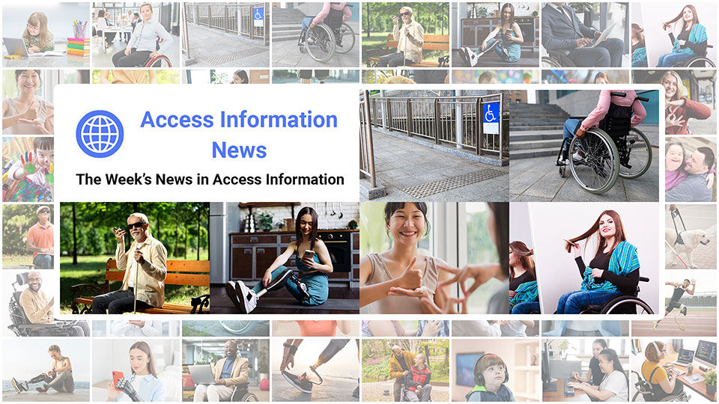
 |  |  |  |  |  |  |  |  |  |  |  | 
Access Information News for Monday, August 18, 2025 - Volume 1028
♿️ The Week's News in Access Information
Access Information News. The world's #1 online resource for current news and trends in access information.
A Mind Vault Solutions, Ltd. Publication
Subscribers: 40,525 🔢️ opt-in subscribers were sent this issue via email.

Sponsors 🏅️
 | 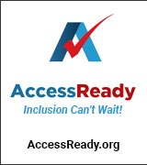 | 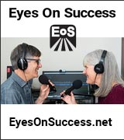 | 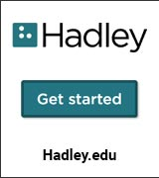 |  | 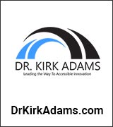
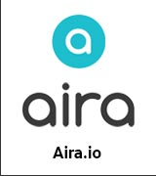 |  |  | 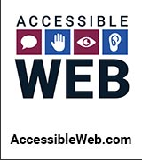 | 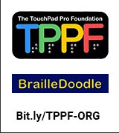 | 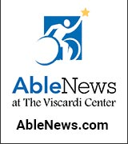
 |  |  |  |  | 

Access Awareness: Updates That Matter ♿️
Reacting To People Faking Their Disability? | Molly Burke | YouTube.com | August 15, 2025
Here, Molly Burke reflects on the ableism behind widespread accusations that disabled people are faking their conditions, emphasizing that while fraud exists, it is extremely rare compared to how often the media and public speculate about it. She critiques sensationalized news reports that encourage suspicion of disabled individuals, arguing that such coverage harms the broader community by reinforcing stereotypes and misunderstanding the spectrum of disability. Using examples ranging from veterans' benefits fraud to a Twitch streamer accused of faking paralysis, and even a blind man caught driving, she highlights how ableist assumptions, like believing blind people can't read, or wheelchair users can't stand, fuel harmful narratives. Burke insists that most disabled creators are genuine, not seeking "clout," and that society should lead with empathy and the benefit of the doubt rather than suspicion.

This Week's Featured Advertisement 🎯️
Getting Started with WCAG: Easy Wins | Upcoming Webinar | August 21, 2025 | 11:00 AM PT, 12:00 PM MT, 1:00 PM CT, 2:00 PM ET, 6:00 PM GMT
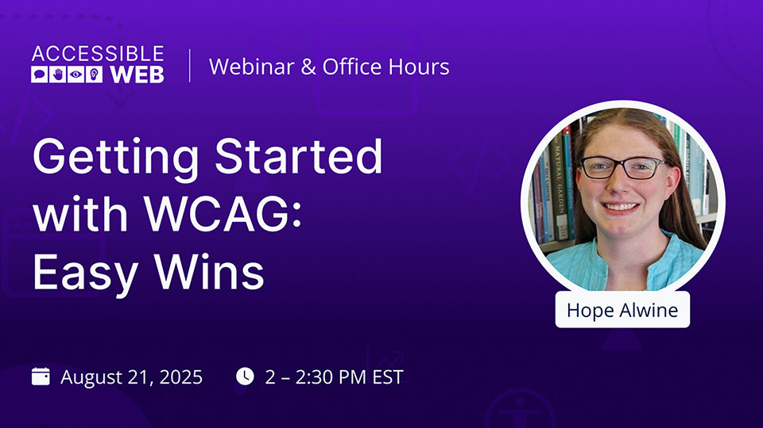
Getting started with Web Content Accessibility Guidelines (WCAG) doesn't have to be a headache. In this webinar, we'll go through some easy WCAG checks you can implement without much technical knowledge.
If you're not a web developer or haven't built up digital accessibility skills, you can still start building up these more straightforward WCAG practices.
Join us, August 21, at 2 PM EST to learn some easy WCAG wins such as:
- Text Alternatives
- Easy contrast adjustments
- Accessible headings
- Link purpose
- and more!
If you're eager to get ahead, check out our free WCAG Training Course designed to help you complete an manual audit in six months or fewer: Manual Audit Mondays.
We'll see you there!
👉 Register Now

News 📰️
👉 Submit a News Article for free here, with timing and placement determined by our editors.
👉 Submit a Sponsored News Article here, with timing and placement determined by you.

1.) Top 5 Most Clicked News Articles From Last Week 📊️
A.) Remembering Dr. Russell Smith, 20 Years On | Mosen.org | August 6, 2025
Jonathan Mosen reflects on the life and legacy of Dr. Russell Smith MNZM, a pivotal figure in blindness technology and CEO of HumanWare, who passed away tragically 20 years ago. Mosen shares personal anecdotes of Smith's influence, his innovative contributions, and the impact he had on many lives through business and compassion.
B.) The Many "Blindnesses" of Neurodivergence That Have Nothing To Do With Sight | ButtonDown.com | July 30, 2025
When people hear the word "blindness," they often think of vision loss. But for many neurodivergent people, the word describes something entirely different. Neurodivergent "blindness" is a functional gap characterized by difficulty processing certain types of information in real-time, even when the person's five senses are working. This kind of "blindness" has nothing to do with eyesight and everything to do with how the brain interprets the world.
C.) How These Visually Impaired Friends Are 'Travelling The World Through Lego' | CBC.ca | August 2, 2025
Friends Guy Christien and Natalie Dorion, both visually impaired, have spent the last seven years creating elaborate Lego projects, including a 30,000-piece steam train. They share a love for the tactile experience of building Lego structures which allows them to explore and learn about global landmarks and transportation history.
D.) Podcasts By Dr. Kirk Adams: August 4, 2025: Interview with Penn Street, Development and Outreach Director, Host, 'The Blind Chick' Podcast, After Sight | Dr. Kirk Adams | August 4, 2025
In this engaging episode, Dr. Kirk Adams sits down with disability advocate, outdoor enthusiast, and "The Blind Chick" podcast host Penn Street. Penn recounts the dramatic origins of her blindness—two rattlesnake bites at age nine triggered Stevens-Johnson syndrome, leaving her with severe burns, lasting eye damage, and years of surgeries. Growing up as the ninth of ten siblings, she credits a rugged childhood, supportive teachers, and the Lion s Clubs with building her resilience. A move to Colorado opened doors to better medical care and the mountains she loves; later, climber Erik Weihenmayer's example convinced her she could still scale rock walls, raft the Grand Canyon, and teach adaptive outdoor skills to other blind adventurers.
E.) Donna J. Jodhan Delivers Live-Streamed Entrepreneurship & Self-Advocacy Labs At The 2025 EYE Retreat, July 25 — August 2, 2025 | AT-Newswire.com | August 4, 2025
Donna J. Jodhan continued her role at the Envisioning Youth Empowerment Retreat this year, providing live-streamed sessions focusing on entrepreneurship and self-advocacy for blind and low-vision youth. Throughout the retreat, participants engaged in labs that fostered innovation and personal growth, emphasizing the importance of accessibility as a foundation for future success.
August 18, 2025 📅️
2.) Sponsorship Packages Available | AccessInformationNews.com | August 18, 2025
Would your product, service or message benefit from reaching over 40,000 access information readers each week? For just $200 / month? If you're thinking yes, we invite you to try a Sponsorship Package with Access Information News. The benefits are amazing and the traffic delivered to your properties each week is measurable. No obligation. Cancel anytime.
3.) One Time Advertisements Available | AccessInformationNews.com | August 18, 2025
One time advertisements are available to anyone, with or without a Sponsorship. Would your product, service or message benefit from reaching over 40,000 access information subscribers? If you're thinking yes, please check out our one time advertising options. They are cost-effective, targeted and measurable. Scheduling is optional. Learn more today.
4.) Premium Subscribers | AccessInformationNews.com | August 18, 2025
Next Issue: Premium Subscribers will receive their 10th issue of the Top 60 Most Clicked News Articles for April, May and June of 2025 on Monday, July 7, 2025. Back Issues: There are currently 9 back issues available. Premium Subscribers are entitled to all back issues, anytime they sign up. All available back issues will be sent to you via email within 24 hours of purchasing your subscription. Please Join Us: If you would like to receive a perfectly formatted and searchable Word Document with each of the Top 60 Most Clicked News Articles of the last 3 months listed neatly within it, please consider joining us today for just $1 a month.
5.) Sponsored News Articles | AccessInformationNews.com | August 18, 2025
Use Sponsored News Articles to reach the access community when you need to. Whether you are a current Sponsor or not. Drive traffic to your access product and service announcements, events, updates or fundraisers using this incredibly cost-effective and easy-to-use advertisement tool. Learn more today.
6.) Do You Have A Link In This Issue? Learn How To Track It For Free | AccessInformationNews.com | August 18, 2025
This article will outline, step-by-step, how you can get free website traffic reporting on any link to your domain (AKA domain name, website or web address) that has been published by Access Information News since January 22, 2024, when we launched this feature.
7.) We Are Not One Thing: Intersectionality Through a Disability Inclusion Lens | Dr. Kirk Adams | August 18, 2025
Inclusion fails when it's built for one story at a time. Real people live at intersections. Race, gender, disability, class, identity, all at once. And yet, most systems are built to see just one. Disability is everywhere. It cuts across every community, every culture, every conversation about equity. But too often, it's left out or treated as a single-issue checkbox. August is Intersectionality Awareness Month. This is the time to shift that frame.
August 17, 2025 📅️
8.) Podcast: Finding Emotional Support with Vision Loss | Hadley Presents: A Conversation with the Experts | August 17, 2025
Losing vision is a loss. It often brings feelings of grief, anger, and sadness. It can help to know you're not alone and that there are things you can do to help you through the rough patches. In this episode, we talk about Hadley's Adjusting & Coping Together virtual support groups. These small groups offer a space to speak openly, connect with others who are also experiencing vision loss, and learn a few things you can do to cope and adjust.
August 15, 2025 📅️
9.) Blind Tennis In New York City | NYTimes.com | August 15, 2025
Blind tennis is gaining popularity in New York City, offering visually impaired players a chance to embrace the sport in a supportive environment. The initiative highlights the importance of accessibility and community engagement in sports, aiming to enhance the quality of life for participants through physical activity.
10.) World-Renowned Advocate Donna J. Jodhan Asks How Well Is The Accessible Canada Act Doing These Days? | Donna J. Jodhan | BarrierFreeCanada.org | August 15, 2025
Donna J. Jodhan, a globally recognized disability rights advocate and founder of Barrier-Free Canada, acknowledges that the Accessible Canada Act (ACA) has successfully laid a much-needed foundation and generated positive momentum, but warns that, five years in, its progress is stalling. She highlights concerns that long implementation timelines (stretching to 2040), inconsistent accountability, and lackluster enforcement risk eroding the sense of urgency essential for meaningful change. Jodhan argues that many organizations are dragging their feet and that the government's own mixed signals are undermining the ACA's efficacy; to truly honor accessibility as a human right, she insists, the Act must be backed by sharper enforcement, clearer expectations, and immediate action, not deferred to decades ahead.
August 14, 2025 📅️
11.) Missouri Doctoral Student Takes On Fashion Accessibility For Blind People | KOMU.com | August 14, 2025
Doctoral student Emma Nicoson is combining her lifelong passion for fashion with research into accessibility, aiming to make clothing more inclusive for blind individuals.
12.) Social Security Administration Adds 13 More Medical Conditions To Expedited Benefits List | PhillyBurbs.com | August 14, 2025
The Social Security Administration has expanded its Compassionate Allowances list, enabling applicants with 13 additional serious medical conditions to access expedited disability benefits processing.
13.) Study Finds Better Physical Ability Is Tied To Higher Cognition In MS | MultipleSclerosisNewsToday.com | August 14, 2025
A new study shows that stronger physical performance correlates with higher cognitive function in people with multiple sclerosis, particularly among those with greater levels of disability.
14.) What's Next For Students With Disabilities Attending Schools The State Ordered Closed | Columbiamissourian.com | August 14, 2025
The closure of 12 Missouri schools for students with disabilities has sparked concern about transitions, with officials emphasizing individualized education programs and support teams to guide affected students.
15.) How Much Should You Spend On Accessibility? | KarlGroves.com | August 14, 2025
Determining an appropriate budget for digital accessibility is a strategic necessity for businesses, reflecting its emergence as a key compliance obligation alongside regulations like the ADA and GDPR. Organizations should consider allocating 5%—10% of their compliance budget to accessibility to mitigate risks and enhance inclusivity.
16.) UK: Train Access Problems Leave Some 'Disenfranchised' | BBC.com | August 14, 2025
A disabled man in Cornwall says he feels 'disenfranchised' by the lack of accessible routes at Bodmin Parkway station, where reaching the eastbound platform requires navigating a footbridge without a lift.
August 13, 2025 📅️
17.) Leisure Activities When Blind | Ed Henkler | TheBlindGuide.com | August 13, 2025
Thriving with disabilities is so much more than performing ADL's (activities for daily living) like cooking and cleaning. Or even finding employment. Thriving with disabilities means you can do whatever you want. Previous posts have focused on thriving with sports, as an athlete and as a spectator. But how about video games?
18.) From Layoffs to Lifelines: How Companies Are Supporting Workers in 2025 | HR Spotlight | August 13, 2025
In a period of unprecedented workforce turbulence, where economic shifts and industry disruptions are making headlines, organizations face a critical test of their leadership and cultural values.
19.) HapWare August Updates: Media, Recognition, And Incredible Talent | HapWare.com | August 13, 2025
HapWare celebrates recent recognition in the Colorado Chamber of Commerce's Top 10 Coolest Things Made in Colorado list, showcasing innovative technology for the blind and low vision community. Additionally, HapWare shares insights on the packaging experience and features on 9News that highlight their mission of accessibility and independence.
20.) Kansas Native To Represent State, Advocate For Accessibility At Ms. Wheelchair America Competition | WIBW.com | August 13, 2025
Autumn Green, paralyzed since childhood, will represent Kansas at the Ms. Wheelchair America competition, using the platform to inspire others with disabilities and promote accessibility nationwide.
21.) Canada: Mahone Bay, N.S., Introduces New Accessibility Guidelines For Sidewalk Patios | CBC.ca | August 13, 2025
Mahone Bay, N.S., has adopted new accessibility rules for sidewalk patios after a 100-year-old woman fell outside a restaurant, moving ahead of provincial standards set to take effect next year.
August 12, 2025 📅️
22.) "Shakedown" Lawsuits Over Website Access Torment St. Louis Restaurateurs | StLouisMag.com | August 12, 2025
A blind man's complaint over inaccessible restaurant websites in St. Louis led to legal demands for settlements, raising concerns for local restaurateurs about ADA compliance and costly lawsuits.
23.) Kids With Autism Are At Greater Risk Of Drowning. Swim Classes Can Help. | WGBH.org | August 12, 2025
Children with autism face a heightened risk of drowning, prompting programs like Swim Angelfish to offer tailored swim safety classes that help families protect their kids while building confidence in the water.
24.) UK: Disabled People Face 'Accessible Housing Shortage' | BBC.com | August 12, 2025
Disabled Londoners face a severe shortage of accessible housing, with campaigners warning that the lack of adapted homes forces many into distressing living conditions and undermines their independence.
25.) Australia: Australia Updates NCC To Enhance Accessibility | BuildAustralia.com.au | August 12, 2025
Australia has updated the National Construction Code to reflect recent changes in disability access standards, incorporating new design principles to ensure public buildings meet modern accessibility requirements.
26.) UK: The Fringe Shows That Put Accessibility Centre Stage | BBC.com | August 12, 2025
The Edinburgh Fringe is spotlighting accessibility this year as ZOO Playground partners with Extant, a theatre company of visually impaired artists, to improve experiences for blind and visually impaired audiences.
August 11, 2025 📅️
27.) 'He Trusted Me': A Priesthood Holder's Strength Beyond Disability | TheChurchNews.com | August 11, 2025
Nick Hansen, a Special Olympics record holder with Down syndrome, recently achieved a personal and spiritual milestone by being ordained to the Melchizedek Priesthood in his local Latter-day Saint congregation.
28.) Thousands Waiting: SC Families Struggle Amid Cuts To Disability Housing Programs | Live5News.com | August 11, 2025
More than 6,000 South Carolinians with disabilities remain on a decade-long waitlist for supportive housing, as nonprofits work to provide long-term solutions like residential communities.
29.) This Is The Tallest Subway Station In New York City—And It's Finally Getting Major Accessibility Upgrades | TimeOut.com | August 11, 2025
Brooklyn's Smith — 9th Streets subway station, the tallest in New York City, will receive long-awaited elevators as part of the MTA's capital plan to expand accessibility across the system.
30.) How To Attract And Retain Talent With Disabilities | USChamber.com | August 11, 2025
With one in four U.S. adults living with a disability, businesses have significant opportunities to recruit disabled professionals by intentionally creating accessible, inclusive hiring and workplace practices.
31.) Canada: Mind The Gap: Wheelchair Passengers Question Accessibility Of New Mark V Skytrains | GlobalNews.ca | August 11, 2025
Despite promises of improved accessibility, some wheelchair users report difficulties boarding TransLink's new Mark V SkyTrains due to uneven platform levels, raising concerns about barriers in the upgraded transit system.
Last Week 📅️
32.) Southwest Airlines Strands Blind Women At Airport, Sparks Accessibility Calls | WebProNews.com | August 10, 2025
Two blind women were left behind at a New Orleans airport by Southwest Airlines and given minimal compensation, prompting public outrage and calls for stronger disability protections in air travel.
33.) Assemblyman Santabarbara Leads Push For Inclusive Education With New Law For Accessible Materials | CBS6Albany.com | August 10, 2025
New York has passed legislation requiring publishers to provide accessible instructional materials for college students with disabilities, ensuring equal access to learning resources.
34.) In 'The Remarkable Life Of Iberlin,' A Disabled Gamer Finds Accessibility And Influence He Couldn't In The Real World | HollywoodReporter.com | August 10, 2025
A new Netflix documentary tells the story of Mats Steen, a Norwegian gamer with muscular dystrophy who built deep online friendships and influence through World of Warcraft despite severe physical limitations.
35.) 5 Simple Fixes That Make Digital Spaces Calmer — for Neurodivergent And All Users | KnowAboutAccessibility.org | August 8, 2025
Implementing simple, high-impact changes can significantly enhance digital accessibility for neurodivergent users. Suggested fixes include allowing control over motion, simplifying navigation, avoiding rigid time constraints, minimizing visual clutter, and supporting multiple input methods, which collectively create calmer and more usable experiences for all users.
36.) Accessibility And The Agentic Web | Tetralogical.com | August 8, 2025
The article explores the limitations of current retail websites for visually impaired users, emphasizing the importance of detailed product descriptions and the potential role of AI in improving accessibility. It introduces agentic AI tools that act as personal shopping assistants, providing a more user-friendly experience compared to traditional website navigation.
37.) Disability Rights Advocates Say Downtown Wichita Falls Short On Accessibility | KMUW.org | August 8, 2025
Advocates in Wichita highlight challenges for disabled residents, citing inaccessible parking, uneven sidewalks, and public buildings that prevent equal participation in civic life.
38.) A Welcoming, Accessible Church | LivingLutheran.org | August 8, 2025
Eleanor Jerbi, a neurodivergent advocate, underscores the importance of churches creating spaces that balance sound and accessibility to better welcome people with diverse needs.
39.) Medicare Will Test Using AI To Help Decide Whether Patients Get Coverage — Which Could Delay Or Deny Care, Critics Warn | MarketWatch.com | August 8, 2025
Medicare will pilot an AI-driven prior authorization system in six states starting in 2026, raising concerns it could delay or deny necessary care for patients.
40.) Medicaid Work Requirements Don't Work For New Mexicans With Disabilities | SourceNM.com | August 8, 2025
A new federal law imposing work requirements for Medicaid participants has raised alarms in New Mexico, where advocates warn the unfunded tracking system could harm people with disabilities.
41.) Canada: What Will It Take To Get More Disabled Characters, And Actors, On The Big Screen? | CBC.ca | August 8, 2025
A report found a modest rise in disabled characters in 2024's top films, but advocates argue meaningful representation remains lacking, with only 20 of the top 100 movies featuring leading or co-leading characters with disabilities.
42.) UK: 'Disabled People Deserve Dolls That Represent Us' | BBC.com | August 8, 2025
Sheffield-based Grace True has launched a range of mobility aids for dolls, including powerchairs and scooters, aiming to foster inclusivity and challenge stigmas by normalizing disability representation in toys.
43.) Australia: Framing My Story Shows Ballarat's Disability Pride In Words And Photos | ABC.net.au | August 8, 2025
The Framing My Story exhibition in Ballarat showcases personal stories and photographs of people with disabilities, celebrating identity and pride as part of Disability Pride Month.
44.) FCC Launches Review of Emergency Alert Systems | Radio-Online.com | August 7, 2025
The FCC has unanimously approved a proposal to review the Emergency Alert System and Wireless Emergency Alerts. This initiative aims to evaluate their effectiveness and explore necessary changes to enhance public safety, focusing on modern technological needs and ensuring accessibility for all.
45.) Trump Administration Moving To Shrink Disability Benefits For Some Recipients | HuffPost.com | August 7, 2025
The Trump administration plans to roll back a policy that expanded Supplemental Security Income, potentially reducing benefits for recipients who receive food or housing assistance from others.
46.) Canada: Toolkit Empowers Municipal Accessibility | RemiNetwork.com | August 7, 2025
The Rick Hansen Foundation has launched a free online Municipal Accessibility Policy Toolkit to help Ontario municipalities remove built environment barriers, developed in collaboration with accessibility experts and supported by the provincial government.
47.) UK: Minister's Comments Add Fuel To Access To Work Concerns | DisabilityNewsService.com | August 7, 2025
Concerns over the sustainability of the Access to Work scheme have deepened after minister Sir Stephen Timms suggested it was unlikely to last in its current form, amid leaked plans for cost-cutting that could make securing support more difficult for disabled people.
48.) Announcing The Launch Of "Inclusive Publishing And The Quest For Reading Equity" | InclusivePublishing.org | August 6, 2025
The publication of Dr. Agata Mrva-Montoya's book highlights the current state and future potential of accessible publishing. It underscores the industry's need for systemic changes that prioritize inclusivity in book production and distribution, aiming for a future where accessibility becomes an integral part of publishing.
49.) Spotify Audiobooks+ Is Launching In The USA | GoodEReader.com | August 5, 2025
Spotify has introduced its Audiobooks+ service in the United States, priced at $11.99 per month, providing subscribers with an additional 15 hours of audiobook streaming each month. This service is designed for Spotify Premium members, allowing enhanced access to audiobooks alongside existing subscriptions.

Featured Events 📅️
👉 Submit your event for consideration within this section here.

August 18, 2024 | Unlocking The Value Of Accessibility Testing With Assistive Technology Users | MakeItFable
10:00 AM PT, 11:00 AM MT, 12:00 PM CT, 1:00 PM ET, 5:00 PM GMT
Fable presents a foundational session exploring the impact of accessibility testing with real users. Discover how assistive technology works in daily life, why human insight is crucial beyond automated tools, and how inclusive testing can be integrated into your workflow through small, actionable steps.
August 19, 2024 | Innosearch Game Night: Mystery Game Night (Finale!) | Innosearch
6:00 PM PT, 7:00 PM MT, 8:00 PM CT, 9:00 PM ET, 1:00 AM GMT
Innosearch wraps up the Game Nights series with a surprise finale challenge, rewarding top performers, most referrals, and consistent attendees with bonus credits and cash prizes. Full details here. Questions? Email us at support@innosearch.ai 📧️.
August 20, 2025 | AI Reality Check for Disability Advocates and Innovators | Mai Ling Chan | Exceptional Leaders Network
2:00 PM PT, 3:00 PM MT, 4:00 PM CT, 5:00 PM ET, 9:00 PM GMT
Think AI is just hype? Think again — it's already shaping disability access, often without your voice. Join Mai Ling Chan, CCC-SLP, for a candid, interactive 1-hour session that will challenge what you think you know about AI and disability advocacy. Discover where AI is getting it wrong, how biased data and inaccessible tools are creeping into hiring, healthcare, and education, and — most importantly — how you can take back control. You'll learn practical ways to influence AI, protect yourself and your clients, and stop being sidelined by systems built without your input. Perfect for disability professionals, educators, content creators, and advocates ready to lead, not follow. Don't let AI create a future without you — step up, get informed, and be part of the solution. Reserve your spot now — and be a part of this epic event!
August 20, 2025 | Part 2: PDF Accessibility Basics — How To Test For Accessibility With JAWS (Digital Accessibility Webinar) | Access Ingenuity
10:00 AM PT, 11:00 AM MT, 12:00 PM CT, 1:00 PM ET, 5:00 PM GMT
Join Rachel Reeves to learn how to test PDF documents for accessibility using JAWS. This session outlines both automated and manual testing strategies aligned with WCAG requirements to ensure digital content meets accessibility standards.
August 21, 2025, 2024 | VPAT ® 101: Introduction To The Voluntary Product Accessibility Template | TPGI
9:00 AM PT, 10:00 AM MT, 11:00 AM CT, 12:00 PM ET, 4:00 PM GMT
In this free webinar, Brian Elton, Practice Manager of Training at TPGi, explains the purpose and benefits of the Voluntary Product Accessibility Template (VPAT), addressing what information it contains, whether it applies beyond websites, and how organizations can create or obtain one. Participants will gain clarity on best practices for documenting accessibility and determining whether to develop VPATs in-house or with third-party support.
August 21, 2025 | Six Ways To Manage PDFs More Efficiently With JAWS | Freedom Scientific
9:00 AM PT, 10:00 AM MT, 11:00 AM CT, 12:00 PM ET, 4:00 PM GMT
In this live webinar from Freedom Scientific, presenters Elizabeth Whitaker and Rachel Buchanan share six strategies for accessing, reading, and interacting with PDFs more efficiently using JAWS. Learn how to optimize Adobe Acrobat Reader settings, improve navigation, and apply practical techniques for both school and workplace accessibility.
August 21, 2025 | Six Ways To Manage PDFs More Efficiently With JAWS | Freedom Scientific
9:00 AM PT, 10:00 AM MT, 11:00 AM CT, 12:00 PM ET, 4:00 PM GMT
Learn how to improve your efficiency when working with Portable Document Format (PDF) files using JAWS in this webinar from Freedom Scientific. The session covers multiple methods to access, read, and interact with PDFs, along with tips for optimizing Adobe Acrobat Reader settings for smoother navigation in educational and workplace environments.
August 21, 2025 | Free Zoom Workshop: Echo Vision Smart Glasses | Florida Outreach Center For The Blind
12:00 PM PT, 1:00 PM MT, 2:00 PM CT, 3:00 PM ET, 7:00 PM GMT
Join guest speaker Kevin Chao for a live Zoom session exploring Echo Vision Smart Glasses, the first AI-powered eyewear designed by and for the blind to provide real-time audio descriptions of the visual world. Learn about features such as live descriptive assistance, hands-free remote support, OCR book reading mode, open-ear Bluetooth, and AI-driven navigation tools. | Zoom Meeting ID: 835 8160 5488 | Passcode: 182630
August 25, 2025 | Join Selvas BLV At This Upcoming Webinar | Selvas BLV
5PM PT, 6PM MT, 7PM CT, 8PM ET, 1AM GMT
Selvas BLV's Earle Harrison and Hims' Jenny Axler showcase the newest features of the BrailleSense 6 Android tablet and Braille eMotion smart display during this free, one-hour evening webinar.
August 26, 2025, 2024 | ADA Title II: What Public Entities Need To Know About Digital Accessibility | TPGI And 3Play Media
9:00 AM PT, 10:00 AM MT, 11:00 AM CT, 12:00 PM ET, 4:00 PM GMT
David Sloan, Chief Accessibility Officer at Vispero, and Erik Ducker, Senior Director of Product Marketing at 3Play Media, share insights on ADA Title II compliance for public entities. This session offers a plain-language guide to understanding requirements, building an actionable compliance roadmap, and adopting tools and strategies to make digital content fully accessible.
August 27, 2025 | Outlook With JAWS: Custom Rules And Signature Creation (Assistive Technology Webinar) | Access Ingenuity
10:00 AM PT, 11:00 AM MT, 12:00 PM CT, 1:00 PM ET, 5:00 PM GMT
Assistive Technology Specialists Mark Schaffer and Ian Ramos explain how to enhance email workflows using JAWS and Microsoft Outlook, covering custom rules, email management techniques, and creating professional signatures.
August 28, 2025 | Supercharge Your Bottom Line Through Disability Inclusion Webinar: From Rocket Science To Inclusion Science: Paolo Gaudiano's Data-Driven Path To Disability ROI | Dr. Kirk Adams
11AM PT, 12PM MT, 1PM CT, 2PM ET, 6PM GMT
In this live webinar, Dr. Kirk Adams and Paolo Gaudiano of Aleria demonstrate how data-driven tools like the Inclusion Impact Calculator can expose the hidden costs of exclusion and reveal measurable returns from disability inclusion, offering leaders clear, actionable steps to drive competitive advantage through evidence-based workplace equity.
August 28, 2025 | Selvas BLV Product Overview | Selvas BLV
3:00 PM PT, 4:00 PM MT, 5:00 PM CT, 6:00 PM ET, 10:00 PM GMT
Earle Harrison and Antonio Guimaraes provide an overview of SELVAS BLV's productivity tools, including Braille tablets, Braille displays, and multimedia devices designed for seamless use and accessibility.
September 16-17, 2025 | The Deaf And Hard Of Hearing Accessible Technology's State Of Science Conference | Gallaudet University's Technology Access Program
6:00 AM PT, 7:00 AM MT, 8:00 AM CT, 9:00 AM ET, 1:00 PM GMT
In this two-day hybrid gathering, Gallaudet University's Technology Access Program showcases cutting-edge research on caption quality, hearing-technology accessibility and sign-language innovation, featuring keynotes, breakout discussions and student presentations aimed at advancing equitable communication tools for the Deaf and Hard of Hearing community.
September 20, 2025 | Disability Strong Virtual Conference: Building Change | Disability Strong Virtual Conference
1:00 PM PT, 2:00 PM MT, 3:00 PM CT, 4:00 PM ET, 8:00 PM GMT
Disability advocate and civic leader Nico Meyering shares his lived experience with orphan disease and navigating inaccessible systems toward impactful leadership. Drawing from his work in reshaping civic institutions, Nico offers practical insights on building power, forging coalitions, and creating inclusive spaces where Disabled people lead, thrive, and belong.
September 21, 2025 | Disability Strong Virtual Conference: From Trauma To Healing & Intersectionality Of Race And Disability | Disability Strong Virtual Conference
9:00 AM PT, 10:00 AM MT, 11:00 AM CT, 12:00 PM ET, 4:00 PM GMT & 1:00 PM PT, 2:00 PM MT, 3:00 PM CT, 4:00 PM ET, 8:00 PM GMT
Nicole Demos shares her personal journey of trauma and healing in Finland, highlighting the importance of self-care, advocacy, and safe spaces. Later, Nancy Williams-Nettles examines how racism and ableism intersect, creating unique challenges for people of color with disabilities, and explores ways to foster inclusive, justice-driven approaches.
September 22, 2025 | Disability Strong Virtual Conference: Civic Engagement, Policymaking, And Advocacy Panel | Disability Strong Virtual Conference
4:00 PM PT, 5:00 PM MT, 6:00 PM CT, 7:00 PM ET, 11:00 PM GMT
Panelists Nico Meyering, Nancy Williams-Nettles, and Jesse Schwartzman discuss practical ways to engage in community advocacy, both politically and non-politically. They share strategies for using personal experiences to drive change and highlight the power of active participation in shaping more inclusive communities.
September 22, 2025 | Twenty-Sixth Audio Description Institute | American Council Of The Blind
1:00 PM PT, 2:00 PM MT, 3:00 PM CT, 4:00 PM ET, 8:00 PM GMT
Led by Dr. Joel Snyder, this five-day virtual training from the American Council of the Blind offers an in-depth introduction to the theory, techniques, and applications of audio description. Attendees will gain practical skills through lectures, discussions, and collaborative sessions, and receive a certificate of completion along with a training manual.
September 23, 2025 | Disability Strong Virtual Conference: Using Inclusive Language / How To Be An Ally | Disability Strong Virtual Conference
5:00 PM PT, 6:00 PM MT, 7:00 PM CT, 8:00 PM ET, 12:00 AM GMT
Nicole Demos guides participants through strategies for fostering belonging, equity, and empathy by using inclusive language and practicing genuine allyship. Attendees will explore how words and actions can work together to make accessibility and inclusivity an everyday reality.
September 24, 2025 | Disability Strong Virtual Conference: How Violence And Disability Converge | Disability Strong Virtual Conference
5:00 PM PT, 6:00 PM MT, 7:00 PM CT, 8:00 PM ET, 12:00 AM GMT
Margaux Sorenson examines how violence disproportionately impacts people with disabilities, the systemic barriers to reporting, and the historical roots of ableism. The session highlights advocacy efforts centering disabled survivors and explores ways to promote safety, equity, and justice for all.
September 27, 2025 | NJCB Virtual Convention: The Grassroots Revival | New Jersey Council Of The Blind
9:00 AM PT, 10:00 AM MT, 11:00 AM CT, 12:00 PM ET, 4:00 PM GMT
The New Jersey Council of the Blind presents its 2025 Virtual Convention, The Grassroots Revival, bringing together expert speakers, live Q&A sessions, assistive technology demonstrations, and community engagement. Running for the first time in over 15 years, this online gathering highlights advocacy, access, and connection with presentations on adaptive living, accessible technology, healthcare, and independent living resources.
October 14, 2025 and October 15, 2025| Virtual Web Accessibility Training | WebAIM
9:00 AM PT, 10:00 AM MT, 11:00 AM CT, 12:00 PM ET, 4:00 PM GMT
In this two-day, expert-led online program from WebAIM, participants will learn essential and advanced web accessibility practices to ensure compliance with international guidelines and legal requirements. Designed for developers, designers, and accessibility professionals, the training covers WCAG principles, assistive technology use, inclusive design for various disabilities, evaluation techniques, and offers a complimentary document accessibility course.
November 15, 2025 | International Neurology Conference 2025 | PubScholars Group
12:00 AM PT, 1:00 AM MT, 2:00 AM CT, 3:00 AM ET, 8:00 AM GMT
The International Neurology Conference 2025 is a flagship hybrid event hosted by PubScholars Group on November 15-16, 2025, at the Hard Rock Hotel at Universal Orlando (5800 Universal Blvd, Orlando, FL) and streamed online. The conference explores "Mind-Brain Connection: Understanding Neuroscience through Mental Health," aiming to integrate cutting-edge science with clinical relevance. Who Should Attend: Neurologists, neurosurgeons, neuroscientists, psychologists, rehabilitation professionals, engineers, industry leaders, students, and allied health practitioners. Important Dates & times: Abstract Submission Deadline: September 15, 2025. Registration Deadline: September 30, 2025. Event Timing: November 15, 2025 (8 AM start) - November 16, 2025 (6 PM close). Format: Hybrid Event (In-person & Virtual. Contact Person: Richard A. Email: info@pubscholars.org 📧️. Phone: +91 7042134266 📱️. Venue: Hard Rock Hotel at Universal Orlando, 5800 Universal Blvd, Orlando, FL 32819, USA.
May 21, 2026 | Tech Blitz 2026: Assistive Technology Showcase Brings Together Blind, Deafblind, And Low Vision Community For Innovation, Discovery, And Connection. | Helen Keller Services
3:00 PM PT, 4:00 PM MT, 5:00 PM CT, 6:00 PM ET, 11:00 PM GMT
In this in-person showcase hosted by Helen Keller Services, assistive technology vendors, innovators, and users come together for a day of interactive demonstrations, in-depth discussions, and community connection focused on advancing access and independence for the blind, DeafBlind, and low vision communities.

Directories 📝️
1) Access Information Email Newsletter Directory | Submit

Sponsor Classified Ads 🎯️

⬆︎ 8.) Sponsor: Innosearch.ai

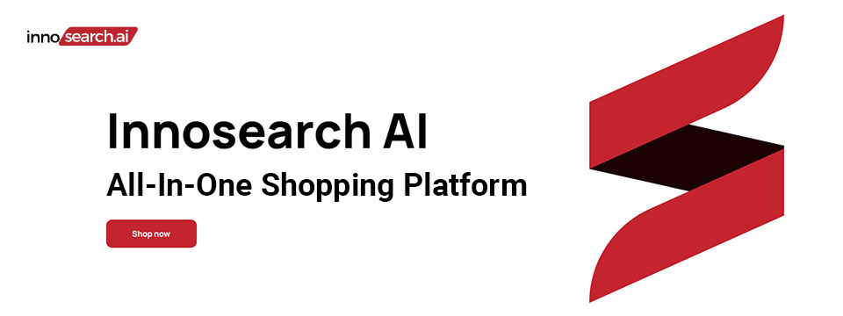
👉️ Classified Advertisement: Shop by Phone — No Screens, Just Your Voice!
Call 1-855-SHOP-GPT (1-855-746-7478)
Shopping online can be hard if you're blind, visually impaired, or not tech-savvy. That's why Innosearch AI created Shop by Phone — a 100% free, voice-only service.
Just call and say what you need:
👉 "Find me a phone charger."
👉 "Add it to my cart."
👉 "Check out."
No apps, no websites — just easy, hands-free shopping from over 500,000 stores.
- ✔ Free to use
- ✔ Works anywhere, anytime
- ✔ Perfect for seniors, blind, and low-vision users
Available in:
- 🇬🇧 UK: +44 7727 247467 📱️
- 🇨🇦 Canada: +1 782 222 7467 📱️
- 🇦🇺 Australia: +61 489 267 467 📱️
- 🇺🇸 USA: 1-855-SHOP-GPT 📱️ (1-855-746-7478 📱️)
Call now and shop with ease!
Sponsor Since: October 15, 2024 📅️
Website: https://www.innosearch.ai 🌐️
Email: info@innosearch.ai 📧️
About: Innosearch is an all-in-one shopping platform augmented with a cutting-edge AI-powered shopping assistant. This innovative feature mimics the experience of shopping in real life by allowing you to interact with the assistant using natural language. It aggregates millions of products from top US online retailers, bringing them directly to you. With this advanced generative AI, Innosearch offers personalized product recommendations, highlights the best deals, and provides comprehensive information including reviews, total prices, shipping options, and more. Innosearch delivers a seamless end-to-end shopping experience, eliminating the need to search and browse in multiple tabs across retailers.
YouTube Review By Sam Seavey: https://youtube.com/watch?v=-rjL-HAwaZY.
Key Features: Key Features of the Innosearch All-in-One AI Shopping Platform include:
➜ Research Products: Easily compare products across retailers, or weigh pros and cons of similar products to make informed decisions.
➜ Uncover the Best Deals: Never miss a door buster, coupon, or clearance sale again. Get notified about the best prices and offers.
➜ AI Summarized Trusted Reviews: See what others are saying and make confident purchases.
➜ All in One: Innosearch brings millions of products from top online retailers directly to you, allowing you to shop the best deals with easy checkout and personalized AI assistance.
➜ Shop with Confidence: Rest assured, Innosearch has you covered with free shipping and returns on every purchase.
➜ Know Before You Buy: Innosearch equips you with expert buying guides, empowering you to make well-informed decisions.
How To Shop: Simply create a free account and start shopping today!

⬆︎ 7.) Sponsor: Aira

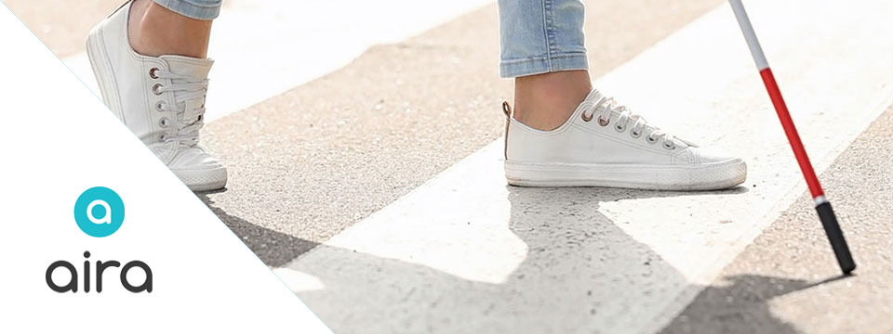
Sponsor Since: September 9, 2024 📅️
Website: https://aira.io/ 🌐️
Download the App: Apple App Store | Google Play Store
Plans and Pricing: https://aira.io/pricing/
Phone: NA: +1.800.835.1934 📱️ | AU: +1.800.765.096 📱️ | UK: +0.800.046.5668 📱️ | NZ: +1.800.425.451 📱️
Text Message: NA: +1.858.242.4457 📱️ | AU: +61.488.839.767 📱️ | UK: +44.149.320.2474 📱️
Email: support@aira.io 📧️
Social: Twitter | Facebook | LinkedIn | YouTube | Instagram
About: Aira's mission is to remove barriers and make the world more accessible with visual interpreting.
We provide a live, human-to-human professional assistance service, an accommodation or productivity tool, that enhances independence by delivering on-demand, skilled and reliable visual interpreting for just about any task. Using the powerful combination of a camera and the Aira app on someone's device of 'choice', a professionally-trained agent will assist by visually interpreting what is in the camera's view or on screen, from describing to reading, from explaining to navigating - just about anything, safely and securely. Aira supports a growing range of devices including smart and tactile button phones, desktop computers and soon, wearables.
Whether you are involved in the work of business, the work of school or the work of life, Aira enhances everyday efficiency, engagement, and independence. Used by employees and customers of hundreds of organizations including airports, banks, the largest software companies, financial firms, retailers and universities, we invite you to join the community, access the Aira app today and try it for free.
https://aira.io/download-and-try-it/
Step One: Subscribe and Download. Pick the plan that lets you explore on your terms and on your time, sign up in a few minutes, and download the Aira app to your smartphone. Plans shown are for the United States, Canada, Australia, New Zealand and the United Kingdom. Add or cancel at any time.
Step Two: Connect with an Aira Agent. On the first call, connect with one of our certified, specially-trained Agents and learn how everything works.
Step Three: Real-time Assistance. At the touch of a button, Aira delivers instant access to visual information, when and where you want it.

⬆︎ 6.) Sponsor: Dr. Kirk Adams

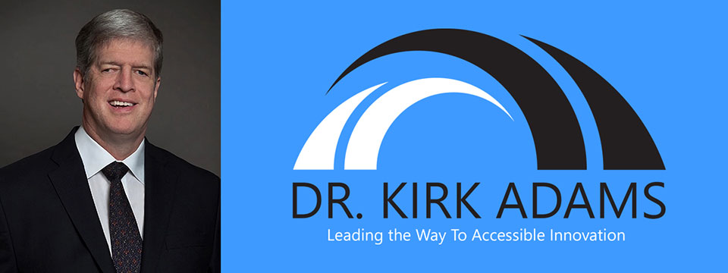
Sponsor Since: July 22, 2024 📅️
Website: https://drkirkadams.com 🌐️
About: Dr. Kirk Adams is a visionary leader, transformative speaker, and lifelong advocate for disability inclusion. With over three decades of experience in advancing accessibility and creating opportunities for individuals who are blind or low-vision, Dr. Adams has become a powerful force for change in the areas of leadership, accessibility, and inclusion. His journey — from navigating vision loss as a young child to becoming a recognized thought leader in disability empowerment — uniquely equips him to help organizations understand, integrate, and champion inclusive practices that benefit all.
Dr. Adams is a highly sought-after speaker, known for his engaging and thought-provoking keynotes on disability inclusion, accessible leadership, and the power of resilience. He has spoken at numerous national and international conferences, including corporate seminars, public policy forums, and industry events, where his personal story and professional insights have inspired leaders to rethink their approach to diversity, equity, and inclusion. His passion lies in empowering organizations to create environments where every individual — regardless of ability — can thrive.
As a speaker, Dr. Adams brings authenticity, warmth, and a depth of experience that resonates with audiences from all backgrounds. He understands that true leadership is about more than just policy; it's about creating cultural shifts that value each person's unique contributions. Whether he is addressing a Fortune 500 company, a non-profit, or a community group, Dr. Adams' message is clear: inclusion benefits everyone, and together we can build a world where opportunity is accessible to all.
Dr. Adams currently resides in Seattle, Washington, where he continues his advocacy work, builds strategic partnerships, and enjoys life with his family. He is proud to be a part of the movement towards a more inclusive future — one conversation at a time.

⬆︎ 5.) Sponsor: Barrier Free Canada

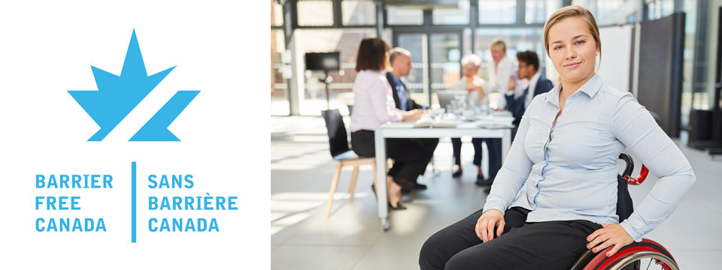
👉️ Classified Advertisement: Barrier Free Canada — Canada sans Barrières Announces Strategic Investment to Empower the Workforce of Tomorrow | Barrier Free Canada
Barrier Free Canada — Canada sans Barrières is proud to announce a bold new strategic investment aimed at advancing accessibility and inclusion in Canada's workforce. This initiative supports innovative training, education, and employment opportunities for persons with disabilities, helping to eliminate systemic barriers and foster a more equitable labor market. By partnering with key stakeholders across sectors, the investment will drive meaningful change, preparing a diverse and inclusive workforce to meet the challenges of tomorrow. This milestone reflects Barrier Free Canada's ongoing commitment to building a barrier-free nation where everyone can thrive and contribute fully to society.
Sponsor Since: November 10, 2023 📅️
Website: https://barrierfreecanada.org/ 🌐️
About: Barrier-Free Canada/Canada Sans Barrieres (BFC/CSB) advocates for the Canadian Parliament to enact a strong and effective Canadians with Disabilities Act (CDA) to achieve a barrier-free Canada for all persons with disabilities.
To this end, BFC/CSB is seeking endorsements from national disability organizations to build a non-partisan community coalition. BFC/CSB would also like to identify point persons from these organizations to act as key contacts.
The steering committee of BFC/CSB has drafted a set of principles concerning a CDA that are drawn from the principles that underpin the provincial disability legislation in Ontario and Manitoba. A CDA is not meant to replace provincial disability legislation. It will complement such legislation and benefit Canadians living in provinces with and without provincial disability legislation. At this point in time, CNIB, March of Dimes Canada, Canadian Hearing Society and MS Society of Canada have endorsed the BFC/CSB principles and confirmed their support for the movement to enact a CDA. There is no individual or organizational charge for membership in BFC/CSB.
Please contact Donna Jodhan, Founder of Barrier-Free Canada, at info@barrierfreecanada.org 📧️ with any questions or to express your organization's support and identify a key contact.
Social: Facebook | X (Formerly Twitter) | Mastodon (Search For: @news@mastodon.barrierfreecanada.org).

⬆︎ 4.) Sponsor: Hadley

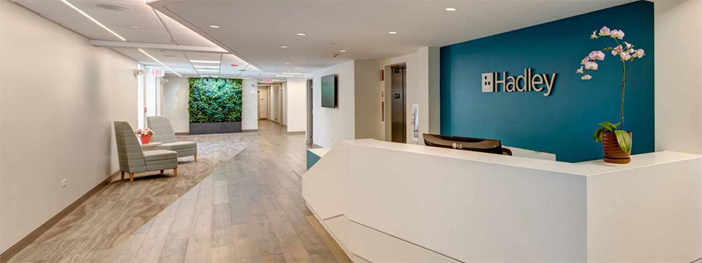
👉️ Classified Advertisement: New NVDA Workshops at Hadley | Hadley
Learn the basics of NVDA. From getting started with the program to customizing the speech to learning helpful shortcuts, Hadley's workshops have you covered.
Sponsor Since: September 18th 2023 📅️
Website: https://hadleyhelps.org/ 🌐️
Email: info@hadleyhelps.org 📧️
Phone: (800) 323-4238 📱️
Get Started: https://hadleyhelps.org/learn 🎓
What would you like to learn today?
Donate: https://hadleyhelps.org/donate/support-hadley ❤
A 501(c)(3) non-profit organization, Hadley relies on contributions from individuals, foundations, and corporations to fund its programs.
About: The mission of Hadley is to create personalized learning opportunities that empower adults with vision loss or blindness to thrive — at home, at work, and in their communities.
Founded in 1920 by William Hadley, an educator who lost his eyesight later in life, Hadley offers practical help, connection and support free of charge to anyone with a visual impairment, their families and professionals supporting them. With Hadley, you can discover new ways to do things that have become more difficult due to vision loss and connect with a network of peers who "get it." And you don't need to come to Hadley. Hadley's help comes to you; online, on the phone or through the mail.
Since relaunching in July 2020, more than 70,000 people have signed up with Hadley, registering more than 200,000 workshop interactions. And our workshops have 98% satisfaction ratings. We reach all 50 states and more than 100 countries. And more people learn braille from Hadley than from any other organization worldwide.
Hadley is a proud partner of the National Eye Institute and the National Eye Health Education Program.
Hadley's help conveniently meets learners where they are. Free of wait lists. Free of office visits. Free of charge.
Social: Facebook | X (Formerly Twitter) | YouTube

⬆︎ 3.) Sponsor: Eyes on Success

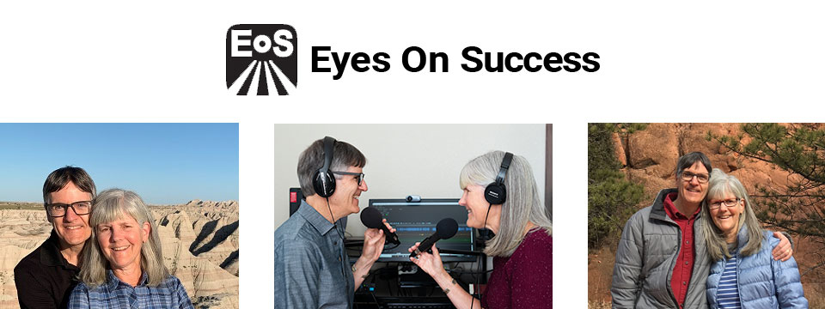
Sponsor Since: August 21, 2023 📅️
Website: https://www.eyesonsuccess.net/ 🌐️
About: This half-hour weekly podcast and radio program discusses products, services and daily living tips for people with vision loss. It is available through radio reading services across North America, via several internet streaming services, and to everyone else as a podcast. To date, the show has been downloaded in all 50 states in the US and over 100 other countries on all the inhabited continents. Eyes On Success is hosted and produced by Peter Torpey and Nancy Goodman Torpey.
Each episode is basically a success story. Some are human stories of visually impaired people's accomplishments in academics, employment, sports or pastimes. Others are descriptions of adaptive aids that enable visually impaired people to achieve things. These include screen readers, magnifiers, navigation aids, and others. In all cases, the focus is on success.
Eyes On Success has been airing weekly since January 2011. Prior to January 2013 the name of the show was ViewPoints. Other than the name, nothing has changed.
Listening To Eyes On Success
You can listen to Eyes On Success on your smart home device by saying "play the Eyes On Success podcast", subscribe to the podcast wherever you get your podcasts, or listen on Apple Podcasts, iTunes, YouTube or your local radio reading service. Listeners can also follow the show on Facebook and X (Formerly Twitter).
Connecting with Eyes On Success
Email: To contact us with questions, comments or suggestions for future shows send an e-mail to hosts@EyesOnSuccess.net 📧️.
Weekly Announcements: If you would like to receive weekly announcements of upcoming episodes, you can join our low traffic "announcements only" list by sending an e-mail to: EyesOnSuccess+subscribe@GoogleGroups.com 📧️.
Email Forum: If you would like to connect with other listeners and share your thoughts about what you've heard on the show, you can join our listener email forum by sending an email to: EOS_Discuss+Subscribe@GoogleGroups.com 📧️

⬆︎ 2.) Sponsor: Access Ready, Inc.

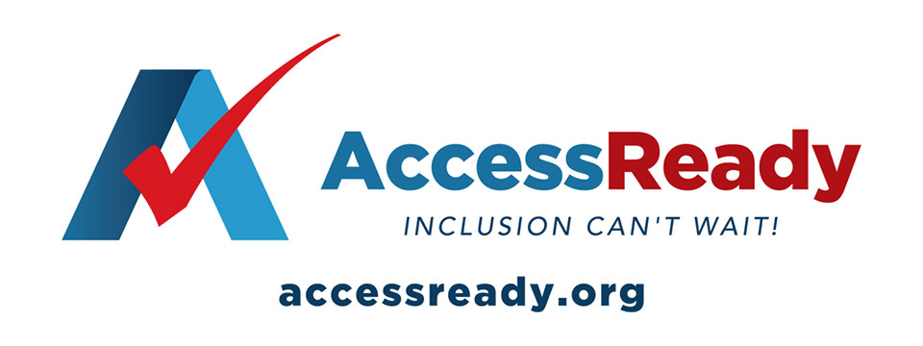
👉️ Classified Advertisement: Help Access Ready, Inc. Rebuild After Hurricanes Helene and Milton | Access Ready, Inc.
Help Access Ready, Inc. support people with disabilities after Hurricanes Helene and Milton.
Based in Saint Petersburg, Florida, Access Ready is committed to providing adaptive equipment, restoring independence and dignity to those affected. Many lost vital devices that help them communicate, work, and live independently.
Donations will go toward repairing or replacing this equipment, ensuring people can regain normalcy after the disaster. Every contribution directly aids recovery efforts.
Since 2018, Access Ready has promoted accessible technology, led by CEO Douglas George Towne.
Your support can make a real difference. Donate Now — be a lifeline for those in need.
info@accessready.org 📧️
+1 (727) 531-1000 📱️
Sponsor Since: December 1st 2022 📅️
Website: https://accessready.org/ 🌐️
Email: info@accessready.org 📧️
Phone: (727) 531-1000 📱️
About: Access Ready Inc. is a certified, 501(c)(3) nonprofit organization. The mission of Access Ready Inc., a nonprofit cross-disability rights advocacy organization, is to promote a policy of accessibility benefiting all people regardless of ability across information and communications technology utilized for two way communications.
The purpose of Access Ready Inc. is to educate the public and private sectors of the importance of accessible information and communications technology to the future of all people regardless of ability.
To support this education by developing initiatives that promote policies that ensure the creation and maintenance of accessible technologies utilized for two way communications at all levels which allow for easy use by people with the widest range of abilities possible.
To develop employment and business opportunities for people with disabilities that support its educational activities in the field of information and communications technology and related areas.
To provide consulting and educational services to buyers, developers, and users of information and communications technology that promotes its highest and best use in society.
To promote the concept of a technologically accessible society which fosters:
Freedom of expression, speech, and worship.
Freedom from fear, ignorance, and want.
Freedom from dishonesty, exclusion, and immorality.
Freedom of aspiration, invention, and inclusion.

⬆︎ 1.) Sponsor: Pneuma Solutions

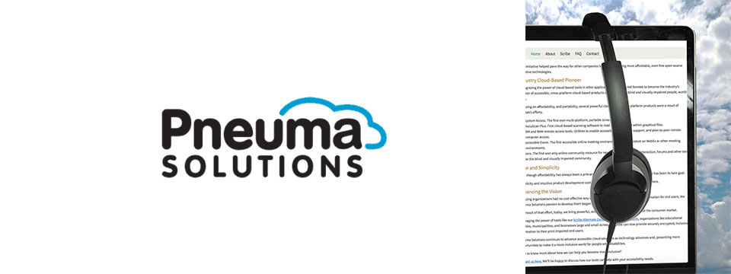
👉️ Classified Advertisement: From Now Through the 18th: Experience Unmatched Independence in the Field of Remote Desktop Access with a Remote Incident Manager Free for All! | Pneuma Solutions
As the United States finishes celebrating Independence Day, regular attendees of the summer blindness conventions will prepare to begin activities centered around independence for people who are blind or visually impaired. IN light of this, we at Pneuma Solutions are lighting our own fireworks over a very unique and never-before-seen level of independence in the field of remote desktop access!
To a technician or trainer who is blind, nothing says independence quite like performing a remote session with a sighted end user's computer, regardless of platform, and being able to fully use it, despite the lack of an installed screen reader. Our Remote Incident Manager is the world's first application that allows this to happen. As such, To celebrate this exciting level of independence, we are proud to offer unlimited access to Remote Incident Manager for the next 14 days, completely free of charge!
Sponsor Since: November 7th 2022 📅️
Website: https://pneumasolutions.com/ 🌐️
Email Newsletter: Click here to receive periodic news via email concerning Pneuma Solutions products for business, consumers and education.
Sales: (866) 202-0520 📱️
Support: (650) 249-1000 📱️
About: Backed by two decades of creating award-winning accessible cloud technologies for people with visual impairments, Pneuma Solutions is the global leader in accessible cloud-based solutions. Pneuma Solutions was founded by long-time accessibility developers Mike Calvo and Matt Campbell. For more information on their individual profiles, click on their respective bio pages. We're proud to be the first company to develop cloud-based accessibility at the network level. Our tools provide organizations, like yours, a way to deliver secure, accessible information right from your network or from our secure servers. You can provide your print disabled consumers, students, employees, and citizens with a multitude of accessible options. Additionally, we offer a suite of cloud-based applications to blind and print disabled consumers directly from our website. Our consumer products are designed to make the day-to-day lives of blind and print disabled individuals more accessible and simpler to manage. Access to information is not a privilege, it's a right. It's also your right to obtain affordable, accessible cloud solutions to serve your end user. When organizations like yours implement our tools, together we help make it a more inclusive world for people with disabilities. Want to know more about how we can help you become more inclusive?
Contact us here. We'll be happy to discuss how our tools can help with your accessibility needs.

⬆︎ 12.) Sponsor: Able News at The Viscardi Center

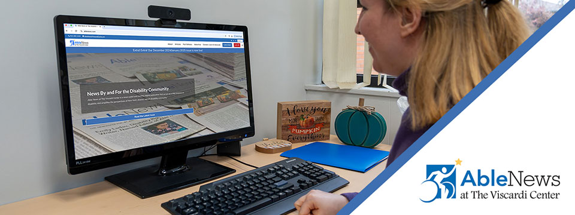
👉️ Classified Advertisement: Your Disability News Platform — Subscribe Now! Discounted Rate! | Able News at The Viscardi Center
Digital subscription just $15 a year with promo code ACCESS.
We share news for, by, and about people with disabilities. As a subscriber, you'll have 24/7 full access and be the first to read about news, community resources, culture, technology, advocacy, health/wellness, and stories from the disability community. You'll also receive our bi-weekly newsletter. Subscribe today!
Sponsor Since: July 4, 2025 📅️
Website: https://ablenews.com 🌐️
Email: ablenews@viscardicenter.org 📧️
Phone: +1 (516) 465-1416 📱️
About: Able News at The Viscardi Center is a news outlet and monthly digital publication that serves as a vital resource on disability and amplifies the perspectives of the diverse, vibrant disability community. The Viscardi Center is a Long Island-based network of non-profit organizations that educate, employ, and empower children, adults, and veterans with disabilities. Central to our mission is featuring original content by writers with disabilities on a range of important topics, from policy and legislative updates, to arts and culture, to community events.

⬆︎ 11.) Sponsor: The Touch Pad Pro Foundation / BrailleDoodle

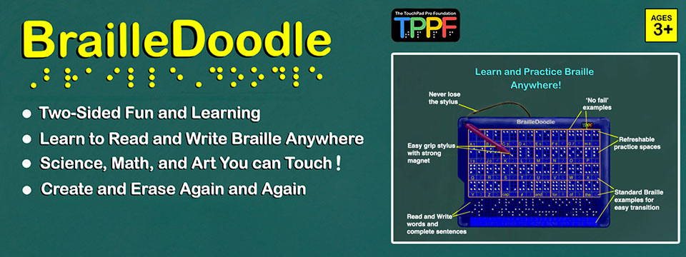
👉️ Classified Advertisement: BrailleDoodle Available at A. T. Guys Now! Just $149.00 USD | The Touch Pad Pro Foundation / BrailleDoodle
The BrailleDoodle is a groundbreaking, affordable, two-sided tablet designed to empower individuals of all ages and skill levels with Braille literacy and tactile exploration. One side is dedicated to Braille learning, featuring practice spaces for letters, numbers, and words, making it perfect for beginners or those looking to improve their skills. The other side offers a tactile refreshable surface, ideal for creating art, exploring STEM concepts like math and graphing, and expressing creativity in limitless ways.
With its easy-to-use magnetic stylus, users can write and create tactile designs, feel their progress as they go, and erase effortlessly, making learning and creativity interactive and engaging. Whether you're a teacher, parent, or individual learner, the BrailleDoodle is a versatile tool that combines education, creativity, and fun. Priced at just $149.00 USD, it is an affordable solution to enhance accessibility and opportunity for blind and low-vision individuals. Order now and take the first step in transforming education and creativity! Visit A.T. Guys today to learn more.
Sponsor Since: January 1, 2025 📅️
Website: https://touchpadprofoundation.org 🌐️
About: The TouchPad Pro Foundation (TPPF) is a 501(c)(3) nonprofit organization committed to creating opportunities for blind and low-vision individuals through Braille literacy, STEM, and art education.
Founded by educators and innovators passionate about accessibility, TPPF strives to address the critical gaps in resources and tools for the visually impaired community. With a mission to promote equality and unleash human potential, the foundation provides innovative solutions that make education inclusive, engaging, and affordable.
Their initiatives include offering free devices to under-served communities and providing training to maximize the impact of their groundbreaking tools.
At the heart of their mission is the BrailleDoodle, a dual-sided, tactile learning tablet designed to make education and creativity accessible to all.
One side focuses on Braille literacy, offering interactive learning spaces for letters, numbers, and words, while the other provides a refreshable surface for tactile drawing, STEM exploration, and artistic expression.
Affordable and versatile, the BrailleDoodle empowers individuals of all ages and skill levels to develop essential literacy and creative skills.
By fostering independence and encouraging innovation, TPPF and the BrailleDoodle are transforming the lives of blind and low-vision learners worldwide.
For more information, visit the TouchPad Pro Foundation website.

⬆︎ 10.) Sponsor: AccessibleWeb

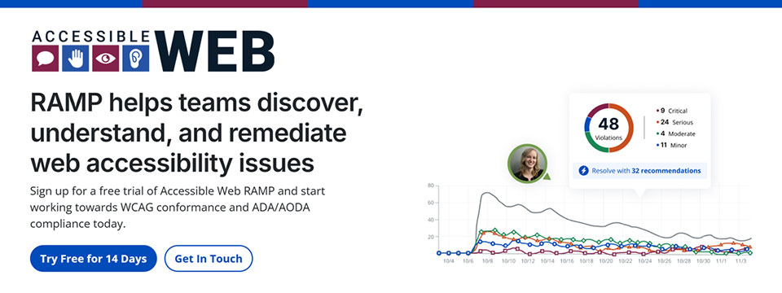
👉️ Classified Advertisement: Have You Run Into An Accessibility Barrier On A Website Recently? | AccessibleWeb
Accessible Web is on a mission to help eliminate online barriers and make the digital space more inclusive for everyone, regardless of ability. Our accessibility testing software, RAMP, allows organizations of any size to discover, understand, and remediate barriers. We offer tools to integrate with existing sites and workflows so businesses with a digital presence can start making their sites more accessible quickly.
Plans start at $49 a month. Plus, we have a 14-day free trial with no credit card needed. We believe any organization can start making progress with Accessible Web RAMP.
Sponsor Since: December 16, 2024 📅️
Website: https://accessibleweb.com 🌐️
About: At Accessible Web, our mission is to make the internet accessible to everyone, regardless of ability.
We offer a comprehensive suite of accessibility testing software tools and educational resources to help organizations achieve and maintain web accessibility in line with the Web Content Accessibility Guidelines (WCAG) and comply with legal standards such as the Americans with Disabilities Act (ADA) and the Accessibility for Ontarians with Disabilities Act (AODA).
➜︎ Services:
⚫️ WCAG Audits: Our certified specialists conduct thorough analyses of websites and applications, identifying accessibility issues and providing detailed recommendations for remediation.
⚫️ VPAT Preparation: We prepare Voluntary Product Accessibility Templates (VPATs), offering industry-standard reports that demonstrate a product's accessibility compliance, which can be crucial for sales and contractual obligations.
⚫️ Accessibility Testing: Our team of individuals with disabilities tests websites and web applications using assistive technologies, providing actionable feedback to enhance user experience and accessibility.
⚫️ Remediation Support: Our certified specialists offer coaching and support to assist organizations in implementing accessibility improvements effectively, ensuring that digital assets meet accessibility standards.
⚫️ Accessibility Certification: Through a comprehensive process of auditing, remediation, and verification, we provide WCAG certifications that validate a company's conformance and commitment to accessibility best practices.
➜︎ Tools:
⚫️ Accessible Web RAMP: Our digital accessibility platform that enables teams to discover, monitor, and remediate web accessibility violations. RAMP offers continuous monitoring, prioritized workflows, and progress reporting to facilitate ongoing compliance efforts.
⚫️ Accessible Web Helper Extension: An accessibility browser extension that allows users to scan web pages, highlight accessibility violations, and check color contrast ratios directly from their browser, streamlining the auditing process.
➜︎ Education:
⚫️ Accessible Web Academy: We offer self-guided online courses tailored to various organizational roles, promoting a culture of inclusivity and equipping teams with the knowledge to implement accessible design from the outset.
⚫️ Knowledge Base and Blog: Our resources include articles on assistive technologies, remediation tutorials, and answers to common web accessibility questions, supporting continuous learning and awareness. We host webinars most Thursdays on various accessibility topics.
We emphasize a proactive approach to web accessibility, advocating for integrating accessible design principles early in the development process to enhance user experience, attract new customers, and mitigate legal risks associated with non-compliance.
For more information or to explore our services and resources, visit our website.
Facebook | LinkedIn | Reddit | YouTube

⬆︎ 9.) Sponsor: Magnifiers & More

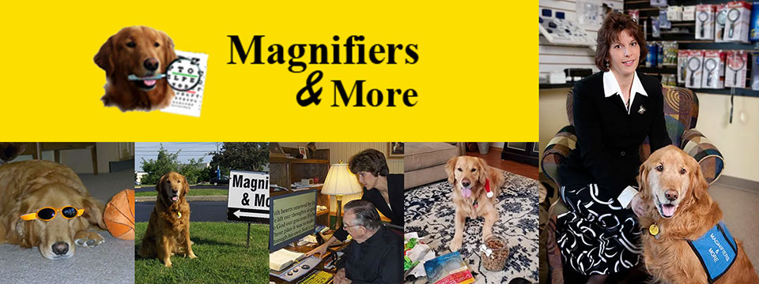
Sponsor Since: October 25, 2024 📅️
Website: https://www.magnifiersandmore.net 🌐️
Email: info@magnifiersandmore.net 📧️
Phone: (440) 946-3363 📱️
Fax: (440) 946-8899 📠️
Visit: 7775 Mentor Avenue, Mentor, Ohio 44060, USA
About: Magnifiers & More, established in 2002 by Deborah Kogler, is Northeast Ohio's only retail store dedicated to providing products and consultations for individuals with low vision, blindness, and vision disabilities. With over forty years of experience in eye care, Deborah founded the company to create a one-stop shop for vision aids, including specialized tools for managing conditions like macular degeneration, glaucoma, diabetic retinopathy, and cataracts.
The store offers a wide range of over seventy-five magnifiers, talking items, large print products, special lights, electronic aids, Braille items, glare control solutions and More.
A key figure in the company's story is Murphy, Deborah's Golden Retriever and original CEO, "Canine Executive Officer," who was the store's mascot and greeter for 15 years. Today, Jeffrey, another Golden Retriever trained as a service dog, serves as the CFO, "Canine Fun Officer," delighting customers and supporting Deborah.
Deborah's journey into vision rehabilitation was inspired by her grandmother's experience with macular degeneration, sparking her passion to make vision aids accessible. She continues to advocate for and educate those living with vision disabilities, both locally and internationally.
Magnifiers & More is committed to helping people improve their quality of life through practical solutions and compassionate support.

⬆︎ 13.) Sponsor: Your Name Here

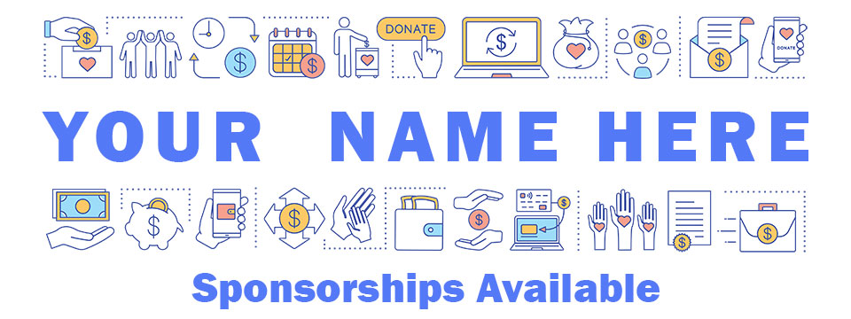
Sponsor Since: Today 📅️
Website: https://accessinformationnews.com/dearsponsor 🌐️
Phone: (855) 578-6660 📱️
Email: news@accessinformationnews.com 📧️
About: Founded in 2022, Access Information News is the world's leading not-for-profit access information news publication that reaches over 40,000 blind, low vision, deaf, hard of hearing, deafblind, neurodivergent and/or disabled professionals, educators and enthusiasts, all over the world, each week. Subscribe here. Review the most recent issues here.

Access Information News Supporters 🤝️
We couldn't do it without you! Thank you for your support!
Why: Access Information News Supporters donate an amount of their choosing either one time or annually in order to assist with the ongoing distribution of the Access Information News publication.
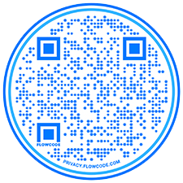
Benefits: All Access Information News Supporters receive a listing within the "Our Supporters" section of each weekly newsletter, as well as a listing within the "Our Supporters" section of the Access Information News website.
In addition, all Access Information News Supporters automatically become Premium Subscribers as well, and therefore enjoy all of the benefits that a Premium Subscription has to offer.
One Time Donation: If you would like to become a Access Information News Supporter by making a one time donation in an amount of your choosing to assist with the ongoing distribution of the Access Information News publication, you may utilize this donate link, or scan the QR code to the right.
Annual Donation: If you would like to become a Access Information News Supporter by making a small annual donation to assist with the ongoing distribution of the Access Information News publication, we also offer the following options, all with our sincerest thanks, and most heartfelt gratitude for your ongoing support.
Support: In tandem with Our Sponsors, these are the people that make the ongoing distribution of Access Information News possible.

Platinum Supporters:

Become an Access Information News Platinum Supporter today.
1.) James Hulme
Platinum Supporter Since: December 5, 2022
2.) Donna Jodhan
Platinum Supporter Since: March 24, 2023
3.) Your name here.
Platinum Supporter since ...

Gold Supporters:

Become an Access Information News Gold Supporter today.
1.) Your name here.
Gold Supporter since ...

Silver Supporters:

Become an Access Information News Silver Supporter today.
1.) Your name here.
Silver Supporter since ...

Bronze Supporters:

Become an Access Information News Bronze Supporter today.
1.) Your name here.
Bronze Supporter since ...

One Time Supporters:

One Time Supporters donate an amount of their choosing — one time to assist with the ongoing distribution of the Access Information News Publication.
Become an Access Information News One Time Supporter today.
1.) Sharyn Sobel
One Time Supporter on November 28, 2023
2.) Amanda Lee
One Time Supporter on July 31, 2023
3.) Gaylen Kapperman
One Time Supporter on June 4, 2024
4.) Your name here.
One Time Supporter on ...

Access Information News Team 🗞️

Distribution: Sponsors, Supporters and Mind Vault Solutions, Ltd.

Distribution Since: 2022
As of November 7, 2022 the distribution of Access Information News is made possible by our Sponsors, our Supporters, our Advertisers and Mind Vault Solutions, Ltd., a leading international provider of professionally outsourced marketing administration and consultation services.
Any time the Access Information News Publication carries less than its Sponsor limit, Mind Vault Solutions, Ltd. donates the remaining dollars necessary to keep the publication running.
Please help us to support the ongoing distribution of this publication. Learn more about the benefits of Sponsorship today.

Publisher: Aaron Di Blasi

Publisher Since: November 7, 2022
Location: Cleveland, Ohio
Time Zone: Eastern Standard Time (EST/EDT) (GMT-5/GMT-4)
In addition to serving as Publisher for Access Information News Aaron also serves as Publisher for the Top Tech Tidbits and AI-Weekly newsletters, PR-Director for the AT-Newswire Press Release News Distribution Service, and President and Senior Project Management Professional for Mind Vault Solutions, Ltd.
As Publisher Aaron oversees the weekly distribution of Access Information News on behalf of Mind Vault Solutions, Ltd.
Aaron Di Blasi, PMP
Email: publisher@accessinformationnews.com 📧️
Toll-Free: +1 (855) 578-6660 📱️
Aaron Di Blasi, PMP
Email: publisher@toptechtidbits.com 📧️
Toll Free: +1 (855) 578-6660 📱️
PR Director (2024-Present)
AT-Newswire 🌐
Access Technology's Digital Newswire
Publisher (2024-Present)
AI-Weekly 🌐
The Week's News in Artificial Intelligence
Publisher (2022-Present)
Access Information News 🌐
The Week's News in Access Information
Publisher (2020-Present)
Top Tech Tidbits 🌐
The Week's News in Access Technology
Sr. Project Management Professional (2006 - Present)
Mind Vault Solutions, Ltd. 🌐
Innovative ideas. Solutions that perform.
Certified:
Digital Marketing Associate
Meta Certified (2022 - Present)
Social Marketing Professional
Hootsuite Certified (2020 - Present)
Email Marketing Professional
Constant Contact Certified (2019 - Present)
Specializing in:
Digital Strategy and Content Marketing
Social Media Advertising
Online Fundraising
ADA, WCAG and Section 508 Compliance

Editor: John Hanlin

Editor Since: November 7, 2022
Location: Boulder, Colorado
Time Zone: Mountain Standard Time (MST/MDT) (GMT-7/GMT-6)
In addition to serving as an Editor to Access Information News John also serves as an Editor to the Top Tech Tidbits and AI-Weekly newsletters and is also an attorney-at-law specializing in long-term disability claims for blind and low-vision persons.
John is also a long-time contractor and member of the Board of Trustees at Mind Vault Solutions, Ltd.
John Hanlin, Esq.
Editor (2024-Present)
AI-Weekly 🌐
The Week's News in Artificial Intelligence
Editor (2022-Present)
Access Information News 🌐
The Week's News in Access Information
Editor (2020-Present)
Top Tech Tidbits 🌐
The Week's News in Access Technology
Board of Trustees (2006 - Present)
Mind Vault Solutions, Ltd. 🌐
Innovative ideas. Solutions that perform.

Editor: Jenna Lang

Editor Since: November 7, 2022
Location: Des Moines, Iowa
Time Zone: Central Standard Time (CST/CDT) (GMT-6/GMT-5)
In addition to serving as an Editor to Access Information News Jenna also serves as an Editor to the Top Tech Tidbits and AI-Weekly newsletters and runs her own advocacy foundation.
Jenna also serves as a certified Project Management Professional (PMP) for Mind Vault Solutions, Ltd.
Jenna's son was born blind and she is always seeking new and innovative ways to empower him through technology.
Jenna Lang, PMP
Editor (2024-Present)
AI-Weekly 🌐
The Week's News in Artificial Intelligence
Editor (2022-Present)
Access Information News 🌐
The Week's News in Access Information
Project Management Professional (2022 - Present)
Mind Vault Solutions, Ltd. 🌐
Innovative ideas. Solutions that perform.
Editor (2020-Present)
Top Tech Tidbits 🌐
The Week's News in Access Technology

Editor: David Woodbridge

Editor Since: February 6, 2023
Location: Central Coast, New South Wales, Australia
Time Zone: Australia Eastern Standard Time (AEST/AEDT) (GMT+10)
In addition to serving as an Editor to Access Information News David also serves as an Editor to the Top Tech Tidbits publication and is also the National Commercial Assistive Technology Advisor for Vision Australia where he has worked since 1990. Over this time he has assisted people who are blind or vision impaired in their home, education, and work settings to take advantage of the benefits of using assistive and main stream technology.
In the last seventeen years, he has also been involved with evaluating technology for use by people who are blind or vision impaired covering both low and high tech equipment (including Microsoft, Samsung, Google, Amazon, and Apple). David is also one of the key spokespersons for Vision Australia relating to technology.
He has been an Apple Ambassador for Apple Australia since 2009 with a group of other Ambassadors / Apple Distinguished Educators (ADE)'s covering the range of Apple's Accessibility solutions throughout Australia.
David produces a range of podcasts (since 2011) covering Apple and other technologies which are distributed on his own podcast (http://davidwoodbr.podbean.com). In addition, he also has a regular Talking Tech program (since 2013) which can be heard every Tuesday at 4:30 Eastern Summer Time on Vision Australia Radio Melbourne (available online) or via https://omny.fm/shows/talking-tech-vision-australia-radio
David also runs a weekly Tech Monday where people can chat about assistive and main stream technology, share information, and any tips and tricks.
David lost his sight when he was 8 years old and had to learn Braille. Since then, he completed high school, went to Sydney University receiving a Social Work degree, spent 4 years drug and alcohol counselling, and then moved into his current job.
As a person who is blind, David believes that as a user of the technology that he recommends to others, that he is well situated to look at the strengths and shortcomings of the assistive technology that he comes across in both his professional and personal life, in particular, mainstream technology that is accessible.
In addition to his weekly contributions to Access Information News and Top Tech Tidbits, David's regularly occurring activities are his weekly tech radio show, bi-monthly exploring tech webinars for Vision Australia, his iSee podcast when something of note grabs his attention, and the weekly Tech Monday chat sessions.
David Woodbridge
X (Formerly Twitter): @dwoodbridge
Mastodon: woody@dragonscave.space
iSee Podcast: https://davidwoodbr.podbean.com
Vision Australia Radio Talking Tech: https://omny.fm/shows/talking-tech-vision-australia-radio
Editor (2023-Present)
Top Tech Tidbits 🌐
The Week's News in Access Technology
Editor (2023-Present)
Access Information News 🌐
The Week's News in Access Information
National Commercial Assistive Technology Advisor
(1990 - Present)
Vision Australia 🌐
Live the life you choose. We're here to support all Australians who are blind or have low vision.

Editor: Vicki Walton

Editor Since: January 9, 2024
Location: Benton City, WA
Time Zone: Pacific Standard Time (PST/PDT) (GMT-6/GMT-7)
IIn addition to serving as an Editor to Access Information News Vicki also serves as an Editor to the Top Tech Tidbits publication and works as a Web Accessibility Specialist / IT Quality Assurance Tester at Washington State Board for Community and Technical Colleges.
Vicki Walton
Editor (2024-Present)
Top Tech Tidbits 🌐
The Week's News in Access Technology
Editor (2024-Present)
Access Information News 🌐
The Week's News in Access Information
Web Accessibility Specialist / IT Quality Assurance Tester
Washington State Board for Community and Technical Colleges 🌐
Better Jobs, Brighter Futures, a Stronger Washington

Subscription Information 📰️
ABOUT ♿️
Founded in 2022, Access Information News is the world's leading not-for-profit access information news publication that reaches over 40,000 blind, low vision, deaf, hard of hearing, deafblind, neurodivergent and/or disabled professionals, educators and enthusiasts, all over the world, each week. Subscribe here. Review the most recent issues here. Access Information refers to informational topics that directly affect the lives of people with disabilities. Access Information includes any and all information related to bettering the lives of people who are blind, low vision, deaf, hard of hearing, deafblind, neurodivergent and/or disabled. Access Information News is a Mind Vault Solutions, Ltd. Publication. Publisher: Aaron Di Blasi. Editors: John Hanlin, Jenna Lang, David Woodbridge and Vicki Walton. Access Information News is a sponsor, reader and advertiser supported publication.
RELEASE SCHEDULE 📅️
Access Information News is released every Monday morning at 6:00 AM ET.
SUBSCRIBE 📧️
Do you, a friend, or colleague wish to receive the Access Information Newsletter? If so, please use or pass along our CAPTCHA-free sign-up link. You can also subscribe to receive the Access Information Newsletter on the Access Information News Website. Either of these methods will provide you with an accessibly friendly and secure medium through which you can subscribe to our mailing list. Just enter your email address, click send, and begin receiving the Access Information Newsletter. It's that easy.
WEBSITE 🌐️
Visit the Access Information News website online at: https://accessinformationnews.com.
PREMIUM SUBSCRIBER 💸️
Only Access Information News Premium Subscribers receive our special quarterly issue listing the Top 60 Most Clicked News Articles of the Last 3 Months. Just $12 USD per year. This special quarterly issue is provided to Premium Subscribers as a native Microsoft Word document with full headings, links and abstracts to all 60 articles. There are no restrictions placed on these documents. Complete list of all back issues available. Premium Subscribers are entitled to all back issues, anytime they sign up. Join us today and begin receiving this incredibly informative issue every 3 months.
SPONSOR 🏅️
If you would like to become 1 of only 24 Access Information News Sponsors whose ongoing support makes the distribution of Access Information News possible, we offer you the following advertising benefits, with our sincerest thanks, and most heartfelt gratitude for your ongoing support.
ADVERTISE 🎯️
Access Information News offers a variety of one-time advertising options to both Sponsors and non-Sponsors alike. Here we offer a sample newsletter that provides a breakdown of exactly what those one-time advertising options are, where they appear, and what they cost per publication.
DONATE ❤️
If you would like to become an Access Information News Supporter by making a small donation to assist with the ongoing distribution of the Access Information News publication, we offer the following options, with our sincerest thanks, and most heartfelt gratitude for your support.
FACEBOOK 💬️
Are you on Facebook? Follow Access Information News on Facebook to begin receiving current news and trends in Access Information as part of your Facebook News Feed.
X (FORMERLY TWITTER) 💬️
Are you on X? Follow Access Information News on X to begin receiving current news and trends in Access Information as part of your X News Feed.
MASTODON 💬️
Are you on Mastodon? Follow Access Information News on Mastodon to begin receiving current news and trends in Access Information as part of your Mastodon News Feed or by searching for @news@mastodon.accessinformationnews.com on your server today.
LINKEDIN 💬️
Are you on LinkedIn? Follow Access Information News on LinkedIn to begin receiving current news and trends in Access Information as part of your LinkedIn News Feed.
YOUTUBE ▶️
Are you on YouTube? Follow Access Information News on YouTube to begin receiving current news and trends in Access Information as part of your YouTube Video Feed.
RSS 📡️
Do you prefer RSS? Follow Access Information News via RSS today to begin receiving current news and trends in Access Information using your choice of news aggregator.
QUESTIONS ❓️
Article abstracts are intentionally concise. As a result we know that some readers may not always understand all of the items listed because little explanation is given. If a particular article brings up a question in your mind, feel free to ask, and we will try to answer as time and knowledge permit.
ARCHIVE 🗄️
Read the most recently released issues of Access Information News online here. Visit the Access Information News Archive here, where you can read back issues.
CONTENT CONTRIBUTORS ✍️
Any information for future issues of Access Information News may be submitted online via our News Item Submission Form or directed to our Editors via email.
THANK YOU 🙏️
Thank you for reading. On behalf of all of us here at Access Information News we look forward to keeping you informed.
Information provided by:
Access Information News
https://accessinformationnews.com/ 🌐️
A Mind Vault Solutions, Ltd. Publication
1284 SOM Center Road, PMB 194,
Mayfield Heights, Ohio 44124
+1 (855) 578-6660 📱️

